MutiaraConnect System Models
The use case and class diagrams describe the five agreed MutiaraConnect functions: announcements, the construction impact map, feedback submission, feedback tracking and administration. They distinguish the proposed system design from the Part A front end simulation.

Use Case Diagram
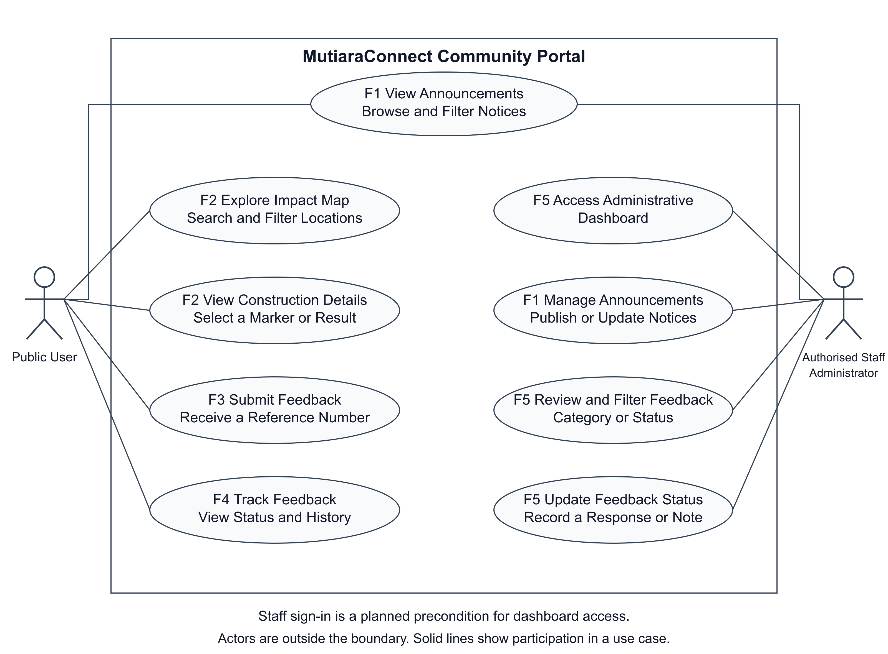
Figure 1 Public and authorised staff use cases across the five functions
Public User represents residents, commuters, business owners and visitors. The actor browses and filters announcements, explores the impact map, selects construction details, submits feedback and tracks a report. Authorised Staff, shown as Administrator, manage announcements, review reports and update statuses or responses. Staff can also read public announcements.
Both actors are outside the system boundary. Solid associations identify participation in a use case. Staff sign in is a precondition for the proposed dashboard; the front end does not provide production authentication. For F2, users search or filter locations, select a marker or result, inspect its impact and access information, and open the matching announcement.

Class Diagram
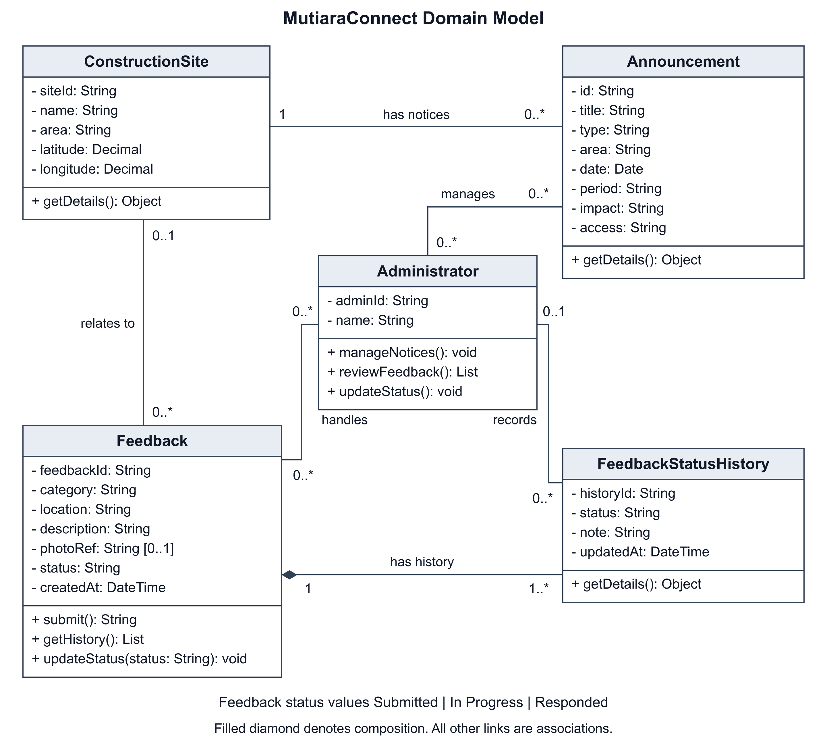
Figure 2 Domain classes with association multiplicities and feedback history ownership
ConstructionSite identifies a mapped location. Each mapped Announcement belongs to one site, and a site can have zero or more announcements. The prototype links four shared announcements to three illustrative locations. Notice text, dates, impact and access information come from the existing announcement collection; the map does not maintain a second copy.
In the proposed feedback model, a Feedback record can refer to zero or one known site. It owns one or more FeedbackStatusHistory entries, shown by composition at the Feedback end. The initial entry records Submitted. Each history entry has zero or one Administrator so that the first submission can exist without a staff author.
Administrators can manage many announcements, handle many feedback records and record many history entries. Feedback states are Submitted, In Progress and Responded. A staff update changes the current status and adds a dated history note. These are domain responsibilities; the Part A simulation does not require persistent database classes.

