################ PART II. Pre-requisite

####################### Step 0.1 Download and install the necessary softwares: PuTTY, PuttyGEN, WinSCP and SuperPuTTY

####################### Step 0.2 Setup the 3 machines, with the following machine names: better using the same security group and use the security keys. The following instructions assume the 3 linux instances generated are: machine0, machine1, machine2 with the following IP addresses:

54.174.16.168 machine0

54.174.1.80 machine1

54.174.1.89 machine2

####################### Step 1.1 At each of the machine, Add the dedicated user.

After logon to each of the machine, run the following:

### Step 1.

sudo adduser hduser sudo

sudo usermod –g rcloud gz5427

### Step 2.

sudo mkdir /home/hduser/.ssh

sudo chown –R hduser:hduser /home/hduser/

sudo cp /home/ubuntu/.ssh/* /home/hduser/.ssh

sudo chown –R hduser:hduser /home/hduser/.ssh

####################### Step 1.3 At each of the machines, Copy the private key ‘authorized_keys’ from .ssh folder of the user ‘ubuntu’ to that of the user ‘hduser’

sudo cp /home/ubuntu/.ssh/authorized_keys /home/hduser/.ssh

sudo chown hduser:hadoop /home/hduser/.ssh/authorized_keys

sudo chmod 600 /home/hduser/.ssh/authorized_keys

### After this you can close all putty sessions and re-login on with user name ‘hduser’ since the ### private key has been put in the ‘hduser’s .ssh folder.

####################### Step 2. Use WinSCP to copy the key pair file “.pem” to the .ssh folder of each machine. You could copy it to one of the machine and then use scp to copy it to the other machines.

####################### Step 2. 1 Open the WinSCP tool. You should see a screen like this.

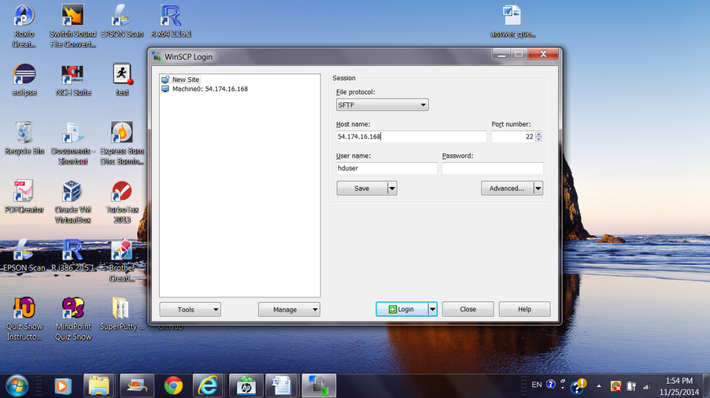

####################### Step 2. 2 Pick “SCP” function, input the IP address of the machine0, the user ‘hduser’, and click on the ‘Advanced’.

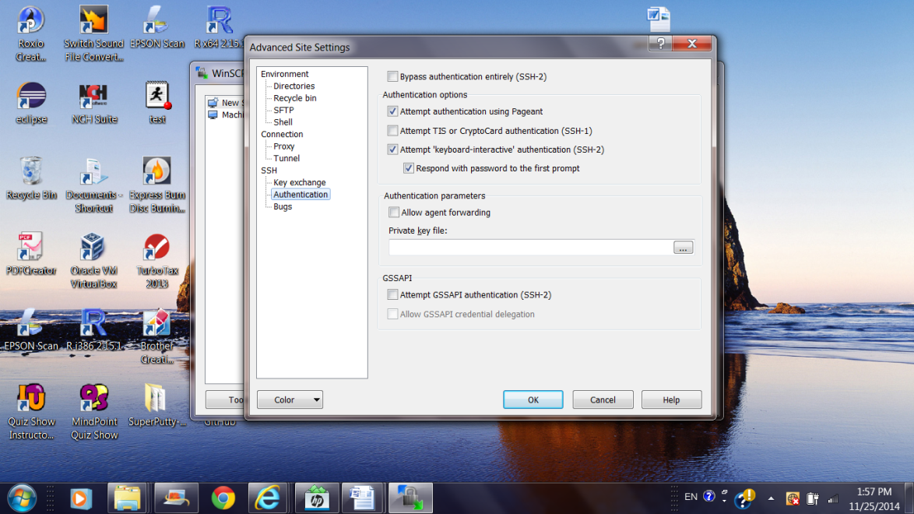

####################### Step 2. 3 Click ‘SSH’ and ‘Authentication, then open the browser to locate the private key file and input it.

## ####################### Step 2. 4 Click ‘OK’ and click ‘Login’. You should see a screen. The right-hand-sight of the panel is the folders of your linux instance: machine0 (Yours may have very few items!)

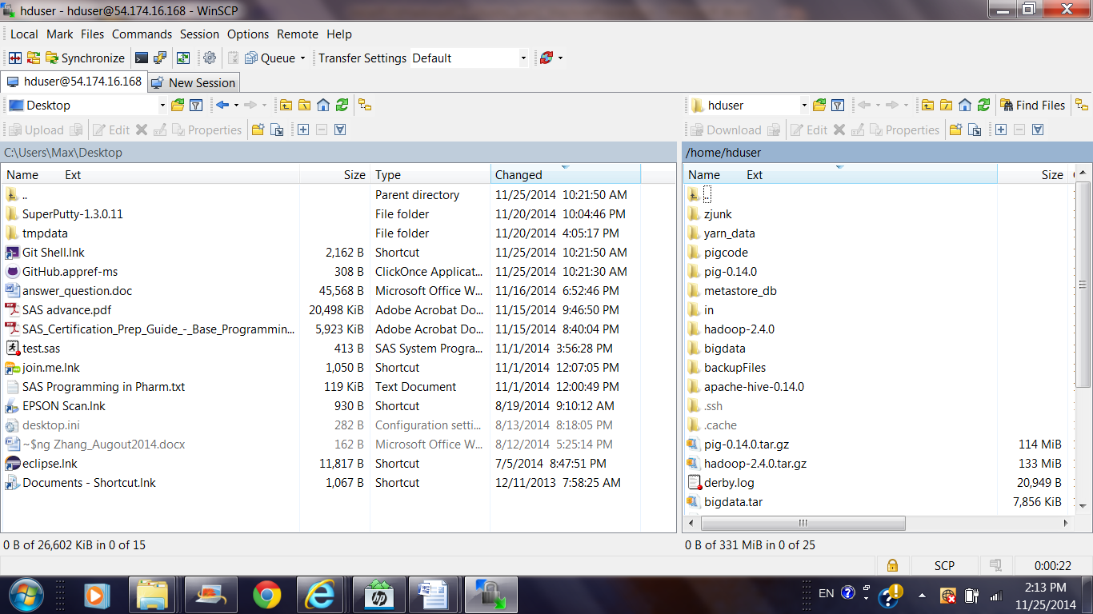

####################### Step 2.5 You can use this GUI to copy files to the “.ssh” folder of your target machine0. Then close the WinSCP session.

####################### Step 3.

####################### Step 3.1 At machine0, copy the machine0.pem to id_rsa, the default remote access code.

cp ~/.ssh/machine0.pem ~/.ssh/id_rsa

chmod 600 ~/.ssh/id_rsa

####### With id_rsa in place, you can run the following to see if it works!

ssh 54.174.1.80 (machine1) to see if it works.

####### Full version command will be “ssh –i machine0.pem hduser@54.174.1.80”

####################### Step 3.2 After keyless “ssh” works at one machine, then copy the key file to the folder “.ssh” of the other machines (machine1 and machine2).

chmod 700 ~/.ssh/machine0.pem

scp ~/.ssh/machine0.pem hduser@ec2-54-174-1-80.compute-1.amazonaws.com:/home/hduser/.ssh

scp ~/.ssh/machine0.pem [hduser@ec2-54-174-1-89.compute-1.amazonaws.com:/home/hduser/.ssh](mailto:hduser@ec2-54-174-1-89.compute-1.amazonaws.com:/home/hduser/.ssh)

chmod 400 ~/.ssh/machine0.pem

####################### Step 3.3 Use PuTTY to access machine1 and machine 2, on each of the slave machines, run the following to change name and chmod mode.

mv ~/.ssh/machine0.pem ~/.ssh/id_rsa

chmod 400 ~/.ssh/id_rsa

####################### Step 3.4 After this, you should be able to ssh from one another using IP address or amazonaws domain name. such as following from machine0

ssh ec2-54-174-1-80.compute-1.amazonaws.com #(From machine0)

ssh ec2-54-174-1-80.compute-1.amazonaws.com #(From machine0)

ssh ec2-54-174-16-168.compute-1.amazonaws.com #(From machine1)

####################### Step 4.1 Exiting all session and re-logon as ‘hduser’ at all machines, and add the following to the Unix environment set up --- Edit the /etc/hosts files --- sudo vi /etc/hosts

54.174.16.168 machine0

54.174.1.80 machine1

54.174.1.89 machine2

####################### Step 4.2 After this you should be able to ssh from one another by referencing the machine nick name.

ssh machine1 #(from machine0)

ssh machine2 #(from machine0)

ssh machine0 #(from machine1 or machine2)