Abstract

Intro
compare to fungal paper from same samples.

Methods

Sample collection and processing was reported elsewhere:

Avicennia alba
Lee, N. L. Y., Huang, D., Quek, Z. B. R., Lee, J. N., & Wainwright, B. J. (2019). Mangrove-Associated Fungal Communities Are Differentiated by Geographic Location and Host Structure. Frontiers in Microbiology, 10, 2456. https://doi.org/10.3389/fmicb.2019.02456

Sonneratia alba
Lee, N. L. Y., Huang, D., Quek, Z. B. R., Lee, J. N., & Wainwright, B. J. (2020). Distinct fungal
communities associated with different organs of the mangrove Sonneratia alba in the Malay Peninsula. IMA Fungus, 11(1), 17. https://doi.org/10.1186/s43008-020-00042-y

Results

No real difference between mangrove species. Location and plant part much more important.
Permanova R2: Strucutre = 19.7%, host = 1.4%, location =9.7%, structure:location = 16.6%

Mantel test showed geographic location important
Alpha diversity significantly different based on: structure, host species,
Sediment was most diverse, followed by pneumatophores, leaf, then fruit

No evidence of nestedness… ASVs found in sediment were not shared in plant structures, but at species-level ID’d taxa, there was a lot of overlap, especially between sediment and pneumatophores (venndiagram). Perhaps ASVs too fine resolution, or perhaps there’s strong selection going on?

Combination of simper, indicspecies, and corncob identified 8 bacterial genera that had strong support for differential abundance based on plant structure. (corncob plot)
Take a look at these 8 taxa:

Pleurocapsa = N-fixing cyanobacteria
Waterbury, J. B., & Stanier, R. Y. (1978). Patterns of growth and development in pleurocapsalean cyanobacteria. Microbiological Reviews, 42(1), 2–44.

Tunicatimonas =
Yoon, J., Oku, N., Park, S., Katsuta, A., & Kasai, H. (2012). Tunicatimonas pelagia gen. Nov., sp. Nov., a novel representative of the family Flammeovirgaceae isolated from a sea anemone by the differential growth screening method. Antonie van Leeuwenhoek, 101(1), 133–140. https://doi.org/10.1007/s10482-011-9626-6

Halomonas = common marine bacteria, potentially human pathogen
Stevens, D. A., Hamilton, J. R., Johnson, N., Kim, K. K., & Lee, J.-S. (2009). Halomonas, a Newly Recognized Human Pathogen Causing Infections and Contamination in a Dialysis Center: Three New Species. Medicine, 88(4), 244–249. https://doi.org/10.1097/MD.0b013e3181aede29

Marinomonas = no real info on ecology; non-motile

Rubrivirga = no real info on ecology; non-motile;
Song, J., Joung, Y., Park, S., Cho, J.-C., & Kogure, K. 2016. (n.d.). Rubrivirga profundi sp. Nov., isolated from deep-sea water, and emended description of the genus Rubrivirga. International Journal of Systematic and Evolutionary Microbiology, 66(9), 3253–3257. https://doi.org/10.1099/ijsem.0.001182

Altererythrobacter = no real info on ecology; non-motile; “Members of the genus have been isolated from marine environments such as the mangrove rhizosphere, cold-seep sediments and seawater of tidal flats”
Park, S. C., Baik, K. S., Choe, H. N., Lim, C. H., Kim, H. J., Ka, J.-O., & Seong, C. N. 2011. (n.d.). Altererythrobacter namhicola sp. Nov. And Altererythrobacter aestuarii sp. Nov., isolated from seawater. International Journal of Systematic and Evolutionary Microbiology, 61(4), 709–715. https://doi.org/10.1099/ijs.0.021196-0

Lewinella = common in activated sludge; breakdown complex molecules;
Kang, H., Kim, H., Joung, Y., & Joh, K. 2017. (n.d.). Lewinella maritima sp. Nov., and Lewinella lacunae sp. Nov., novel bacteria from marine environments. International Journal of Systematic and Evolutionary Microbiology, 67(9), 3603–3609. https://doi.org/10.1099/ijsem.0.002176

Erythrobacter = facultative photoheterotrophs
Koblížek, M., Béjà, O., Bidigare, R. R., Christensen, S., Benitez-Nelson, B., Vetriani, C., Kolber, M. K., Falkowski, P. G., & Kolber, Z. S. (2003). Isolation and characterization of Erythrobacter sp. Strains from the upper ocean. Archives of Microbiology, 180(5), 327–338. https://doi.org/10.1007/s00203-003-0596-6

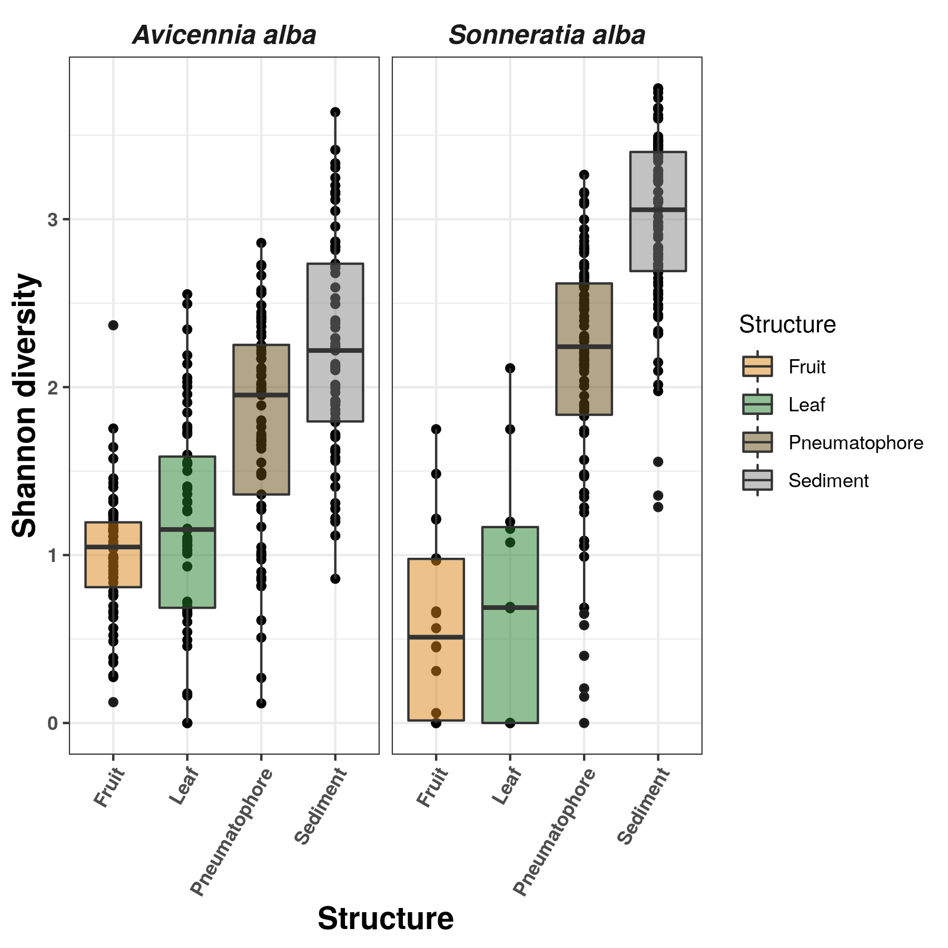
Results

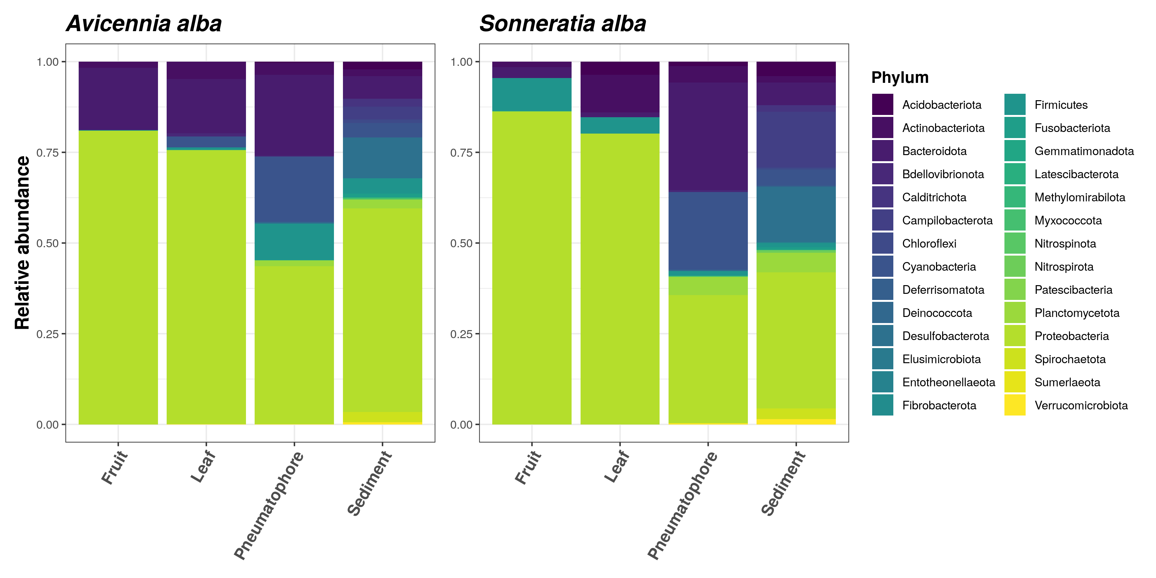
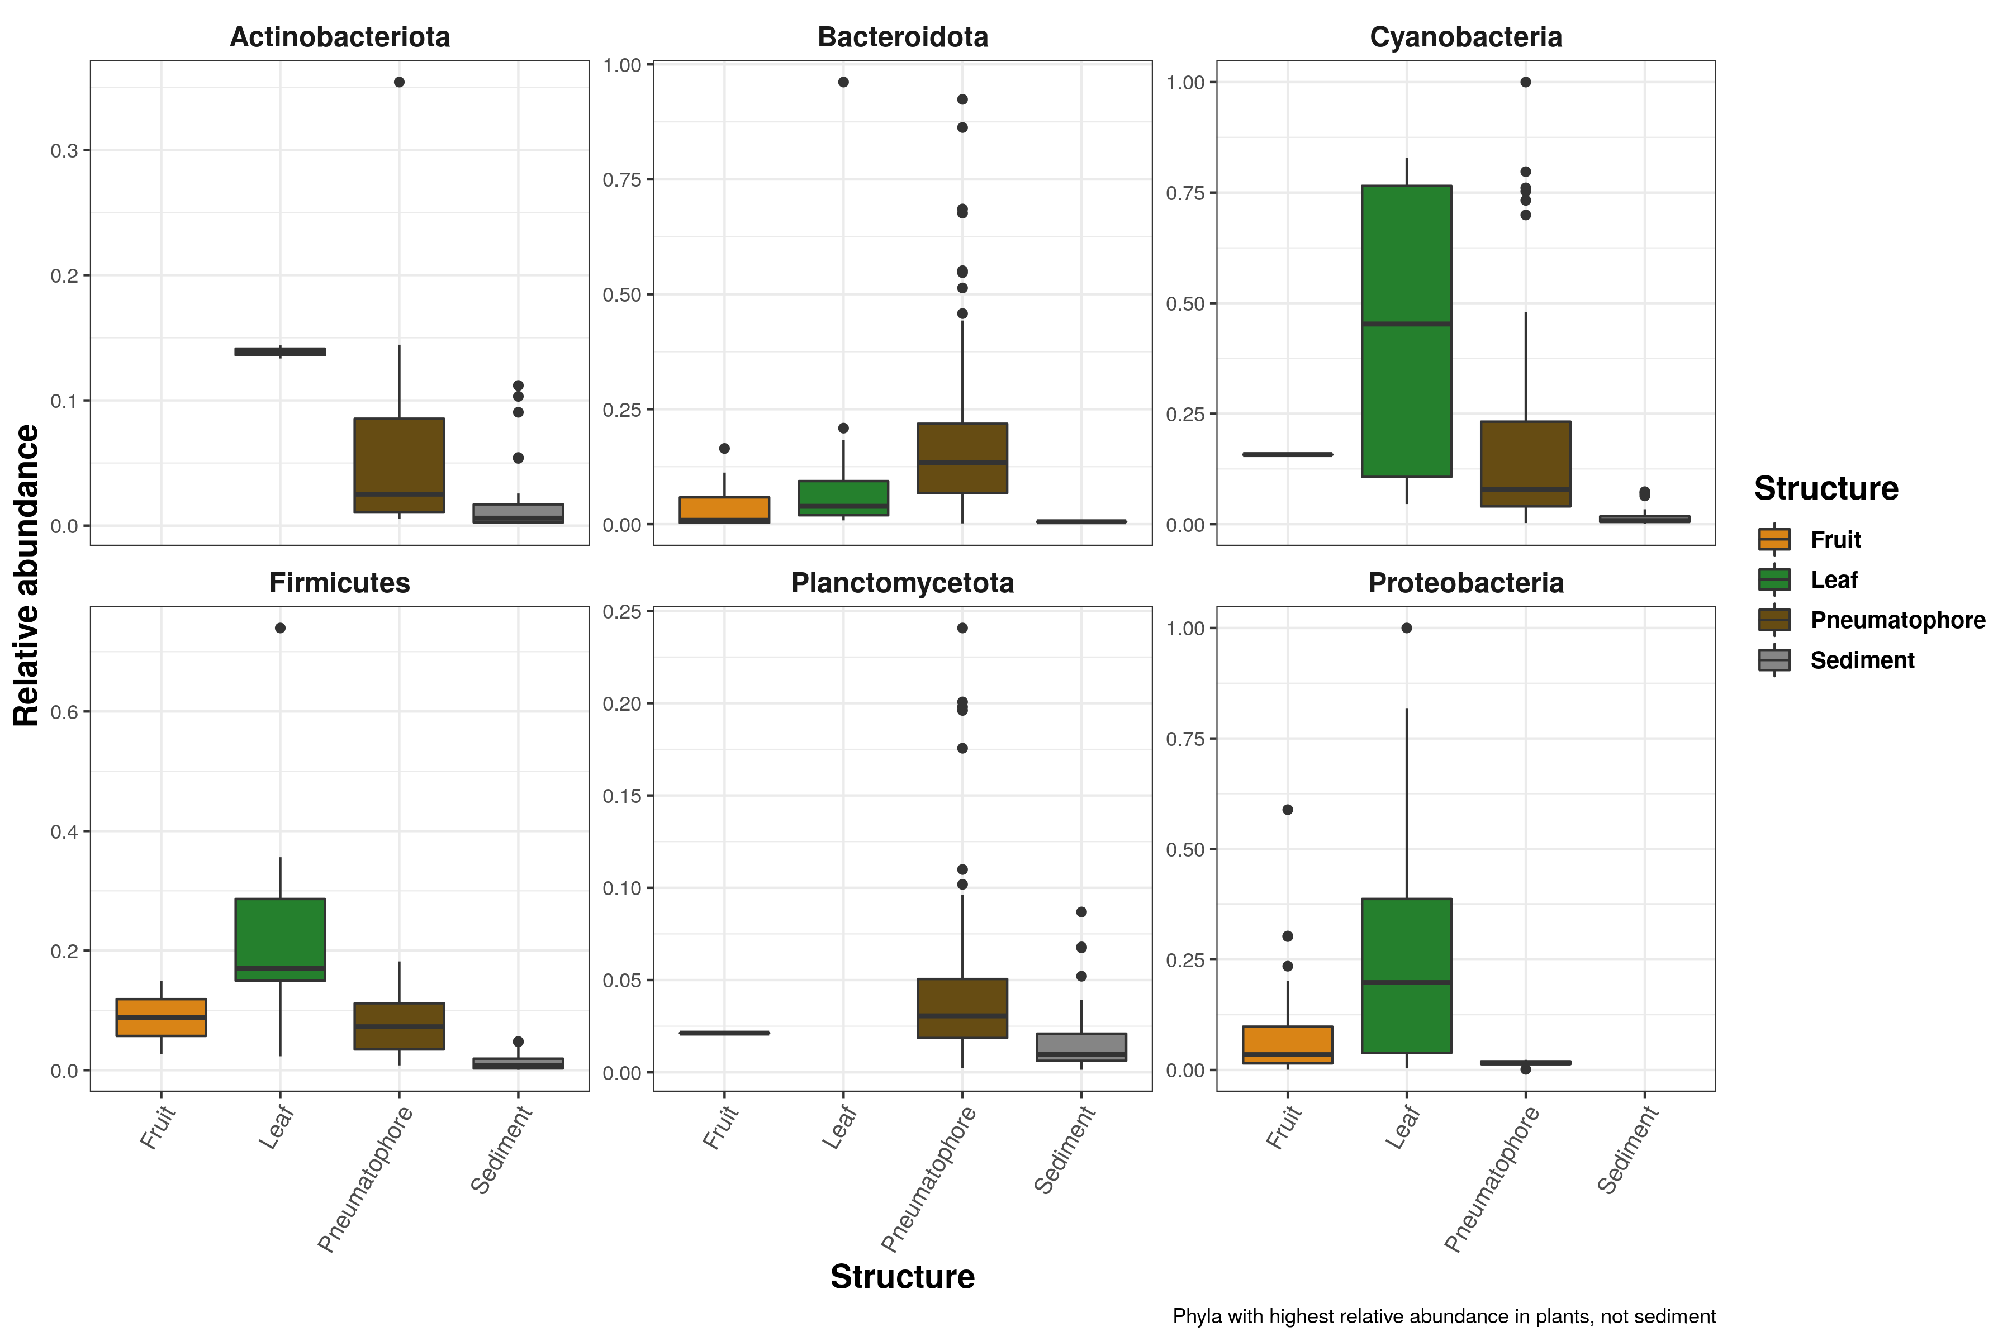
most abundnat phyla in plant parts vs sediment

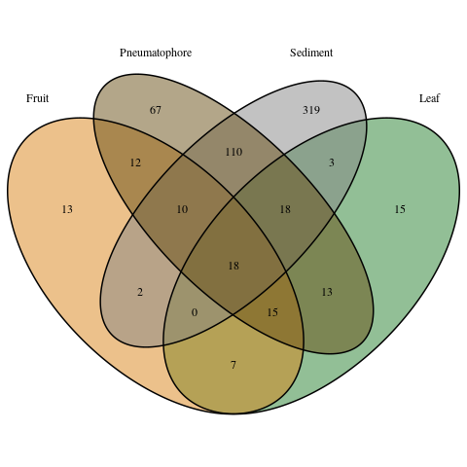

shared species

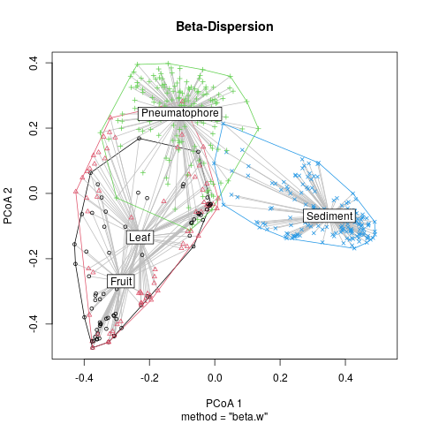

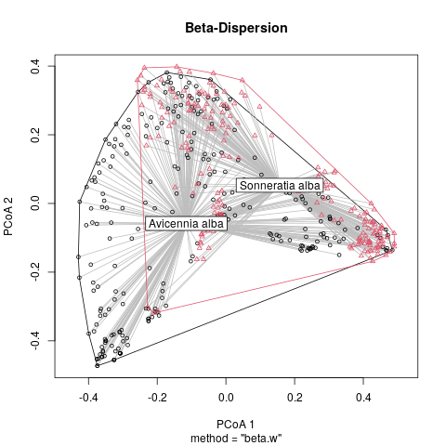
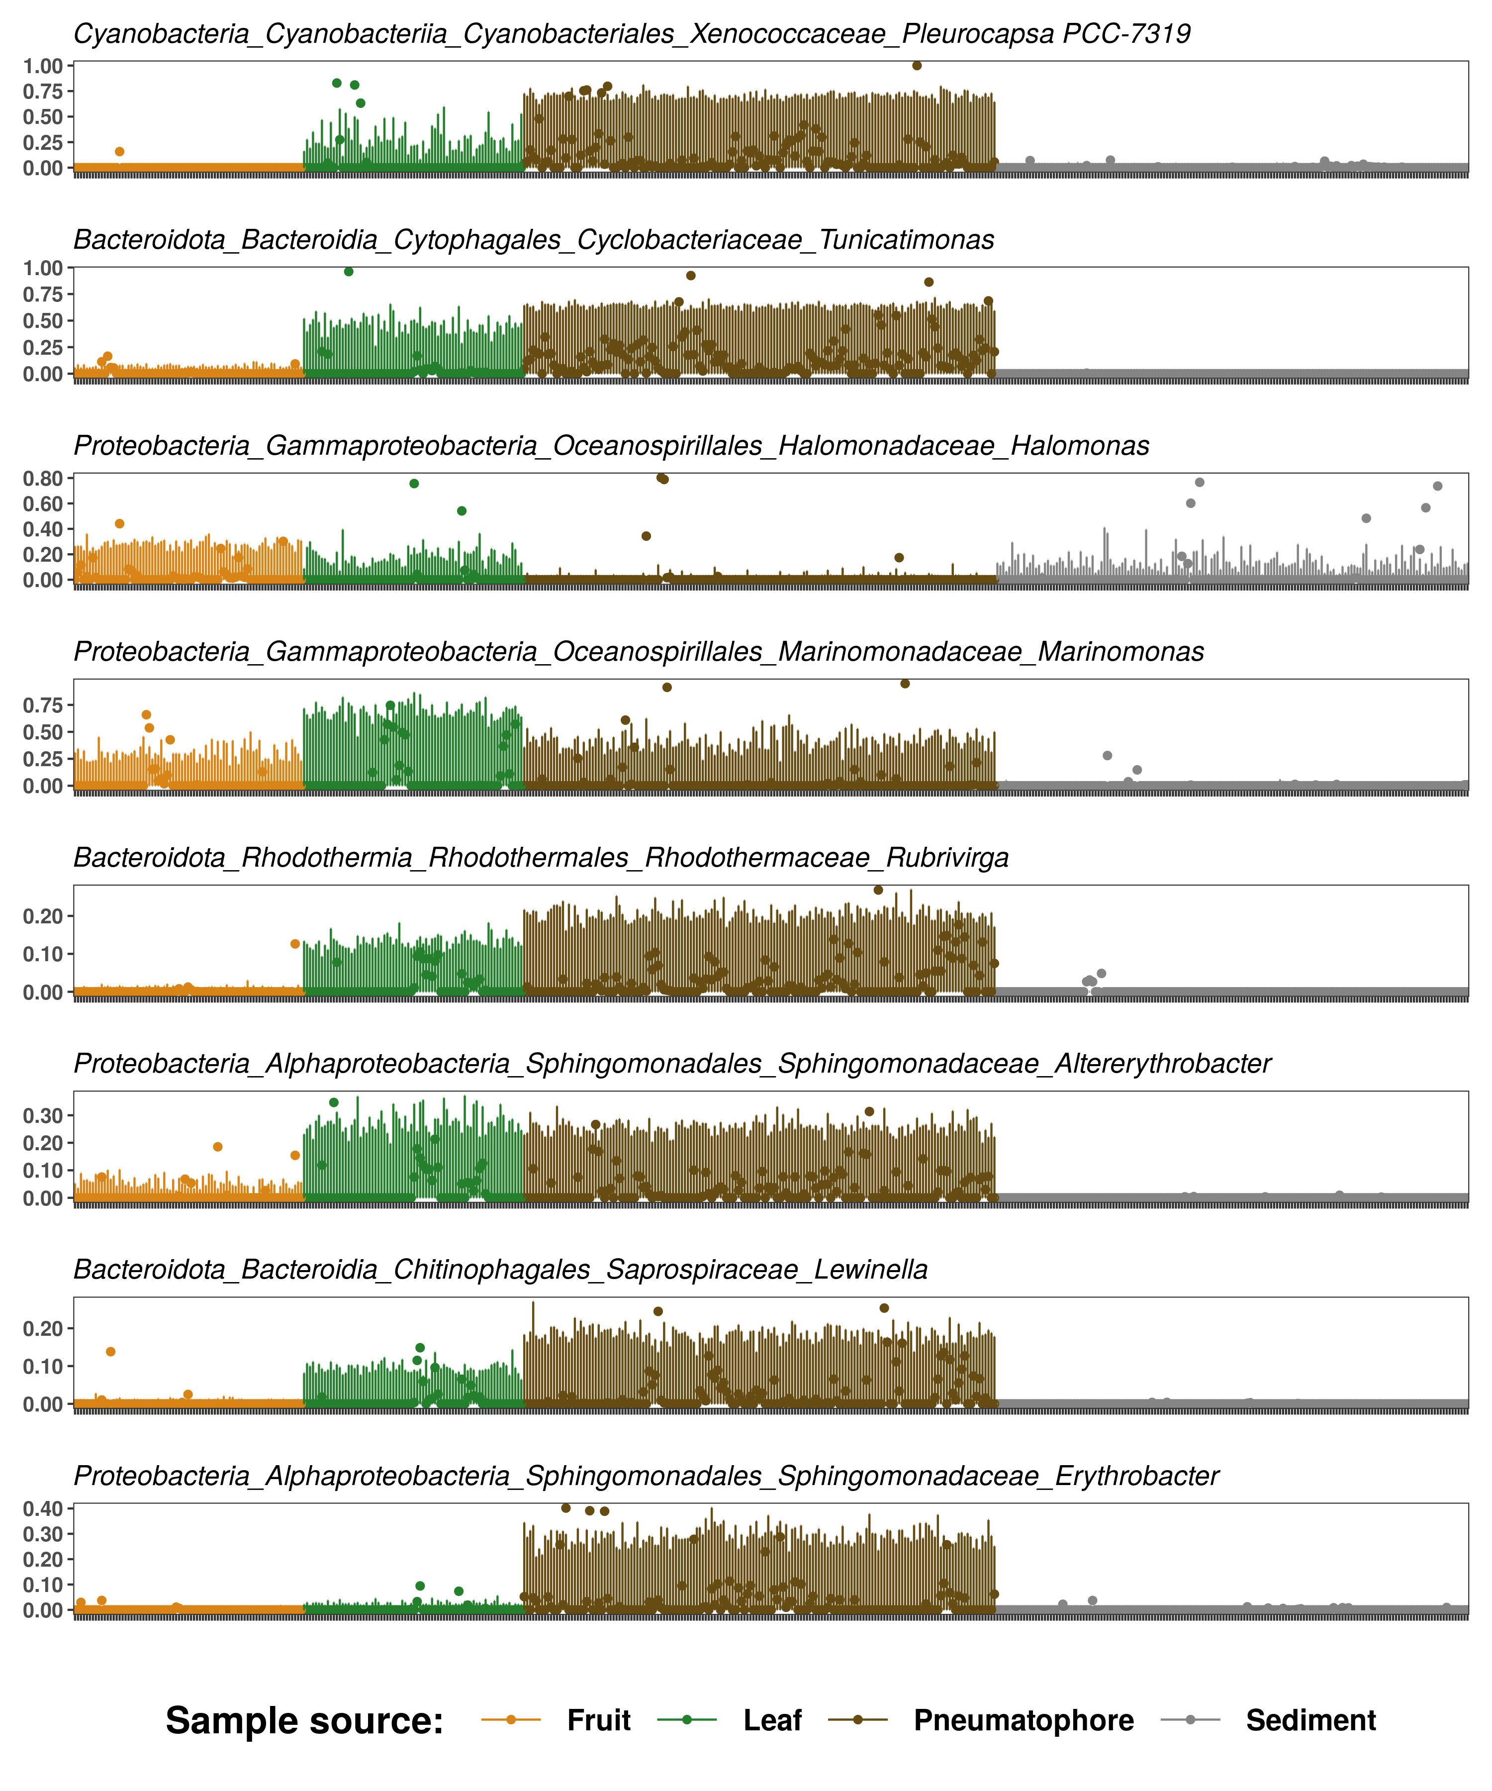

Discussion

