Every messy dataset is uniquely horrible, but here are four of the main mistakes people make:

• Column headers are values, not variable names.

• Multiple variables are stored in one column.

• Variables are stored in both rows and columns.

• Non-Rectangular...many tables in a single data file.

Column headers are values, not variable names.
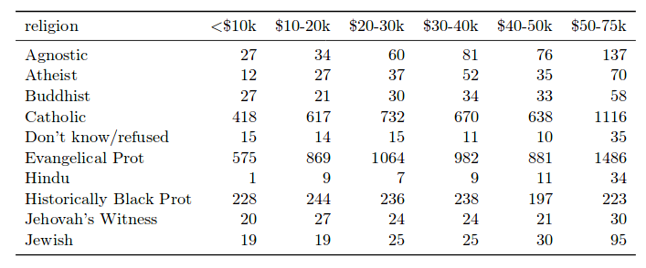

Noooooooo!

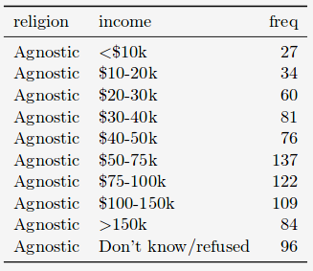

Yesssssss!

Multiple variables are stored in one column.

Don't code column variables that contain more than one piece of info. Here, "sex" and "age" are combined. This is a mortal sin.

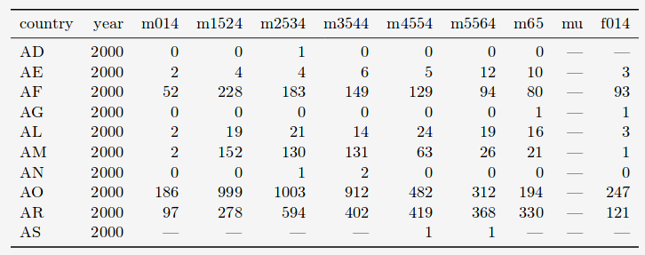

Bad!

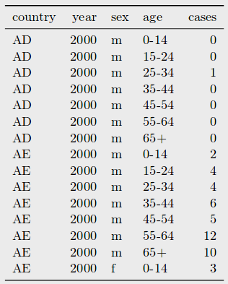

Good!

Variables are stored in both rows and columns.

Here, there is a column for each day of the month and "element" contains two variables.

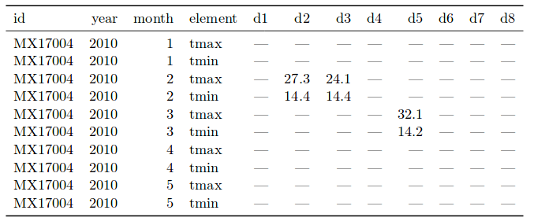

Gross!

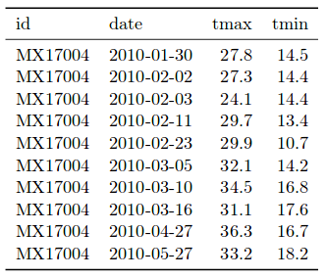

Lovely!

Non-Rectangular...many tables in a single data file.

This is the most hideous thing of all. There's no saving it except through many many hours of manual editing.

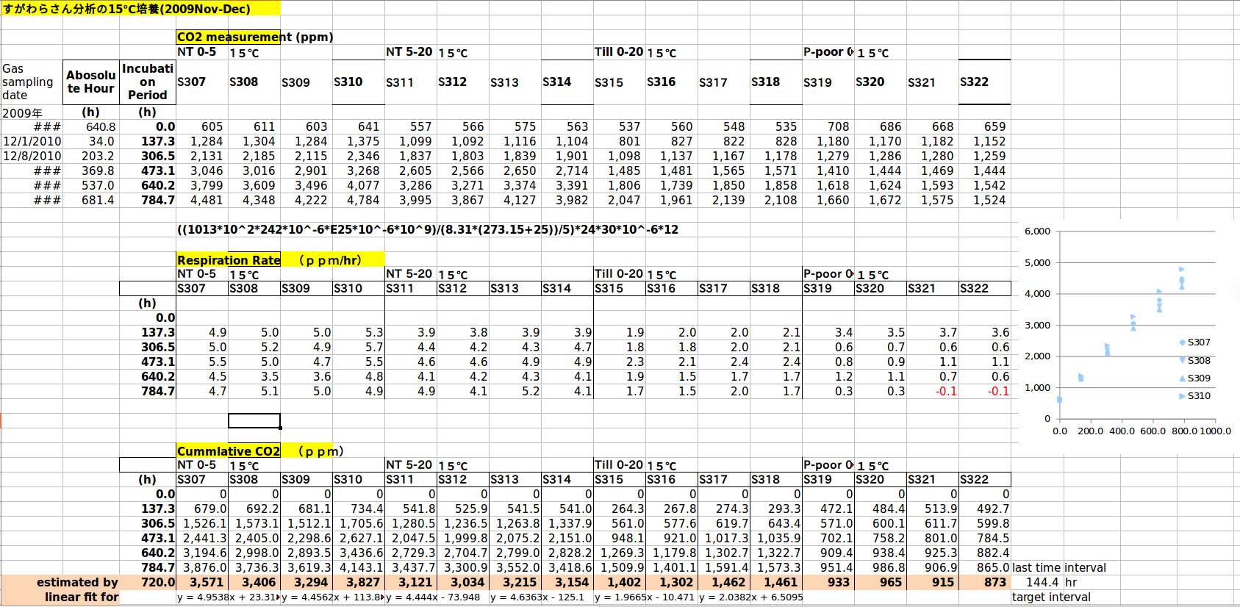

Calculations going on inside the raw data, multiple tables, not even in the same locations, stupid figure crammed in on the side, column headers taking up more than one row...

This is the most commonly-seen form of data in the wild, managing to break all the rules of sane data entry and storage.

It is also my own data!

I too was a sinner, but I have been saved.

