Excel will change common gene names into dates.
Once saved, this is irreversable!

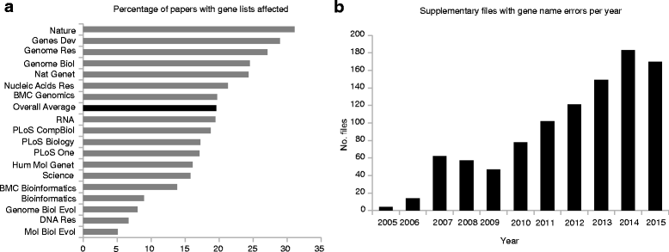
Ziemann, M., Eren, Y., & El-Osta, A. (2016). Gene name errors are widespread in the scientific literature. Genome Biology, 17(1), 177. https://doi.org/10.1186/s13059-016-1044-7

Here's a great article about this:
http://www.theallium.com/biology/scientific-community-capitulates-microsoft-officially-changes-gene-names-dates/

Excel has two conflicting ways of storing dates. These are different on PC and Mac.

One is the number of days since 1900 (falsely treated as a leap year to fix an old bug in some software that went out of fashion in 1991).

The other is the number of days since Jan 4th, 1904. No one knows why this exists. Maybe a disgruntled employee or Russian saboteurs or something, but it's NOT going to change.

These date conversions ABSOLUTELY WILL DESTROY YOU IF YOU AREN'T DILIGENT!

Set column to "text"
- Highlight column BEFORE entering dates
- Go to Format -> Cells
- Select "Text" under "Category"

Always use YYYY-MM-DD

What is 08-01-12 ?????

