Supplemental Info
Differential abundance plots, split by burn year

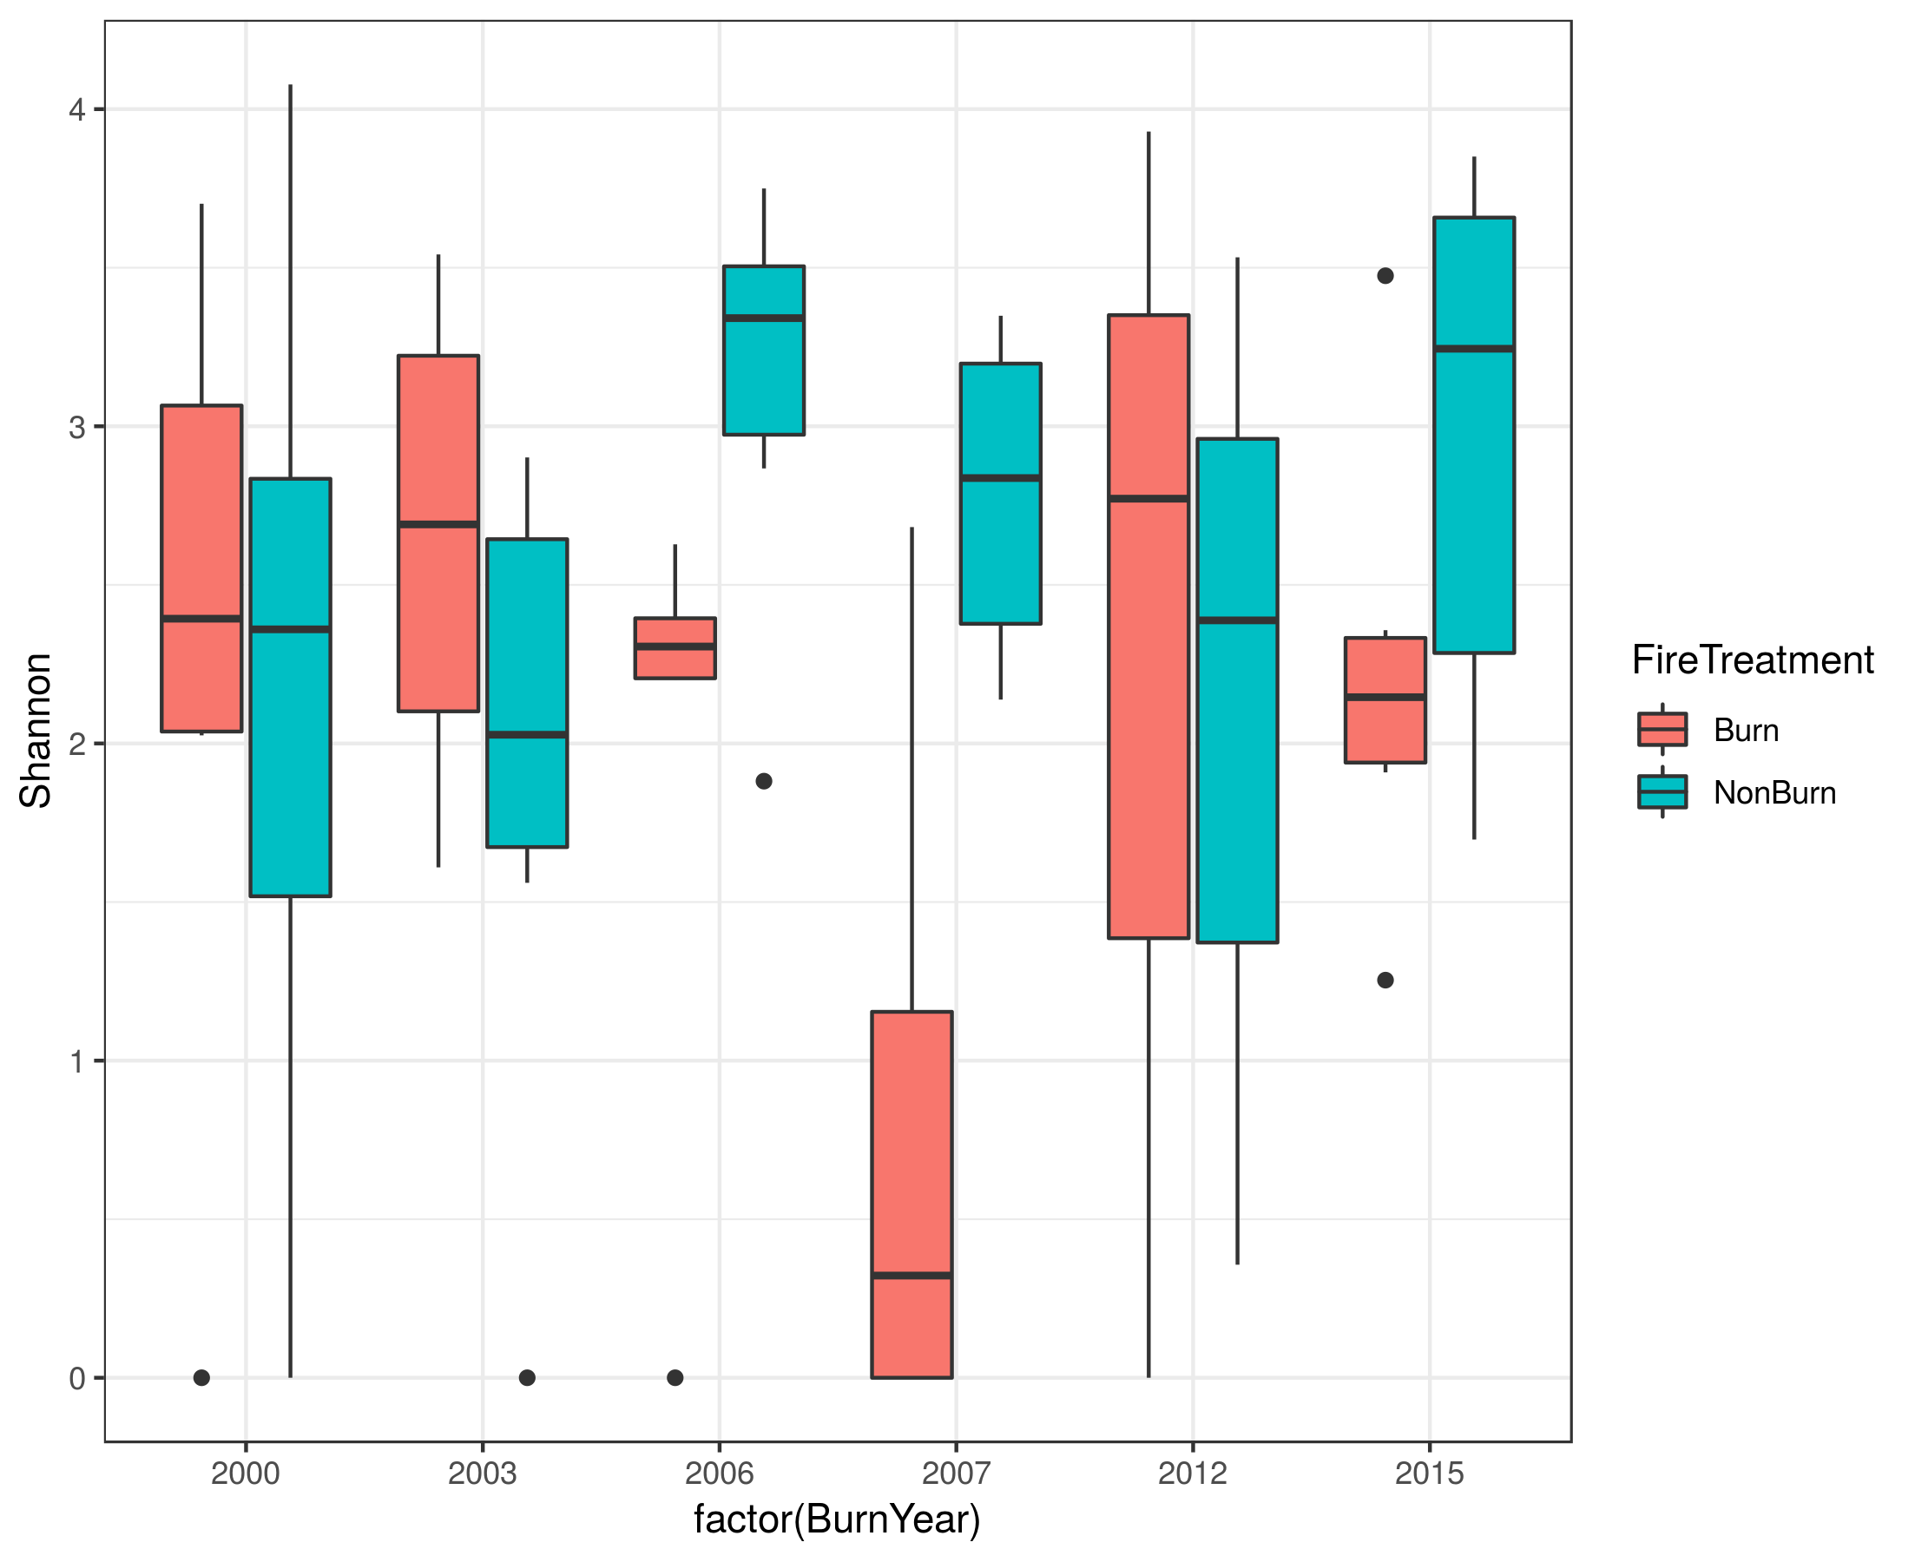
Shannon diversity over time

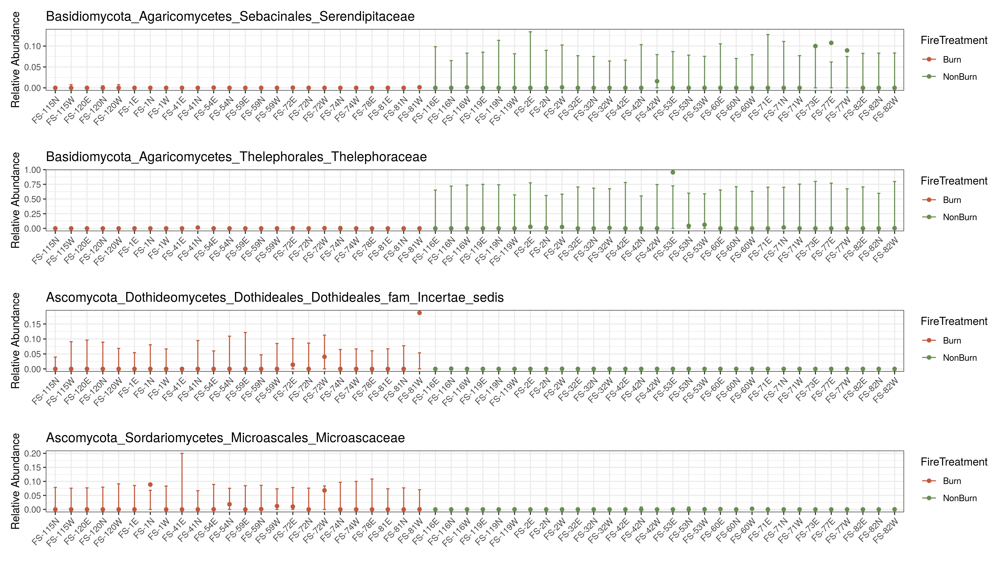
Differential abundance plot of fungal families based on fire treatment – All burn years included

BBDML Model Summaries for previous plot:

$Basidiomycota_Agaricomycetes_Sebacinales_Serendipitaceae

Call:
bbdml(formula = forms[[i]], phi.formula = phi.form, data = ps_object)

Coefficients associated with abundance:
Estimate Std. Error t value Pr(>|t|)
(Intercept) -8.5052 0.6826 -12.460 < 2e-16 ***
FireTreatmentNonBurn 3.8291 1.1045 3.467 0.00109 **
---
Signif. codes: 0 ‘***’ 0.001 ‘**’ 0.01 ‘*’ 0.05 ‘.’ 0.1 ‘ ’ 1

Coefficients associated with dispersion:
Estimate Std. Error t value Pr(>|t|)
(Intercept) -6.8706 0.9983 -6.882 9.17e-09 ***
FireTreatmentNonBurn 5.4626 1.3846 3.945 0.000249 ***
---
Signif. codes: 0 ‘***’ 0.001 ‘**’ 0.01 ‘*’ 0.05 ‘.’ 0.1 ‘ ’ 1

Log-likelihood: -51.102

$Basidiomycota_Agaricomycetes_Thelephorales_Thelephoraceae

Call:
bbdml(formula = forms[[i]], phi.formula = phi.form, data = ps_object)

Coefficients associated with abundance:
Estimate Std. Error t value Pr(>|t|)
(Intercept) -6.7827 0.7614 -8.908 6.78e-12 ***
FireTreatmentNonBurn 3.9770 0.9300 4.276 8.55e-05 ***
---
Signif. codes: 0 ‘***’ 0.001 ‘**’ 0.01 ‘*’ 0.05 ‘.’ 0.1 ‘ ’ 1

Coefficients associated with dispersion:
Estimate Std. Error t value Pr(>|t|)
(Intercept) -4.4202 0.9613 -4.598 2.93e-05 ***
FireTreatmentNonBurn 4.6388 1.1044 4.200 0.00011 ***
---
Signif. codes: 0 ‘***’ 0.001 ‘**’ 0.01 ‘*’ 0.05 ‘.’ 0.1 ‘ ’ 1

Log-likelihood: -97.859

$Ascomycota_Dothideomycetes_Dothideales_Dothideales_fam_Incertae_sedis

Call:
bbdml(formula = forms[[i]], phi.formula = phi.form, data = ps_object)

Coefficients associated with abundance:
Estimate Std. Error t value Pr(>|t|)
(Intercept) -4.656 1.055 -4.414 5.42e-05 ***
FireTreatmentNonBurn -4.914 1.391 -3.532 0.000896 ***
---
Signif. codes: 0 ‘***’ 0.001 ‘**’ 0.01 ‘*’ 0.05 ‘.’ 0.1 ‘ ’ 1

Coefficients associated with dispersion:
Estimate Std. Error t value Pr(>|t|)
(Intercept) -1.069 1.171 -0.913 0.36558
FireTreatmentNonBurn -5.768 1.688 -3.417 0.00127 **
---
Signif. codes: 0 ‘***’ 0.001 ‘**’ 0.01 ‘*’ 0.05 ‘.’ 0.1 ‘ ’ 1

Log-likelihood: -43.842

$Ascomycota_Sordariomycetes_Microascales_Microascaceae

Call:
bbdml(formula = forms[[i]], phi.formula = phi.form, data = ps_object)

Coefficients associated with abundance:
Estimate Std. Error t value Pr(>|t|)
(Intercept) -4.6707 0.5391 -8.664 1.59e-11 ***
FireTreatmentNonBurn -3.7176 0.7884 -4.716 1.97e-05 ***
---
Signif. codes: 0 ‘***’ 0.001 ‘**’ 0.01 ‘*’ 0.05 ‘.’ 0.1 ‘ ’ 1

Coefficients associated with dispersion:
Estimate Std. Error t value Pr(>|t|)
(Intercept) -2.7315 0.6586 -4.147 0.000130 ***
FireTreatmentNonBurn -3.7894 1.0248 -3.698 0.000541 ***
-

