Collection #1
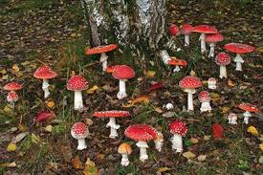
Description, according to cheat-sheet terms:

I. Cap
A. Pulvinate shape
B. Straight margin
C. Dark red with white spots, white flesh staining yellow
D. Warty scales, white and dusty
E. Margin entire, but scales in some specimens
F. Moist cap surface, scales rather dry, firm flesh
G. Light almond scent, somewhat sweet
II. Gills
A. Gills adnexed
Photo of mushrooms in location
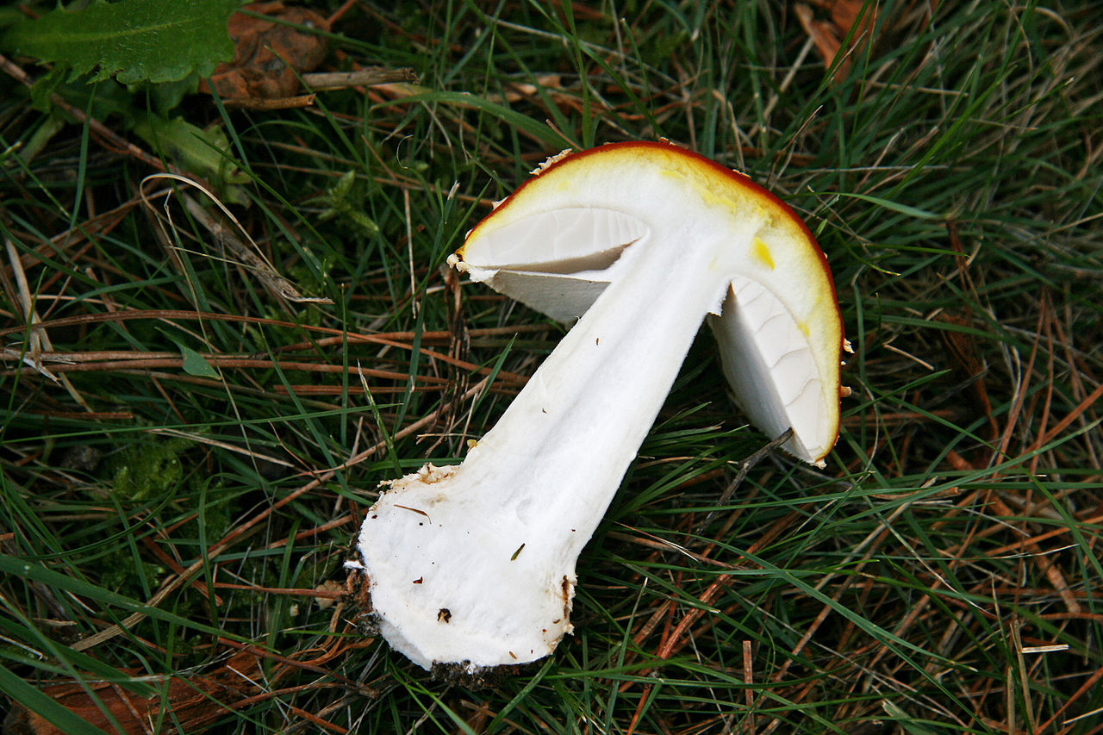
B. Broad
C. Average thickness
D. Crowded to closely spaced
E. White
III. Stem
A. Central
B. 1-2.5cm thick
C. Clavate shape with napiform base

Cross-section D. White in both young and old specimens
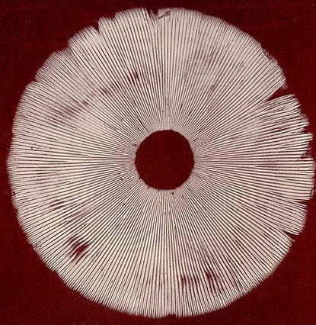
E. Smooth and dry
F. Fibrous and firm
G. Hollow
IV. Partial veil not present
V. Universal Veil Present
A.White
B. Membranous
C. Leaving full intact ring on stem
D. Persistent ring on upper stem
VI. Mycelium not observed
VII. Habitat
Scattered to gregarious, under birch trees, growing from soil in grass and leaf litter, American Fork Canyon (GPS point)

Spore print

