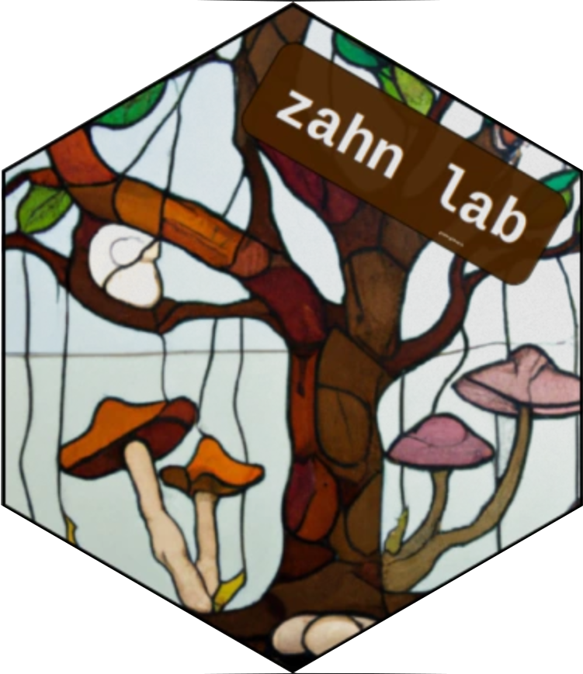
Geoff Zahn, PhD
Updated September, 2024
Translational mycology | Host-Microbe symbiosis
zahn.ecology@gmail.com
https://gzahn.github.io

Professional Appointments
2024 – Current
Visiting Faculty – Dartmouth College
2023 – Current
Associate Professor – Utah Valley University
2017 – 2023
Assistant Professor – Utah Valley University
2020 – Current
Consultant – Forensic bioinformatics and data science
2018 – 2021
Director of Environmental Biology -GeoDataCrawler Research Institute
2015 – 2017
Postdoc Associate – University of Hawai`i at Manoa (Amend Lab)

Education
2015 PhD Biology
University of Arkansas
“The Functional and Distributional Ecology of Mycetozoans under Changing Edaphic and Climatic Dynamics”
2010 BS Ecology
Missouri State University
“Pil1 recruits synaptojanins and amphiphysins to facilitate receptor-mediated endocytosis in yeast”

Publications
*mentee | †corresponding/senior author
Google Scholar Profile | 31 Peer-reviewed Publications | H-index: 15 | i10-Index: 21
Amend, A., Gunde-Cimerman, N., Dias-Coelho, M., Durkin, C., Ettinger, C., Gifford, H., Gladfelter, A., Gostincar, C., Granit, L., Grigoriev, I., Gutiérrerez, M., Hickman, K., James, T., Jones, A., Levi, R., David-Palma, M., Peng, X., Quandt, A., Rama, T., Vargas-Gastelum, L., Whitner, S., Williams, A., Yarden, O., Yenewodage, A., Zahn, G. The ten most pressing questions about marine Fungi (and how to answer them). Limnology and Oceanography Letters. (In Review)

Mora, J*. E., Olson, M., Rocks, S., & Zahn, G.† Aquatic plant mycobiomes change with watershed urbanization. Science of the Total Environment (In Review)
Pre-print: bioRxiv. https://doi.org/10.1101/2024.06.23.600282
Wainwright, B., Leon, J.*, Vilela, E.*, Hickman, KJE*, … Zahn, G.† (2024). Wallace’s line structures seagrass microbiota and is a potential barrier to the dispersal of marine bacteria. Environmental Microbiome.
Hickman, K. J. E.*, & Zahn, G.† Ten simple rules for leading a successful undergraduate-intensive research lab. PLOS Computational Biology. 2024
Wainwright BJ, Millar T*, Bowen L*, Semon L*, Hickman KJE*, Lee JN, Zahn G.† The core mangrove microbiome reveals shared taxa potentially involved in nutrient cycling and promoting host survival. Environmental Microbiome. 2023
Rawson C*, Zahn G.† Inclusion of database outgroups reduces false positives in fungal metabarcoding taxonomic assignments. Mycologia. 2023
Mikryukov, V., Dulya, O., Zizka, A., … Zahn, G. … Tedersoo, L. Connecting the multiple dimensions of global soil fungal diversity. Science Advances. 2023
Zahn G.† Marker Genes (16S and ITS) Protocol for Plant Microbiome Analyses.
BIO-PROTOCOL. 2022
Watmough, S., Gilbert-Parkes, S., Basiliko, N., Lamit, L. J., … Zahn, G. Variation in carbon and nitrogen concentrations among peatland categories at the global scale. PLOS ONE, 17(11), e0275149. 2022.
Tedersoo, L., Mikryukov, V., Zizka, A., … Zahn, G., … Abarenkov, K. Global patterns in endemicity and vulnerability of soil fungi. Global Change Biology. 2022
McGee, S.*, Tidwell, A.*, Riggs, E., Veltkamp, H.*, Zahn, G.† Long-term soil fungal community recovery after fire is impacted by climate change. Western North American Naturalist. 2022
Sur G.L.*, Zahn G., Stacy EA. Examination of host-taxon, environment, and distance effects on leaf fungal endophytes in the dominant woody genus, Metrosideros, on O’ahu. Fungal Ecology. 2021
Wilson, T., Poulson, A., Packer, C., Carlson, R., Davis, R., Dey, M.*, Owen, N.*, Smalley, S.*, Dodge, R.*, Baadsgaard, A., Stevens, M., Zahn, G.† Essential oil, insect, and microbe relationships in Juniperus osteosperma (Cupressaceae) trees killed by wildfire. Phytologia. 2021

Tedersoo, L., Mikryukov, V., Anslan, … Zahn G., … Abarenkov, K. The Global Soil Mycobiome consortium dataset for boosting fungal diversity research. Fungal Diversity. 2021

Quek, Z., Zahn, G., Lee, N., Ooi, J., Lee, J., Huang, D., & Wainwright, B. Biogeographic structure of fungal communities in seagrass Halophilia ovalis across the Malay Peninsula. Environmental Microbiology Reports. 2021

Egan, C., Koko, J., Muir, C., Zahn, G., Swift, S., Amend, A., Hynson, N. Restoration of the mycobiome of the endangered Hawaiian mint Phyllostegia kaalaensis increases its resistance to a common powdery mildew. Fungal Ecology. 2021

Tipton, L., Zahn, G.., Darcy, J. L., Amend, A. S., & Hynson, N. A. (2021). Hawaiian fungal amplicon sequence variants reveal otherwise hidden biogeography. Microbial Ecology. 2021

Darcy, J., Swift, S., Cobian, G.*, Zahn, G., Perry B., Amend, A. Fungal communities living within leaves of native Hawaiian dicots are structured by landscape-scale variables as well as by host plants. Molecular Ecology. 2020
Wainwright, B., Zahn, G., Afiq-Rosli, L., Tanzil, J., Huang, D. Host age is not a consistent predictor of microbial diversity in the coral Porites lutea. Scientific Reports. 2020
Zahn G., Tipton L., Datlof E.*, Kivlin S., Sheridan P., Amend A., Hynson N. Fungal aerobiota are not affected by time nor environment over a 13-y time series at the Mauna Loa Observatory. PNAS. 2020

Zahn G.†, Amend A. Foliar fungi alter reproductive timing and allocation in Arabidopsis under normal and water-stressed conditions. Fungal Ecology. 2019
Wainwright, B., Zahn, G., Zushi, J.*, Lee, N., Ooi, J., Lee, J*. Seagrass-associated fungal communities show distance decay of similarity that has implications for seagrass management and restoration. Ecology and Evolution. 2019
Wainwright, B., Bauman, A., Zahn, G., Todd, P., & Huang, D. Characterization of fungal biodiversity and communities associated with the reef macroalga Sargassum ilicifolium reveals fungal community differentiation according to geographic locality and algal structure. Marine Biodiversity. 2019
Wainwright, B., Afiq-Rosli, L., Zahn, G., Danwei Huang. Characterisation of coral-associated bacterial communities in an urbanised marine environment shows strong divergence over small geographic scales. Coral Reefs. 2019
Wainwright, B., Zahn, G., Arlyza, S., Amend, A. Seagrass-associated fungal communities follow Wallace’s line, but host genotype does not structure fungal community. Journal of Biogeography. 2018
Zahn, G.†, Amend, A. Foliar microbiome transplants confer disease resistance in a critically-endangered plant. PeerJ. 2017
Datlof, E.*, Amend, A., Earl, K., Hayward, J., Morden, C., Wade, R., Zahn, G., Hynson, N. (2017). Uncovering unseen fungal diversity from plant DNA banks. PeerJ. 2017
Wainwright, B., Zahn, G., Spalding, H., Sherwood, A., Smith, C., Amend, A. Fungi associated with mesophotic macroalgae from the ‘Au‘au Channel, west Maui are differentiated by host and overlap terrestrial communities. PeerJ. 2017
Zahn, G.†, Wagai, R., Yonemura. S. The effects of amoebal bacterivory on carbon and nitrogen dynamics depend on temperature and soil structure interactions. Soil Biology and Biochemistry. 2016
Zahn, G.†, Stephenson, S., Spiegel, F. Ecological distribution of protosteloid amoebae in New Zealand. PeerJ. 2014
De Haan, M., Cocquyt, C., Tice, A., Zahn, G., Spiegel. F. First records of Protosteloid Amoebae (Eumycetozoa) from the Democratic Republic of the Congo. Plant Ecology and Evolution. 2014
Murphy, E., Boxberger, J., Colvin, R., Lee, S., Zahn, G., Loor, F., Kim, K. Pil1, an eisosome organizer, plays an important role in the recruitment of synaptojanins and amphiphysins to facilitate receptor-mediated endocytosis in yeast. European Journal of Cell Biology. 2011

Code and software publications
CommunityAssemblR – Simulations of microbiome biotic interactions
mycobank – Fungal name synonym and taxonomy correction
hubfindr – Identification of network hub taxa in microbial communities
virulator – Detection of novel virus signatures in metagenomes
QIIME Database builder – QIIME2 plugin for custom taxonomies
Microbiome Workshop – 2-day intro to microbiome data analysis
Custom Unix tools – Collection of bioinformatics scripts
R for Biologists – 16-week online course
Bioinfo Data Skills Course – 16-week online course

Funding (Total $3,372,199 awarded)

RCN: FOMO-Net: The fungal oceanic mycomass observation network for global quantification of marine fungal biomass and nutrient flux
PI | NSF BIO | $450,000 (Pending)
ROA: Co-dispersal of bacteria and AM Fungal spores
Co-PI | NSF Supplement to DEB-2205650 | $80,000
S-STEM: Faculty-Mentored Experiences for Improving Undergraduate Biology Student Outcomes
PI | NSF (DUE – 2424080) | $1,918,705
Myco-Ed: Mycological Curriculum for Education and Discovery
Senior Personnel | JGI
Burning questions in microbial ecology: Ecological mechanisms that control microbiome transplant outcomes
Co-PI | NSF BIO | $878,200 (Declined, resubmitting)
Molecular predictors of mangrove holobiont assembly
Writer/Senior Personnel | Singapore MOE (IG20-SI003) | $180,000
GEL: Using neural networks to link host expression and microbiome assembly
PI | UVU Grants for Engaged Learning (GEL-007) | $30,000
Previous external funding
Faculty-Mentored Experiences for Improving Undergrad Biology Student Outcomes PI | NSF (DUE – 1833880) | $972,287
Methods for fungal endophyte sampling from endangered cacti
PI | 2019 | Capitol Reef National Park Field Station | $3,000
Assessing the Implementation of Undergraduate Research Teams at an Open Enrollment Institution
Co-PI | 2018 | GREEN Grant, UVU | $29,327
Engaging undergraduates in advanced research
PI | 2018 & 2019 | UVU Grants for Engaged Learning (GEL-002) | $19,997
Restoration of critically endangered Hawaiian native plants by understanding and manipulating foliar microbial symbionts
Co-PI | 2015 | OANRP Rare Plant Management Grant | $40,500
JSPS alumni travel award
PI | 2014 | Japan Society for the Promotion of Science | $750
JGI travel award
PI | 2014 | Joint Genome Institute | $450
The Importance of Microbial Interactions to Soil Carbon Cycling on a Warming Planet
PI | 2013 | JSPS Summer Fellowship | $12,500
The Importance of Microbial Interactions to Soil Carbon Cycling on a Warming Planet
PI | 2013 | NSF EAPSI Fellowship | $5,070 + living expenses
Assessing the status of USDA Green Ribbon Schools nationally
PI | 2013 | Clean Air, Cool Planet Climate Fellowship | $5,000
Mycological Society of America Travel Award
PI | 2011 | $350
NSF GK-12 Fellowship
PI | 2011 | $30,500

Awards
Dean's Award of Excellence for Faculty Scholarship – UVU
Awarded 2020 & 2022 | $5,500
Presidential Award for Faculty Scholarship – UVU
Awarded 2019 | $8,000
Plant conservation from a microbial perspective
Awarded 2016 | MSA Translational Mycology Postdoctoral Award | $2,500

Selected Presentations
Invited
Linking ecological lessons from natural microbial dispersal to microbiome transplantation success
University of Maine 2025
Using neural networks to detect biotic interactions during disruptive community assembly of fungi
Mycological Society of America 2024
Toward predictive modeling of mycobiome transplantations
National Univ. of Singapore 2024
Modeling community assembly processes for useful and reproducible
microbiome transplantations
NIAES, Japan 2024
Translating mentored undergraduate research into student retention and success
NSF S-STEM Symposium 2023
Less content, more context: Research as pedagogy in undergraduate mycology courses
Mycological Society of America 2022
Who’s there and who cares: the how and why of fungal community structure
Univ. of Arkansas/Missouri State Univ 2018
Plant conservation from a microbial perspective
O`ahu Army Natural Resources Program 2016
Contributed
Metagenomic Tools for Mycobiome Analyses in Model vs. Non-Model Systems
Mycological Society of America 2023
Aquatic Plant-Associated Fungi Along an Urbanization Gradient
Mycological Society of America 2023
Improving the Accuracy of Meta-Amplicon Taxonomic Assignments Through the Inclusion of Outgroups in Fungal Databases
Mycological Society of America 2023
Inspecting the microbiome and metabolomic compartments of Mediterranean sponge holobionts through an integrated ‘omics approach
International Sponge Symposium, Netherlands 2022
Fungal endophytes and pathogens in endangered hawaiian endemics: Plant conservation from a microbial perspective
Mycological Society of America 2016
The interactive effects of protozoan predation pressure and environmental factors on carbon and nitrogen cycling in soils under warming conditions
ISME, South Korea 2014

Teaching and Mentoring
Designed and director of Undergrad Bioinformatics Degree Program
Instructor of record for:
Mycology
Course-based research experience – Fungal systematics, anatomy, physiology, and ecology
Plant Pathology
Course-based research experience – Fungal, protistan, bacterial, nematode, and viral pathogens
Data Analysis for Biologists
Data cleaning, visualization, modeling, and reporting (R language)
Bioinformatics Data Skills
Command-line data skills, bash scripting, metagenomic analysis, High-performance computing
Microbiome Boot Camp
Numerical ecology, community ecology analysis, spatial analysis, R package design, scientific writing
Organismal Biology
Intro majors biology, evolution, phylogenetics, tree of life survey, intro ecology
Director and PI of NSF S-STEM Biology Program (UVU)
Career and academic mentor to 41 NSF Scholars
Manage budget and reporting
Graduate committee member:
Valerio Mazzella (Stazione Anton Dohrn)
Rae Berner (Washington State U)
Becca Evans (Washington State U)
Gary Sur (U Hawaii at Manoa)
Syrena Whitner (U Hawaii at Manoa)

Undergraduate thesis supervisor:
(External funding for mentees: $110,630)
Tayler Fearn
Austen Miller
Jo Hickman
Josh Leon
Jacob Mora
Annette Lewis
Ozzly Rallis
Hayden Johnson
Whitney Kraatz
Magnolia Morelli
Nichole Paulette
Lauren Groathouse
Nicholas Fryer
Zachary Petersen
Samuel Anaya
Miles Spencer
Rollo Simmons
Reagan Dodge
Natalia Backman
Sarah van Dijk
Logan Weseman
Erika Lakin
Clayton Rawson
Jonathan Wasden
Spencer McGee
Alyssa Tidwell
Harrison Haws
Nicholas Long
David Parker
Garrett Matthews
Bryce Brunetti

Service
Department
Associate department chair – Utah Valley University (2023 – 2024)
Faculty search committees (Chair 1x, Member 6x)
Bioinformatics program development
Strategic planning committee
NSF S-STEM program director
College and University
Faculty Senate (2017-2020)
High-performance computing committee chair (2020 – Current)
Program and course development (Univ. of Arkansas, Utah Valley Univ.)
Profession
Associate Editor of Mycologia
Education Committee Mycological Society of America
Fungal Oceanic Mycological Observation Network
Consortium of Fungi
Champion, National Microbiome Data Collaborative
Mangrove Microbiome Initiative
IUCN SSC – Chytrids, Zygomycetes, Downy Mildews, Slime Moulds Specialist Group
Invited to 2024 White House Summit on STEMM Equity and Excellence
Society membership
International Society for Microbial Ecology
Mycological Society of America
International. Society for Fungal Conservation
Japan Society for the Promotion of Science Alumni Assoc.
Genetics Society of America
Council for Undergraduate Research
Invited Reviewer
NSF Panel and ad hoc reviews
NSF GRFP
BARD US-Israel Agricultural Development Fund
Soil Biol. and Biochem. (Distinguished)
Pedobiologia (Distinguished)
ISME Journal
PeerJ
Oikos
Fungal Ecology (Distinguished)
Molecular Ecology
Ecology and Evolution
American Fern Journal
New Phytologist
Phytobiomes
Microbiology Spectrum
PNAS
PLOS Computational Biology

Outreach

Stockman Grass Farmer Magazine
ScienceNews Article
Hawaii News Now
Science fair judge (annual)
Utah Fungus Fest Speaker
NSF GK-12 Fellow (6th-grade)
Mycological art
Poster judge (MSA meeting, annually)

