Protocol Title
Indicate the goal of the procedure and include the model system or organism
Author 1^{1, #}, Author 2^{1, 2, #, $}, Author 3² and Author 4^{2,} *
Indicate First name, Middle name initial, and Last name

¹Dept/Center, Institution name, City, Country; ²Dept/Center, Institution name, City, Country; $Current/Present address: Dept/Center, Institution name, City, Country
*For correspondence: email
#Contributed equally to this work

[Abstract] Enter text here.
Introduce the research field (1-2 sentences), provide context by describingmentioning the existing methodologies (1-2 sentences), summarize the approach/protocol (3-4 sentences max), and finish by summarizing the advantages of the approach/protocol being presented (1-2 sentences).

Graphic abstract: (optional)
Insert the figure here.
It could be a flowchart of the method/procedures, the highlight of the key steps or the innovative design from this protocol etc.
- Resolution: a minimum of 500 dpi.
- Minimize the usage of text in the picture

Keywords: Keyword 1, Keyword 2, Keyword 3 …
exact sequence variants, meta-amplicon, environmental DNA, fungal, bacterial, microbiome

[Background]
It is increasingly common to find onesself needing to take a snapshot of microbial community structure in a given environment. From tracking key microbial members of the human gut, to comparing pathogen effects on crop-associated mutualistic bacteria, to testing the effect of probiotic applications in preventing disease in endangered plants. Whether your question is centered on the microbes or the host, you may find yourself with cost-effective, confusing, and potentially useful meta-amplicon data.
Typically, these data are obtained by sequencing either 16S (for bacteria) or ITS (for fungi) amplicons that have been tagged with sample-specific barcodes. Hundreds of samples can be simultaneously sequenced on a single Illumina flowcell in this manner, making this a useful method for addressing questions that involve "who is there?" and require high replication. A sequencing center will typically return demultiplexed data, where each sample is in its own file. It's at this point when many a researcher suddenly realizes they don't know what to do with all of these files.
Here, we see one possible workflow that (with minor adaptations) can be used for bacteria or fungi. The supplementary materials contain the exact code recipes with ample documentation and lots of comment lines, but here we describe exactly what is happening in each step as we move from raw sequence files to hypothesis testing. Many of the tools and algorthims used in this workflow are quite complicated and I have made an effort to keep explanations simple and at a surface level. More detailed (and fascinating) explanations of each tool are best left to the associated publications.
The workflow presented here utilizes an "amplicon sequence variant" (ASV) instead of an operational taxonomic unit (OTU) approach. OTUs rely on clustering similar sequences, typically with random seeds and a pre-defined set of similarity thresholds. ASVs take error-corrected sequences as the de facto unit of observation. The advantages of ASVs include the potential to uncover diversity that can otherwise be masked by lumping sequences together and enabling fully reproducible results (Tipton et al., 2021). Rather than each taxonomic unit being denoted by a pseudo-random cloud of sequences, an ASV is an exact variant that can be compared across multiple studies.
The standard approach for any meta-amplicon workflow can be broken into two main tasks: 1) turning raw data into a sequence abundance table, and 2) using that table (with associated metadata) to generate and test hypotheses about microbial communities. For someone new to this process, it's difficult to say which of the two tasks is more intimidating. Of course, they really just have very different pitfalls to be aware of. The first task is much more formulaic, with only a few parameters that typically need to be tuned for each new study. The second task is more open-ended but carries all the usual caveats that come with data exploration and hypothesis testing. This chapter will focus on the first task of generating a sequence abundance table from raw meta-amplicon reads, and will then give an example workflow that explores alpha- and beta-diversity and looks for differentially abundant taxa between sample groups. This example will serve as a useful demonstration of how to go about exploring the derived dataset that this workflow generates, but is specific to the example data presented here.

Briefly, introduce the research field that the software/pipeline can be used . Mention related methodologies and summarize the advantages of using your approach . If possible, elaborate on other possible applications of the software/pipeline . (Reference citation format: “Dow et al., 2018”).

Software
- cutadapt (Martin, 2011; version 2.10; https://cutadapt.readthedocs.io/en/stable/changes.html#v2-1-2019-03-15)
- ITSxpress (Rivers et al., 2018; version 1.0; https://github.com/usda-ars-gbru/itsxpress)
- R (R Core Team, 2017; version 3.6.3; https://www.R-project.org/)
- tidyverse (Wickham et al., 2019; version 1.3.0; https://www.tidyverse.org/)
- DADA2 (Callahan et al., 2016; version 1.14.1; https://benjjneb.github.io/dada2/)
- decontam (Davis et al., 2018; version 1.6.0; https://benjjneb.github.io/decontam/)
- phyloseq (McMurdie & Holmes, 2013; version 1.30.0; https://joey711.github.io/phyloseq/)
- Biostrings (Pagès et al., 2021; version 2.54.0; http://www.bioconductor.org/packages/release/bioc/html/Biostrings.html)
- phangorn (Schliep, 2011; version 2.2.5; https://CRAN.R-project.org/package=phangorn)
- msa (Bodenhofer et al., 2015; version 1.18.0; https://bioconductor.org/packages/release/bioc/html/msa.html)
- ShortRead (Morgan et al., 2009; version 1.44.3; https://bioconductor.org/packages/release/bioc/html/ShortRead.html)
- corncob (B. D. Martin et al., 2020; version 0.2.0; https://CRAN.R-project.org/package=corncob)
- vegan (Okansen et al., 2016; version 2.6.0; https://CRAN.R-project.org/package=vegan)
- patchwork (Pedersen, 2020; version 1.0.1; https://CRAN.R-project.org/package=patchwork)

List individual software separately, especially in cases where a long software workflow is used.
Input data
      - Input data are the demultimlexed fastq reads from sequenced bacterial 16S amplicons. There should be two files for each experimental sample that was sequenced; a file for forward reads, and a file for reverse reads. This workflow is written for the commonly used Illumina sequencing platform, but IonTorrent sequences can be used with some slight modification (noted in the workflow).
      - Example data consists of custom subsets of host-associated bacterial 16S amplicons taken from 46 seagrass samples (including PCR negatives). Files have been truncated and modified from their original form to allow for faster computational times while still showing significant differences in community composition between sampling groups. They no longer represent any real study system but are meant to be used as a teaching tool. Raw and intermediate data are provided in the GitHub repository associated with this publication.

Case study
Step-by-step guide for the utility of the software/pipeline

This entire pipeline takes place in the R software environment. Some other environments are used as well, but they are accessed via R for convenience. The analysis, including all data, code, and output, exists as an R-Project within the RStudio IDE. This ensures that all file paths are relative and the project is portable and self-contained (Bryan, 2017). Keeping a project's data and code in a self-contained directory means that it can be run on any computer with the appropriate software without modification of file paths. The pipeline will vary slightly depending on whether you are analyzing bacterial or fungal amplicons. We will work through the pipeline using bacterial 16S sequences and make note as to where the pipeline differs for fungi. All R scripts noted below are present in the GitHub repository and are also available as supplementary files. Figure 1 shows an overview of the following steps for bacterial and fungal amplicons.

Figure 1 - Workflow overview; Steps unique to either bacterial or fungal amplicons are indicated
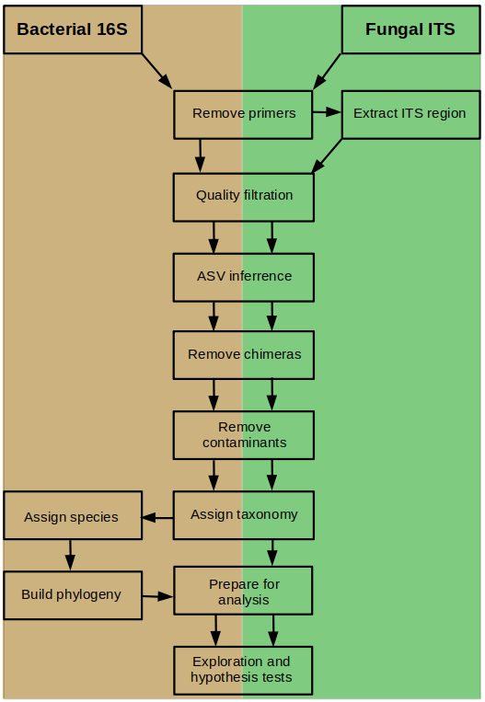

1A. Remove primers (bacteria and fungi)
The first step is to remove any PCR primers that may still be present on your reads. Often, sequencing centers remove these by default, but it's a good idea to check. The R script "00_Remove_Primers.R" walks you through this process. In short, you provide the PCR primers that we used for generating our amplicons and then use the cutadapt tool to search for their presence in all possible orientations. They are then removed and we can proceed with quality filtration.
This process first removes all reads with ambiguous (N) bases, and then removes primer sequences from remaining reads. The newly modified reads are stored in a separate directory (in this case ./data/filtN/ ). When working with bacterial 16S amplicons, this step can generally be accomplished by simply trimming the first N bases from both forward and reverse reads. However, using cutadapt is a more generalized approach that also accounts for mis-oriented reads, does not require you to know ahead of time if your primers are present or not, and is thus reccomended.

1B. Extract ITS region (fungi only)
This step only applies to fungal amplicons, but if you're working with fungi it's important that we extract the ITS region of interest at this point. The problem is that while ITS1 or ITS2 are good at predicting fungal taxonomy, the primers used to amplify these regions sit inside highly conserved flanking regions (Gardes & Bruns, 1993). Since ITS lengths can vary so greatly (Bengtsson-Palme et al., 2013), keeping these conserved regions in our sequences can greatly bias downstream taxonomic assignment algorithms. A solution exists though, in the itsxpress software (Rivers et al., 2018), which can identify and trim these conserved regions from the ends of our ITS reads. This is typically run via the command line, but we can do it from within R. The supplementary file "00_Trim_ITS_Region.R" gives an thorough walkthrough example of how to extract the ITS1 region.

2. Quality filtration (bacteria and fungi)
Once you are sure your primers aren't present in your reads (or flanking conserved regions if analyzing fungal ITS data), it's time to do some quality control work to filter out ambiguous and low-quality reads, and to trim reads where quality begins to suffer. The R script "01_Process_Raw_16S_Reads.R" goes through this step by step, but it's worth our time to explain what's going on. The workhorse software package for this and subsequent steps is DADA2 (Callahan et al., 2016).
We first parse our files generated by cutadapt (and itsxpress, in the case of fungal amplicons). The only filtration done on these so far is to remove ambiguous reads and any remaining primer sequences. The file parsing needs to account for separate forward and reverse reads, and it does so by matching patterns in the file names. In our example data forward reads are denoted by "...pass_1" and reverse reads are denoted by "...pass_2" in their names. This can vary between sequencing centers, and your reads may have different patterns such as "R1" and "R2" or "F" and "R." Be sure to modify the example code to match your forward and reverse reads accordingly where noted.
The plotQualityProfile() function from the DADA2 package takes a look inside these sequence files and allows you to make an informed judgement about how to filter and trim your raw reads. For example, in Fig. 2, we are looking at the separate quality profiles of the forward and reverse reads of two samples. The X-axis shows read length, and the Y-axis shows summary information of quality scores for every read in the file. The green line is the mean, the orange line is the median, and the dashed orange lines are the 25th and 75th quantiles. It's up to you to determine where good cutoff points might be for the forward and reverse reads. Keep in mind that in order to merge the reads later on, they will need to have sufficient overlap (typically >50 bases).
Fig. 2 - Quality profile plots for two samples; Top row is forward reads and bottom row is reverse reads; lines show summary stats along the length of reads: green is mean, orange is median, dashed are 25th and 75th quantiles.
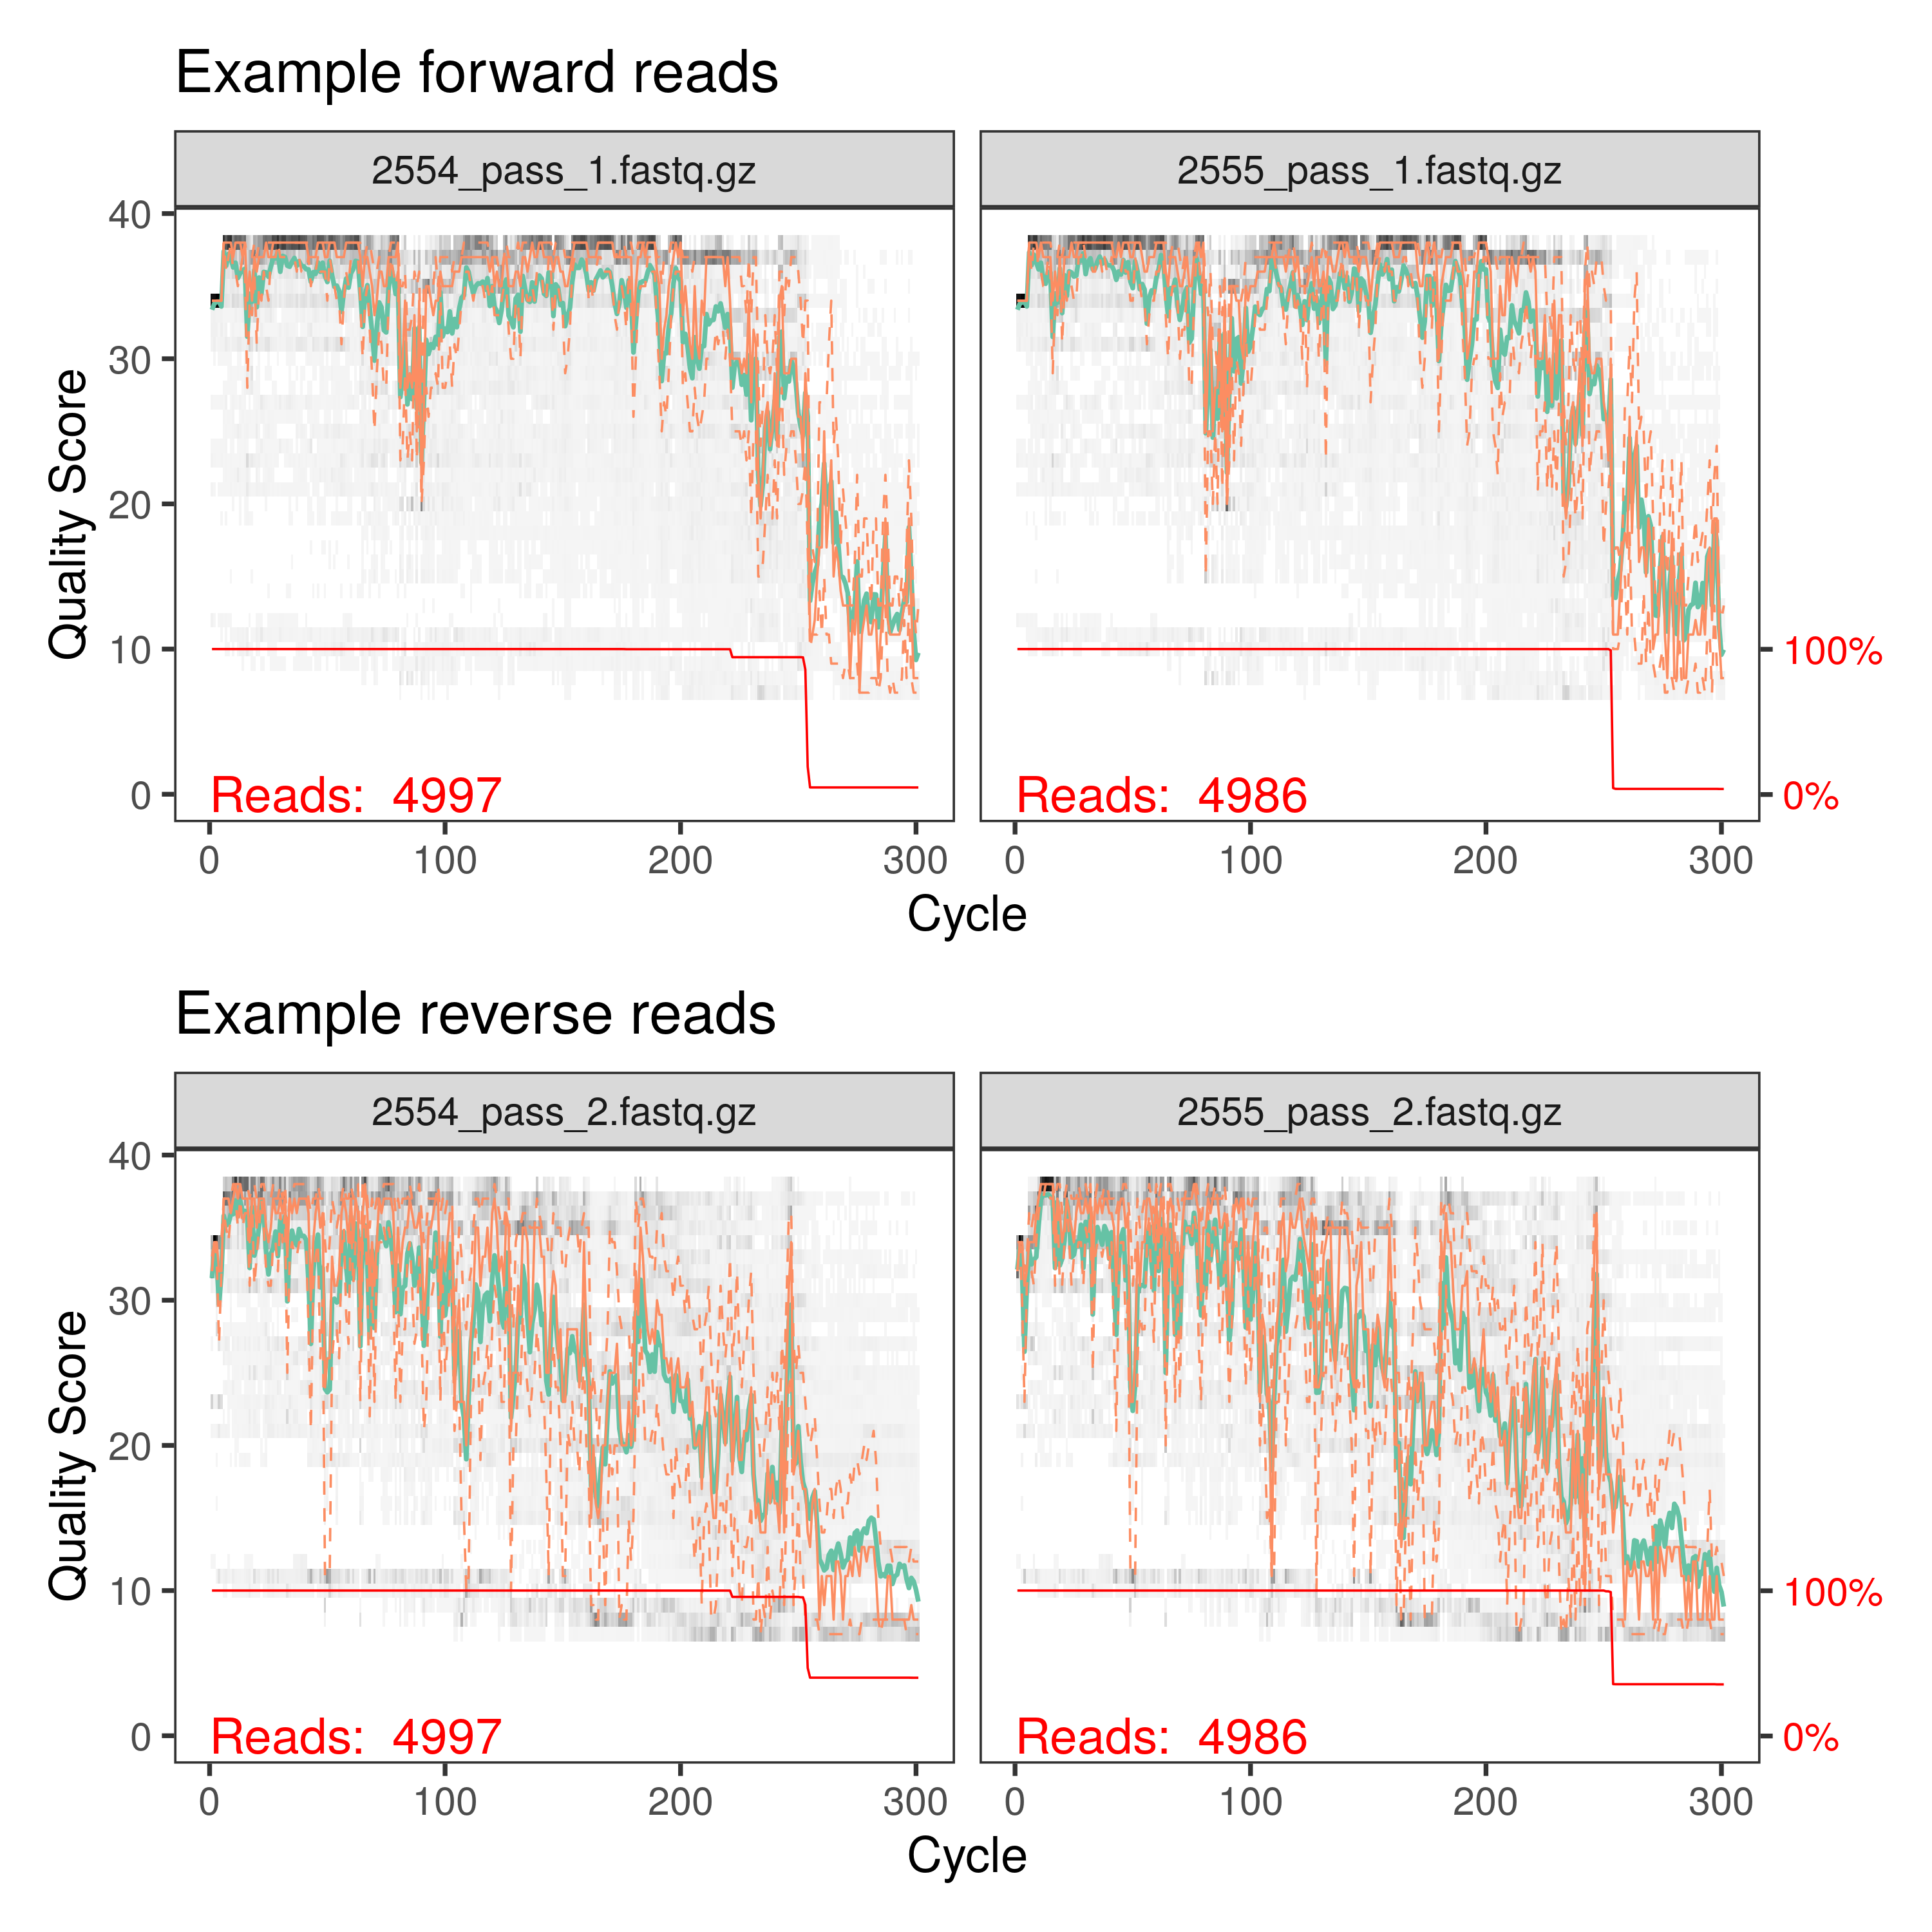

In our case (and this is typical), the forward reads are generally of better quality than our reverse reads (Figure 2). There is no "right value" for this next step, but a common practice is to truncate reads where the mean quality score dips below 25. In this example, that roughly lies at base position 250 for our forward reads and at 200 for our reverse reads. These values vary between data sets, so make your best judgement. When in doubt, it's best to be conservative.
If you are working with fungal ITS reads, it is typical that reverse reads aren't of sufficient quality to merge with forward reads. Especially with variable ITS lengths, it is somewhat common practice to forego using reverse reads, and to just process the forward reads output by itsxpress (Darcy et al., 2020; Tipton et al., 2019, 2021).
The trimming and filtration step will discard some reads; how many depends on how stringently you set the parameters. If you notice that the majority of your reads are being discarded, you might try relaxing the maxEE parameter a bit. Our reads had rather low quality scores so it's not surprising that roughly half of them were rejected by our filtration step (Table 1). Figure 3 shows a comparison of quality profiles for a single sample before and after our filtration step. You can clearly see that the reads have been truncated at 250 nucleotides and that mean quality scores are higher along the length of the reads.

 | reads.in | reads.out
2554_pass_1.fastq.gz | 5000 | 2143
2555_pass_1.fastq.gz | 5000 | 2245
2557_pass_1.fastq.gz | 5000 | 2056
Table 1 - Example output from filtration step (first 3 files shown)

Fig. 3 - Comparison of quality profiles for a single sample pre- and post-filtration
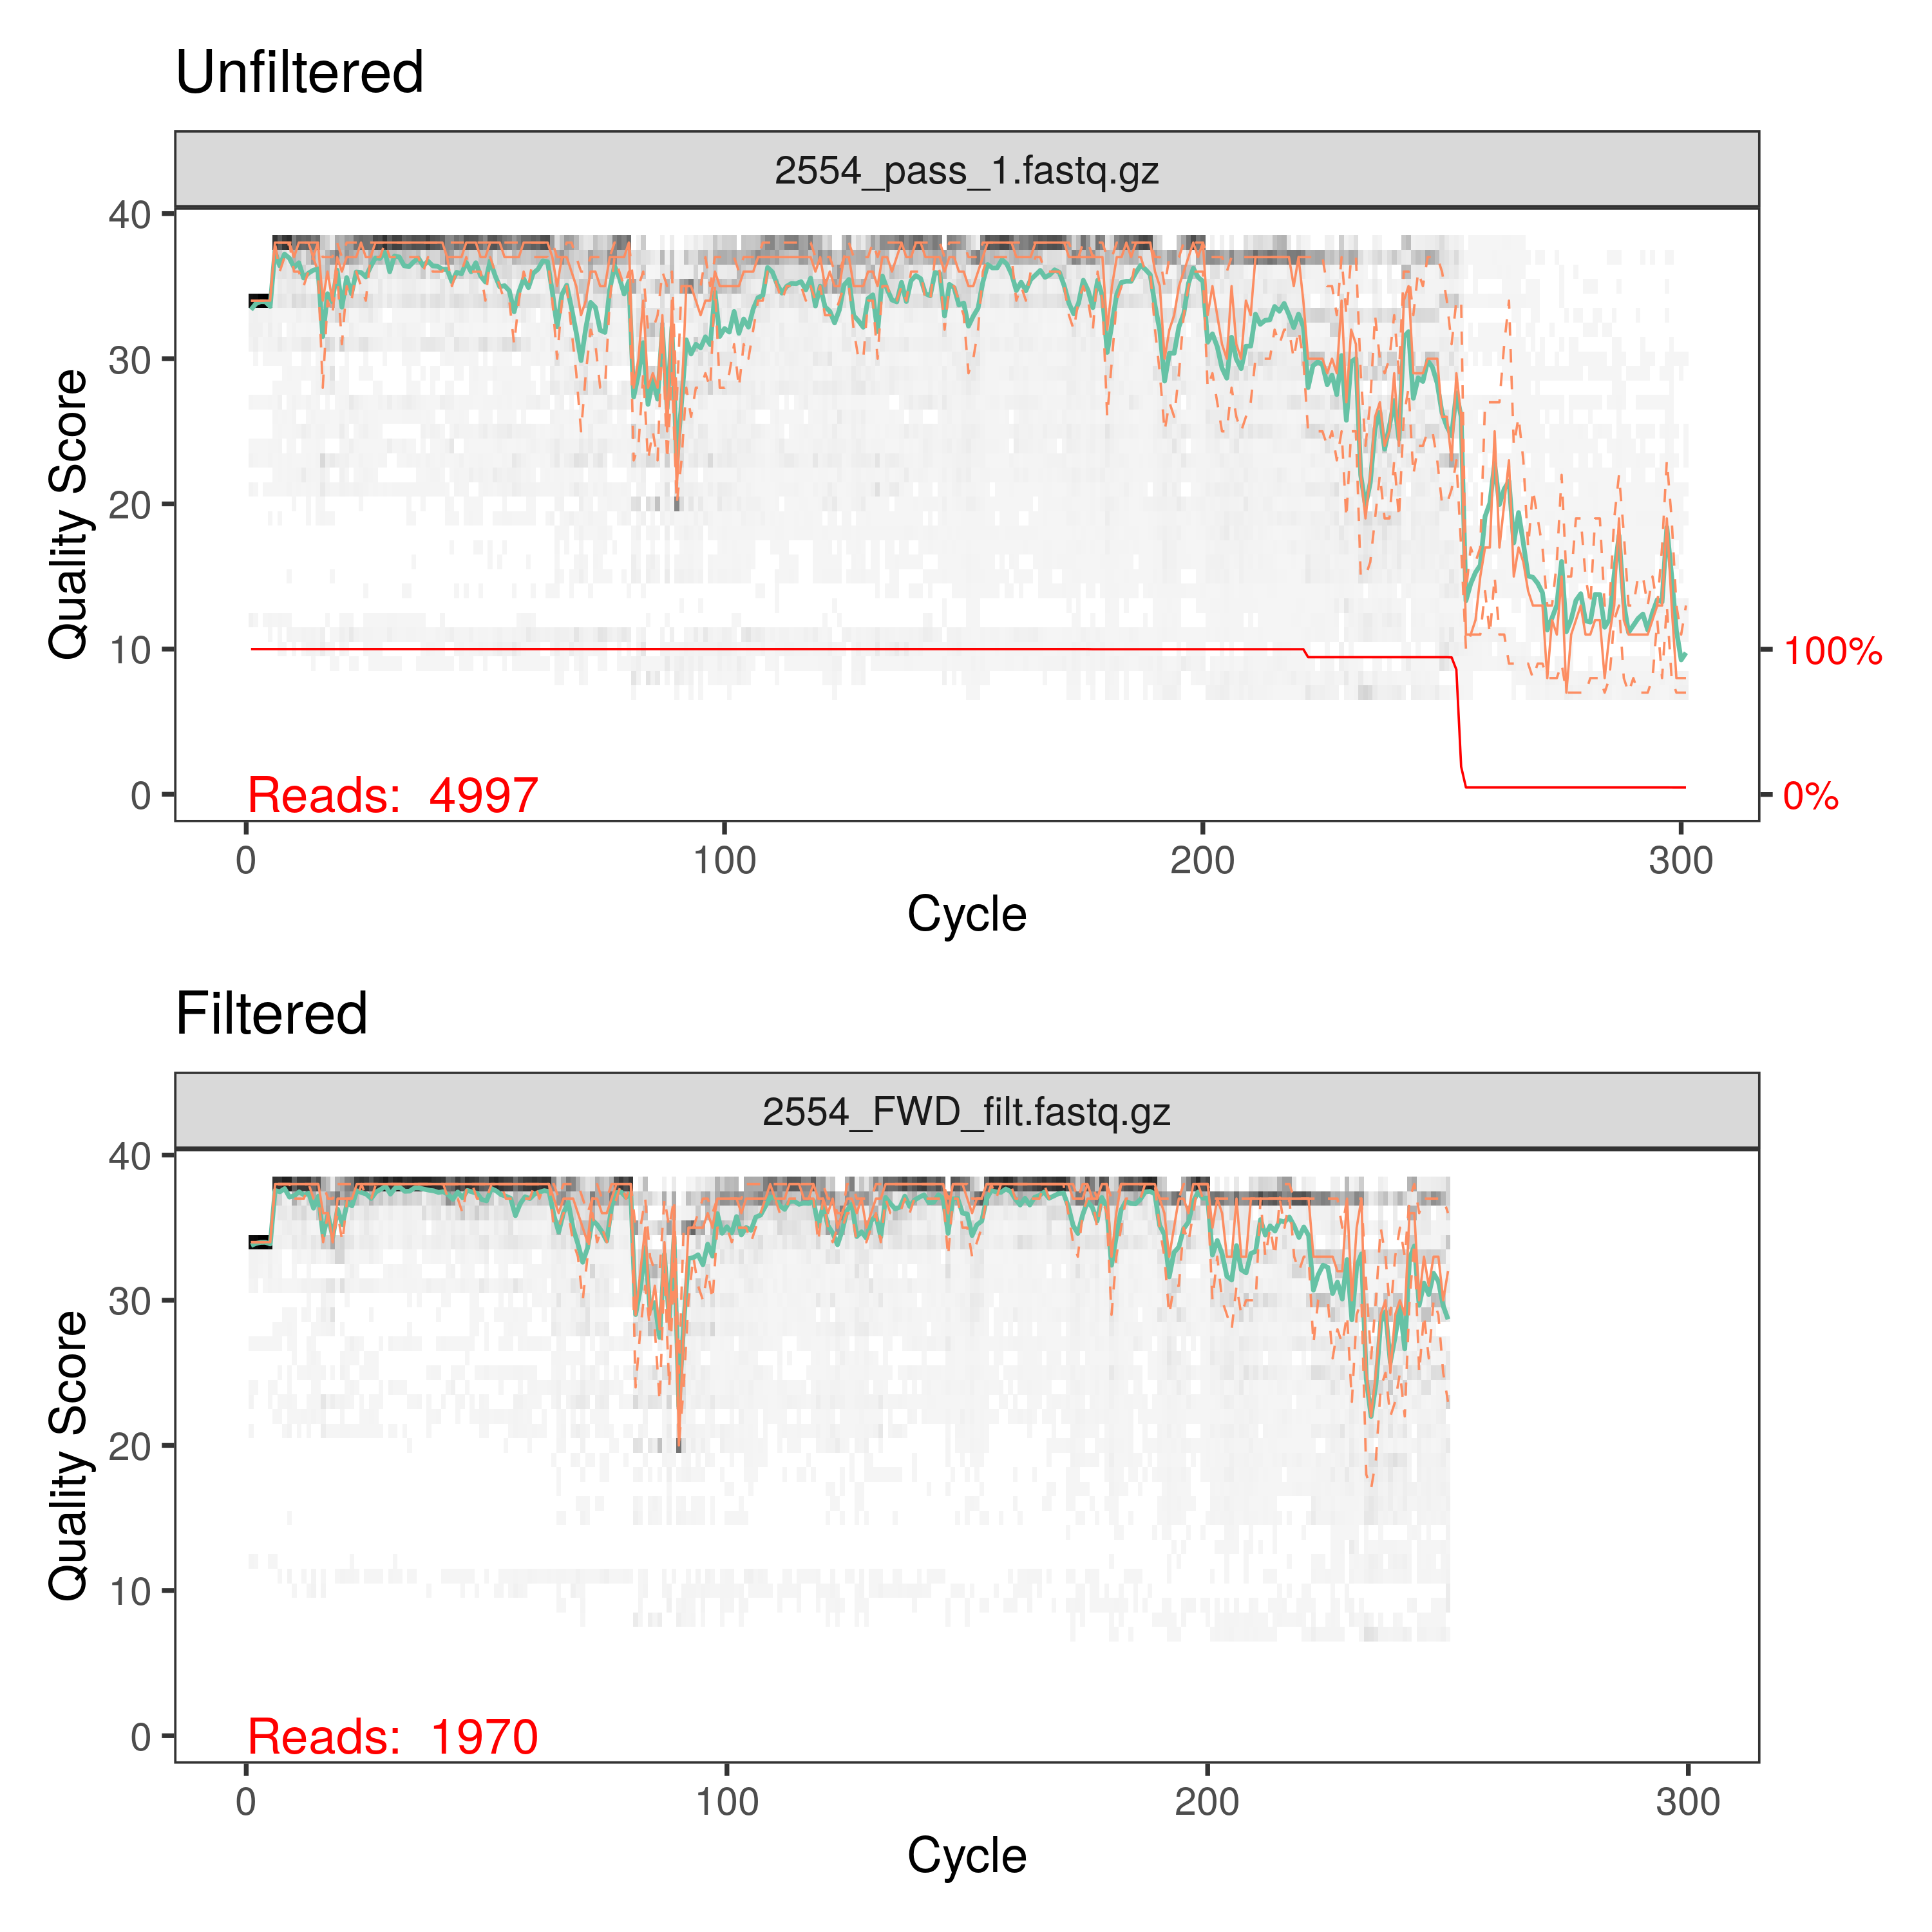

3. ASV inferrence (bacteria and fungi)
Now that we have a set of quality-controlled sequence files, we're ready to perform a "denoising" step that can predict and correct likely sequencing errors. This is an important step when analyzing exact "amplicon sequence variants" (ASVs) as opposed to "operational taxonomic units" (OTUs). There is always a bit of "noise" in sequence data, representing sequence errors. OTUs were, in part, conceived of as a way to deal with this constant threat of sequencing noise. By clustering highly similar sequences together, it accounts for small amounts of variation. However, much of that variation is real and informative (Callahan et al., 2017; Tipton et al., 2021). Methods now exist to discover and correct sequence errors, allowing us to use ASVs. The advantages include finer taxonomic resolution, the potential to discover patterns that might be hidden by artificially clustering sequences together, and most importantly, the ability to easily combine data from multiple studies. Since each ASV is an actual sequence, rather than an undefined cloud of sequences (as with OTUs), they are directly comparable outside of a given study. This facilitates reproducibility and re-use such as in meta-analyses.
The DADA2 R package gives us a set of tools for inferring these ASVs. First, we build a mathematical profile of error rates along the length of our reads. In basic terms, we can think of this error profile as being a mathematical representation of our quality profile plots (Figure 3). The learnErrors() function is a machine-learning tool that builds an error model based on your data. Figure 4 shows this error model. What you're looking for is a decent fit between observed and estimated errors; It doesn't need to be a perfect fit. If your model looks reasonable (as ours does in Figure 4), you are ready to use that error model to correct sequence errors.
The dada() function performs denoising based on the estimated error model. In essence, it is performing statistical tests that determine whether a given sequence was observed too many times to have been caused by sequencing errors in currently inferred sequences (Rosen et al., 2012). The dada() function is run separately on forward and reverse reads and the output is a set of sequence variants that were inferred from the "noisy" input sequences. From this point, we are ready to merge our forward and reverse reads and construct a sequence table. These tasks are accomplished with the mergePairs() and makeSequenceTable() functions, respectively.
These algorithms may seem daunting, but for routine analyses of either 16S or ITS data, they have been made easy to implement in R. Aside from plotting and inspecting your data, all the steps between quality filtration and constructing a tidy sequence table can be performed with just five R functions: learnErrors(), derepFastq(), dada(), mergePairs(), and makeSequenceTable(). The supplementary R script "01_Process_Raw_16S_Reads.R" covers all these steps in detail.
Fig. 4 - Estimated error rate plot; Black dots show observed error frequencies at a given quality score (X-axis); Black lines show the estimated error model for each putative error type.
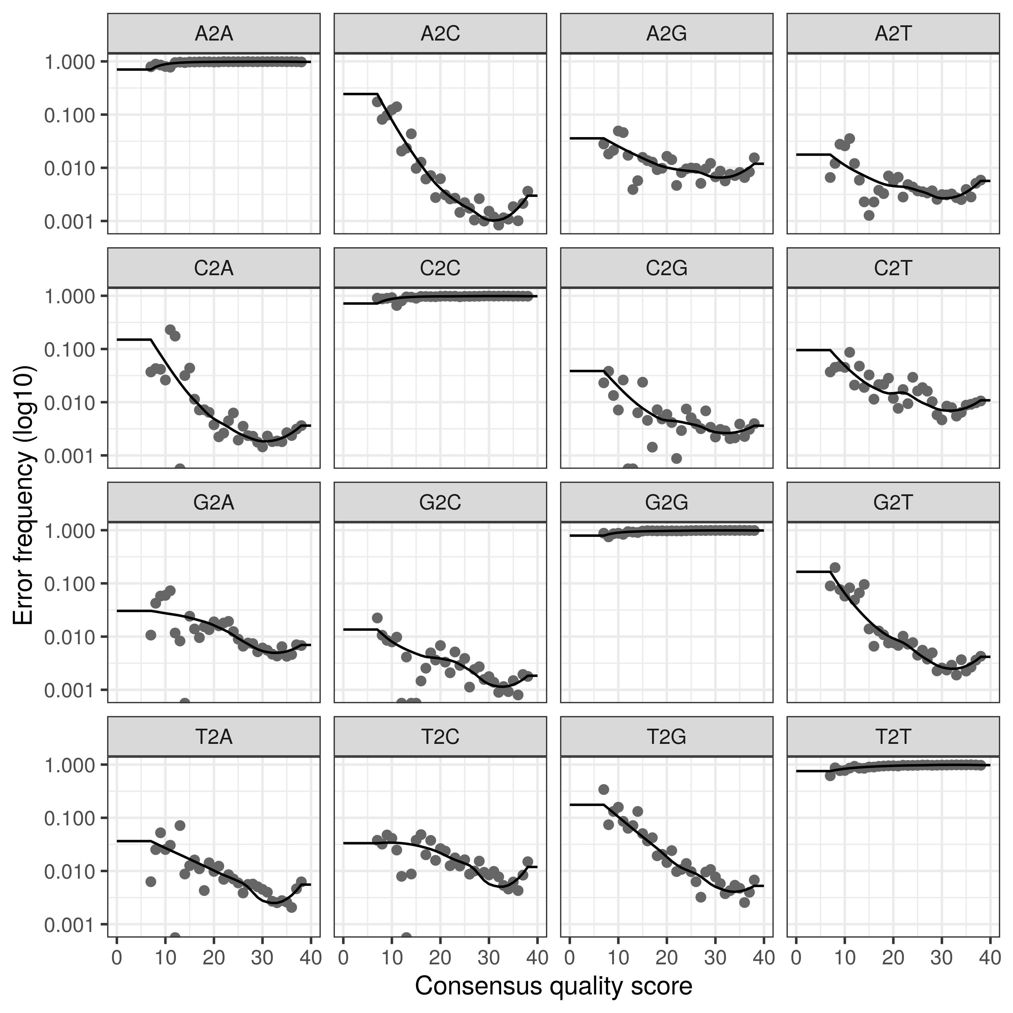

4. Remove chimeras (bacteria and fungi)
Chimeric sequences result from incomplete extension during PCR. Partial amplicons can serve as "false templates" for primers to bind to, resulting in reads that are composed of more than one true sequence. Chimera detection involves evaluating distinct matches between the left-side and right-side of reads and potetial "parent" source reads. In practice, this detection and removal step can be conducted with the removeBimeraDenovo() function as shown in the R script "01_Process_Raw_16S_Reads.R."

5. Remove contaminant sequences (bacteria and fungi)
While sadly not universally practiced, including and sequencing negative controls is a crucial step when performing meta-amplicon studies. Often, these control samples are blank DNA extractions that are then sequenced. This allows us to discover DNA sequences that were present in the lab environment that do not necessarily represent meaningful diversity in our real samples. The decontam package (Davis et al., 2018) has been implemented to deal with these negative controls, using them to detect likely contaminant sequences. The way we will use this package is by giving the isContaminant() function our newly created sequence table and a list of which samples are negative controls. Your sample metadata spreadsheet likely contains study-relevant information about each sequenced sample, but should also include a column denoting whether a sample is a negative control (Table 2 shows an example metadata sheet formatted correctly). Sequences with increased prevalence in control samples can then be identified and removed. Once potential contaminants are removed, we can then remove the negative control samples from further downstream steps since their job is done.

Table 2 - Example metadata organization with column denoting whether a given sample is a negative control
SampleID | Island | Host_ID | Lat | Lon | Status | Control
CHPd62 | Peros Banhos | H. ovalis | -5.42721 | 71.77779 | healthy | FALSE
CHPd63 | Peros Banhos | H. ovalis | -5.42721 | 71.77779 | healthy | FALSE
CHPd65 | Peros Banhos | H. ovalis | -5.42721 | 71.77779 | impacted | FALSE
BLANK1 | NA | NA | NA | NA | NA | TRUE
BLANK2 | NA | NA | NA | NA | NA | TRUE

6. Assign taxonomy (bacteria and fungi)
Assigning taxonomy to DNA barcodes is a complicated subject. The success and accuracy of any assignments depend on the algorithms and databases that you use. In fact, with phylogeny-independent taxonomic assignments, the current limiting factors are the completeness and accuracy of the databases to which we match our sequences. With this in mind, it is critical that you carefully consider what methods to use. The RDP Naive Bayesian Classifier algorithm (Wang et al., 2007) is one such algorithm that is widely used and has several advantages. First, it does not rely on sequence alignments, which makes it suitable for fungal ITS studies. Second, it is incredibly fast compared to algorithms such as BLAST. Third, it provides bootstrapped confidence values to all assignments and allows matching to the "least common ancestor," reducing the incidence of false positive matches. Its performance for species-level taxonomic assignments of bacteria is lacking, and new information has shown that exact 100% matching is the only justifiable method for assigning species to bacterial ASVs (Edgar, 2018). A selection of properly formatted reference files for popular taxonomic databases are available at http://benjjneb.github.io/dada2/training.html. Here, we use two complementary methods to assign taxonomy to our reads: 1) the RDP Classifier using the RDP 16S Training Set database, implemented via the assignTaxonomy() function, and 2) exact 16S matching for species-level assignments implemented via the addSpecies() function. The "Assign Taxonomy" section of "01_Process_Raw_16S_Reads.R" script covers these steps. These functions take our sequence table as input and return a data frame matching our ASVs to taxonomy at the deepest levels that could be assigned unambiguously.
If you are using fungal ITS reads, taxonomic assignment is essentially the same, but you will need to use a eukaryotic database such as the UNITE Eukaryotic Database (Abarenkov et al., 2020) instead of a bacterial 16S database, and the addSpecies() function should be omitted.
A last step in this script is to construct a phyloseq object in which to store your ASV table along with your sample metadata and taxonomic assignments. The phyloseq package (McMurdie & Holmes, 2013) provides a data structure that can combine a sequence abundance table (like our ASV table), taxonomic information, sample metadata, and a phylogenetic tree into one object that makes working with these disparate tables much simpler.

7. Build phylogeny (bacteria only - optional)
If you're working with bacterial 16S, it can be a good idea to build a phylogeny of your ASVs. Some analyses, such as UniFrac community distance measures, use phylogeny-aware methods to improve comparisons between communities (Lozupone & Knight, 2005). Fungal ITS reads are generally not alignable, however, and thus cannot be used to build phylogenies. This step is not required for most downstream analyses, so if you've got ITS reads, just skip to the next section.
It is beyond the scope of this chapter to cover all the methods for building phylogenies, so we will focus on a simple and effective "good enough" approach within the R environment using the msa and phangorn R packages (Bodenhofer et al., 2015; Schliep, 2011). The general workflow is to align your ASVs to each other, build a distance matrix, and then construct a phylogenetic tree from that matrix. The script "02_Build_and_add_Phylogeny.R" walks you through a typical workflow.
Our phyloseq object currently contains our ASV table, taxonomic assignments, and sample metadata. The sequences associated with each ASV can be easily extracted from our phyloseq object and aligned using the MUSCLE algorithm (Edgar, 2004) using the msa() function. This alignment is then used to generate a maximum likelihood distance matrix with the dist.ml() function. We can then construct an initial tree using the Neighbor-Joining method, implemented with the NJ() function. The phangorn package has a range of tools for optimizing and updating trees based on different models, but for our purposes, a simple Neighbor-Joining tree will suffice as "good enough for now" since none of our anticipated downstream analyses will depend on having a phylogeny. If phylogenetic methods are essential for your own analyses, readers are encouraged to explore the phangorn package in further detail. After we have a tree that we are comfortable with, we can add it to our phyloseq object and move on to tidying our dataset in preparation for exploratory analyses.

8. Final cleanup and preparation for analyses (bacteria and fungi)
Our 16S primers can amplify non-bacterial DNA such as chloroplasts or Archaea in addition to bacteria. Unless these sequences are part of your research question, now is a good time to remove them. The script "03_Clean_and_Explore_Data.R" walks through a demonstration of how to use phyloseq to subset and manipulate our full data set.
First, we use the subset_taxa() function to remove any taxa that were not unambiguously assigned to the kingdom Bacteria. This removes any archaea or unknown sequences that were detected. Next, we use the same function to remove taxa that were assigned to known chloroplast identities. Finally, we can clean up our ASV table by removing any samples that are now "empty" by using the subset_samples() function. In other words, some samples may have only contained reads that were non-bacterial and now that we have removed those reads, those samples will contain no information so they should be dropped. This is usually only an issue when sequencing depth is very shallow. With this cleanup completed, we are now ready to start exploring our data set.

9. Exploration and hypothesis testing (bacteria and fungi)
The script "04_Explore_and_Test_Hypotheses.R" walks you through an example of how to use phyloseq to explore a meta-amplicon data set. Of course, this exploration and analysis process will vary greatly between studies, as it is completely contingent on what questions you set out to address. In our case, the example data were collected to assess bacteria associated with a coral bleaching event. The metadata may be different, but the techniques will not change regardless of whether you are studying plant endophytes or human gut microbiomes. Additionally, there are no differences with regard to fungal or bacterial amplicons at this point. In fact, it is possible to combine fungal and bacterial phyloseq objects at this point if you are studying them simultaneously for the same set of samples using the merge_phyloseq() function. Here, we will briefly outline some steps in a typical analysis. The code documentation in the associated script goes into more detail, but this is meant to be simply an example for how to use the functions mentioned here and it is unlikely that any other study will follow these exact steps.
The script begins with a simple exploration of the various phyloseq accessor functions. These make it straightforward to access information without having to understand the structure of the phyloseq object. For example, we can access any of the individual data components independently: sample_data() returns our metadata, otu_table() returns our sequence (ASVs, in our case) abundance table, tax_table() returns our taxonomic assignments, and phy_tree() returns our phylogenetic tree.
Initially, many analyses start with a quick exploration of alpha diversity. The estimate_richness() and plot_richness() functions make this a simple task (Figure 5). Since we cannot guarantee equal sequencing depth between all samples, for most analyses it is important to realize that amplicon sequence data is compositional in nature (Gloor et al., 2017). Traditionally, rarefying data to a common sequence depth was the preferred method for adjusting for discrepancies in sequencing effort, but this has been shown to needlessly remove potentially useful data (McMurdie & Holmes, 2014). We will simply convert our read counts into relative abundance values using the transform_sample_counts() function.
Next, we can take a look at beta-diversity using ordination (ordinate() from the phyloseq package) and permANOVA(adonis() function from the vegan package). It is reasonable to try several ordination methods as we have done (Figure 6), depending on your data set. Figure 6 seems to show strong separation of bacterial communities based on "Colony_Color." We can test this statistically using adonis(), where we model our ASV table as the response and Colony_Color and Island as predictors (Table 3).
While permANOVA can tell us whether any patterns in community dissimilarity exist, it doesn't tell us which taxa are driving those differences. To answer that question, we must turn to special methods designed to detect differential abundant taxa. There are many commonly used tools for this such as DESeq2 (Love et al., 2014) and ALDEx2 (Fernandes et al., 2013), but here we will use the corncob package (B. D. Martin et al., 2020) because it is capable of modeling differential variance in addition to abundance in a user-friendly way, and is well integrated with phyloseq. Note that all of these methods depend on non-transformed data (raw counts) unlike our beta-diversity measures which needed normalized counts.

Table 3 - PermANOVA model output. Island is a significant predictor of community dissimilarity, but Status is not.

term | df | SumOfSqs | R2 | statistic | P-value
meta$Status | 1 | 0.1860 | 0.01445 | 0.6425 | 0.630
meta$Island | 1 | 1.3744 | 0.10679 | 4.7467 | 0.003
meta$Status:meta$Island | 1 | 0.0170 | 0.00132 | 0.0585 | 1.000
Residual | 39 | 11.2925 | 0.87743 | NA | NA
Total | 42 | 12.8699 | 1.00000 | NA | NA

Figure 5 - Alpha diversity boxplots for observed counts, Shannon, and Simpson diversity measures. Figure code:
plot_richness(ps, x = "Colony_Color", measures = c("Observed","Shannon","Simpson"),
color = "Colony_Color", sortby = "Observed") +
geom_boxplot(alpha = .5) + theme_minimal()
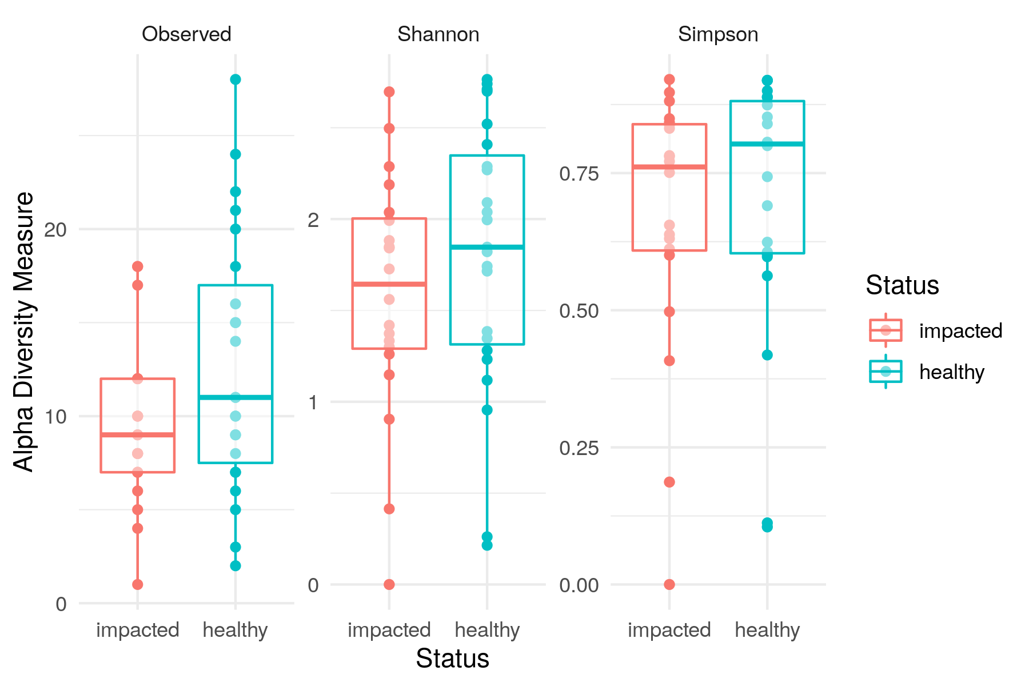

Figure 6 - Comparison of ordination methods; Top = Detrended correspondence analysis (DCA) using Bray-Curtis dissimilarity, Middle = Non-metric multidimensional scaling (NMDS) using Bray-Curtis dissimilarity, Bottom = NMDS using UniFrac dissimilarity. The same pattern is seen with each method.
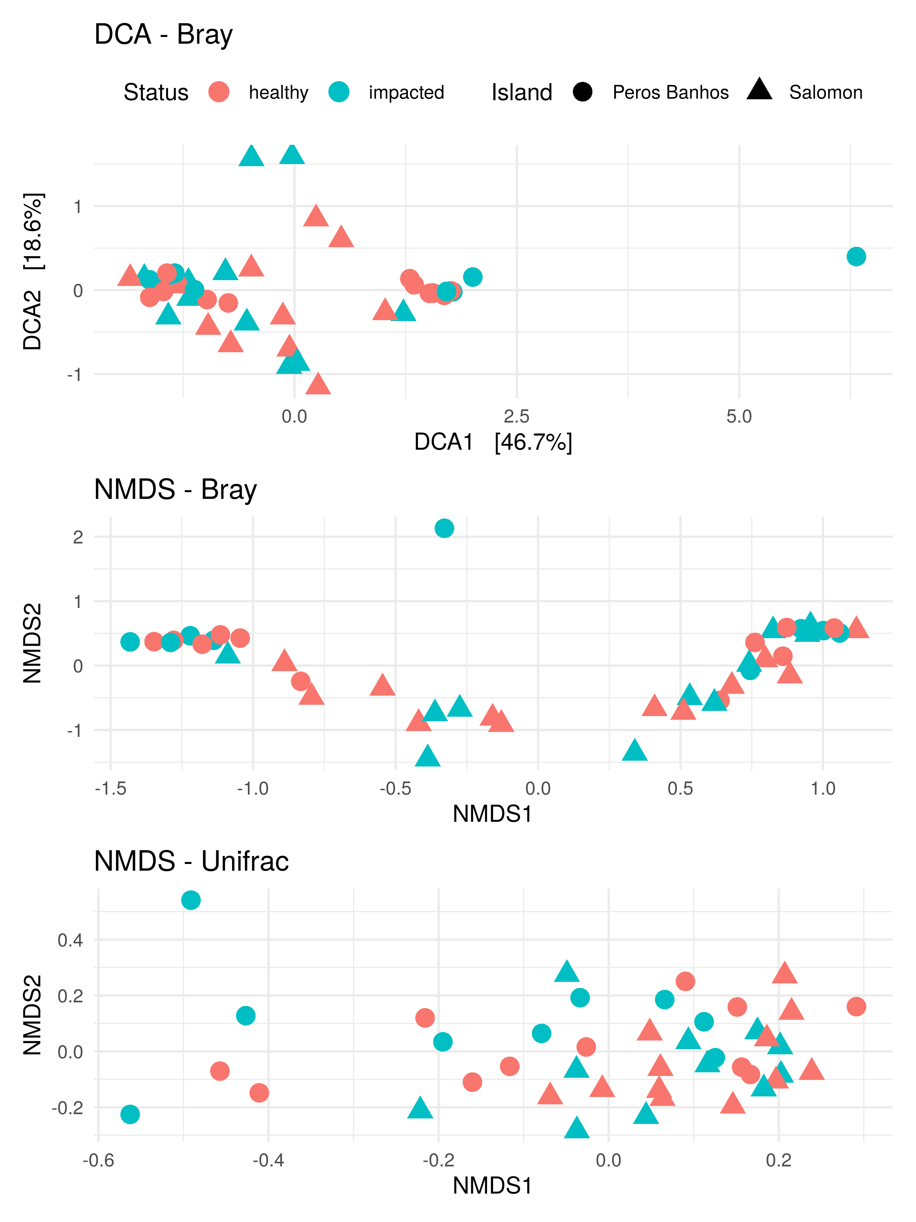

Figure 7 - Relative abundance plots for taxa identified as differentially abundant in a corncob model. Individual samples are on the x-axis and are colored by "Island." Points show relative abundance and bars show dispersion.
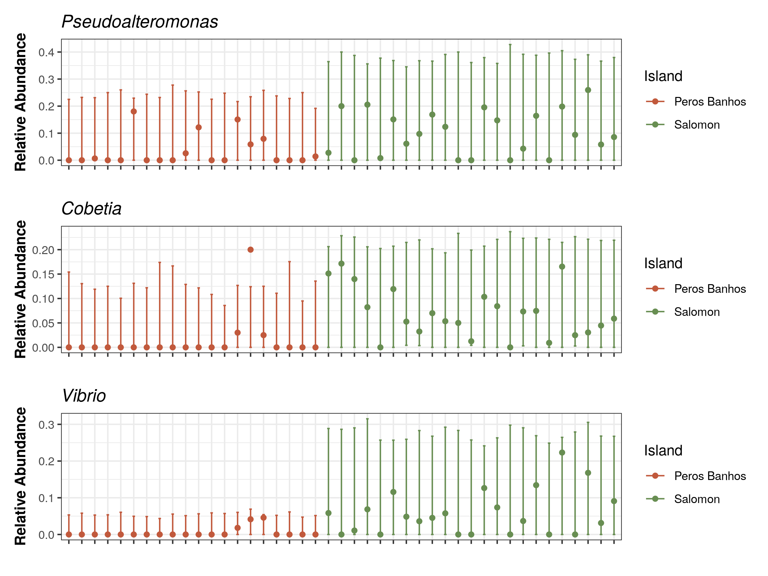

_________

- Write with active voice and verbs in the present tense (e.g., write "Parse the output files from the homology searches” instead of “The output files from the homology searches were parsed.").
- Provide representative data (intermediary and final) and notes/tips to help others: Your protocol should provide enough information for a first-year graduate student to perform it and be successful.
- Codes and Scripts: the codes or scripts could be presented in the Case study section or submitted as supplementary file(s).
- For images:
- Resolution: a minimum of 300 dpi.
- Text in Figure: 8-12 point.
- Panel label: “A, B, C…” (uppercase, bold). Use the same typeface for all figures.
- Each figure should have a title and a comprehensive but concise legend.
- Include scale bars where it applies (e.g. microscope images).
- Figures should be embedded in the text.
- For tables:
- Each table should have a brief title and a comprehensive but concise legend. Put table title above the table. Consistently use “Table 1. Title. Xxx.”, indicate Table 1. 2... in the text.
- Each table should be editable. Prepare all tables using the table function in a word-processing program.
- Each table should have the following three horizontal lines:
One under the title, above the column heading, 1 pound;
One between the column headings and the body of the table, 0.75 pounds;
One at the bottom of the table, 1 pound.
- Each table should be set off from the text close to where it is first cited.
- For videos: typical smart phone camera videos are usually adequate
    - Each video should have a title.
    - Each video file should be less than 1 GB.
    - Each video must be submitted as a separate file.

Result interpretation
Interpretation/insight upon the data analysis above

Discussion (optional)
Justification or suggestion of selection of methods and/or key parameters; perspectives of future method development.

Notes (optional)
Provide general comments such as notes about reproducibility and variability in your hands and cautionary points.

Acknowledgments
Include the following information: 1) acknowledge funding sources; 2) acknowledge previous work or the original research paper where this protocol was derived from.

Competing interests
- The corresponding author should provide a statement of financial and non-financial competing interests on behalf of all authors.
- Examples include paid employment or consultancy, stock ownership, patent applications, personal relationships with individuals involved in the submission or evaluation of a protocol, and receipt of funding or free products from the vendors of the reagents/equipment or other advertisers.

Ethics
- All protocols that have used human and/or animal subjects must mention the specific ethics committee that approved the described experiment.
- Protocols including human subjects should also indicate that informed consent was obtained from all subjects.

References
Dow, L. E., O'Rourke, K. P., Simon, J., Tschaharganeh, D. F., van Es, J. H., Clevers, H. and Lowe, S. W. (2015). Apc restoration promotes cellular differentiation and reestablishes crypt homeostasis in colorectal cancer. Cell 161(7): 1539-1552.
Strongly recommended: providing the references in our standard format (see above) and listing them in the order of aliphatic.

