--***********************

--Name:Gozde Arslan

--ID: 150320190

--Purpose: Assignment 2 DBS311

--***********************

**1-Cpp Code output**

* If the user enters the wrong value, ask the user to enter an option again until the user enters a valid option.

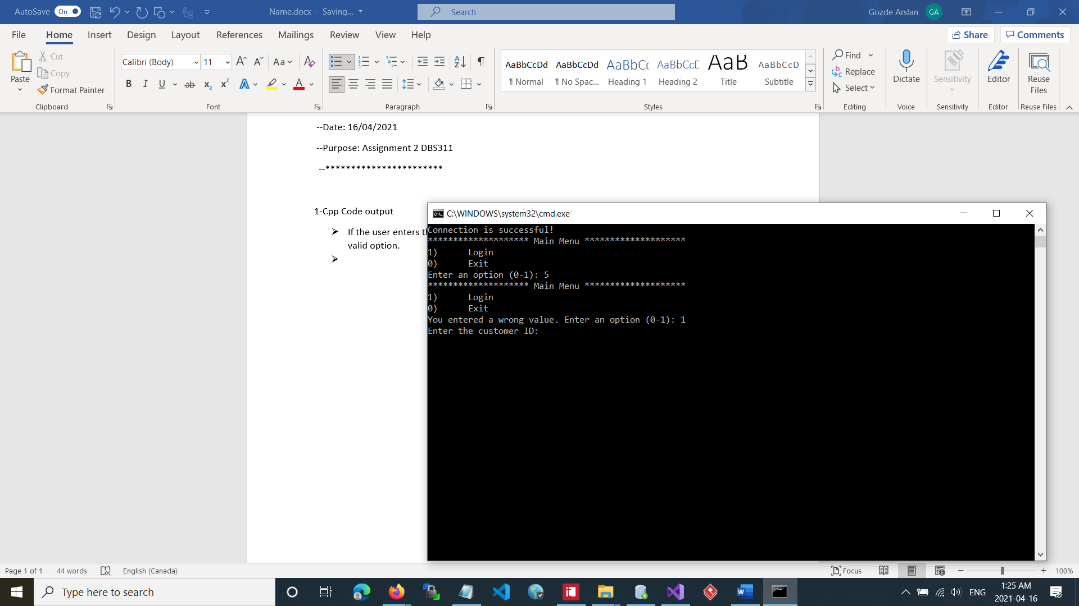

* To validate the customer ID call the find_customer() stored procedure in this function if customer does not exist.

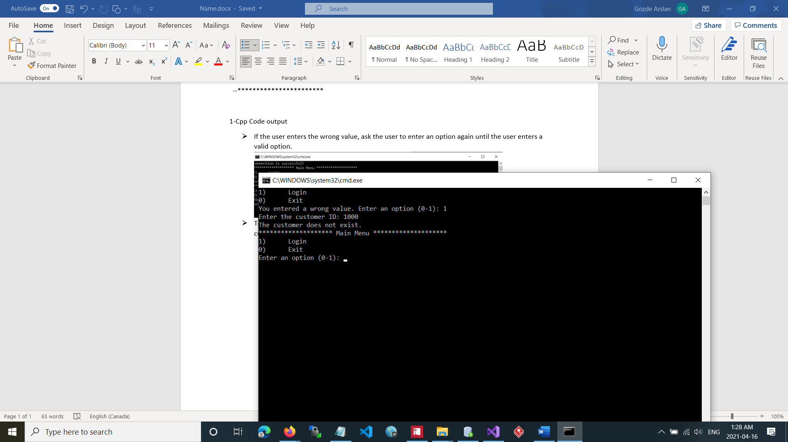

* If customer exist, redirects to the find_product() procedure.

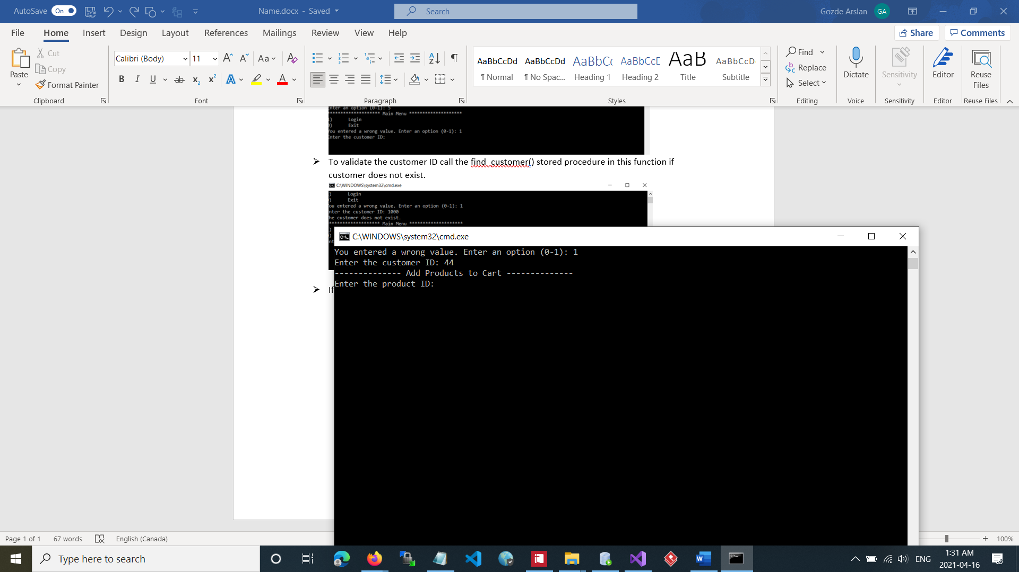

* Prompt the product details

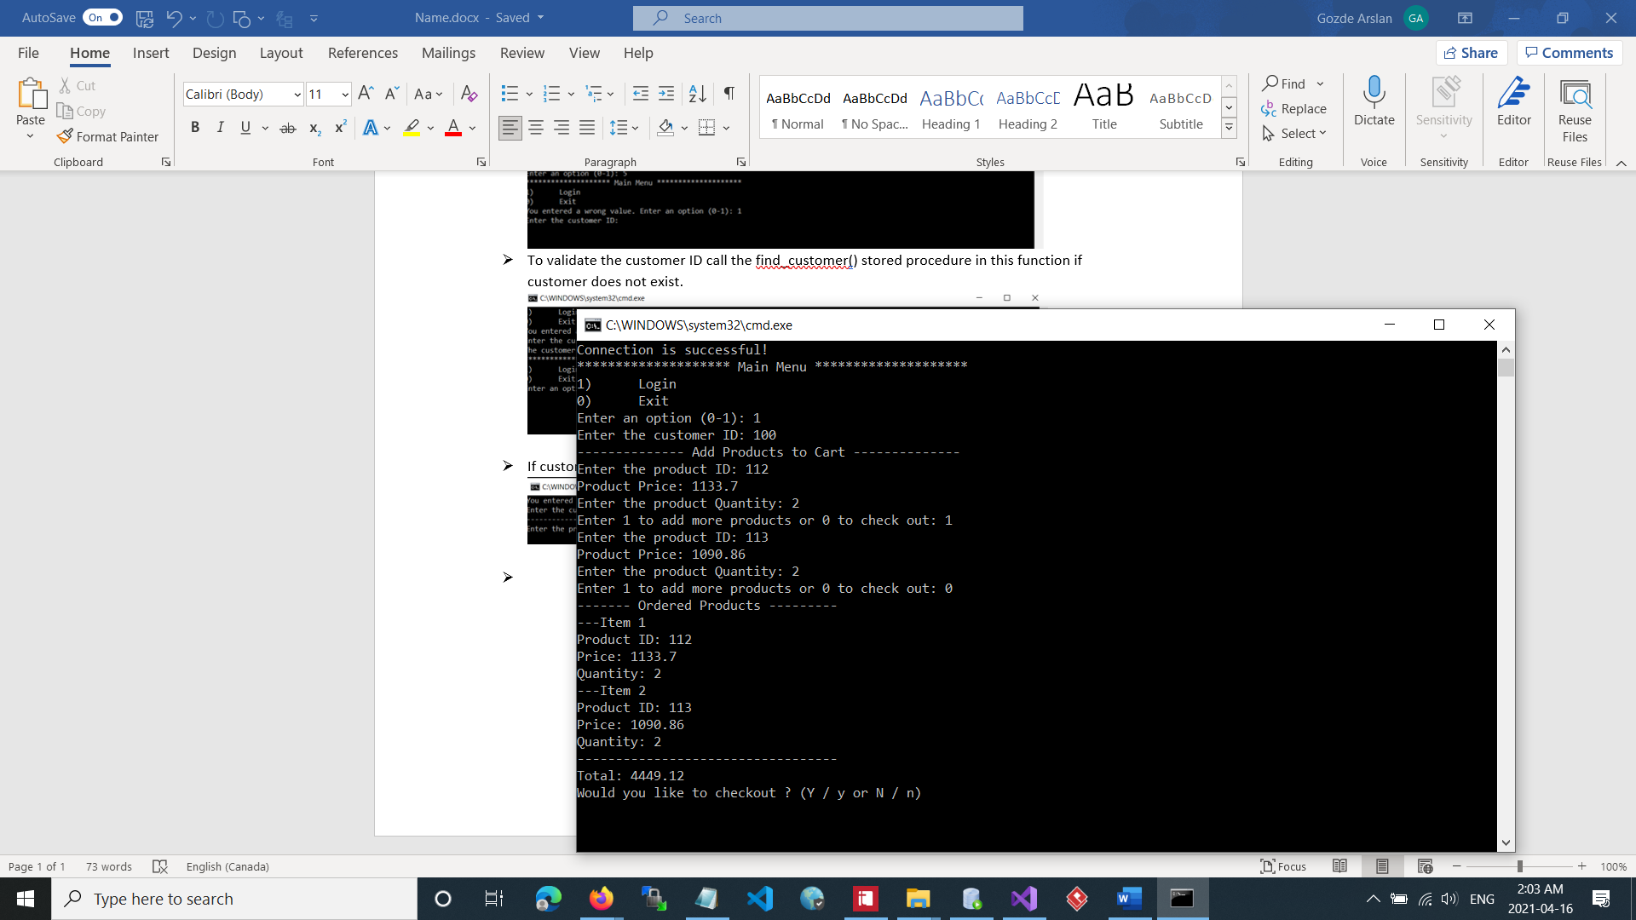

* Display the cart

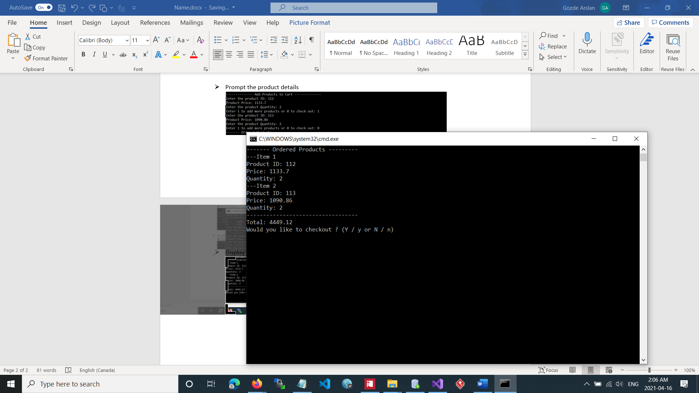

* Calling add_order() and add_order_Item() procedures

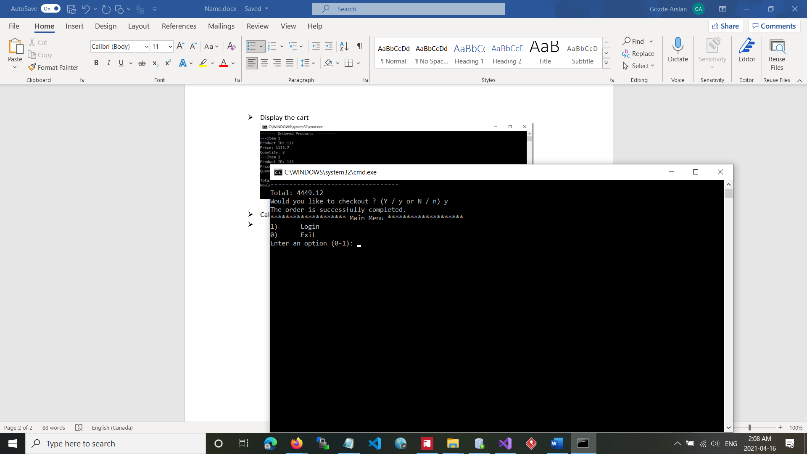

* Exiting the program

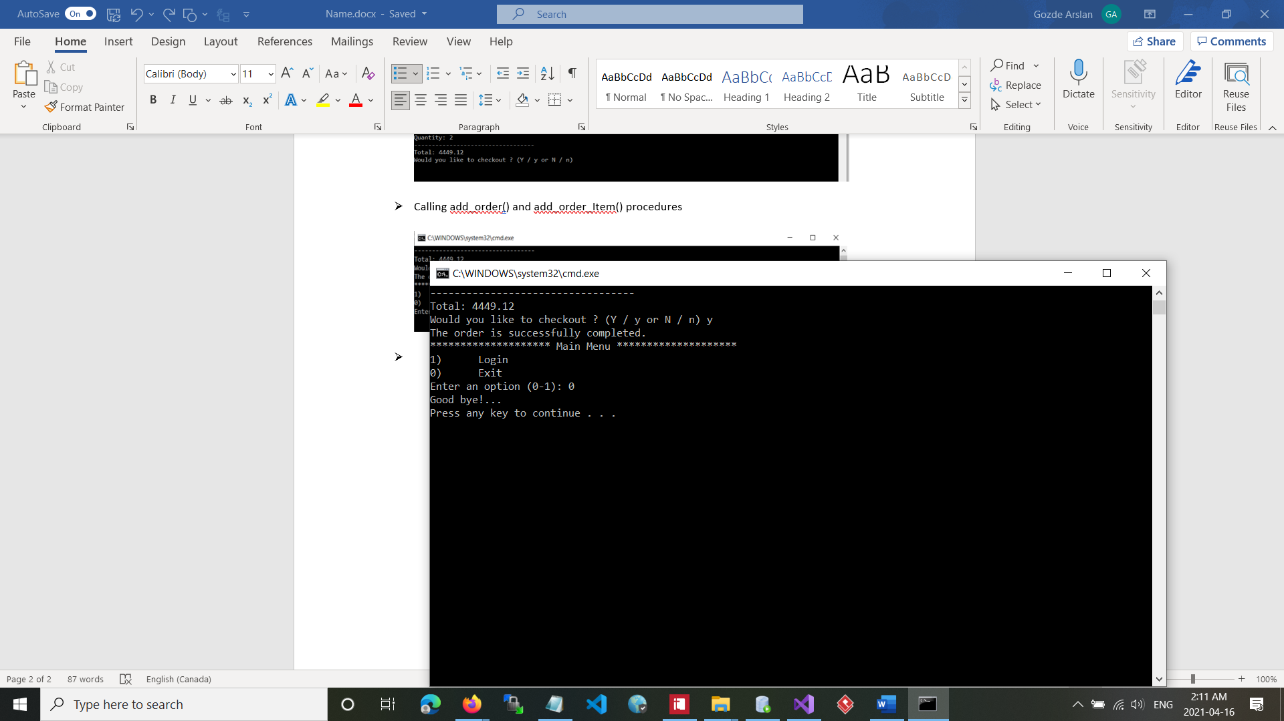

**2-Sql procedure output checks if the procedures work**

