--***********************

--Name:Gozde Arslan

--ID: 150320190

--Date: 20/01/2021

--Purpose: Lab 1 DBS311

--***********************

--Q1 Write a query to display the tomorrow’s date in the following format:January 10th of year 2019the result will depend on the day when you RUN/EXECUTE this query. Label the column “Tomorrow”.--

--Q1 Solution--

SELECT to_char(sysdate+1,'Month DD"th of year" YYYY') AS tomorrow FROM DUAL;

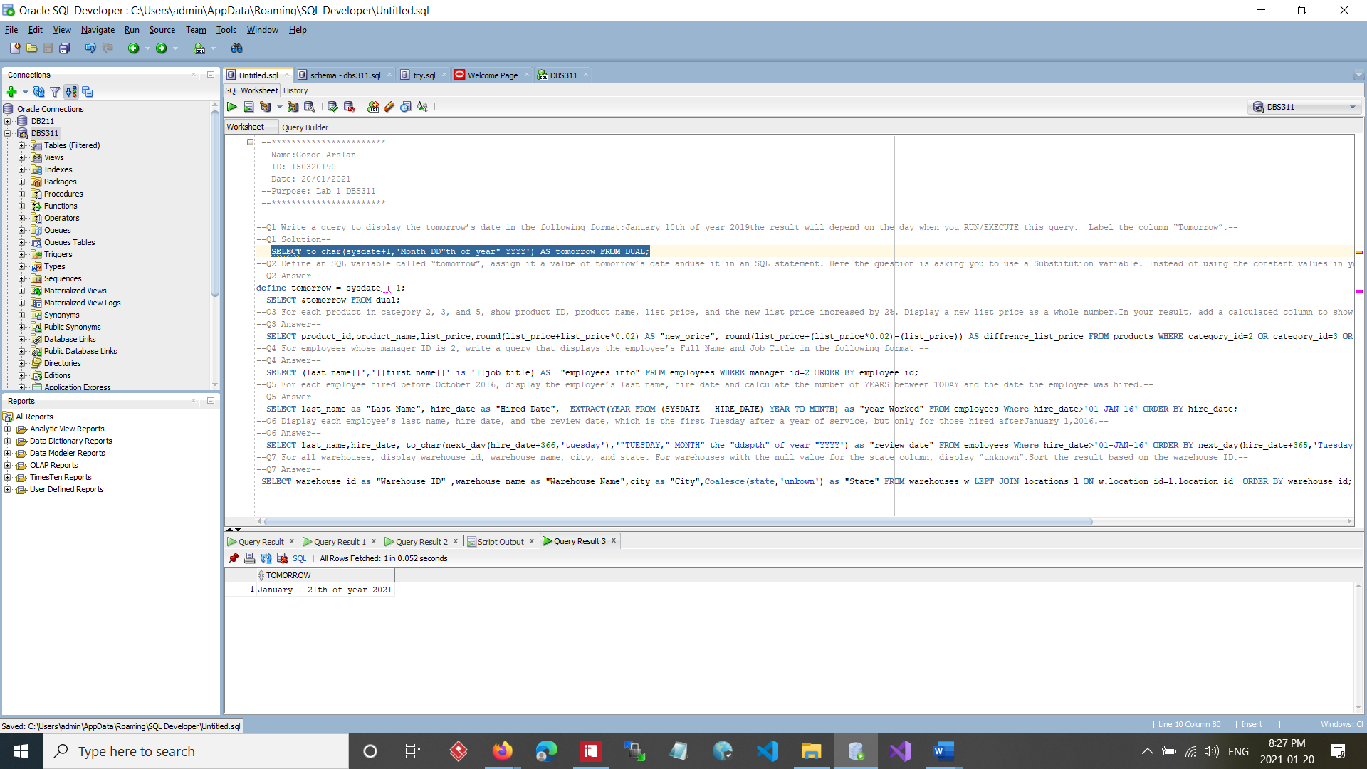

--Q2 Define an SQL variable called “tomorrow”, assign it a value of tomorrow’s date anduse it in an SQL statement. Here the question is asking you to use a Substitution variable. Instead of using the constant values in your queries, you can use variables to store and reuse the values.--

--Q2 Answer--

define tomorrow datetime = sysdate;

define tomorrow = sysdate + 1;

SELECT &tomorrow FROM dual;

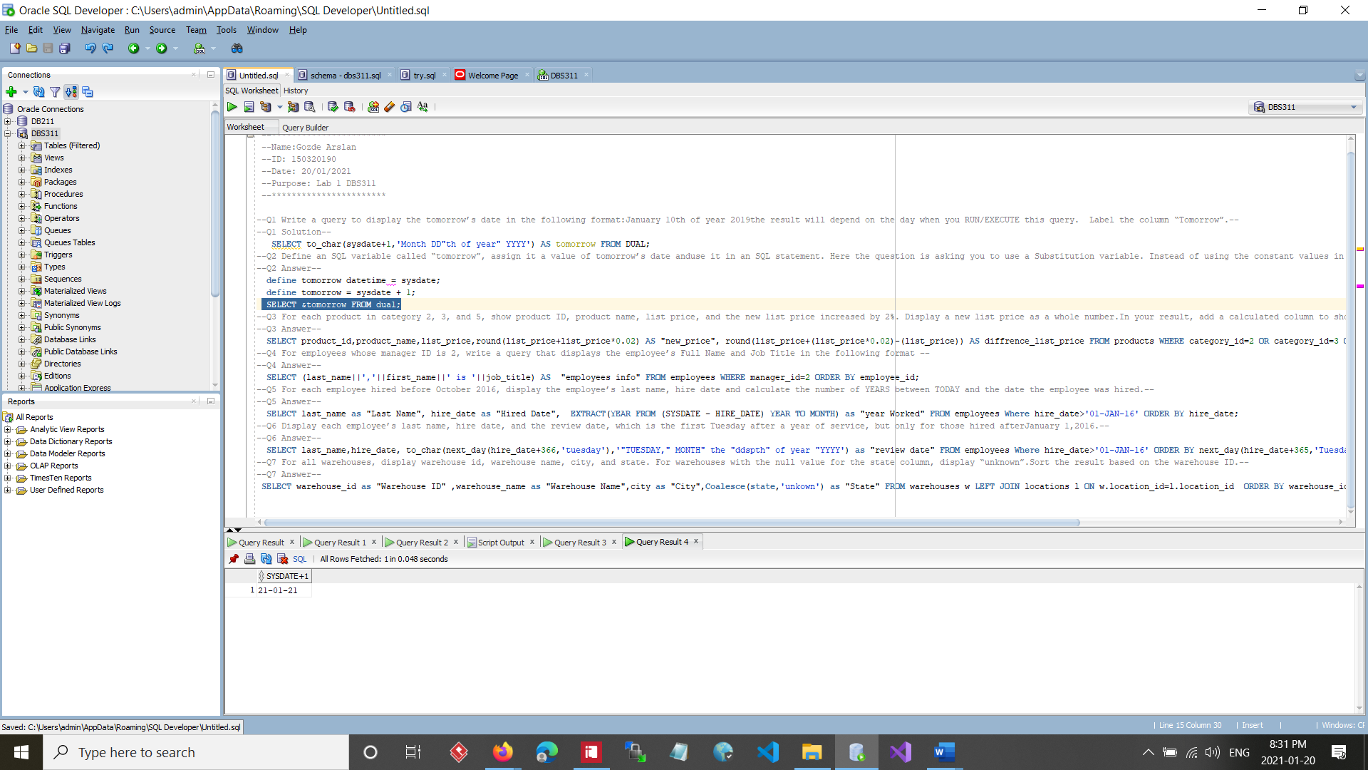

SELECT &tomorrow FROM dual;--Q3 For each product in category 2, 3, and 5, show product ID, product name, list price, and the new list price increased by 2%. Display a new list price as a whole number.In your result, add a calculated column to show the difference of old and new list prices--

--Q3 Answer--

SELECT product_id,product_name,list_price,round(list_price+list_price*0.02) AS "new_price", round(list_price+(list_price*0.02)-(list_price)) AS diffrence_list_price FROM products WHERE category_id=2 OR category_id=3 OR category_id=5 ORDER BY category_id, product_id;

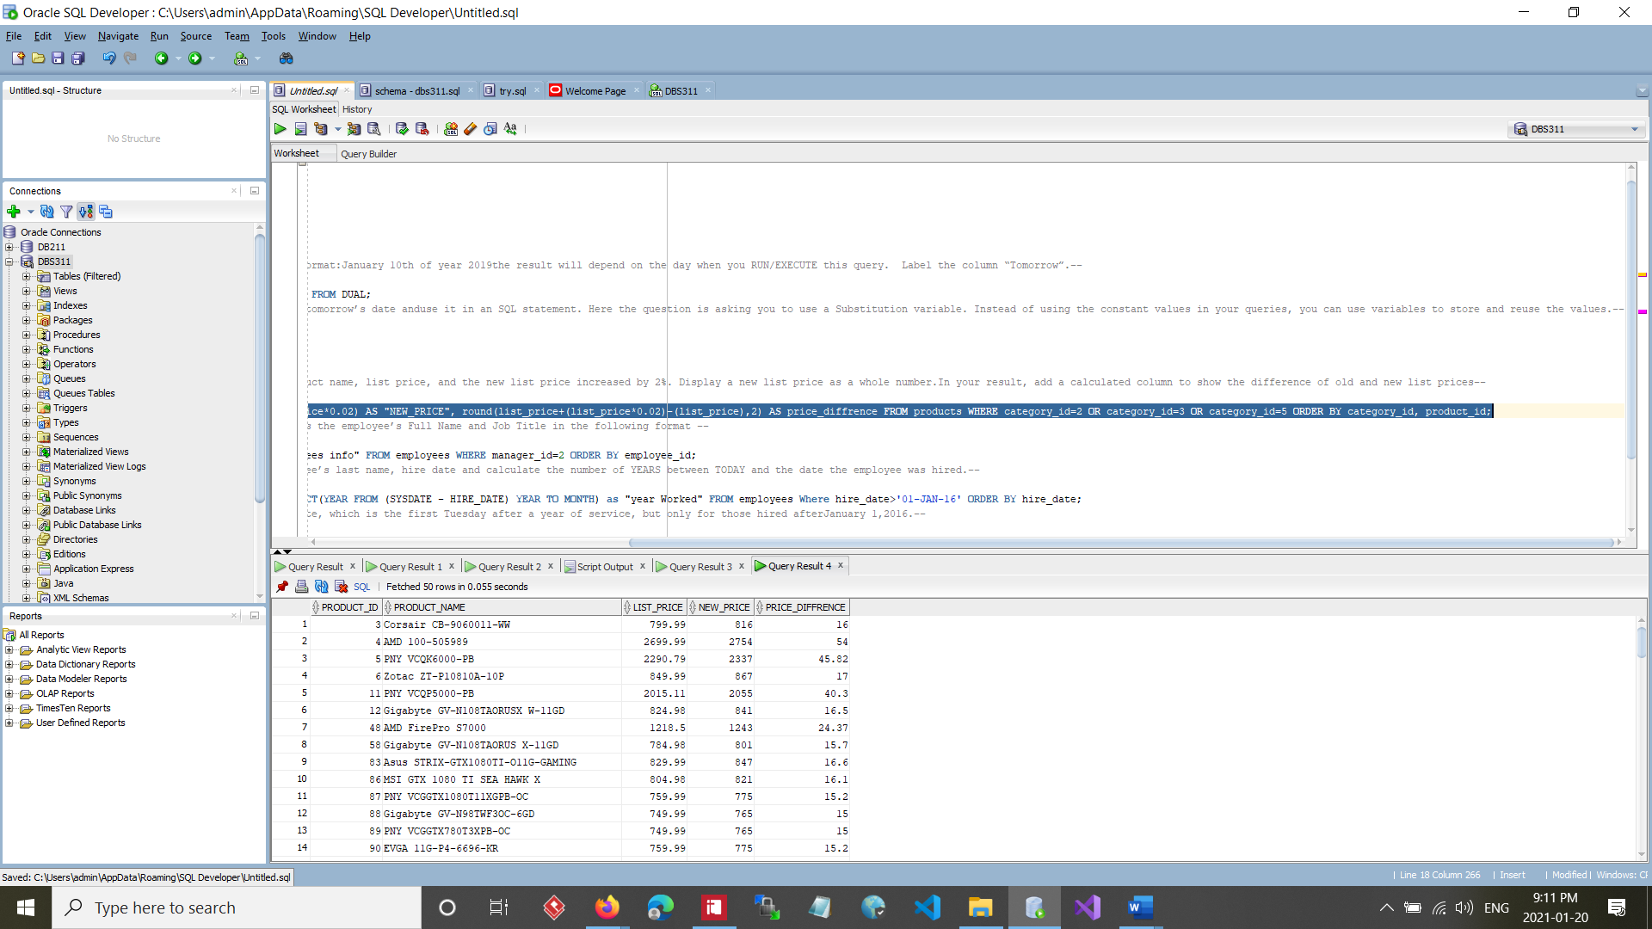

--Q4 For employees whose manager ID is 2, write a query that displays the employee’s Full Name and Job Title in the following format --

--Q4 Answer--

SELECT (last_name||','||first_name||' is '||job_title) AS "employees info" FROM employees WHERE manager_id=2 ORDER BY employee_id;

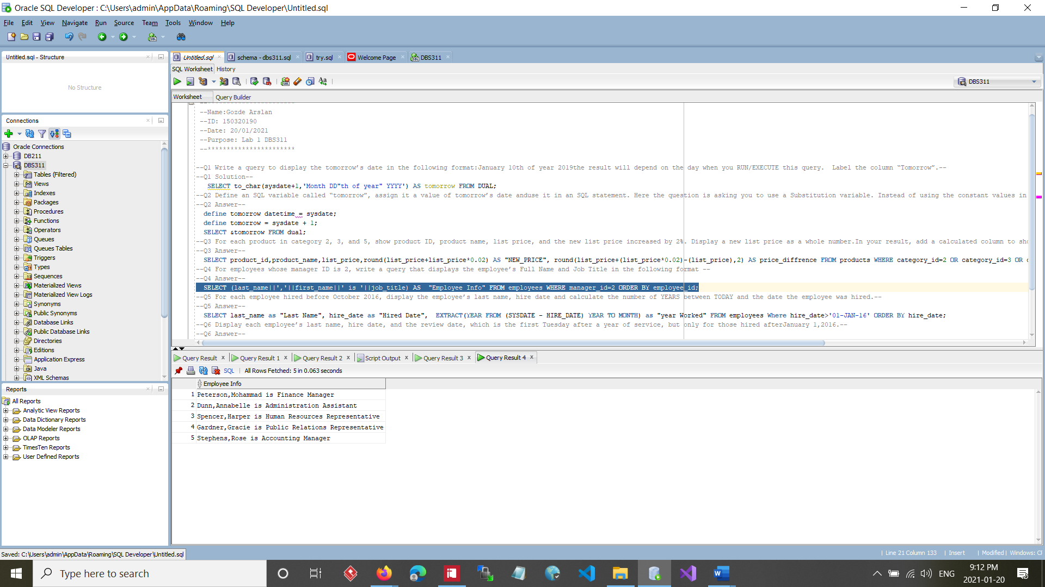

--Q5 For each employee hired before October 2016, display the employee’s last name, hire date and calculate the number of YEARS between TODAY and the date the employee was hired.--

--Q5 Answer--

SELECT last_name as "Last Name", hire_date as "Hired Date", EXTRACT(YEAR FROM (SYSDATE - HIRE_DATE) YEAR TO MONTH) as "year Worked" FROM employees Where hire_date>'01-JAN-16' ORDER BY hire_date;

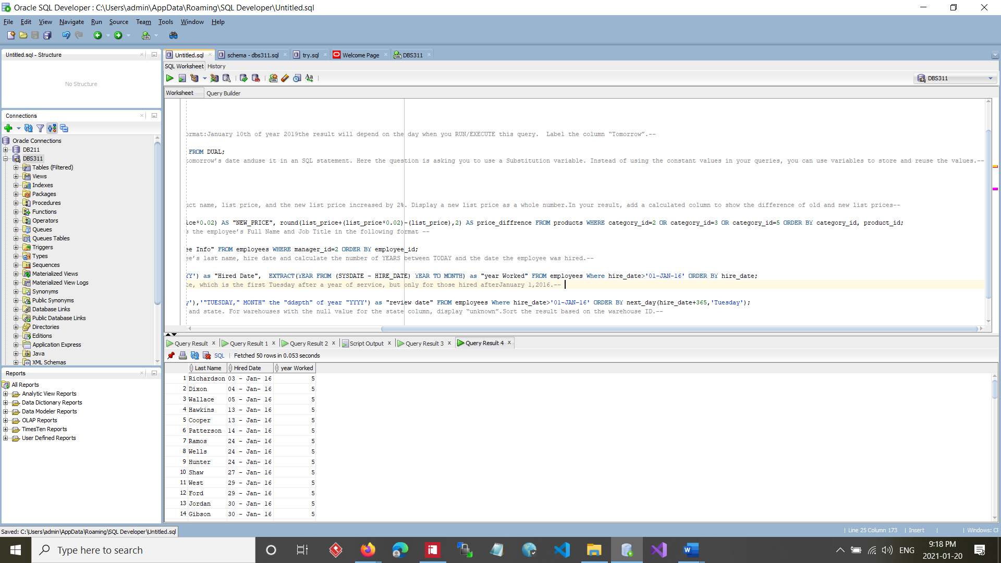

--Q6 Display each employee’s last name, hire date, and the review date, which is the first Tuesday after a year of service, but only for those hired afterJanuary 1,2016.--

--Q6 Answer--

SELECT last_name,hire_date, to_char(next_day(hire_date+366,'tuesday'),'"TUESDAY," MONTH" the "ddspth" of year "YYYY') as "review date" FROM employees Where hire_date>'01-JAN-16' ORDER BY next_day(hire_date+365,'Tuesday');

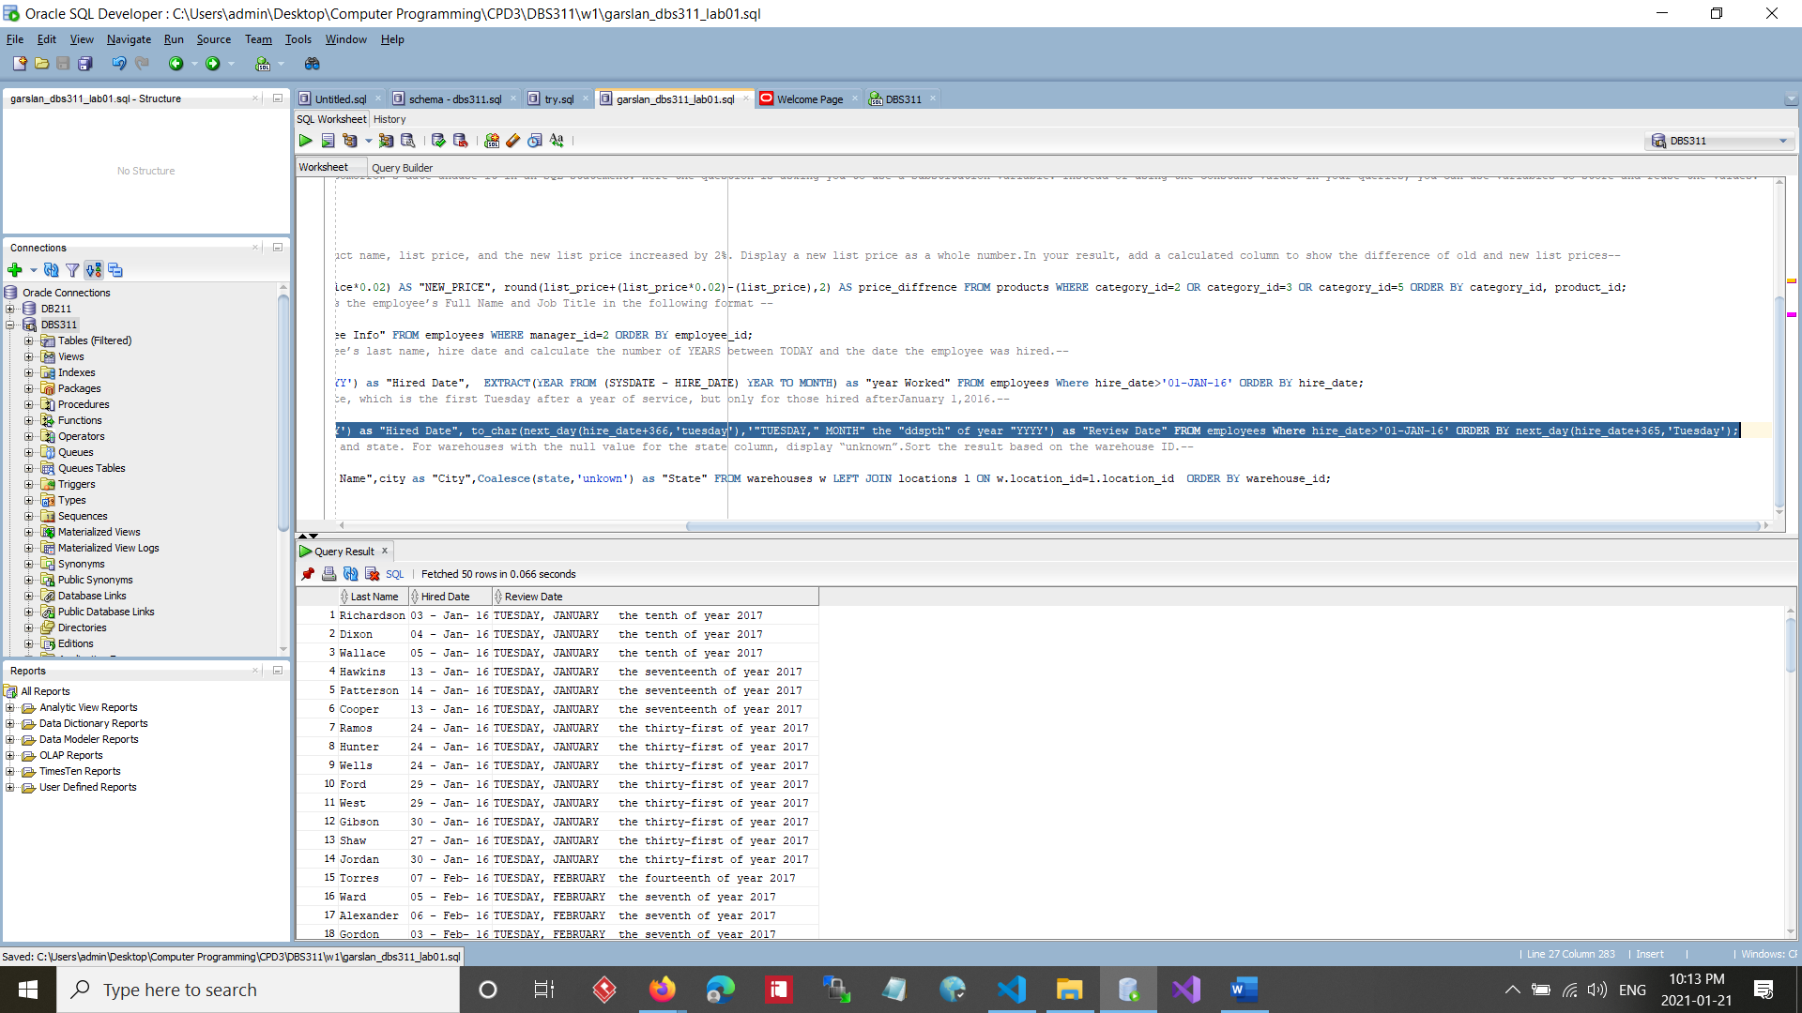

--Q7 For all warehouses, display warehouse id, warehouse name, city, and state. For warehouses with the null value for the state column, display “unknown”.Sort the result based on the warehouse ID.--

--Q7 Answer--

SELECT warehouse_id as "Warehouse ID" ,warehouse_name as "Warehouse Name",city as "City",Coalesce(state,'unkown') as "State" FROM warehouses w LEFT JOIN locations l ON w.location_id=l.location_id ORDER BY warehouse_id;

