--***********************

--Name:Gozde Arslan

--ID: 150320190

--Date: 28/01/2021

--Purpose: Lab 2 DBS311

--***********************

--Q1 For each job title display the number of employees. Sort the result according to the number of employees .--

--Q1 Solution--

SELECT

job_title,

COUNT(job_title) AS "EMPLOYEES"

FROM

employees

GROUP BY

job_title

ORDER BY

"EMPLOYEES" ;

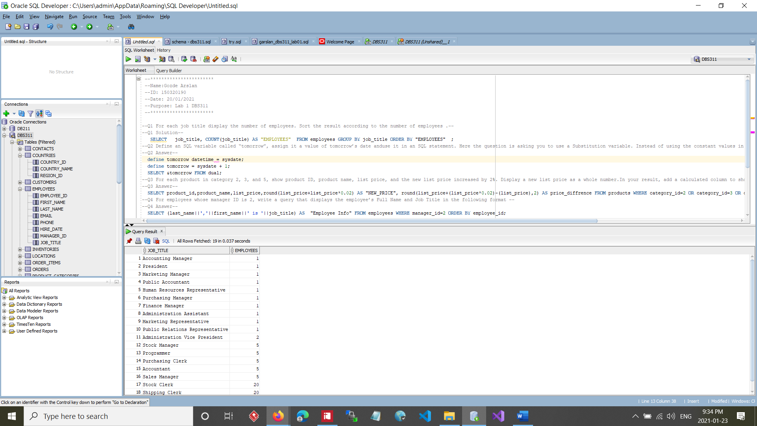

--Q2 Display the highest, lowest,and average customer credit limits. Name these results high, low,and average.Add a column that shows the difference between the highest andthelowest credit limitsnamed “High and Low Difference”.Roundthe average to 2 decimal places.--

--Q2 Answer--

SELECT

MAX(credit_limit) AS HIGHEST,

MIN(credit_limit) AS LOWEST,

round(AVG(credit_limit), 2 ) AS AVERAGE,

(

MAX(credit_limit) - MIN(credit_limit)

)

AS "HIGH TO LOW DIFFRENCE"

FROM

customers;

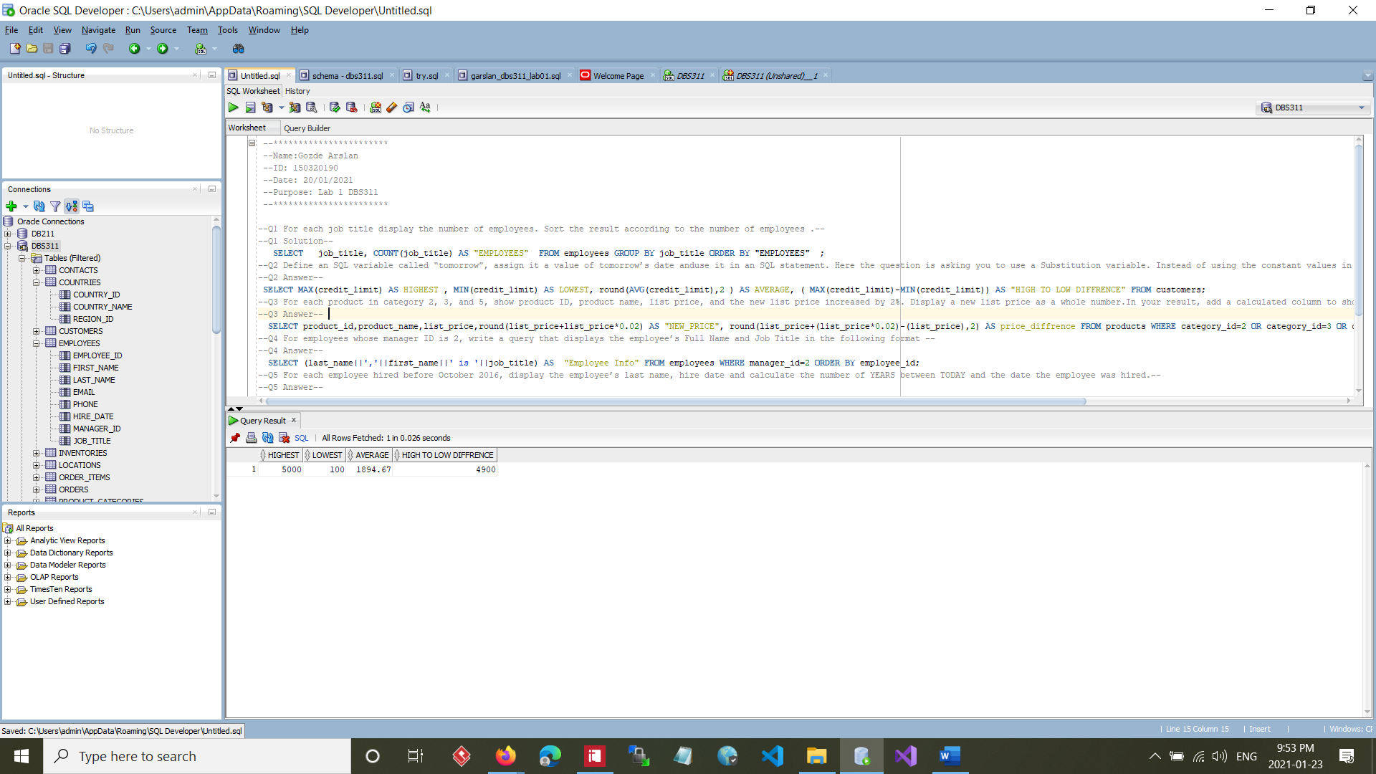

--Q3 Display the order id, the total number of products, andthe total order amount fororders with the total amountover $1,000,000. Sort the result based on total amount fromthehigh to low values--

--Q3 Answer--

SELECT

order_id,

SUM(quantity) AS "TOTAL_ITEMS",

SUM(quantity*unit_price) AS "TOTAL_AMOUNT"

FROM

order_items

GROUP BY

order_id

HAVING

SUM(quantity*unit_price) > 1000000

ORDER BY

"TOTAL_AMOUNT" DESC;

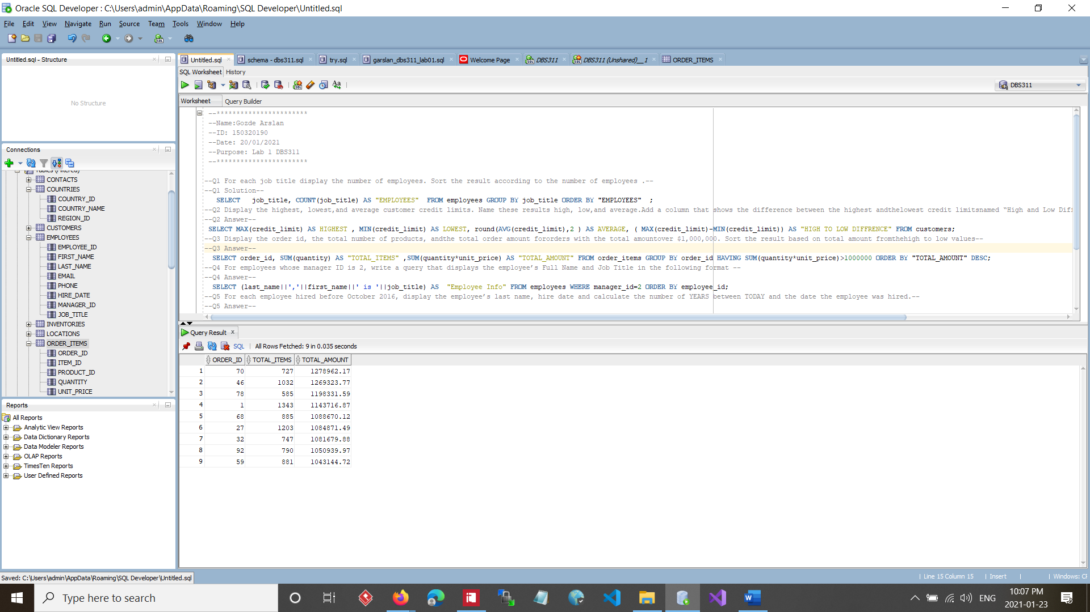

--Q4 Display the warehouse id, warehouse name, and the total number of products for each warehouse. Sort the result according to the warehouse ID --

--Q4 Answer--

SELECT

wh.warehouse_id,

wh.warehouse_name,

SUM(i.quantity) AS total_products

from

warehouses wh

JOIN

inventories i

ON wh.warehouse_id = i.warehouse_id

GROUP BY

wh.warehouse_id,

wh.warehouse_name

ORDER BY

wh.warehouse_id ;

--Q5 For each customer

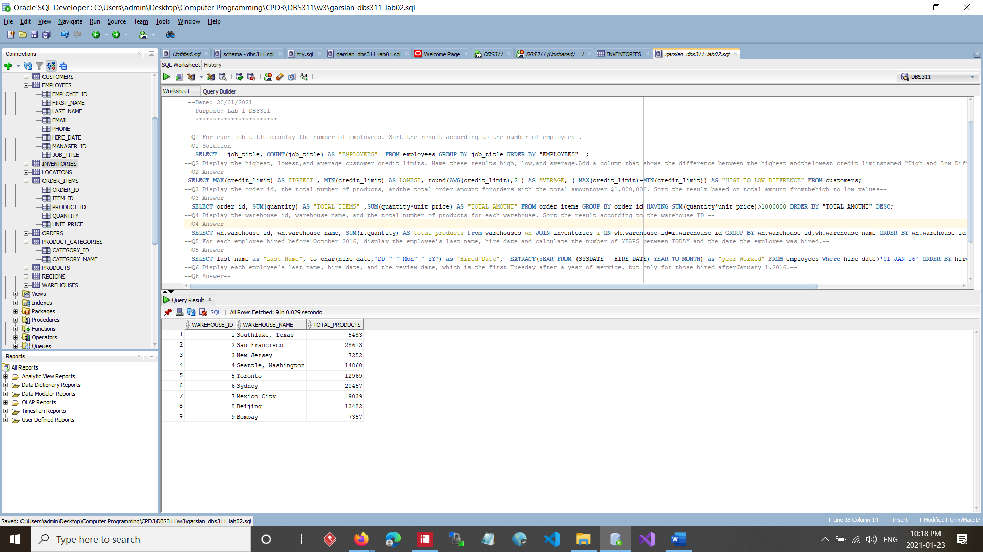

--Q5 For each customer display customer number, customer full name, and the total number of orders issued by the customer.

-- ▪If the customer does not have any orders, the result shows0.--

--▪Display only customers whose customer name starts with ‘O’ and contains‘e’.--

--▪Include also customers whose customer name ends with ‘t’.▪Show the customers with highest number of ordersfirst.--

--Q5 Answer--

SELECT

c.customer_id,

c.name AS "customer name",

COALESCE(COUNT(o.order_id), 0) AS "total number OF orders"

FROM

customers c

FULL JOIN

orders o

ON c.customer_id = o.customer_id

WHERE

UPPER(name) LIKE 'O%'

AND LOWER(name) LIKE '%e%'

OR LOWER(name) LIKE '%t'

AND NOT UPPER(name) LIKE '%&%'

GROUP BY

c.customer_id,

c.name

ORDER BY

"total number OF orders" DESC;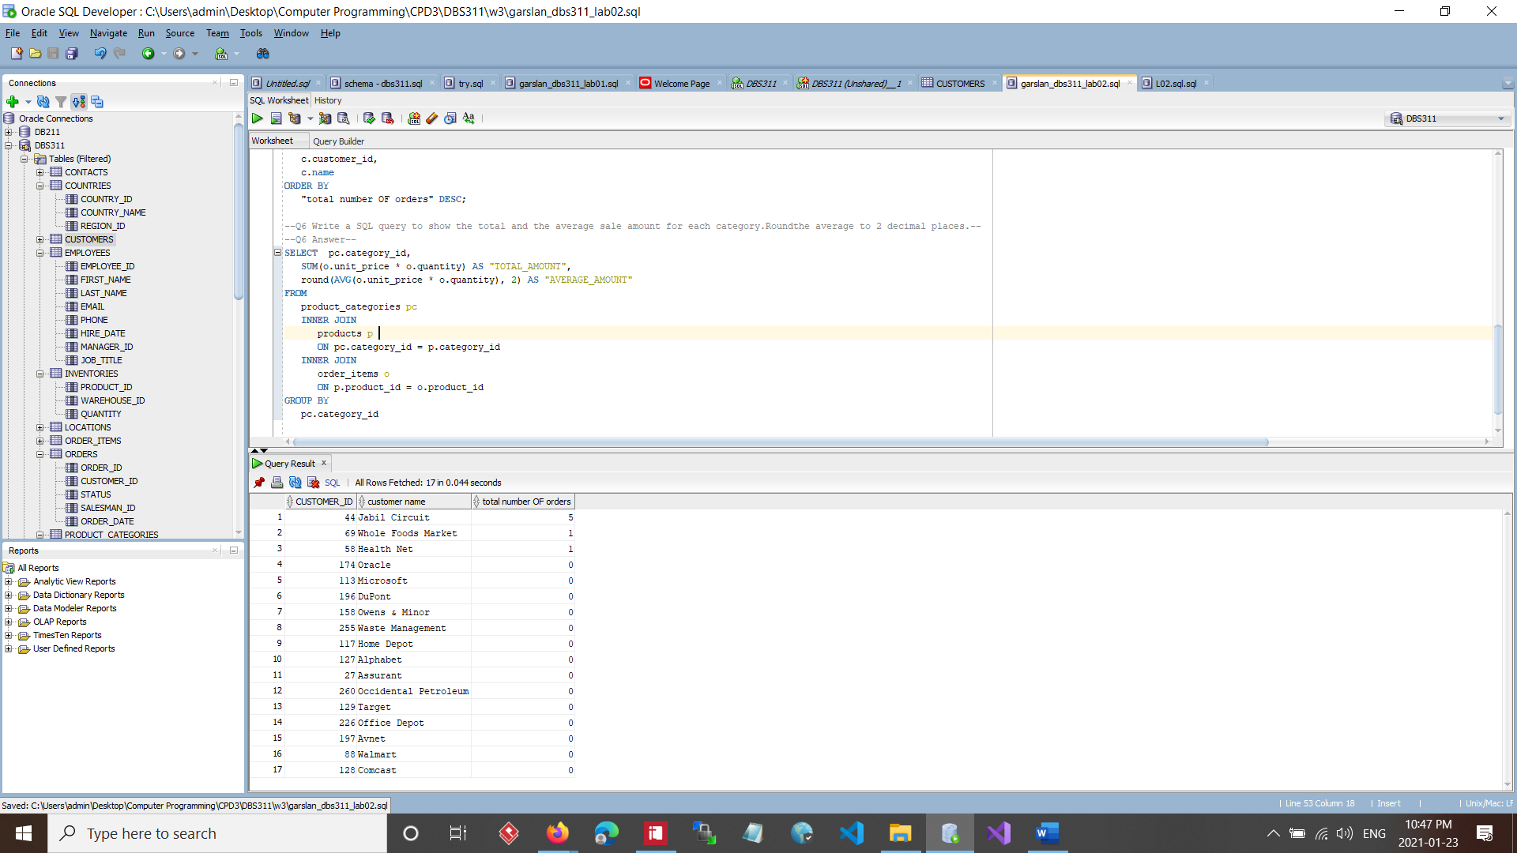

--Q6 Write a SQL query to show the total and the average sale amount for each category.Roundthe average to 2 decimal places.--

--Q6 Answer--

SELECT

pc.category_id,

SUM(o.unit_price * o.quantity) AS "TOTAL_AMOUNT",

round(AVG(o.unit_price * o.quantity), 2) AS "AVERAGE_AMOUNT"

FROM

product_categories pc

INNER JOIN

products p

ON pc.category_id = p.category_id

INNER JOIN

order_items o

ON p.product_id = o.product_id

GROUP BY

pc.category_id ;

