--***********************

--Name:Gozde Arslan

--ID: 150320190

--Date: 12/02/2021

--Purpose: Lab 4 DBS311

--***********************

--Q1 Display cities that no warehouse is located in them. (use set operators to answer this question).--

--Q1 Solution--

SELECT

city

FROM

locations MINUS

SELECT

l.city

FROM

locations l,

warehouses w

WHERE

l.location_id = w.location_id; 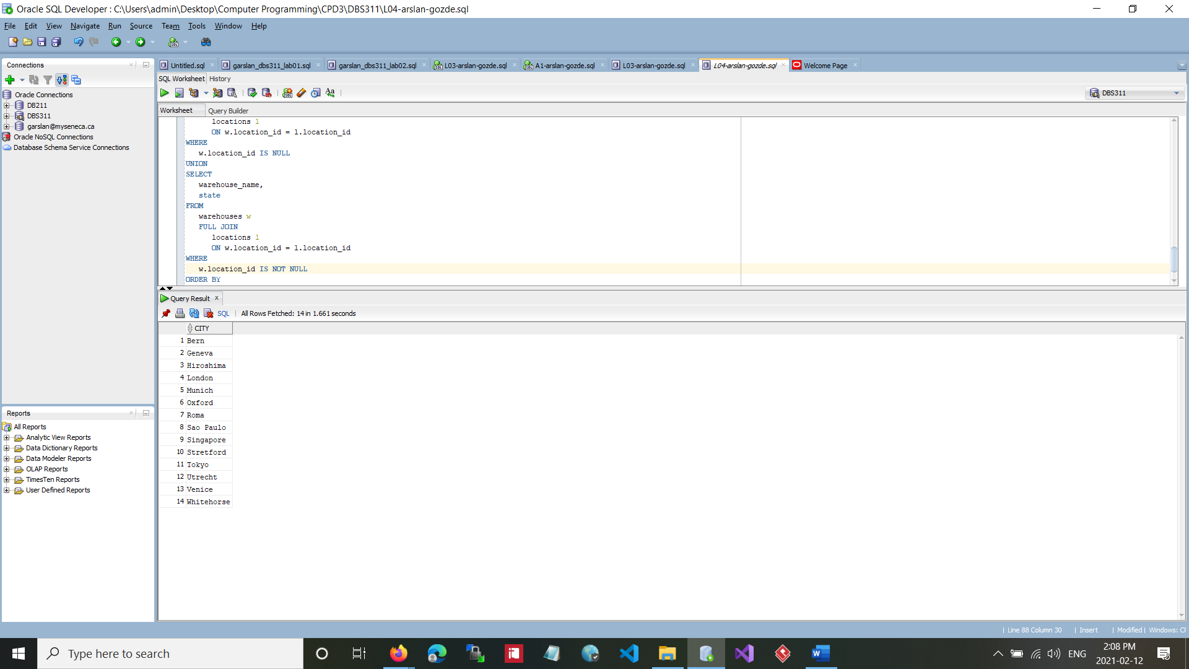

--Q2 Display the category ID, category name,and the number of products in category1, 2, and 5. In your result, display first the number of products in category 5, then category 1 and then 2.--

--Q2 Answer--

SELECT

pc.category_id,

pc.category_name,

COUNT(product_id)

FROM

product_categories pc

JOIN

products p

ON pc.category_id = p.category_id

WHERE

p.category_id = 5

GROUP BY

pc.category_id,

pc.category_name

UNION ALL

SELECT

pc.category_id,

pc.category_name,

COUNT(product_id)

FROM

product_categories pc

JOIN

products p

ON pc.category_id = p.category_id

WHERE

p.category_id = 1

GROUP BY

pc.category_id,

pc.category_name

UNION ALL

SELECT

pc.category_id,

pc.category_name,

COUNT(product_id)

FROM

product_categories pc

JOIN

products p

ON pc.category_id = p.category_id

WHERE

p.category_id = 2

GROUP BY

pc.category_id,

pc.category_name ;

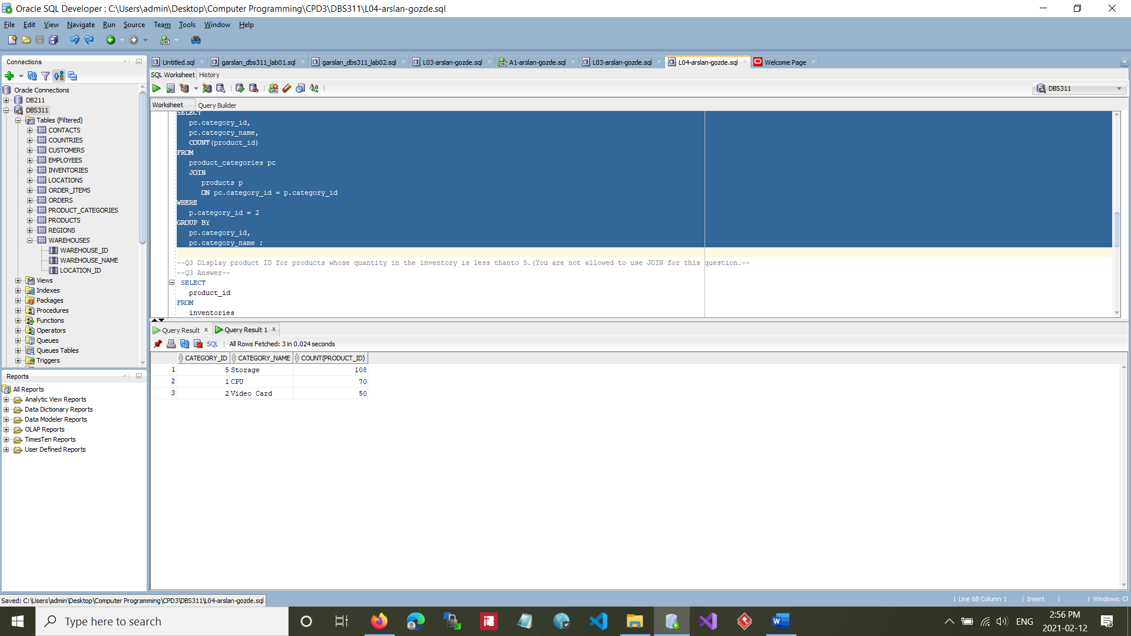

--Q3 Display product ID for products whose quantity in the inventory is less thanto 5.(You are not allowed to use JOIN for this question.--

--Q3 Answer--

SELECT

product_id

FROM

inventories

WHERE

quantity < 5

UNION

SELECT

product_id

FROM

inventories

WHERE

quantity < 5;

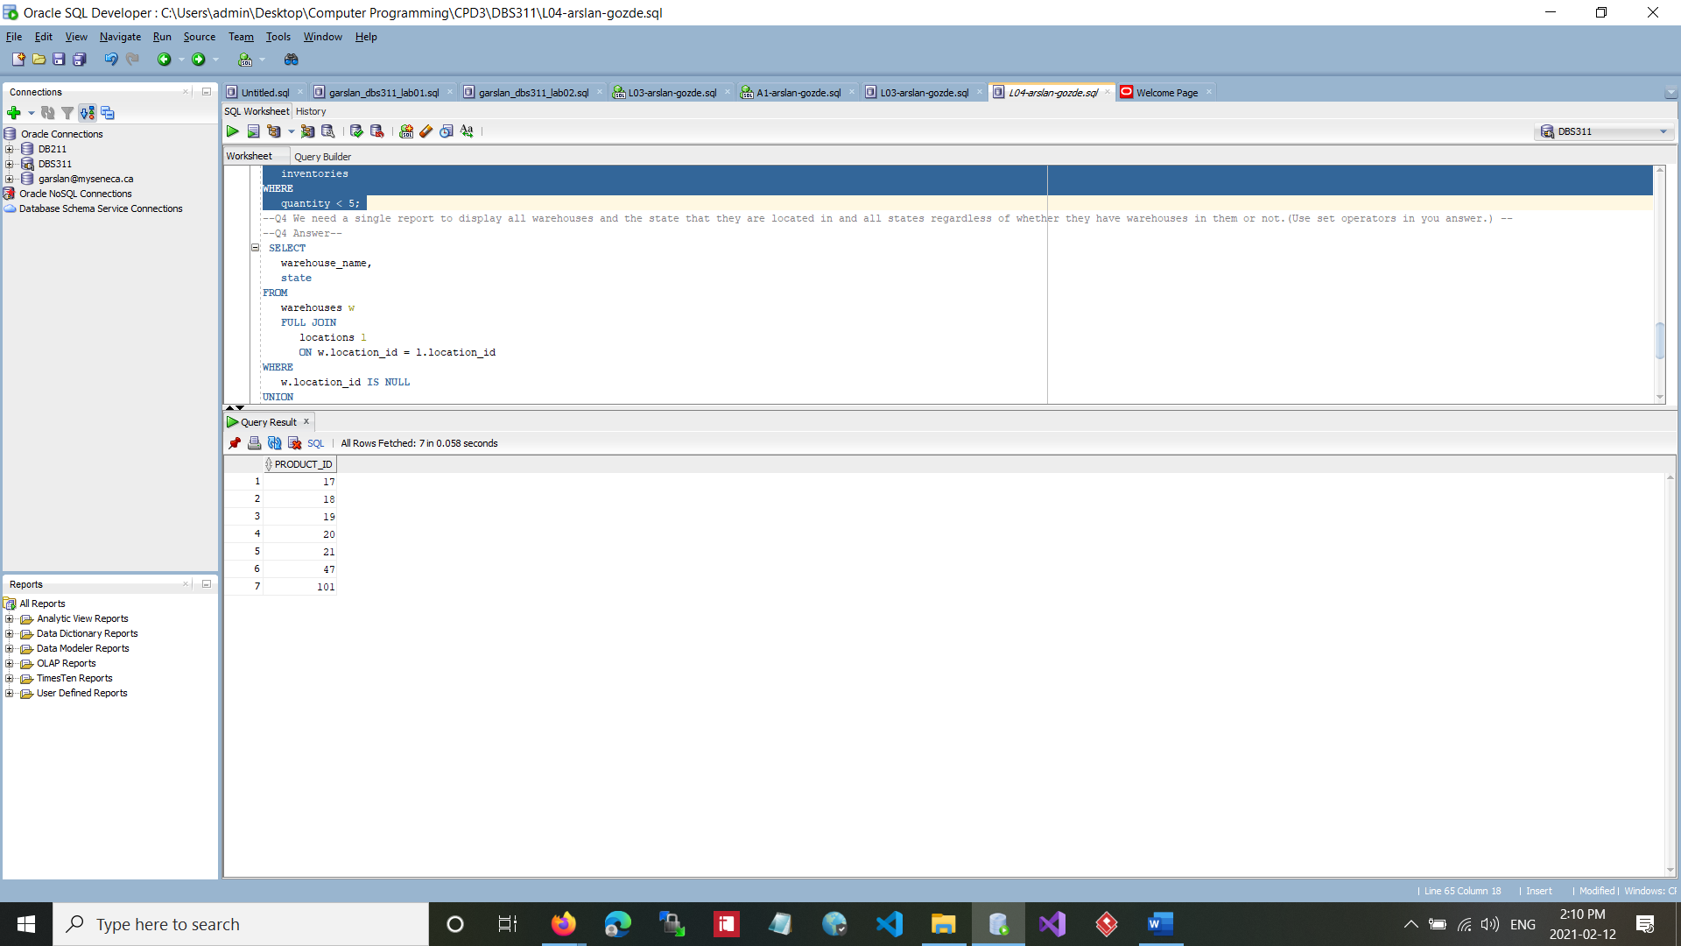

--Q4 We need a single report to display all warehouses and the state that they are located in and all states regardless of whether they have warehouses in them or not.(Use set operators in you answer.) --

--Q4 Answer--

SELECT

warehouse_name,

state

FROM

warehouses w

FULL JOIN

locations l

ON w.location_id = l.location_id

WHERE

w.location_id IS NULL

UNION

SELECT

warehouse_name,

state

FROM

warehouses w

FULL JOIN

locations l

ON w.location_id = l.location_id

WHERE

w.location_id IS NOT NULL

ORDER BY

warehouse_name,

state;

