--***********************

--Name:Gozde Arslan

--ID: 150320190

--Date: 19/02/2021

--Purpose: Lab 5 DBS311

--***********************

SET SERVEROUTPUT ON

-- Q1. Write a store procedure that get an integer number and prints The number is even.

-- If a number is divisible by 2. Otherwise, it prints The number is odd.

CREATE

OR replace PROCEDURE findevenodd(x IN number) IS

BEGIN

IF MOD(x, 2) = 0

THEN

dbms_output.put_line( ' The number is even ');

ELSE

dbms_output.put_line('The number is odd ');

END

IF;

END

;

/

BEGIN

findevenodd(10) ;

END

;

/

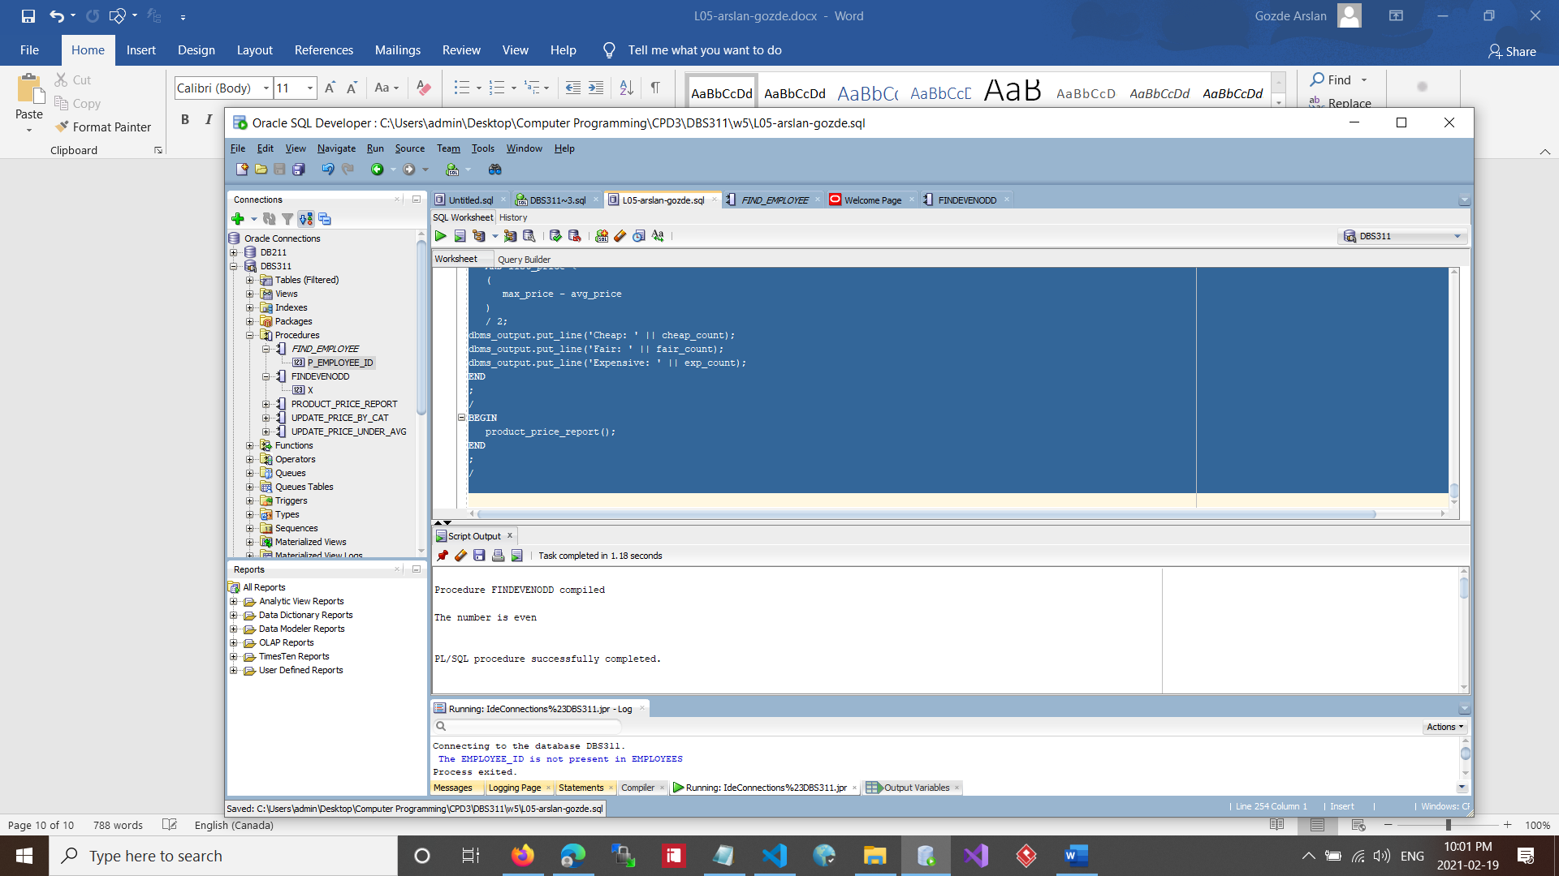

-- Q2. Create a stored procedure named find_employee. This procedure gets an employee number and prints the following

-- employee information: First name Last name Email Phone Hire date Job title

CREATE

OR replace PROCEDURE find_employee(p_employee_id IN number) AS v_count number;

v_first_name employees.first_name % type;

v_last_name employees.last_name % type;

v_email employees.email % type;

v_phone employees.phone % type;

v_hire_date employees.hire_date % type;

v_job_title employees.job_title % type;

BEGIN

SELECT

COUNT(employee_id) INTO v_count

FROM

employees

WHERE

employee_id = p_employee_id;

IF v_count = 0

THEN

dbms_output.put_line( ' The EMPLOYEE_ID is not present in EMPLOYEES ');

ELSE

SELECT

first_name,

last_name,

email,

phone,

hire_date,

job_title INTO v_first_name,

v_last_name,

v_email,

v_phone,

v_hire_date,

v_job_title

FROM

employees

WHERE

employee_id = p_employee_id;

dbms_output.put_line('FIRST_NAME : ' || v_first_name);

dbms_output.put_line('LAST_NAMENAME: ' || v_last_name);

dbms_output.put_line('EMAIL: ' || v_email);

dbms_output.put_line('PHONE: ' || v_phone);

dbms_output.put_line('HIRE_DATE: ' || v_hire_date);

dbms_output.put_line('JOB_TITLE: ' || v_job_title);

END

IF;

exception

WHEN

no_data_found

THEN

dbms_output.put_line('Employee not found.');

WHEN

others

THEN

dbms_output.put_line('Stored PROCEDURE has errors. Please take a look');

END

;

---------------------

/

BEGIN

find_employee(107);

END

;

/

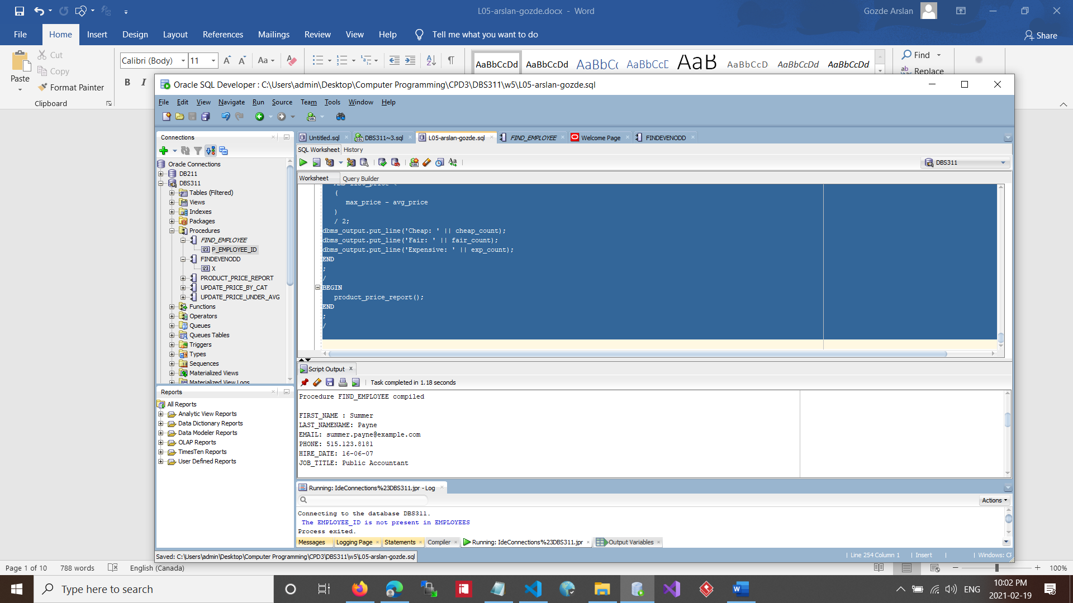

-- Q3.Every year, the company increasesthe price of all products in one category. For example,

--the company wants to increase the price(list_price)of products in category 1 by $5.

--Write a procedure named update_price_by_catto update the price of all products ina given category and the given amount to be added to the current priceif the price is greater than 0.

--The procedure shows the number of updated rows if the update is successful--

CREATE

OR replace PROCEDURE update_price_by_cat(p_category_id IN products.category_id % type, p_amount IN products.list_price % type) AS v_count number;

BEGIN

SELECT

COUNT(category_id) INTO v_count

FROM

products

WHERE

category_id = p_category_id;

IF (p_amount > 0

AND v_count > 0)

THEN

UPDATE

products

SET

list_price = list_price + p_amount

WHERE

category_id = p_category_id;

dbms_output.put_line('Rows Updated =' || SQL % rowcount);

ELSE

dbms_output.put_line('Either there are no CATEGORY matching or the input price is lesser than zero');

END

IF;

exception

WHEN

no_data_found

THEN

dbms_output.put_line('PRODUCTS not found.');

WHEN

others

THEN

dbms_output.put_line('Stored PROCEDURE has errors.');

END

;

----------

DECLARE p_category_id number : = 1;

p_amount number : = 11.11;

BEGIN

update_price_by_cat(p_category_id , p_amount );

END

;

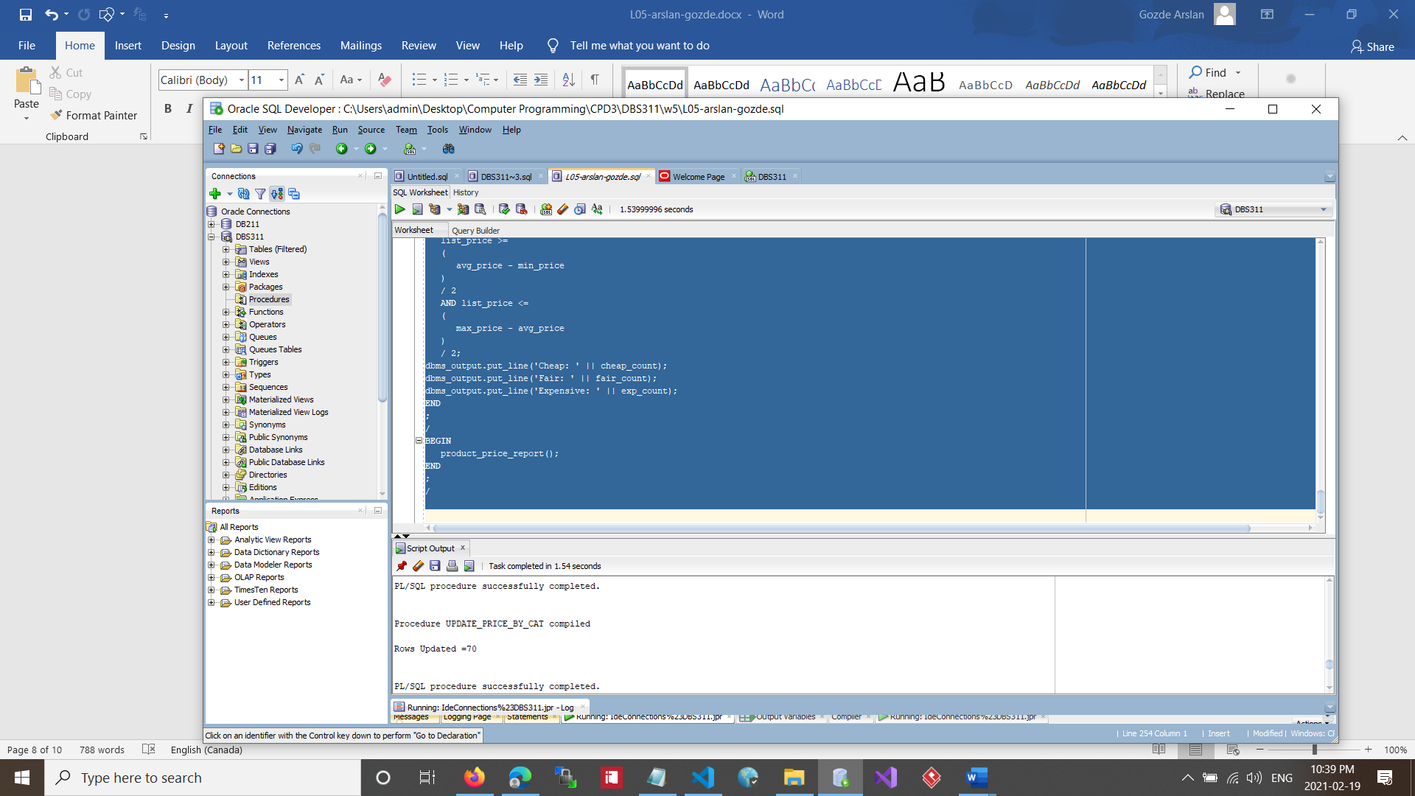

-- Q4. Every year, the company increase the price of products whose price is less than the average price of all products by 1%.

--(list_price * 1.01). Write a stored procedure named update_price_under_avg. This procedure do not have any parameters.

--You need to find the average price of all products and store it into a variable of the same type.

--If the average price is less than or equal to $1000, update products’ priceby 2% if the price of the product is less than the calculated average.

--If the average price is greater than $1000, update products’ price by 1% if the price of the product is less than the calculatedaverage.

--The query displays an error message if any error occurs. Otherwise, it displays the number of updated rows.--

CREATE

or replace PROCEDURE update_price_under_avg AS

v_avg products.list_price%TYPE;

v_rate number;

BEGIN

select avg(LIST_PRICE) into v_avg from products ;

if v_avg >= 1000 THEN

v_rate := 1.02;

ELSE

v_rate :=1.01;

end if;

update products set LIST_PRICE = LIST_PRICE * v_rate where LIST_PRICE <= v_avg;

DBMS_OUTPUT.PUT_LINE('Rows Updated =' || SQL%ROWCOUNT);

EXCEPTION

WHEN NO_DATA_FOUND THEN

DBMS_OUTPUT.PUT_LINE('PRODUCTS not found.');

WHEN OTHERS THEN

DBMS_OUTPUT.PUT_LINE('Stored PROCEDURE has errors. Please take a look');

end;

--------------

/

BEGIN

update_price_under_avg;

END;

/

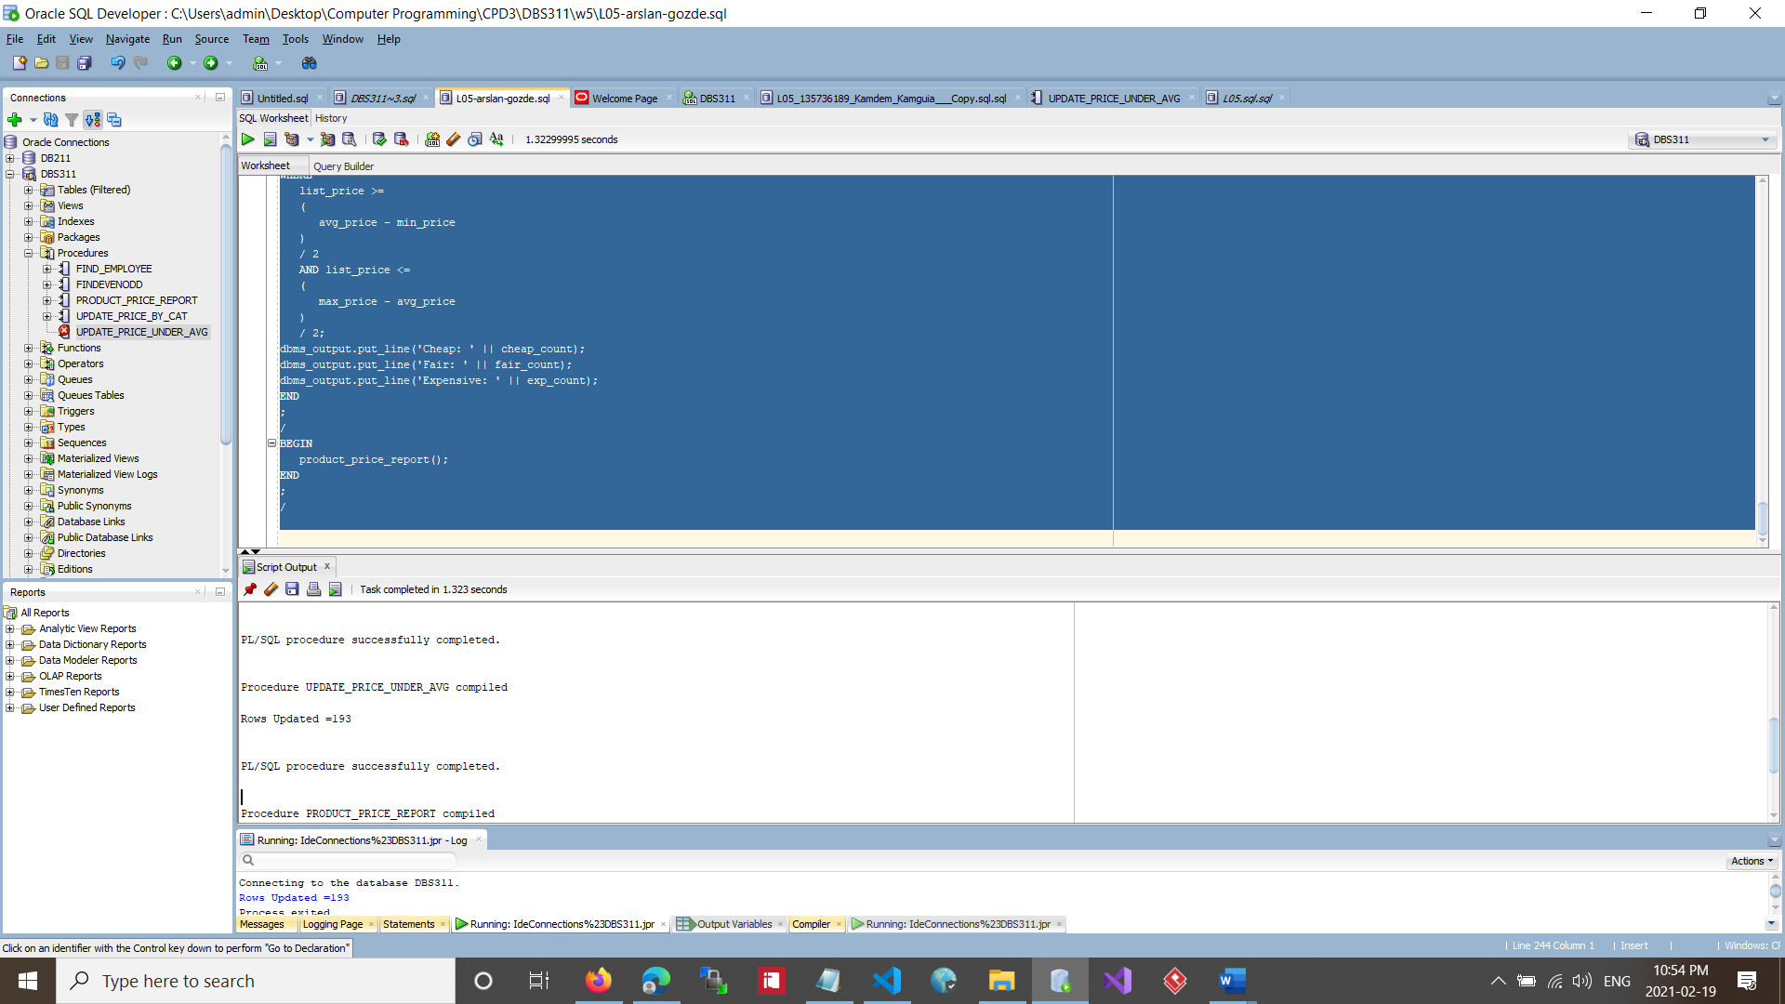

-- Q5. The company needs a report that shows three category of products basedtheir prices. The company needsto know if the product price is cheap, fair, or expensive.

CREATE

OR replace PROCEDURE product_price_report AS avg_price number;

min_price number;

max_price number;

cheap_count number;

fair_count number;

exp_count number;

BEGIN

SELECT

AVG(list_price),

MAX(list_price),

MIN(list_price) INTO avg_price,

max_price,

min_price

FROM

products;

SELECT

COUNT(list_price) INTO cheap_count

FROM

products

WHERE

list_price < (avg_price - min_price) / 2;

SELECT

COUNT(list_price) INTO exp_count

FROM

products

WHERE

list_price > (max_price - avg_price) / 2;

SELECT

COUNT(list_price) INTO fair_count

FROM

products

WHERE

list_price >=

(

avg_price - min_price

)

/ 2

AND list_price <=

(

max_price - avg_price

)

/ 2;

dbms_output.put_line('Cheap: ' || cheap_count);

dbms_output.put_line('Fair: ' || fair_count);

dbms_output.put_line('Expensive: ' || exp_count);

END

;

/

BEGIN

product_price_report();

END

;

/

