Lab 7 – MongoDB – Create/Delete Database/Collection/Documents

--***********************

--Name: Gozde Arslan

--ID: 150320190

--Date: 18/03/2021

--Purpose: Lab 7 DBS311

--***********************

# Tasks

1. In this question you create a new database named *seneca* and a collection *student*. We store student data in this collection.
   * use seneca

This command makes “seneca” your current database. However, the database will not be created until you insert a document into this database.

db.collection_name.insertOne({})

Insert a new document into your collection *student* with the following data: first_name: Sarah

last_name: Stone

email: [s_stone@email.com](mailto:s_stone@email.com) city: Toronto

status: full-time gpa: 3.4 program: CPA

**Solution 1:**

db.student.insertOne({"first_name" : "Sarah", "last_name" : "Stone", "email" : "s_stone@email.com", "city" : "Toronto", "status" : "full-time", "gpa" : "3.4", "program" : "CPA"})

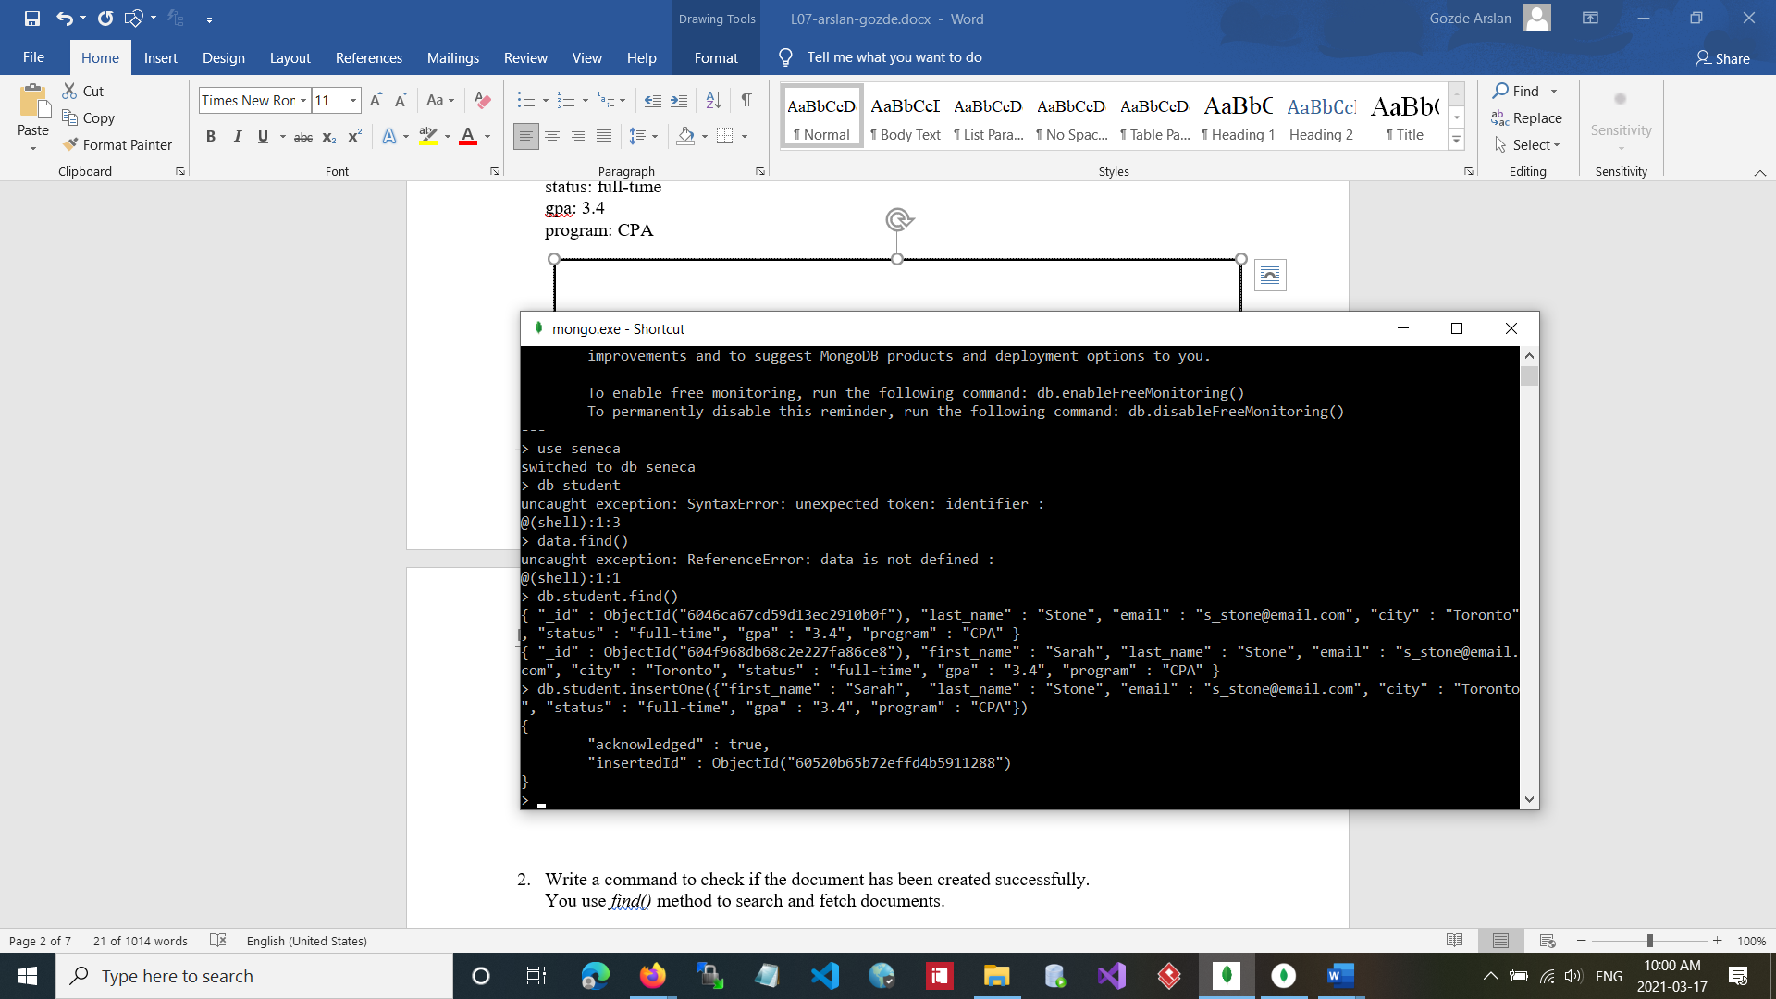

1. Write a command to check if the document has been created successfully. You use *find()* method to search and fetch documents.

See the following example:

* + db.student.find()

**Solution 2:**

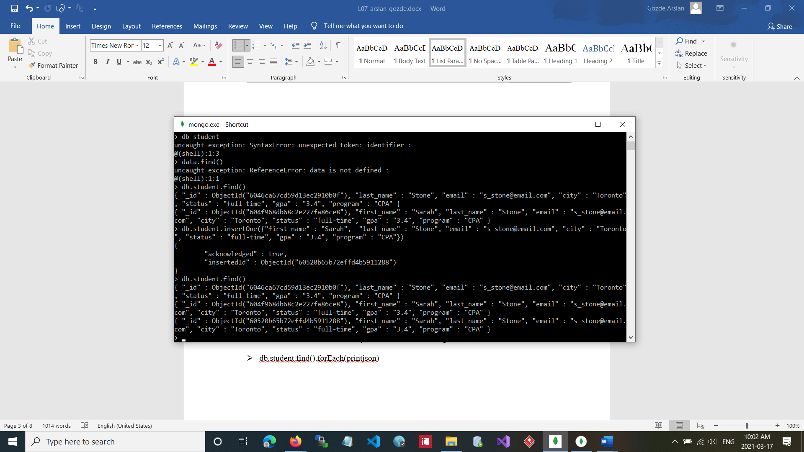

To see the result in *JSON* format, you can run the following statement:

* + db.student.find().forEach(printjson)

{

"_id" : 3,

"name" : "Bao Ziglar", "scores" : [

{

"score" : 71.64343899778332,

"type" : "exam"

},

{

"score" : 24.80221293650313,

"type" : "quiz"

},

{

"score" : 42.26147058804812,

"type" : "homework"

}

]

}

{

"_id" : 6,

"name" : "Jenette Flanders", "scores" : [

{

"score" : 37.32285459166097,

"type" : "exam"

},

{

"score" : 28.32634976913737,

"type" : "quiz"

},

{

"score" : 81.57115318686338,

"type" : "homework"

}

]

}

How many fields are in your document?

There are 8 fields

Is there any new field added to your document? Yes

If yes, what is the name of the field?

id

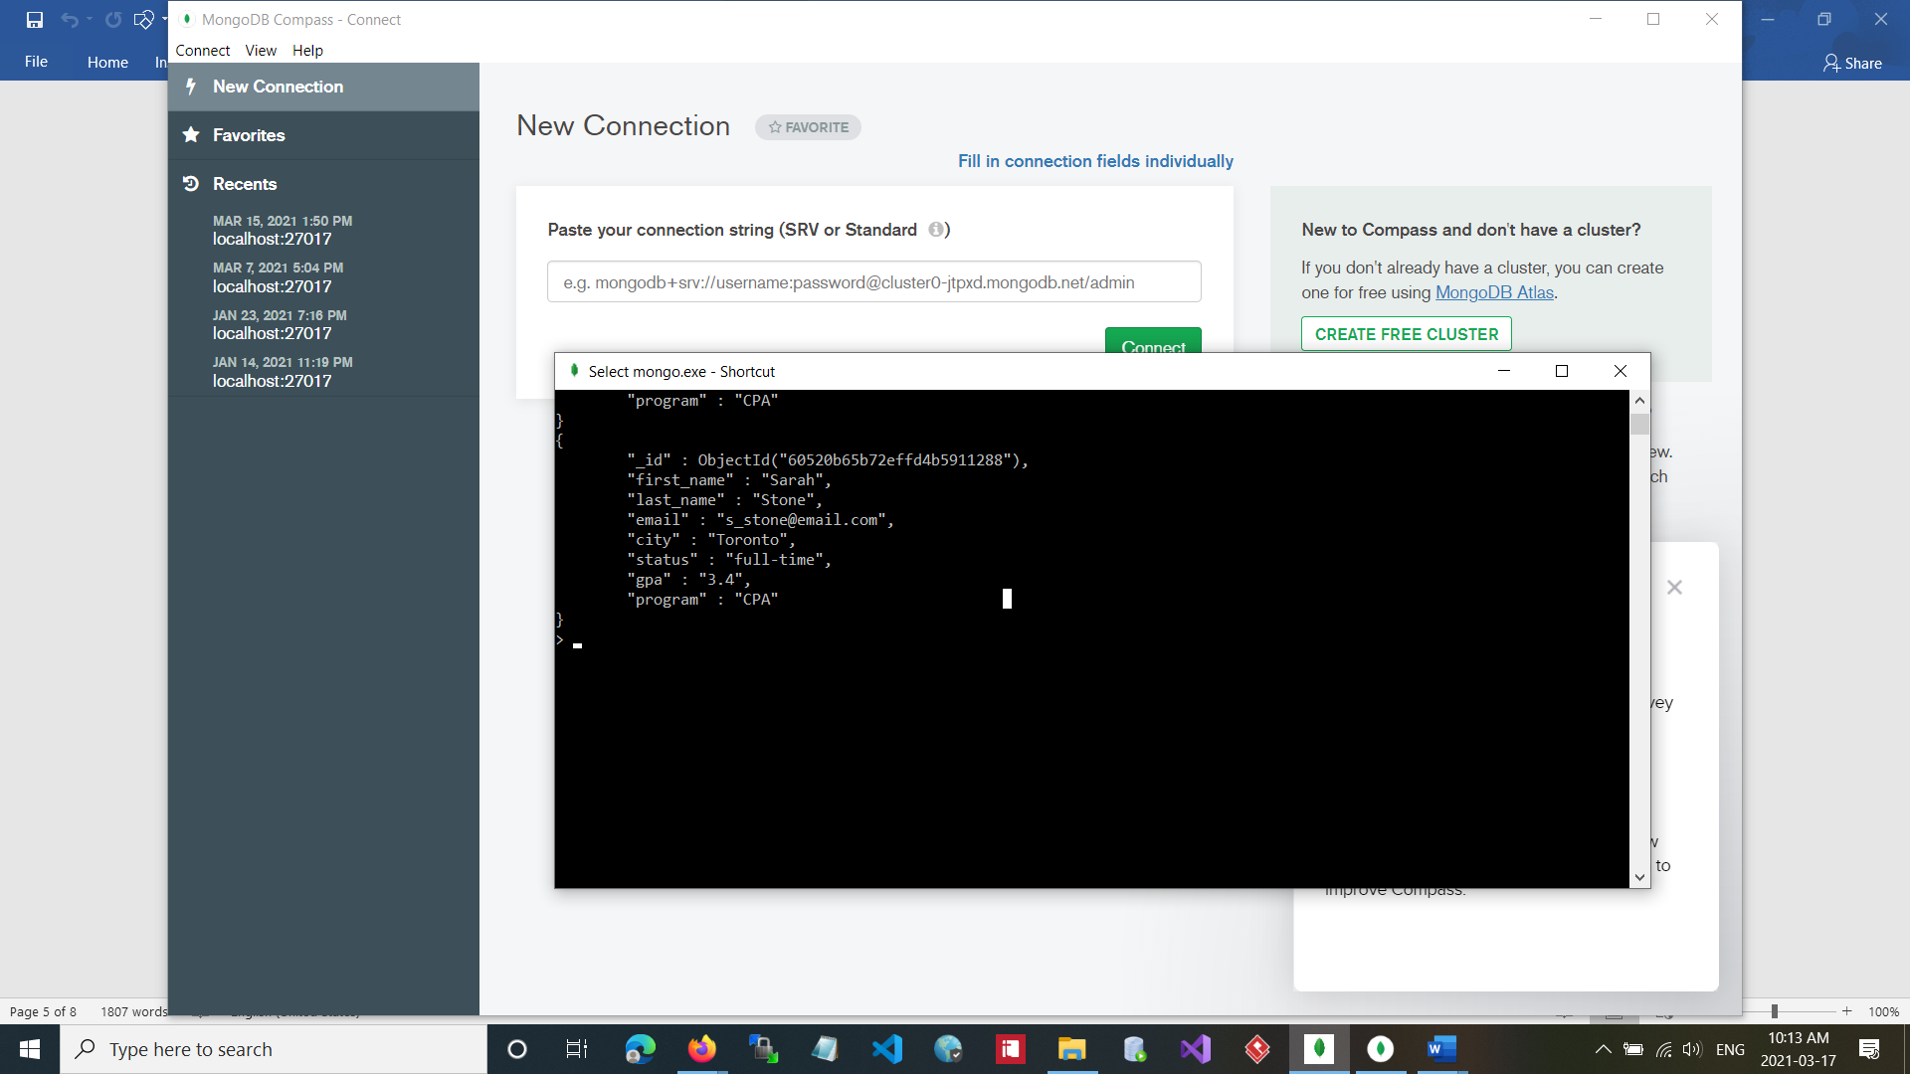

1. Write a command to remove the document that you created in Question 1. (We have only one document at this time, but when removing documents make sure you will not remove some other documents if not needed. So, make sure your command will remove “Sarah Stone” from your collection. For now, we assume that we do not have duplicate names in our database.)

**Note:** To avoid making mistakes, you can first write a find command with the proper criteria to see if the required document is fetched. Then, you can use the same criteria in your delete statement. (Write the statement to remove “Sarah Stone” from the database in the box below.)

**Solution 3:**

db.student.update({},{$unset:{first_name:1}},false,true);

db.student.update({},{$unset:{last_name:1}},false,true);

What is the message as a result of your delete statement? Copy the message in the following box:

WriteResult({ "nMatched" : 1, "nUpserted" : 0, "nModified" : 1 });

WriteResult({ "nMatched" : 1, "nUpserted" : 0, "nModified" : 1 })

To see if the document is removed successfully, write a search statement to see if the document exists. (We look for one document not all).

**db.student.find().forEach(printjson)**

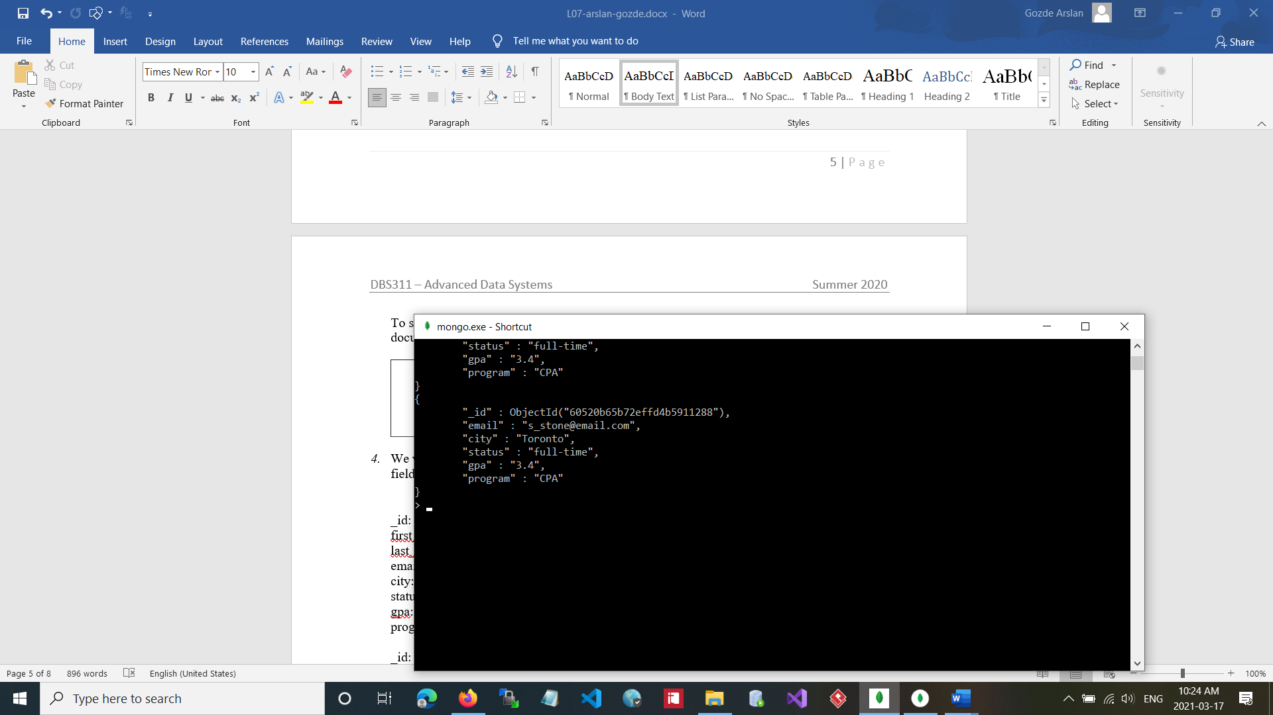

1. We want to add some students to our collection, but this time, we define the value for the *_id*

field. (If the _id is not defined in your document, it will be added automatically.)

_id: 1001 first_name: Sarah last_name: Stone

email: [s_stone@email.com](mailto:s_stone@email.com) city: Toronto

status: full-time gpa: 3.4 program: CPA

_id: 1002

first_name: Jack last_name: Adam

email: [j_adam@email.com](mailto:j_adam@email.com) city: North York

status: part-time gpa: 3.6 program: CPA

**Solution 4:**

db.student.insert({

"starray": [

{

"_id": 1001,

"first_name": "Sarah",

"last_name": "Stone",

"email": "s_stone@email.com",

"city": "Toronto",

"status": "full-time",

"gpa": "3.4",

"program": "CPA"

},

{

"_id": 1002,

"first_name": "Jack",

"last_name": "Adam",

"email": "j_adam@email.com",

"city": "North York",

"status": "part-time",

"gpa": "3.6",

"program": "CPA" }, ]})

To add these students, we want to store these documents into a variable first.

Define a variable named *starray* and add these two document to the variable. (You are storing more than one document so you need to define an array.

Now, use the *starray* array to insert the documents to your collection *student*. Write your insert statement in the box bellow.

What message is displayed after you execute the insert statement. Copy the message in the following box:

WriteResult({ "nInserted" : 1 })

Write a statement that shows all documents inserted in your collection *student*:

db.student.find().forEach(printjson)

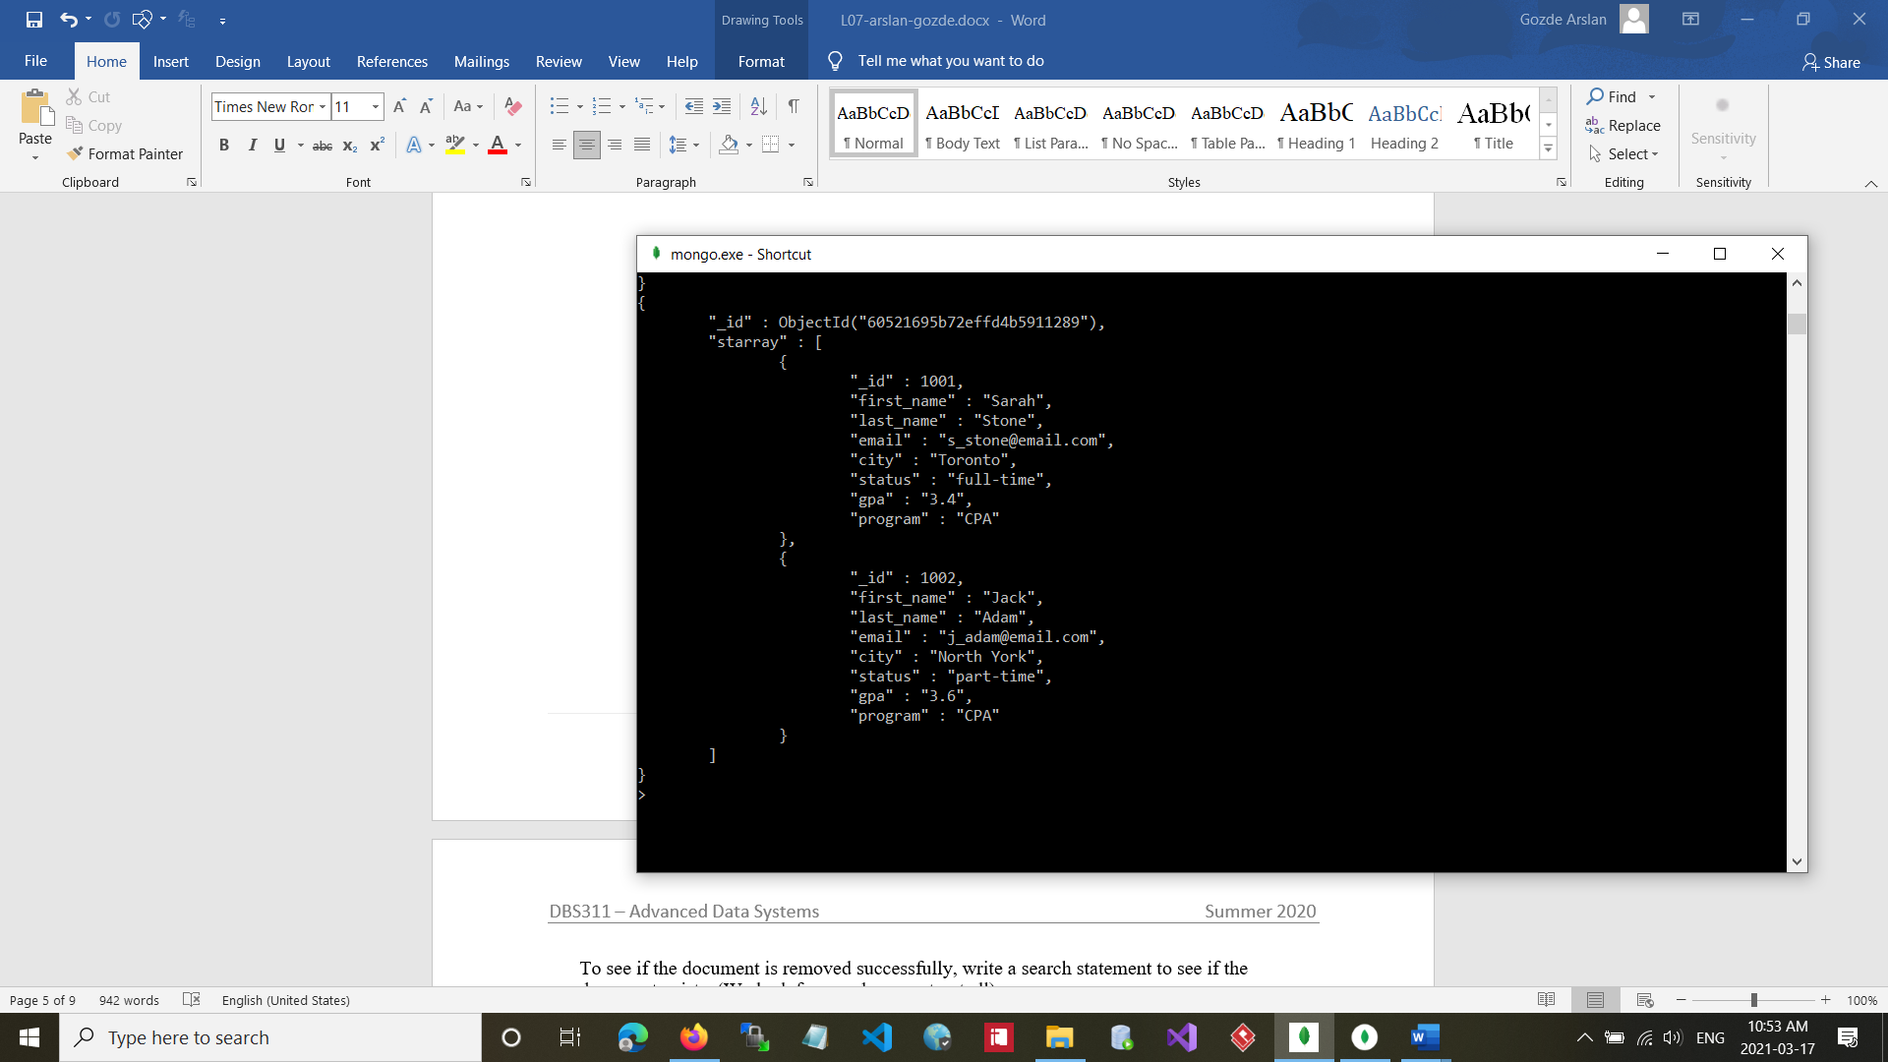

1. Write a statement to remove all documents in the *student* collection.

**Solution 5:**

db.student.remove({})

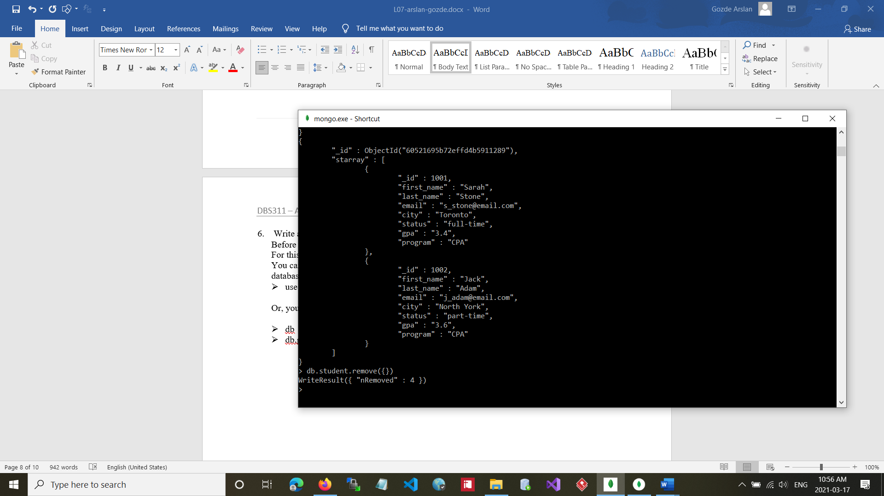

1. Write a statement to drop the database *seneca*.

db.dropDatabase()

Before dropping a database, make sure your current database is the one you want to delete. For this question, we want to delete (drop) the *seneca* database.

You can write the *use* statement before removing the database to make sure your current database is *seneca*.

* + use Seneca

Or, you can write the *db* or db.getName() statement to see the name of your current database:

* + db
  + db.getName()

If your current database is not *seneca*, write the use statement to switch to *seneca* and then delete the database.

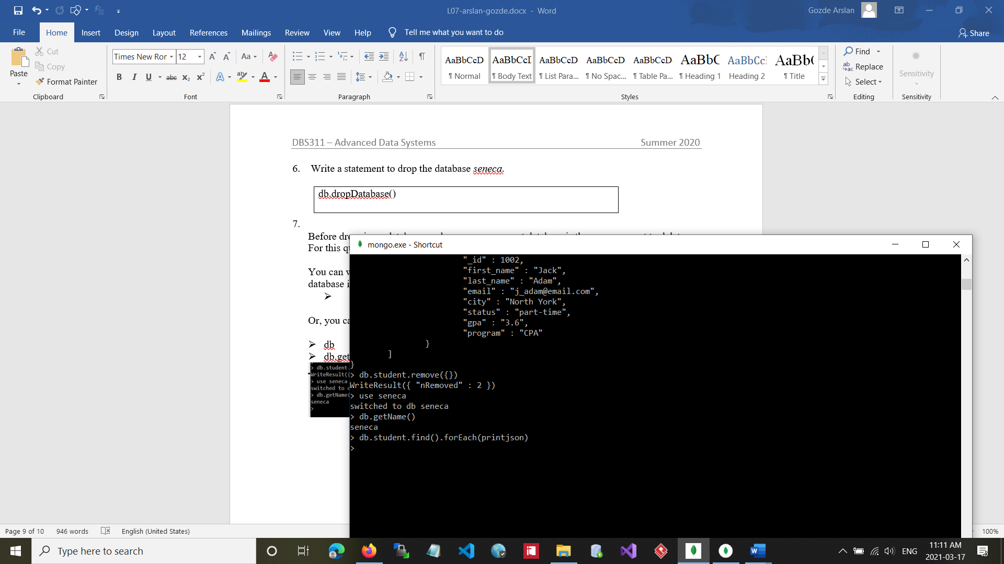

What message is displayed after you execute the drop statement? Copy the message in the box below:

db.dropDatabase()

