**Karman Vortex street**

**Geometry:**

The model used is rectangular 900x400 pixels in size with a cylinder at the centre line represented by circle of radius 10 pixels. The distance between the circle and the wall is 20 times the diameter of the circle.

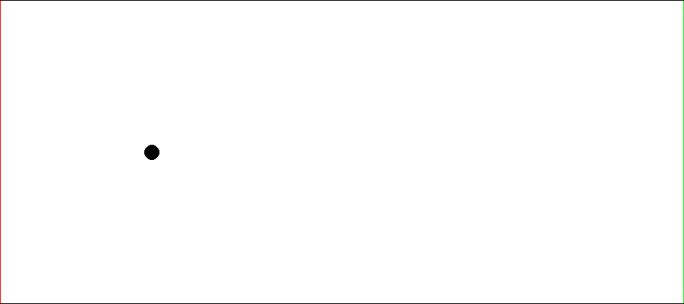

**Setup:**

* The Smagorinsky turbulence model is turned off.
* Reynolds number is taken to be 1000.

**Result:**

* The following result was observed.

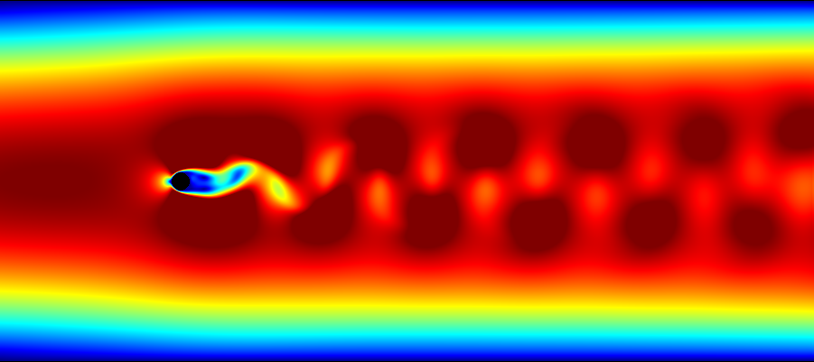

* The literature suggests a standard result of Strouhal number 0.235 at 1000 Reynold’s number.
* To determine the Strouhal number of the simulation, frequency is measured by observing the time taken for 2 vortices to pass through a fixed line perpendicular to the flow. The square root to area of the circle is taken as the characteristic length.
* The following Matlab code has been used:

Re=1000;

nodes_x=900;

nodes_y=400;

res=1.4*10^(-4);

length=nodes_x*res;

width=nodes_y*res;

char=sqrt(3.14159*100*res^2);

visc=8.9*10^-7;

vel=Re*visc/width*3/2;

freq=2/(4.686382*10^(-4)*1900);

St=freq*(char)/vel

* Results from this code show a Strouhal number of 0.2338 at 1000 Reynold’s.