**Lid-Driven Cavity**

To simulate the flow in lid-driven cavity and compare it with the standard acceptable verification data.

**Geometry:**

According to the verification data, a square cavity is used with edge length of 513 pixels and size of one unit as 10-4. The top edge is taken as inlet and all other edges are walls. The flow at inlet is parallel to the inlet surface.

**Setup:**

* The Smagorinsky turbulence model is turned off.
* Reynolds number is taken as 1000.
* Velocity is taken as 1 in x direction and 0 in y direction.

**Results:**

* The following figure is observed:

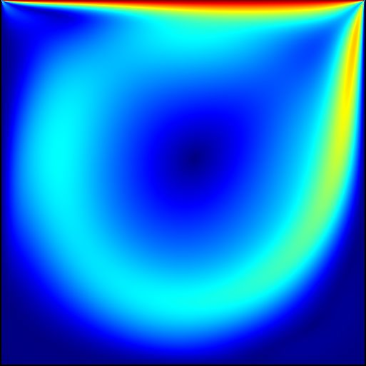

Figure 1: Monitor output

* The verification data is with respect to the centre lines as:

x component of velocity vs. vertical distance

y component of velocity vs. horizontal distance

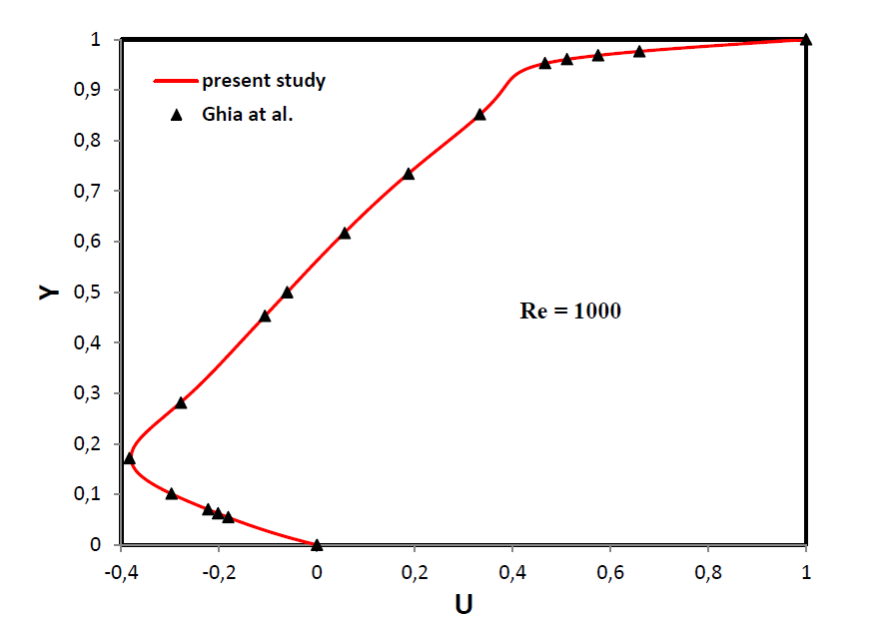

Figure 2: Verification data: X component of Velocity vs. vertical distance

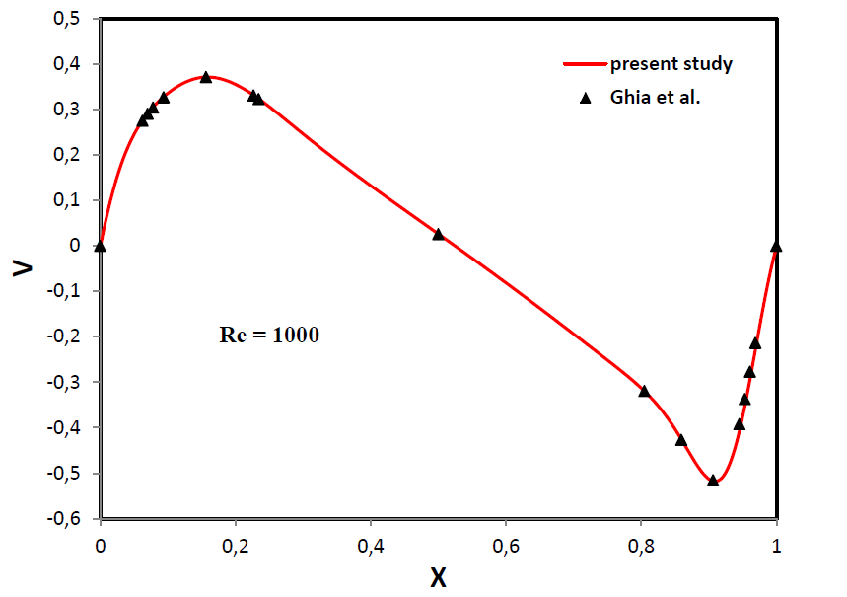

Figure 3: Verification data: Y component of velocity vs. Horizontal distance

* Data plots:

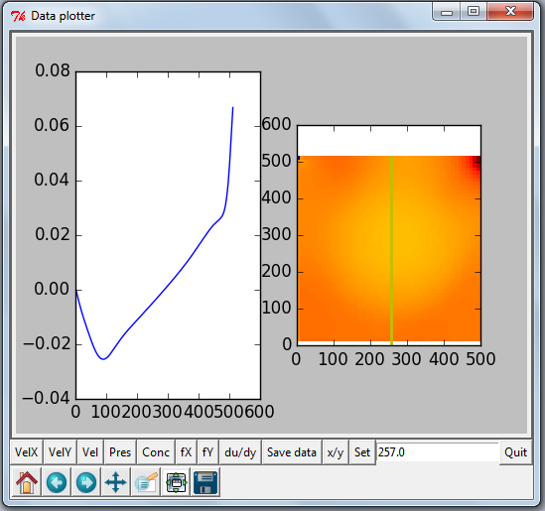

Figure 4: X velocity component at centre

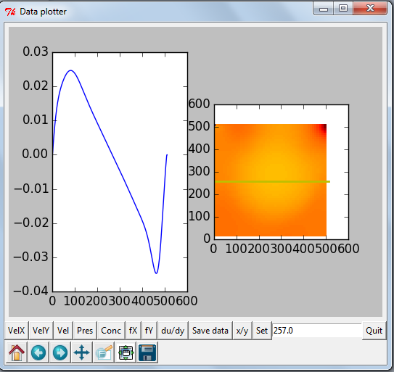

Figure 5: Y velocity component at centre

* **Matlab code:**

A=csvread('xplot_verif.csv')

ver_x=A(:,1);

x1=A(:,2);

B=importdata('x_dir_vel.txt');

x2=B(:,1)/513;

res_x=B(:,2)/0.0668;

subplot(2,1,1)

hold on

plot(ver_x,x1,'o')

plot(res_x,x2)

xlabel('x component of velocity')

ylabel('vertical distance')

C=csvread('yplot_verif.csv')

ver_y=C(:,1);

y1=C(:,2);

D=importdata('y_dir_vel.txt');

y2=D(:,1)/512;

res_y=D(:,2)/0.034111/2;

subplot(2,1,2)

hold on

plot(ver_y,y1,'o')

plot(y2,res_y)

xlabel('horizontal distance')

ylabel('y component of velocity')

* **Graph:**

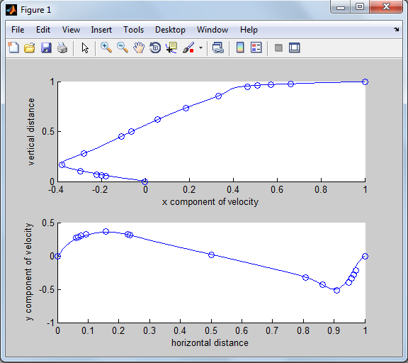

Figure 6: velocities at centre