**Poiseuille Flow**

This is a short guide to demonstrate flow in pipes using **medFlow2D.**

The objective is to simulate the flow in a pipe and compare the velocity profile at mid length to Poiseuille flow.

**Geometry:**

The model used for this demonstration is a 2D pipe with length of 800 pixels and width of 111 pixels. It’s a plane rectangular geometry that can be made using any photo editing software like paint. The Black colour represents the wall, Red the inlet, Green the outlet and blue the protected fluid. Further info can be accessed in the program’s documentations.



Figure 1: Geometry

**Setup:**

* Static condition with Reynolds number 10 is used.

**Results:**

* Velocity profile from medFlow2D

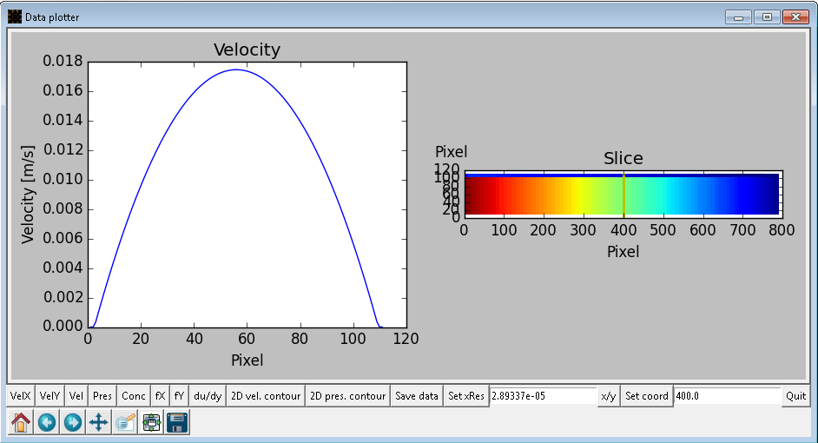

Figure 2:Velocity profile

* Pressure drop:

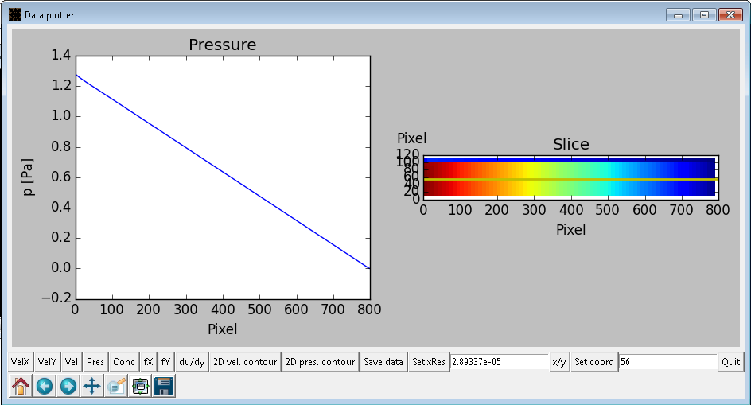

Figure 3:Pressure drop

* Matlab code:

clear all

dy=107;

dx=798;

L=2.8077*10^(-5)*dx;

DIA=2.8077*10^(-5)*(dy);

rad=DIA/2;

r=linspace(rad,-rad,1000);

den=1025;

visc=3.4*10^(-6);

vel=1/2/visc/den*(1.2/L)*((rad^2)-(r.^2));

RL=(rad-r)./DIA*108;

A=importdata('maybe1.txt');

B=A(:,1);

B=B-2;

C=A(:,2);

hold on

grid on

plot(RL,vel,'r')

plot(B,C)

xlabel('radial distance(in pixels)')

ylabel('velocity(m/s)')

* Comparison Graph:

