Chapter 2

What does good mean?

1. Recommendation accuracy?
• Ability to estimate a ranked list of items accurately. A good recommender system should be capable of predicting user
preferences with high precision.

2. Recommendation quality?
• Beyond accuracy, recommendation quality encompasses various factors such as relevance, novelty, diversity, and
serendipity. A truly effective system not only suggests items accurately but also introduces users to new and unexpected
choices, enriching their experience.

3. System usability?
• The manner in which recommendations are presented significantly impacts user engagement and satisfaction.

4. System satisfaction?
• System satisfaction is a measure of user happiness and fulfillment with the recommendations provided. It involves factors
such as trust, transparency, and the system's responsiveness to user feedback

Make accurate predictions is needed but
recommender system also need to account for
factors like diversity, context, evidence,
freshness, and novelty

Higher accuracy does not always
mean higher satisfaction

- Item coverage (or catalog coverage) – The percentage of items in the catalog that are ever recommended to users. A low item coverage means the system keeps recommending a small subset of popular items while ignoring many others.
- User coverage – The percentage of users for whom the system can generate recommendations. Some users might not receive recommendations due to a lack of interaction history.
• Novelty determines how unknown recommended items are to a user.
• The novelty of a recommender system evaluate the likelihood of a recommender system
to give a recommen

Serendipity means “lucky discovery”. It is a measure that evaluates the level
of surprise in successful recommendations.

Offline Methods

Any problem with RMSE or MAE?
these metrics do not really measure the user experience

Top N Recomendations
• Populars measures are the following:
• Mean Average Precision (MAP)
• Normalized Discounted cumulative gain (NDCG)

Offline Methods
Advantage
Only rely on a dataset. Easy to be obtained
Disadvantage
Offline metrics can not reflect business goal

A/B testing is all about comparing a new version (B) against the existing version (A) to see if the new version performs better. The goal is to make data-driven decisions instead of relying on intuition.
If the new recommendation algorithm (B) leads to higher user engagement, more clicks, or increased sales, then it is considered better and can be rolled out to all users. If it performs worse or shows no improvement, the company sticks with the existing algorithm (A) or makes further improvements before testing again.

Why Use A/B Testing?
✅ Minimizes Risk – Instead of launching a major change to all users, only a portion of users see the new version first.
✅ Objective Decision-Making – Results are based on real user behavior, not assumptions.
✅ Continuous Improvement – Companies can keep optimizing their recommendation system over time.

Chapter 3

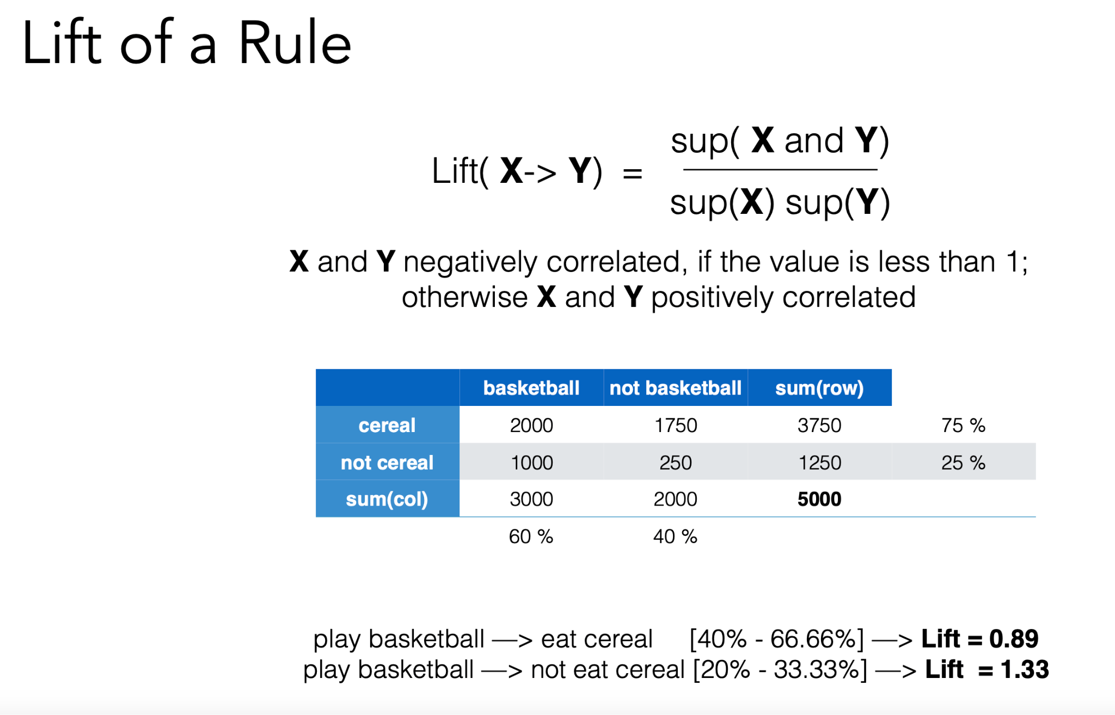

Problems with Lift:
a) Rules that hold 100% of the time may not
have the highest possible lift.
b) It is symmetric

Chapter 4

Problems with collaborative Filtering

• Cold Start: There needs to be enough other users already in the system to find a match.
• Sparsity: If there are many items to be recommended, even if there are many users, the user/ratings
matrix is sparse, and it is hard to find users that have rated the same items.
• First Rater: Cannot recommend an item that has not been previously rated.
• New items
• Esoteric items
• Popularity Bias: Cannot recommend items to someone with unique tastes.
• Tends to recommend popular items.

​​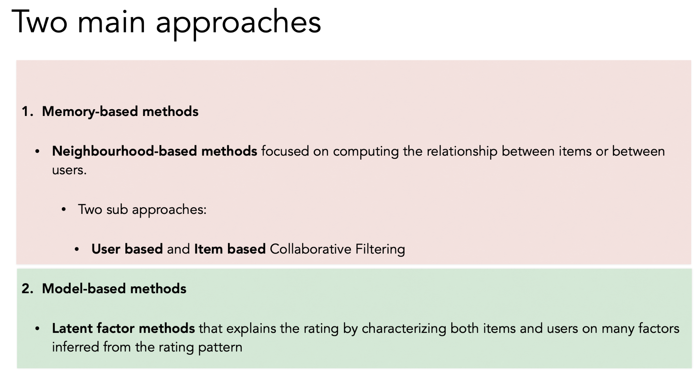

Collaborative Filtering: Core Concept
- Recommends items based on peer ratings and actions.
- Input: User ratings + Community ratings.
- Hypothesis: Similar users like similar items.

🧩 Types of Collaborative Filtering

1. Memory-Based Methods (Neighborhood-based)
- Uses similarities between users or items.
- Two approaches:
  - User-Based CF: Find similar users.
  - Item-Based CF: Find similar items.

2. Model-Based Methods
- Uses latent factors derived from rating patterns.
- Typically involves dimensionality reduction (e.g., SVD, PCA).

🛠️ Similarity Measures
- Euclidean Distance: Simple but sensitive to scale differences.
- Pearson Correlation: Better for normalized data.
- Cosine Similarity: Good for binary/unary ratings.
- Spearman Correlation: Based on rank.
- Adjusted Cosine: Item-based; accounts for user rating biases.

📉 Collaborative Filtering Challenges
- Cold Start: New users/items have no data.
- Sparsity: Few ratings across many users/items.
- First Rater Problem: Can't recommend unrated items.
- Popularity Bias: Tends to recommend well-rated popular items.

⚙️ Prediction Function (User-Based CF)
Estimate:
r^u,j=∑v∈Pu(j)sim(u,v)⋅rv,j∑v∈Pu(j)sim(u,v)r^u,j​=∑v∈Pu​(j)​sim(u,v)∑v∈Pu​(j)​sim(u,v)⋅rv,j​​
- Weighted sum of similar users’ ratings.

🔧 Tricks to Improve CF
- Top-k Similar Users: Avoid weak correlations.
- Similarity Amplification: e.g., raise similarity to power α > 1.
- Clustering: Pre-group similar users to reduce computation.
- Significance Weighting: Discount similarity with fewer common items.
- Long Tail Awareness: Emphasize niche items with higher surprise value.

🧠 Dimensionality Reduction
- Use PCA or SVD on rating matrix for efficiency and better similarity computation.
- Represent users/items with low-dimensional latent factors.
- Reduces noise and enhances robustness.

⚖️ User-Based vs. Item-Based CF
Criteria | User-Based | Item-Based
Scalability | Poor with many users | Poor with many items
Explainability | Worse | Better
Novelty | Lower | Higher
Cold Start | Struggles with new users | Struggles with new items
Performance | Needs user history | Needs only current user’s history

Chapter 5
Here's a breakdown of Vanilla SVD, Regularized SVD, SVD (Funk-SVD), and SVD++ in the context of recommender systems:

1. Vanilla SVD (Singular Value Decomposition)
- Traditional linear algebra technique that factorizes the user-item rating matrix into three matrices:R≈UΣVTR≈UΣVT
- Works well when the matrix is dense (few missing values), but recommender systems have sparse data, making direct SVD impractical.

2. Regularized SVD
- Instead of directly applying SVD, this approach learns user and item latent factors using a loss function with regularization:min⁡∑(rui−(pu⋅qi))2+λ(∣∣pu∣∣2+∣∣qi∣∣2)min∑(rui​−(pu​⋅qi​))2+λ(∣∣pu​∣∣2+∣∣qi​∣∣2)
- Here, pupu​ represents the latent factors for user uu, and qiqi​ represents the latent factors for item ii.
- Regularization (λλ) helps prevent overfitting by penalizing large factor values.
- Trained using Stochastic Gradient Descent (SGD) or Alternating Least Squares (ALS).

3. SVD (Funk-SVD)
- This is the most common version of SVD in recommender systems.
- Unlike traditional SVD, it only factors in the observed ratings (ignores missing values).
- Works well for predicting ratings but does not account for implicit feedback (e.g., clicks, purchases, watch history).

4. SVD++
- Enhances SVD by incorporating implicit feedback.
- It considers not only the explicit ratings but also items a user interacted with (even if they didn't rate them).
- Adds an additional user preference term that captures past interactions, making recommendations more accurate.
- More computationally expensive but performs better when implicit feedback is important.

TL;DR:
Method | Handles Sparse Data? | Uses Implicit Feedback? | Prevents Overfitting?
Vanilla SVD | ❌ No | ❌ No | ❌ No
Regularized SVD | ✅ Yes | ❌ No | ✅ Yes
SVD (Funk-SVD) | ✅ Yes | ❌ No | ✅ Yes
SVD++ | ✅ Yes | ✅ Yes | ✅ Yes
Key takeaway:
- If you need basic matrix factorization → Regularized SVD
- If you want better recommendation accuracy → Funk-SVD
- If implicit feedback matters (e.g., tracking unclicked items) → SVD++ 🚀

SLIM (Sparse Linear Methods for Top-N Recommender Systems)
SLIM is a collaborative filtering method used for top-N recommendation. Instead of factorizing the user-item matrix like SVD, SLIM learns a sparse item-item similarity matrix that can be used for making recommendations.

How SLIM Works
- Learn a Sparse Item-Item Similarity Matrix (SS)
  - Given a user-item interaction matrix (RR), SLIM models each item's preferences as a linear combination of other items.
  - It learns a sparse weight matrix (SS), where each item is represented by a combination of other items:R≈RSR≈RS
  - This means an item's rating is predicted using other similar items rather than user factors.
- Optimization Objective
  - SLIM learns the matrix SS by solving:min⁡∣∣R−RS∣∣F2+λ∣∣S∣∣1+β∣∣S∣∣22min∣∣R−RS∣∣F2​+λ∣∣S∣∣1​+β∣∣S∣∣22​ where:
    - ∣∣R−RS∣∣F2∣∣R−RS∣∣F2​ minimizes the reconstruction error.
    - ∣∣S∣∣1∣∣S∣∣1​ enforces sparsity (L1 regularization).
    - ∣∣S∣∣22∣∣S∣∣22​ prevents overfitting (L2 regularization).
  - The constraints ensure that each item's similarity weights sum to 1 and are non-negative.
- Making Recommendations
  - After learning SS, user preferences are predicted as:R^=RSR^=RS
  - This is fast to compute and works well for large-scale recommendation.

Why Use SLIM?
✅ No need for latent factors → Unlike SVD, it directly learns an item-item similarity matrix.
✅ Sparse representation → Makes it efficient and scalable.
✅ Great for top-N recommendation → Works well in ranking tasks.
✅ No cold start for items → Since it’s item-based, new users can still get recommendations.

SLIM vs. SVD-based Methods
Feature | SLIM | SVD-based Methods
Factorization | ❌ No | ✅ Yes (user/item factors)
Sparse Representation | ✅ Yes | ❌ No (dense factor matrices)
Handles Implicit Feedback | ✅ Yes | ❌ No (SVD) / ✅ Yes (SVD++)
Computational Efficiency | ✅ Fast (after training) | ❌ Slower due to factorization
Best for | Top-N recommendation | Rating prediction
Chapter 6

📌 What Are Factorization Machines (FM)?
Factorization Machines (FMs) extend linear models by automatically learning interactions between variables, even when data is sparse. They are commonly used in recommender systems, where interactions between users, items, and other features matter.

🔑 Key Points (Explained Simply!)

1️⃣ Matrix Factorization vs. Factorization Machines
📌 Matrix Factorization (like SVD) models user-item interactions but needs structured user-item data.
📌 Factorization Machines go further by handling any kind of features (e.g., user age, item category, purchase history) and are more flexible.
✅ FM can work with explicit (ratings) & implicit (clicks, purchases) feedback.

2️⃣ FM Equation (Breaking It Down)
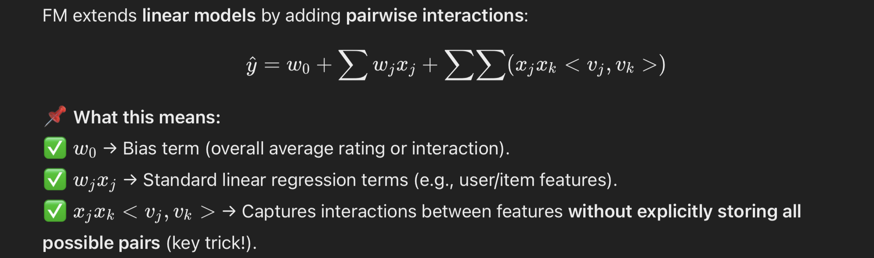🔥 Why is this important?
- Instead of storing massive interaction matrices (which would be slow), FMs approximate interactions using low-dimensional vectors → makes it scalable and efficient.

3️⃣ FM Handles Sparse Data Well
📌 Problem:
- Traditional models (e.g., polynomial regression, SVM) struggle when data is sparse (i.e., most interactions are missing).
📌 FM Solution:
✅ Instead of storing explicit interaction terms, FMs use factorized representations to estimate missing interactions efficiently.
✅ Works great for recommender systems where user-item interactions are naturally sparse!

4️⃣ FM vs. Other Models
Model | Handles Sparse Data? | Learns Feature Interactions? | Good for Recommendations?
Linear Models | ❌ No | ❌ No | ❌ No
Polynomial Models | ❌ No | ✅ Yes (explicit interactions) | ❌ No (too many parameters)
Matrix Factorization | ✅ Yes | ✅ Yes (user-item only) | ✅ Yes (for ratings)
Factorization Machines | ✅ Yes | ✅ Yes (all features!) | ✅ Yes (for all features!)
🔥 Why use FM?
- More powerful than basic matrix factorization (works with any features).
- More scalable than polynomial regression (efficient feature interactions).

5️⃣ FM in Recommender Systems (Compared to SVD++)
📌 FM is similar to SVD++, because:
✅ Both combine explicit ratings & implicit feedback (e.g., clicks, bookmarks).
✅ Both learn user preferences from interactions.
📌 FM is more flexible, because:
✅ It supports extra side information (e.g., user demographics, item tags, timestamps).
✅ Works for more than just user-item interactions (good for ranking, search, etc.).

🚀 Summary – Why Use Factorization Machines?
✅ Works with sparse data (great for recommender systems).
✅ Learns feature interactions automatically (better than linear models).
✅ Scalable (avoids storing large interaction matrices).
✅ More flexible than SVD++ (can use any feature, not just user-item pairs).
In simple words: Factorization Machines are like Matrix Factorization but on steroids! 🎯
Would you like an example or more details on a specific part? 🚀

Chapter 7

Key Takeaways
- Ranking in Recommendations
  - Recommendations are often presented as a sorted list.
  - RMSE/MAE are not ideal metrics for ranking-based recommendations.
  - Higher accuracy ≠ higher user satisfaction.
- Evaluation Metrics for Ranking
  - Precision@K: Measures relevant items in top-K results.
  - Recall@K: Fraction of relevant items retrieved in top-K.
  - Mean Average Precision (MAP): Precision at each correct item’s position.
  - NDCG (Normalized Discounted Cumulative Gain): Handles different relevance levels.
- Learning to Rank (LTR)
  - Optimizing ranking directly is hard since traditional metrics are not differentiable.
  - LTR learns rank order instead of minimizing prediction error.
  - Three approaches:
    - Pointwise: Predicts absolute relevance (e.g., RMSE).
    - Pairwise: Compares two items (e.g., AUC).
    - Listwise: Optimizes entire ranking lists (e.g., cross-entropy).
- Pairwise Learning
  - Models relative order, not absolute scores.
  - Methods include Rank SVM, RankNet, LambdaRank, LambdaMART, Bayesian Personalized Ranking (BPR).
  - RankNet: Minimizes ranking inversions using neural networks.
  - LambdaRank: Scales gradients using NDCG for better ranking.
  - BPR: Focuses on user preference, but does not penalize lower-ranked items well.
- Listwise Learning
  - Directly optimizes ranking lists using metrics like MAP and NDCG.
  - LambdaMART: Uses gradient-boosted trees for ranking tasks.
  - High computational cost, mainly used as a re-ranker.
- Challenges & Applications
  - LTR is computationally expensive and often used for final ranking adjustments.
  - Implicit feedback (e.g., clicks, views) is key in real-world recommendation systems.
  - Used in search engines, movie/music recommendations, e-commerce, and online ads.
Same with extra info

Learning to Rank & Recommender Systems - Notes

🔹 1. Ranking in Recommendations
- Most recommendation systems display items in a sorted list based on relevance.
- Traditional accuracy metrics (RMSE, MAE) are not ideal for ranking because they only measure how close predicted values are to actual values but do not consider the order of recommendations.
- Why is ranking more important?
  - Even if two models have the same RMSE, their ranked recommendations might be completely different.
  - A system with better ranking can provide a better user experience, even if its RMSE is slightly worse.
- Key takeaway: Higher numerical accuracy does not always mean better recommendations for users.

🔹 2. Evaluation Metrics for Ranking
Since RMSE and MAE do not effectively evaluate ranked recommendations, we use ranking-based metrics:

📍 Precision@K
- Measures how many relevant items are present in the top-𝑘 results.
- Formula:Precision@K=relevant items in top KKPrecision@K=Krelevant items in top K​
- Use case: Evaluates the accuracy of top-ranked items, useful for search engines and product recommendations.

📍 Recall@K
- Measures how many relevant items are retrieved compared to all relevant items available.
- Formula:Recall@K=relevant items in top Ktotal relevant items availableRecall@K=total relevant items availablerelevant items in top K​
- Use case: Important in scenarios where retrieving as many relevant items as possible matters, such as medical document retrieval.

📍 Mean Average Precision (MAP)
- Evaluates ranking by checking the precision at every correct item’s position in the results list.
- Better than Precision@K because it rewards models that put relevant items higher in the ranking.

📍 Normalized Discounted Cumulative Gain (NDCG)
- Measures ranking while considering different relevance levels (e.g., a 5-star rating is more important than a 3-star rating).
- It discounts lower-ranked items since users are less likely to scroll down in recommendations.
Why do we need these?
- These metrics directly evaluate the ranking of items, not just how close the predicted rating is.
- For example: Even if a system has a perfect RMSE, if it ranks bad movies above good ones, the user won’t be satisfied.

🔹 3. Learning to Rank (LTR) - The Problem
- The challenge: Traditional machine learning models minimize error (e.g., RMSE), but ranking requires optimizing order, which is not differentiable.
- Solution: Learning-to-Rank (LTR) – Models that learn rank order instead of absolute prediction error.
- Three main approaches:

📍 Pointwise Approach
- Treats ranking as a regression/classification problem (e.g., predicting movie ratings).
- Uses algorithms like SVM, XGBoost, Neural Networks.
- Limitation: It only focuses on individual item scores and does not consider relative ranking.

📍 Pairwise Approach
- Compares two items at a time and learns which should be ranked higher.
- Example: If a user prefers Movie A > Movie B, the model should ensure A is ranked above B.
- Popular methods: RankNet, LambdaRank, Bayesian Personalized Ranking (BPR).

📍 Listwise Approach
- Considers the entire ranking list at once and optimizes it directly.
- Uses advanced loss functions that optimize for metrics like NDCG and MAP.
- More computationally expensive but highly effective for ranking-based applications.

🔹 4. Pairwise Learning - A Deeper Look
Instead of predicting absolute ratings, Pairwise Learning focuses on relative order:
- Example: If a user clicks Item A more than Item B, the system should learn to rank A above B.
- Key advantage: It does not require exact rating labels, just a preference signal (e.g., clicks, purchases).

Popular Pairwise Methods:

✅ RankNet
- Developed using neural networks.
- Minimizes the number of inversions (incorrect ranking pairs).
- Example: If a bad product is ranked higher than a good product, RankNet penalizes the model.

✅ LambdaRank
- Improvement over RankNet by scaling gradients using NDCG (i.e., prioritizing important ranking changes).
- Faster and more effective than RankNet.

✅ Bayesian Personalized Ranking (BPR)
- Optimizes implicit feedback (e.g., clicks, purchases) instead of explicit ratings.
- Problem: It does not penalize lower-ranked irrelevant items enough.

🔹 5. Listwise Learning - A Deeper Look
- Instead of looking at pairs, Listwise methods optimize the entire ranked list.
- Uses ranking-based metrics (MAP, NDCG) as loss functions for training.
- More complex but produces better ranking models.

✅ LambdaMART
- Combines LambdaRank + Gradient Boosted Decision Trees (MART).
- State-of-the-art for many ranking tasks (e.g., Google Search, Bing, Amazon Recommendations).
Key trade-off:
✅ Listwise gives better rankings but requires high computational power.

🔹 6. Challenges & Applications of LTR

📍 Why isn’t LTR used everywhere?
❌ Computationally expensive (especially Listwise).
❌ Hard to train and tune.
✅ Best used as a final re-ranking step after an initial recommendation list is generated.

📍 Where is LTR used?
✅ Search engines (Google, Bing, Yahoo) – Optimizes document rankings.
✅ E-commerce (Amazon, eBay, AliExpress) – Improves product recommendations.
✅ Streaming platforms (Netflix, Spotify, YouTube) – Enhances personalized content ranking.
✅ Online advertising (Google Ads, Facebook Ads) – Optimizes ad placement based on user engagement.

📌 Summary - Why LTR Matters?
✔ RMSE & MAE are not enough – we need ranking-based metrics.
✔ LTR solves ranking problems better than simple prediction models.
✔ Pairwise & Listwise methods outperform Pointwise for ranking tasks.
✔ Used in search engines, e-commerce, streaming, and online ads.

I'll now generate a PDF with these notes so you can download it! 🎯

Chapter 8

🤖 What is Deep Learning in RecSys?
Deep Learning enables:
- Non-linear modeling of complex interactions.
- Reduction in manual feature engineering.
- Integration of heterogeneous data (text, audio, images).
- High flexibility in designing new architectures/losses.
- Strong performance in sequential recommendations.

✅ Why Use Deep Learning in Recommender Systems?
- Learns from complex patterns.
- Great for cold start problems using content (e.g., music/audio).
- Handles both memorization (frequent co-occurrence) and generalization (new combinations).
- Example: Siamese networks for item similarity based on co-occurrence and content.

⚠️ Drawbacks of Deep Learning in RecSys
- Low interpretability.
- Requires large datasets.
- Needs careful hyperparameter tuning.

🎧 Deep Content-Based Recommendation (e.g., Music)
- Problem: New songs have no historical data.
- Solution: Use audio signals to predict latent factors.
- Example: CNNs to extract features directly from audio waveforms.

🎯 Two-Stage Recommendation Systems

1. Candidate Generation
- Deep network narrows millions of items to hundreds.
- Fast, coarse filtering.

2. Candidate Ranking
- Deep network ranks based on user behavior + interface context.
- Trained with logistic regression and watch time weighting.

⚡ Neural Architectures & Approaches
- NeuMF (Neural Matrix Factorization): Combines MLP + GMF.
- Wide & Deep: Mix of memorization (wide) and generalization (deep).
- DeepFM: Combines Factorization Machines + MLP, no need for feature engineering.
- xDeepFM: Learns feature interactions at vector-wise level.

🔄 Memorization vs Generalization
Type | Description | Benefit
Memorization | Learns frequent co-occurrences | More topical
Generalization | Explores rare or new patterns | More diverse recommendations

⏳ Sequence-Aware Recommendations
- Traditional RecSys assume static preferences.
- Real preferences change over time (e.g. seasonality).

🧠 RNNs for Sequential Modeling
- Handle user interaction sequences.
- Predict next-item or session-based recommendations.

RNN Challenges:
- Vanilla RNNs: Limited memory span.
- Use LSTM / GRU for better sequence retention.
- Can be computationally expensive.

🌀 Autoencoder-based RecSys
- Learns compressed representations.
- Can help reconstruct user/item profiles.
- Good for cold start, noise reduction, and dimensionality reduction.

