K.H.U. Faculty of Engineering and Natural Sciences

**BACHELOR’S PROJECT**

**PROPOSAL**

**DEVELOPMENT OF WEBSITE FOR MULTI-BRANCHING COMPANY**

**Project Advisor:** Hasan DAĞ

**Project By:** Duygu YEŞİM

Özlem ERDOĞAN

Gözde CİĞER

**Submission Date:** 11.12.2014

**ABSTRACT:**

This website provides access to detailed information about the café/company which the main page of the website is designed as a customer-oriented. In addition to the site's background; this website will facilitate the realization of activities between Enterprise Resources Planning, Customer Relationship Management, Supply Chain Management, Accounting and Controls departments located within the Multi-branches companies in full. In this way, provide to efficient communication between departments and will be generated reports submitted on a daily basis. We will the integration between departments which was held to have many advantages on this website.

**AIM:**

Our aim is to create simple-looking, and can be controlled to a dynamic website. With this web site, which enables the integration between departments that relationship will be correct and rapid .Also, we will have the ease of decision-making and operational process thanks to the integration between the website and the system. In addition, the company will be providing efficiency throughout business processes.

**METHODOLOGY:**

Desired project scope will be determined in a Microsoft Word Office Program. When starting a website design to will create the analysis with project scope, outputs of the screenshots will be created using Visual Studio and Mock-up program. After the output of the screenshots, Msql program will be used for database design. Than the database design is completed, using the HTML, CSS and JavaScript codes will be created simple-looking client side. To ensure the control and dynamic site’s, will be used PHP codes for perform the connection server side with website. Resulting system in a coding and design, all problems will be fixed after owner have tested and the system will be operated properly.

**WORK PACKAGE DESCRIPTION**

**Number and name of the package**:

**1.** Analysis

**Start date: 02.10.2014**

**Finish date: 05.12.2014**

**Short description**: According to the company owner's request, determine needs and identify roles and functions.

**Outputs**: Complete Analysis

**Relations to other packages**: depending on the work package 1, create the work package 2

**Work to be done by anybody outside the team**: Nobody

**2.** Design

**Start date: 05.12.2014**

**Finish date: 19.01.2015**

**Short description**: According to the company owner's request, determine needs and identify roles and functions.

**Outputs**: Complete Design

**Relations to other packages**: Related to work package 1

**Work to be done by anybody outside the team**: Nobody

**3.** Development

**Start date: 20.01.2015**

**Finish date: 11.03.2015**

**Short description**: Development code of client and server

**Outputs**: Complete Development

**Relations to other packages**: Starting the work package 3, after the work package 1 and work package 2

**Work to be done by anybody outside the team**: Nobody

**4.** Test

**Start date: 11.03.2015**

**Finish date: 10.04.2015**

**Short description**: Providing the test control

**Outputs**: Correction of codes

**Relations to other packages**: According to work package 3, done work package 4.

**Work to be done by anybody outside the team**: Nobody

**5.** Release Code which made and Maintenance & Additional Development

**Start date: 11.04.2015**

**Finish date: 02.05.2015**

**Short description**: Become available to the project and additional task as required by the busines owner

**Outputs**: operation of the project and completion of additional requests

**Relations to other packages**: According to work package 1, 2, 3 and 4, complete work package 5.

**Work to be done by anybody outside the team**: Nobody

**CONTRIBUTIONS OF THE TEAM MEMBERS:**

|  |  |  |  |  |  |  |  |  |  |  |  |  |
| --- | --- | --- | --- | --- | --- | --- | --- | --- | --- | --- | --- | --- |
| Name, Surname | Work Packages | | | | | | | | | | Total | |
| 1 | | 2 | | 3 | | 4 | | 5 | |
| h | % | h | % | h | % | h | % | h | % | h | % |
| Özlem ERDOĞAN | - | 20 | - | 60 | - | 30 | - | 25 | - | 35 | - | 170 |
| Duygu YEŞİM | - | 40 | - | 30 | - | 40 | - | 30 | - | 30 | - | 170 |
| Gözde CİĞER | - | 40 | - | 10 | - | 30 | - | 45 | - | 35 | - | 160 |
| Total | - | 100 | - | 100 | - | 100 | - | 100 | - | 100 | - | 500 |

**PROJECT CALENDER**

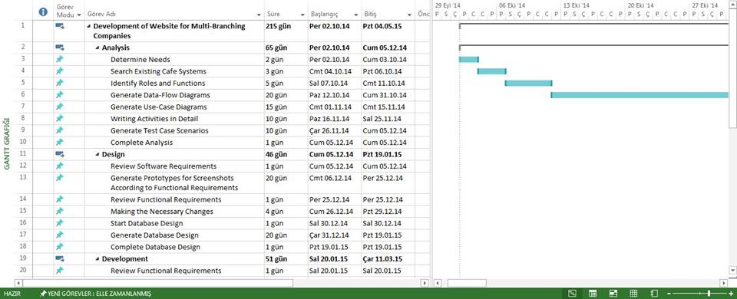

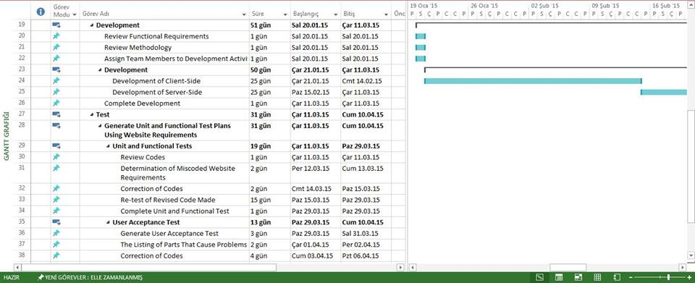

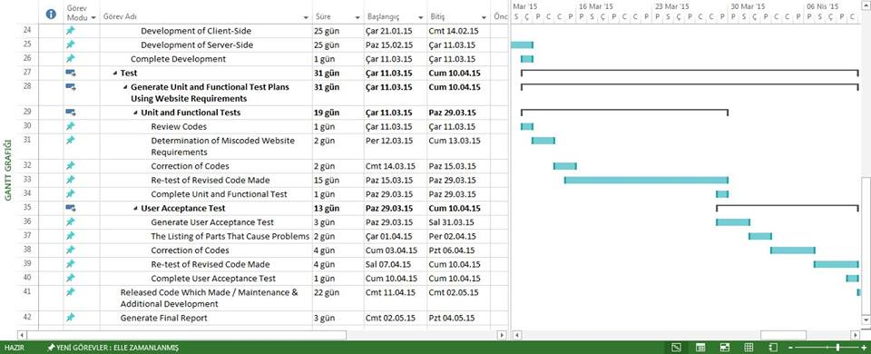

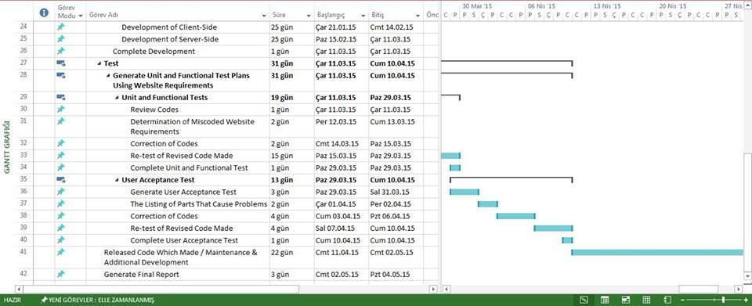

**INFRA-STRUCTURE REQUIREMENTS:**

(*List the facilities to be used in the project under the following categories. Justify each item referring to work packages. Indicate (if any,) items that can be provided by the project team.*)

**Laboratory(ies):** Php Language,Sql Language ,Html Languageand ,Javascript Language,MS Office Program,Visual Studio,Visual Paradigm and Mock-up

**Equipment:** not used

**Computer(s):** Personel Computer,Laptops and Ipad were used.

**Personnel:** Team Members , Advisor

**PROJECT BUDGET:**

|  |  |  |  |  |  |
| --- | --- | --- | --- | --- | --- |
|  | **Work Packages** | | | |  |
|  | **I** | **II** | **III** | **IV** | **TOTAL** |
| **Equipment** | - | - | - | - | - |
| **Consumable goods** | - | - | - | - | - |
| **Publications/Software** | - | - | - | - | - |
| **Transportation** | - | - | - | - | - |
| **Services** | - | - | - | - | - |
| **TOTAL** | - | - | - | - | 0 |

**Equipment:** not applicable

**Consumable goods:** not applicable

**Publications/Software:** not applicable

**Transportation:** not applicable

**Services:** not applicable

**REFERENCES:**

1. <http://www.visualstudio.com/>

2. <http://balsamiq.com/products/mockups/>