Assignment 2
Name: ID:
I. True (√) or False (×) (3pts)
  - <1 1 1> represents Miller indices of a family of directions. (√)
  - In steel, 0.0218% < wt%(C) ≤ 2.11%. (√) [using the limits specified in this course]
  - Both Al and Cu have good electrical conductivity. (√)
II. Please choose the correct answer and note it down in the blanket after each question. (10pts) (2pts)
- Which one does NOT have graphite? (C) White cast iron
(A) Gray cast iron
(B) Malleable cast iron
(C) White cast iron
(D) Ductile cast iron
- Which one does NOT belong to alloy structural steel? (A) Stainless steel
(A) Stainless steel
(B) HSLA steel
(C) Alloy carburizing steel
(D) Rolling bearing steel
III. Please list 4 basic types of binary phase equilibrium crystallization? (2pts)
1) Isomorphous crystallization: L → α (a continuous solid solution).
2) Eutectic crystallization: L → α + β.
3) Peritectic crystallization: L + α → β.
4) Monotectic crystallization: L₁ → α + L₂.
IV. Please draw out the corresponding directions or faces according to the miller indices. (5pts)
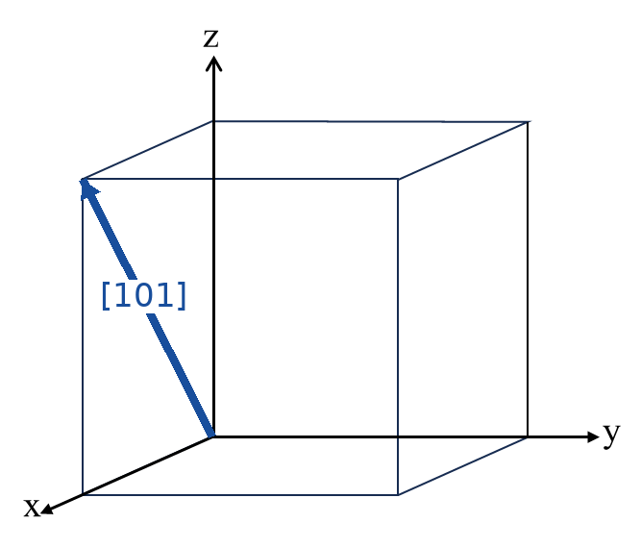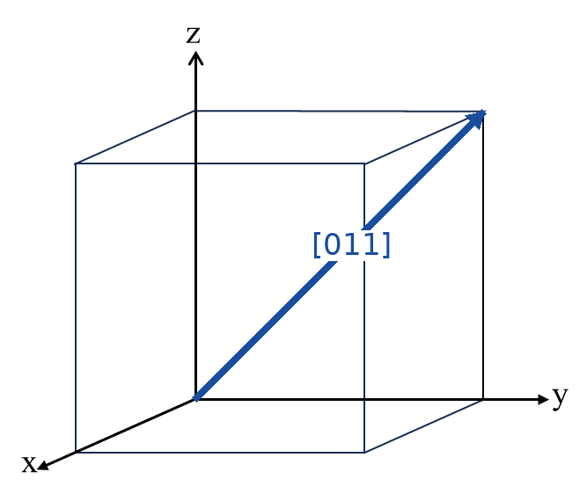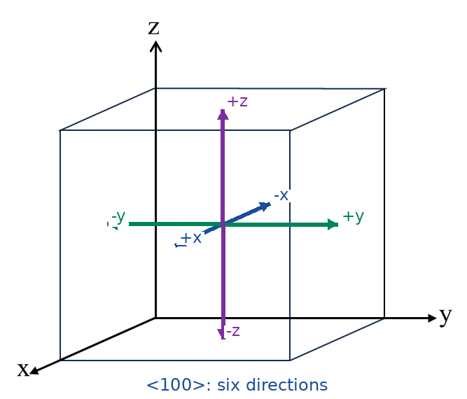
[1 0 1] [0 1 1] <1 0 0>
[101]: O → (1,0,1); [011]: O → (0,1,1). <100> contains [100], [−100], [010], [0−10], [001] and [00−1]; the six arrows are drawn from the cube centre.
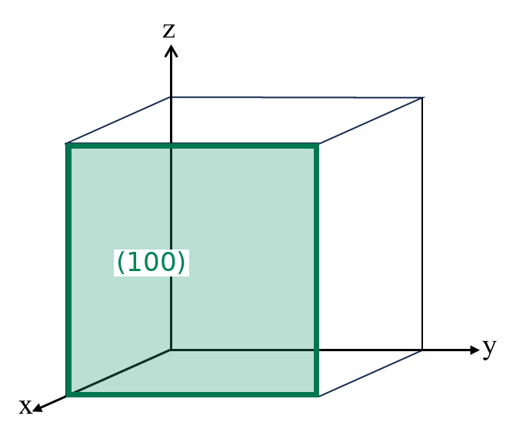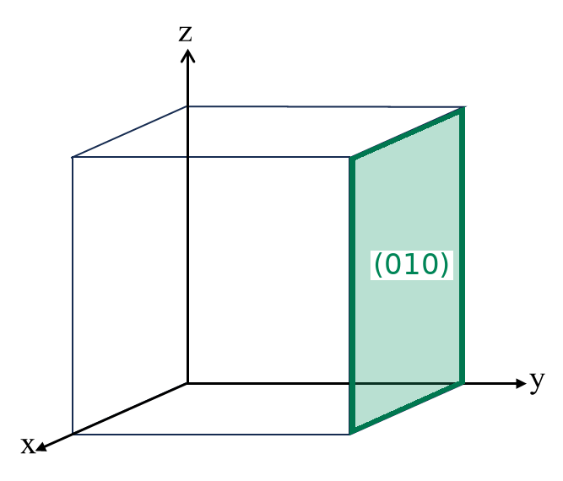
(1 0 0) (0 1 0)
(100): x = 1, parallel to y and z (the front face). (010): y = 1, parallel to x and z (the right-hand face).
IV: Dislocation (8pts)
- Which kinds of dislocations are shown in Image A and Image B respectively? (2pts)
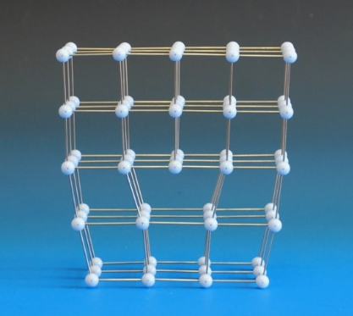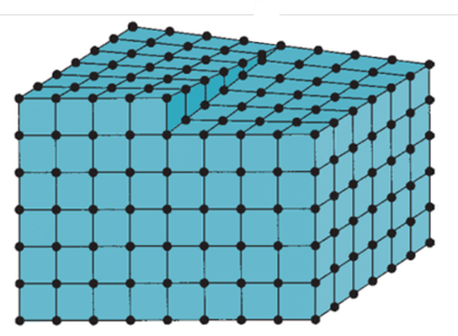
Image A Image B
Image A: Edge dislocation — an extra half-plane terminates inside the crystal; b ⟂ t.
Image B: Screw dislocation — the lattice planes form a helical step; b ∥ t.
- In the follow image, tangent vector ($\vec{t}$) is provided.
1) Please draw out a right-hand circuit and the Burgers vector ($\vec{b}$) accordingly. (2pts)
2) Based on the relationship of $\vec{t}$ and $\vec{b}$, please explain if the dislocation in the above image is positive or negative, and why. (1pts)
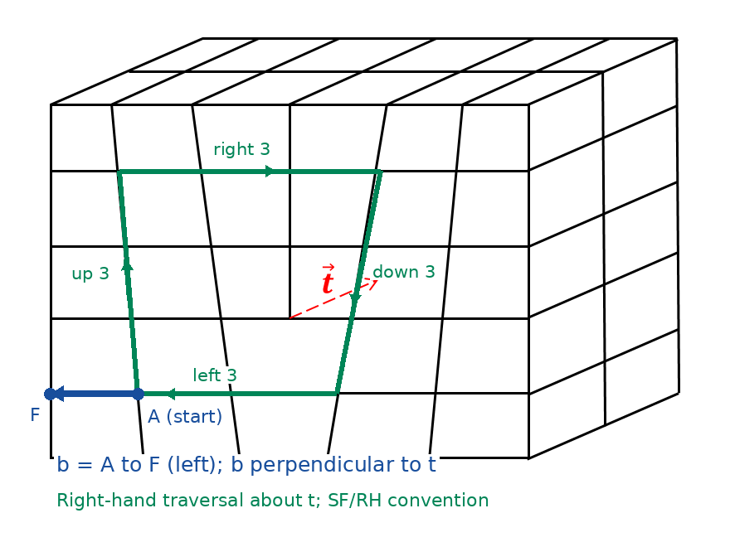
Convention used for both Burgers circuits: copy a closed right-hand circuit from a perfect lattice into the given lattice. The displacement from the starting point A to the finishing point F is b (start-to-finish/right-hand, SF/RH). The return arrow F → A would be −b.
1) With the thumb along the supplied t (towards the back of the block), the circuit is clockwise when viewed along t. The marked path is up 3, right 3, down 3 and left 3 lattice steps; it ends one spacing left of A, so b points left.
2) Positive edge dislocation: b is perpendicular to t, and the extra half-plane is above the slip plane. With the stated convention, t × b points towards the extra half-plane. Perpendicularity identifies an edge dislocation; the extra-half-plane orientation establishes its sign.
- In the follow image, tangent vector ($\vec{t}$) is provided.
1) Please draw out a right-hand circuit using point A as the starting point, and then draw the Burgers vector ($\vec{b}$) accordingly. (2pts)
2) Based on the relationship of $\vec{t}$ and $\vec{b}$, please explain if the dislocation in the above is right-handed or left-handed, and why. (1pts)
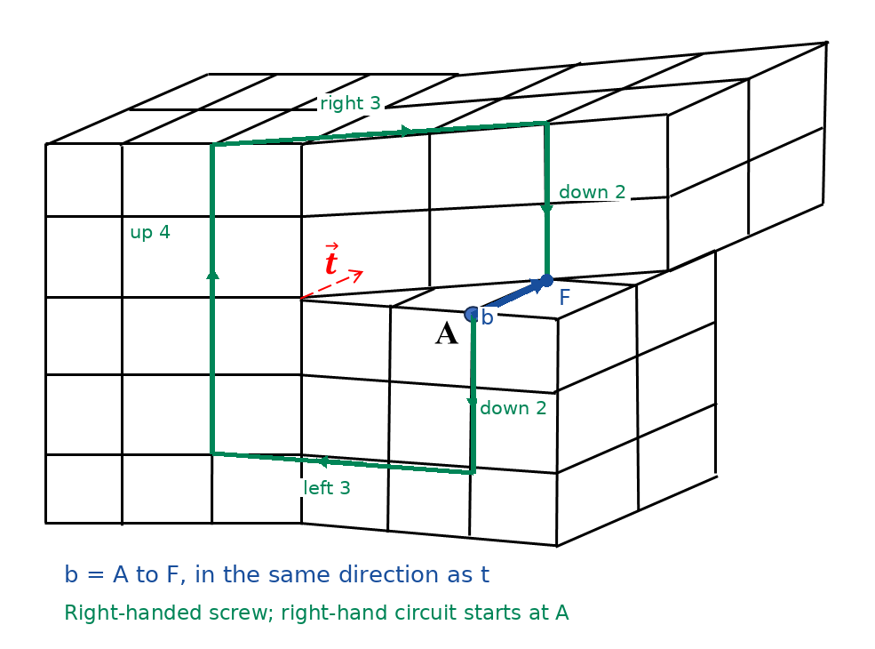
1) Start at the provided point A and follow the green right-hand path: down 2, left 3, up 4, right 3, down 2 lattice steps. The net ideal step count is zero, but the actual path ends at F, one lattice translation behind A.
2) b = A → F is parallel to t and has the same sense. Therefore this is a right-handed screw dislocation under the stated SF/RH convention (b · t > 0).
V. Please find below the Fe-Fe₃C phase diagram and answer the following questions. (11pts)
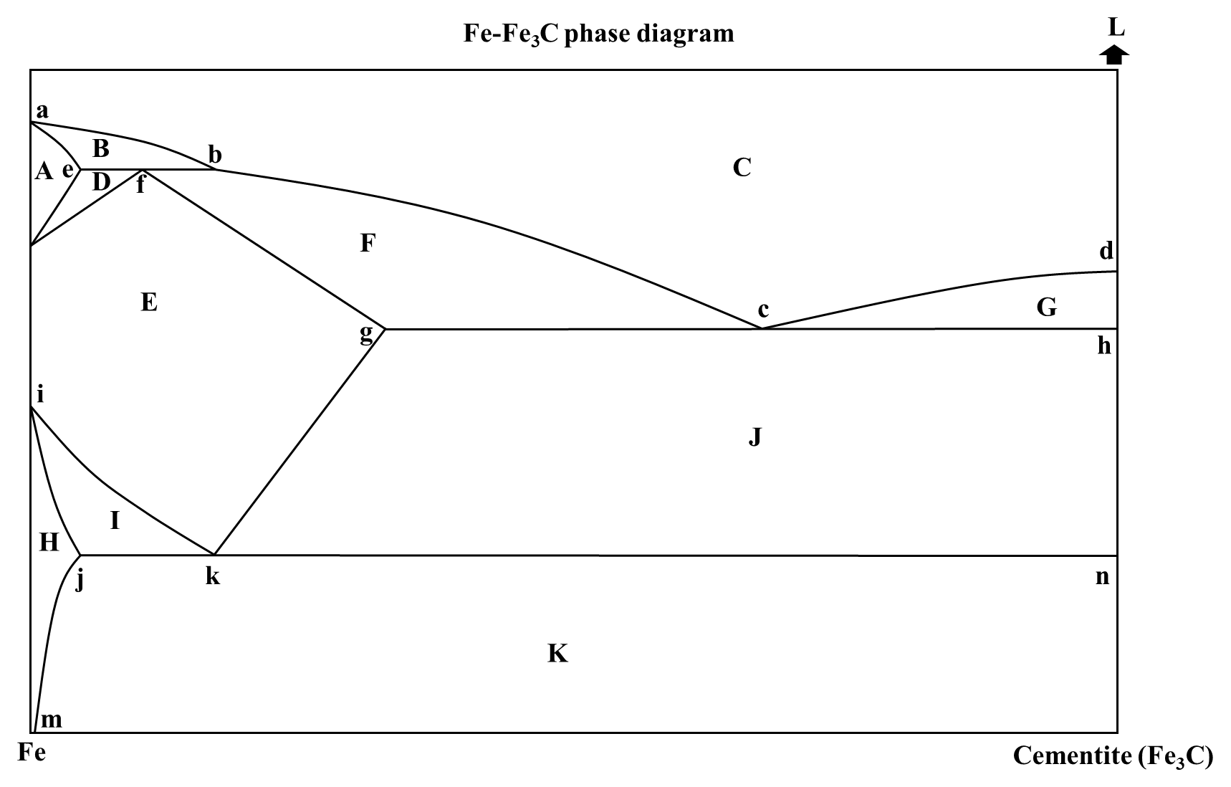
Note: A, B, …, and L represents Region A, region B, …, and region L, respectively. Point a, point b, …, and point n are labeled as a, b, …, and n in the phase diagrams, respectively.
Question1. Please point out all single-phase regions and write down the corresponding phase for each region. (3pt)
A: δ-ferrite, a BCC solid solution of carbon in high-temperature iron.
C: Liquid (L).
E: Austenite (γ), an FCC solid solution of carbon in iron.
H: α-ferrite, a BCC solid solution of carbon in low-temperature iron.
L: Cementite (Fe₃C), the single-phase compound at the right-hand composition boundary (6.67 wt% C). The capital L on that boundary is a region label, not the symbol for liquid.
Question2. Please point out all two-phase regions and write down the corresponding phases for each region. (4pts)
B: Liquid + δ-ferrite (L + δ).
D: δ-ferrite + austenite (δ + γ).
F: Liquid + austenite (L + γ).
G: Liquid + cementite (L + Fe₃C).
I: α-ferrite + austenite (α + γ).
J: Austenite + cementite (γ + Fe₃C).
K: α-ferrite + cementite (α + Fe₃C). Pearlite and ledeburite are microconstituents, not additional single phases.
Question3. Please fill in the blanks below. (4pts)
Note1: You can use “abcd” to represent the line that starts from point a, ends at point d, and passes through point b and c.
Note2: In the reaction formula, please note down the composition of each phase (for example: A_{g} means Austenite phase with the same composition of point g).
      - Peritectic reaction line: efb. Peritectic point: f. On cooling, at approximately 1493 °C:
L_b (≈0.53 wt% C) + δ_e (≈0.09 wt% C) → γ_f (≈0.17 wt% C).
      - Eutectic reaction line: gch. Eutectic point: c. On cooling, at approximately 1147 °C:
L_c (4.30 wt% C) → γ_g (2.11 wt% C) + Fe₃C_h (6.67 wt% C).
      - Eutectoid reaction line: jkn. Eutectoid point: k. On cooling, at approximately 727 °C:
γ_k (≈0.77 wt% C) → α_j (0.0218 wt% C) + Fe₃C_n (6.67 wt% C).
      - Liquidus line: abcd. Solidus line: aefgh.
V. Below shows the F-G phase diagram (red dotted line) and F-Fe₃C phase diagram (black solid line). Please answer the following questions. (4pts)
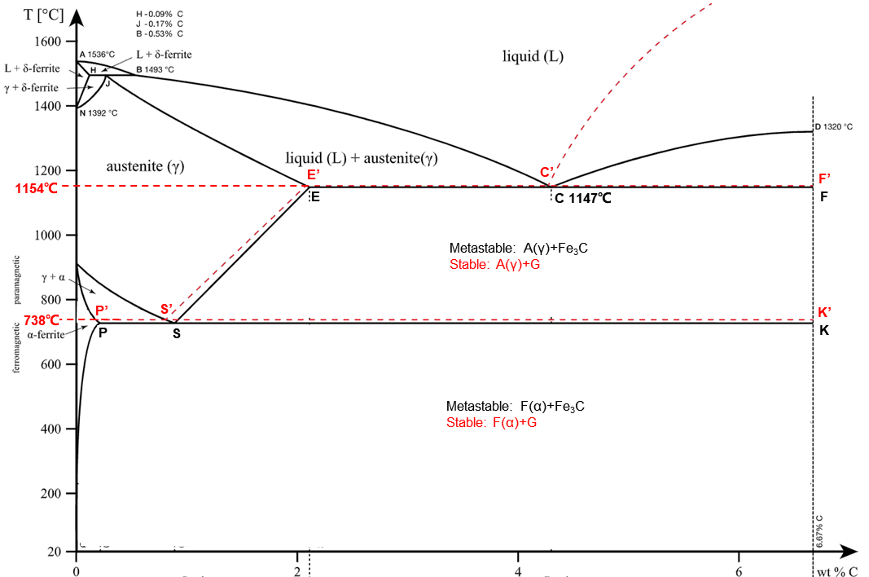
Question1. In which phase diagram does graphitization happen, and how many stages of graphitization are there in this phase diagram? (1pts)
Graphitization follows the stable Fe–graphite (Fe–G) diagram, shown by the red dashed lines, rather than the metastable Fe–Fe₃C diagram. There are three principal stages.
Question2. Please write down the reaction for each stage of graphitization, and point out on which line, or in which region, does each stage of graphitization happen. (3pts)
Stage I — liquid/solidification and high-temperature graphitization: primary graphite precipitates from liquid (L → L + G) in the L + G field above C′F′; the stable eutectic reaction L_C′ → γ_E′ + G_F′ occurs on E′C′F′ at about 1154 °C. High-temperature cementite can also decompose into γ + G.
Stage II — secondary graphite: as austenite carbon solubility decreases along E′S′, γ_(higher C) → γ_(lower C) + G_II in the γ + G field between the stable eutectic and eutectoid temperatures.
Stage III — eutectoid/low-temperature graphitization: γ_S′ → α_P′ + G_K′ on P′S′K′ at about 738 °C. Below this line, cementite may decompose into α + G; decreasing carbon solubility in ferrite can additionally precipitate tertiary graphite in the α + G field.

