xDEMO Code Cookbook
Directory structure
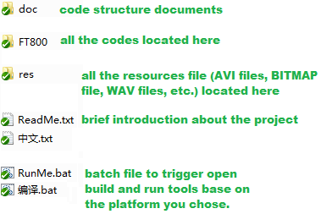

In the FT800 directory
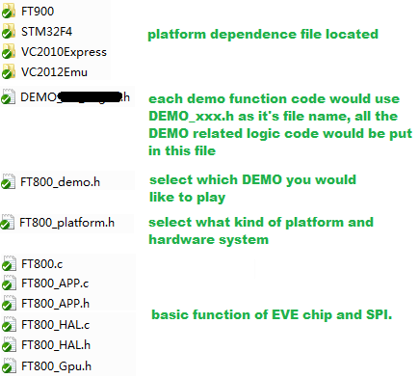
Q&A
- Why we not use the same style as FTDI SampleApp?
  - In SampleApp, MSVC source code (files in “Hdr”, “Src”) only works for MSVC, Arduino code needs to run under other location (Project\Arduino\SampleApp).
    - It means once you modify/debug your codes in MSVC, you need to merge to Arduino code manually…
  - SampleApp is powerful indeed, but too much useless information, it confuse (or threaten) the beginner who just get to know FT800 at the very first stage.
  - SampleApp does have some kind of modulation in coding, but no enough.
    - Each DEMO be provided by SG R&D are in an independent which include all other unnecessary files.
    - Not easy to be cut off the useless function for current customer to use.
    - Not able to integrated the entire existing demo together under one coding structure.
    - I don’t know how R&D do the version control, if each demo create a branch/view to save it (Clocks, Keyboard, Metaball, etc.), and each of them have its own basic function part (e.g. FT_CoPro_Cmds.h, FT_Gpu.h, etc.), if any of the basic function file have a modification in later time (bug fix, functional enhancement, etc). release manger needs to go through each branch/view of its demo’s directory, find each related files, then change it, the more demo we have, the more action they may needs to do in future.
    - For xDemo, all the demos share the same basic function, any of the update in basic function, would automatically have effect to all demos.
- Why use BATCH file?
  - Since by the time I develop this code, Arduino platform have to use CPP file for current code structure, and embedded system have to use C file. In order to avoid user did not change the file name (use CPP while running Arduino, use C while running embedded system) before open particular build environment, we create a batch file to do all the things for user.
  - Another reason is, the code high level logic should not have close relationship with any of MCU or IDE platform, hide those stuff (MCU related build IDE, environment, etc.) for easy management of the whole platform structure.
  - One of our advantage is “able to develop upper level function before the hardware is ready”, in order to achieve it, leave the high level logic part of the code unchanged (no copy/past is needed) to guarantee the previous develop/debug result, the best way is make the only files be changed is platform related.
    - Let’s take SampleApp structure as a bad example:
      - you develop the code under the MSVC platform before you have the embedded hardware, you would have some codes in /Src, /Hdr which all related to the function.
      - By the time you develop Arduino, you have to copy all the files under the /Src, /Hdr, except for those platform related files, you would have to carefully go all through other files to make sure they all have proper modification.
      - It do increase the development loading while switching the platform.
- Why not use “FT_CoPro_Cmds” and “FT_Gpu_Hal” in SampleApp, but use a new way in “FT800_HAL” and “FT800_APP”?
  - It just a study code while I start to learn the FT800, even this whole project’s code structure is made during my study of FT800, as the big boss ask me to give a modulized demo, I was a little bit lazy to create a brand new one, and just keep using my previous one
  - The code in “FT800_HAL” and “FT800_APP” isn’t perfect, or, not good at all, it’s even too personalize, but for me, it looks easy understanding and straightforward than SampleApp’s way
- Do I have to use FT800_HAL.c and FT800_APP.c for FT800 operation?
  - No, you can port the FT_CoPro_Cmds.c, FT_Gpu_Hal.c, and keep using the SampleApp style by using proper precompile define if you like.
- Does “FT800_APP.h” and “FT800_Gpu.h” have all the integrated co-processor command we need?
  - No, you may refer to programmer guide to add the missing co-processor command if current file does not included them.
  - As time goes by, we may add more and more command in it, but I don’t want it omnipotent with all kinds of useless command for current demo at this stage.
- Why not put “FT800_HAL” and “FT800_APP” related files into one directory, and put all the “DEMO” related files into another directory to make the whole xDEMO looks in better structure?
  - Due to the limitation of Arduino platform, it’s not possible to structure the code this way.
- How to read/edit the codes
  - For me, I recommend open sources VIM (whatever under the Windows or Linux).
  - You can also select UltraEdite, SourceInsignt, even notepad application in windows
  - Or, you can just use the MCU related image build IDE such as ArduinoIDE, MSVC2010Express, Keils, Eclipse, etc. if it’s convenience to you.
- How does main routine work and what’s the structure?
  - Read FT800.c/cpp it just a little bit more than 100 lines, easy for a coder to understand

