Results

Perceived depth and glossiness averaged across all observers are shown in Figure #a and Figure #b respectively. The results are binned into three gloss and three depth levels, where low depth (gray) corresponds to depth values [0.8, 1.2, 1.6] cm, medium depth (red) is [2.0, 2.4, 2.8] cm and high depth (green) is [3.2, 3.6, 4.0] cm. Similarly for gloss, low gloss (light shades) corresponds to gloss values of [10, 20, 30] %, medium gloss (medium shades) is [40, 50, 60] % and high gloss (dark shades) is [70, 80, 90] %.
Figure #a shows observers' depth estimates as a function of true depth where colors represent the three different depth levels and the saturation of the colors represent different gloss levels. If the observer perfectly matched perceived depth to true depth, the data would fall on the blue identity line. As can be seen from this figure, perceived depth is overestimated for low depth levels (gray) and underestimated for high depth levels (green). There is no difference in estimated depth across different gloss levels.
Figure #b shows observers' gloss estimates as a function of true glossiness where colors show different depth levels. Estimated glossiness changes depending on the depth level, where stimuli with high depth (green) are judged to be glossier and stimuli with low depth (gray) are underestimated in glossiness.

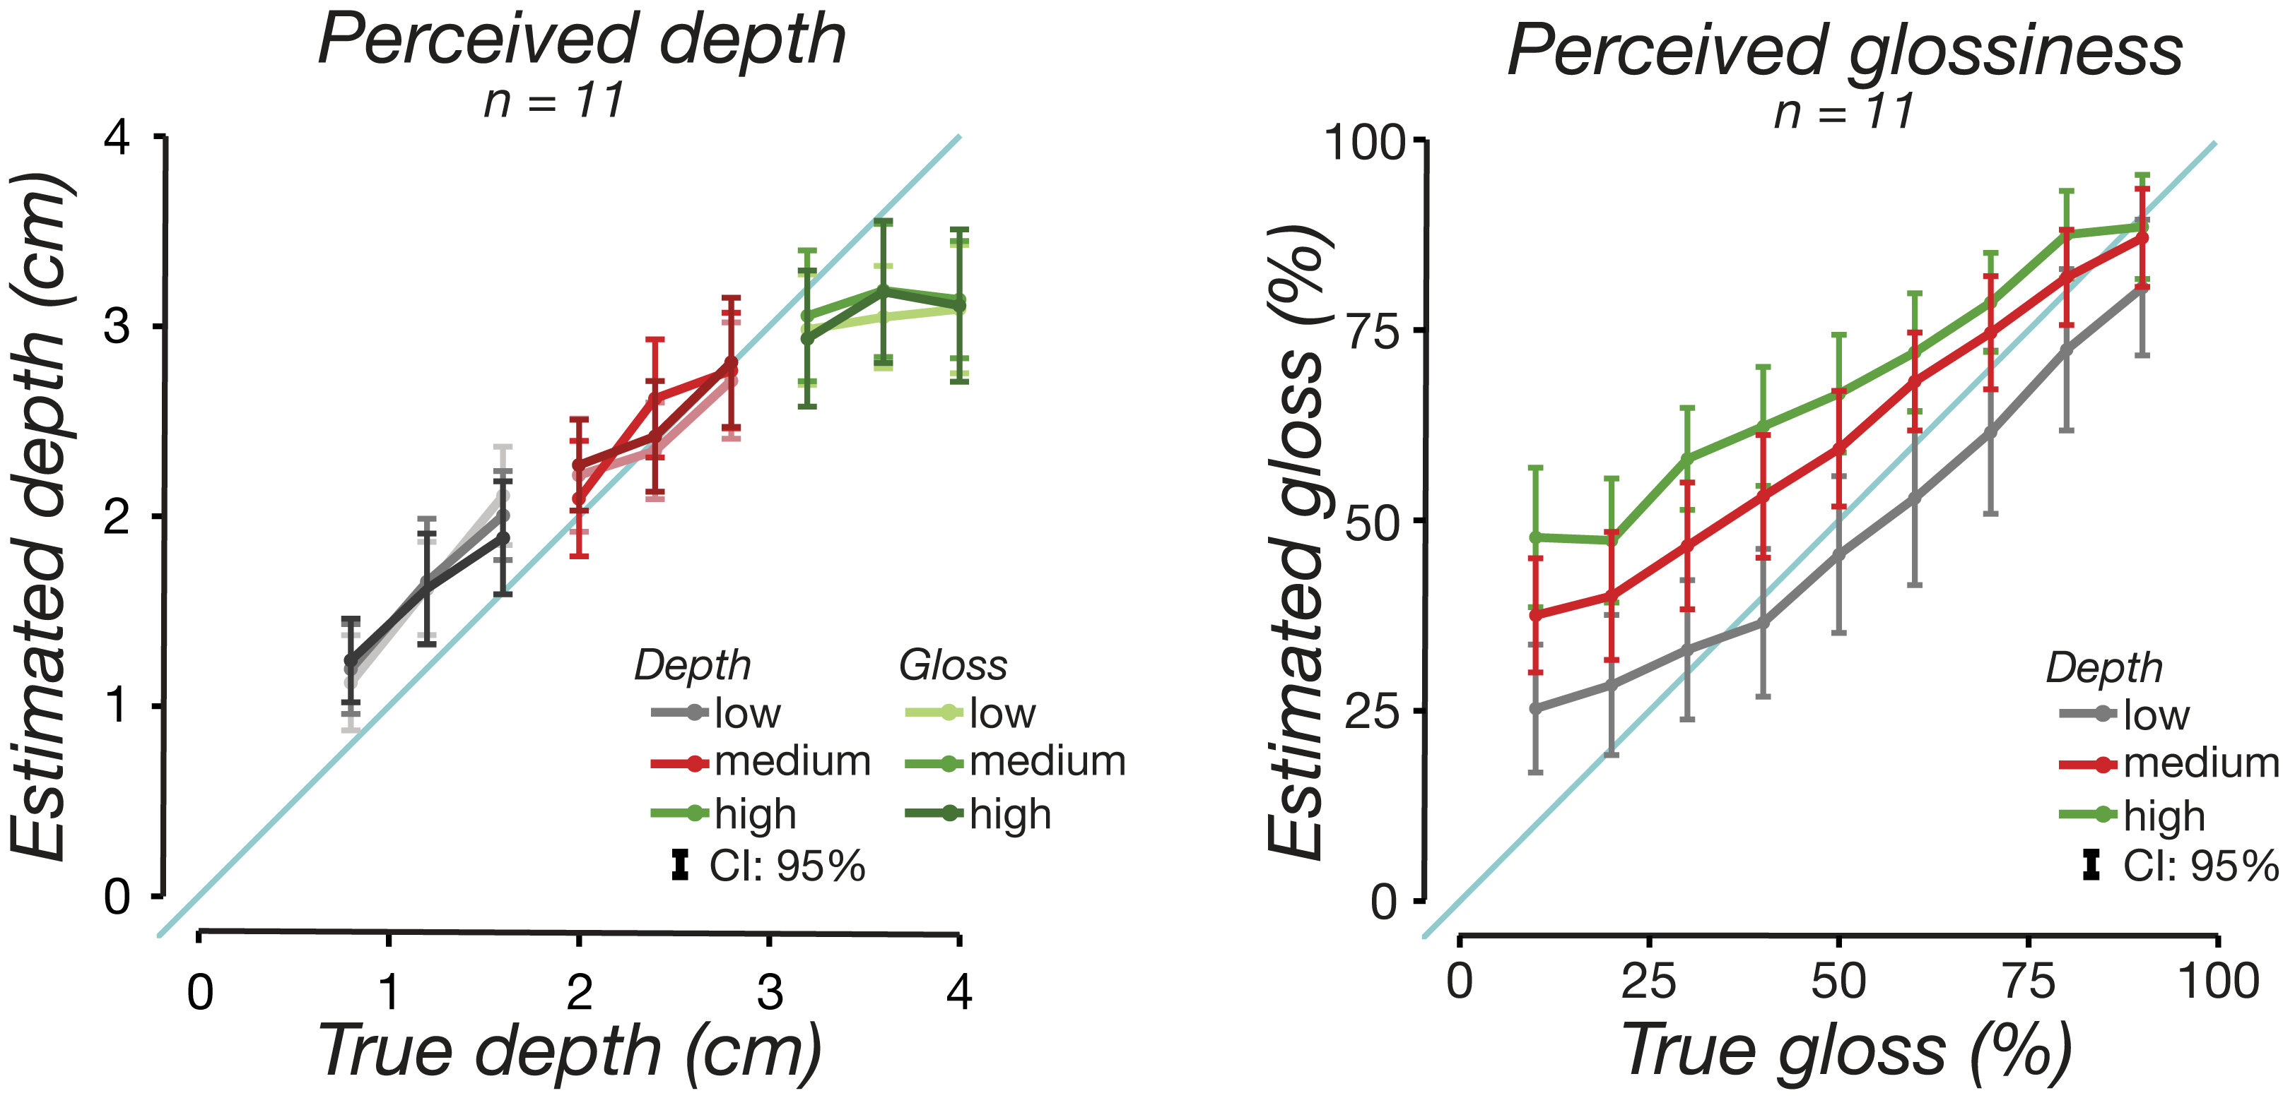

Figure #: Results for the matching task averaged across eleven observers. We converted observers' numerical matches back to centimeters for depth and percentages for gloss. Gloss and depth levels were binned into three groups: low, medium, high. Low gloss: [10, 20, 30] %, medium gloss: [40, 50, 60] %, high gloss: [70, 80, 90] %. Low depth: [0.8, 1.2, 1.6] cm, medium depth: [2.0, 2.4, 2.8] cm, high depth: [3.2, 3.6, 4.0] cm. (a) Perceived depth as a function of true depth averaged across all participants. Low depth (gray) values are overestimated in depth and high depth (green) values are underestimated in depth. There is no difference in depth estimates across different gloss levels. (b) Perceived gloss as a function of true gloss averaged across all participants. Objects with high depth (green) are perceived to be glossier than their true gloss and objects with low depth (gray) are perceived to be less glossy than they are. All error bars are 95% confidence intervals.

We used linear mixed modeling (LMM) to linearly fit estimated gloss and estimated depth while accounting for repeated measurements per participant (Bolker et al., 2009). Random intercepts and slopes per participant were estimated for each main effect to reduce the influence of between-subjects variance on fixed effects estimation (Barr, 2013). For both gloss estimate and depth estimate the factors were gloss and depth levels. The factors were included in the model as summation contrast coded predictors, in other words, fixed effects. Type II Wald chi-square tests were used to test for significant deviation of the estimated parameters from zero, and significant interactions were followed up by ... To compensate for deviations from the normal distribution, estimated depth curves (Fig. #a) were Box-Cox transformed with lambda = -0.?.
We used lme4 package which estimated model parameters with LaPlace approximation (Bates, Mächler, Bolker, & Walker, 2015). (For each model, we conducted 10,000 parametric bootstrap runs to approximate reliable 95% confidence intervals as well as p-values to assess whether parameter estimates significantly differed from zero. - I didn’t do this but might need to.)
The results show a significant main effect of depth on estimated depth (𝛸2(1, N=11) = 3716.04, p<0.001) but no significant main effect of gloss or gloss-depth interaction. For estimated gloss we found a significant main effect of gloss (𝛸2(1, N=11) = 2775.75, p<0.001), depth (𝛸2(1, N=11) =719.25, p<0.001) and gloss-depth interaction (𝛸2(1, N=11) = 27.54, p<0.001).
As we collected a gloss estimate value for each gloss-depth pair, we can create a contour plot from this data that shows the equi-gloss contours averaged across all observers. Figure # shows this contour plot for true gloss as a function of true depth where the red lines are equi-gloss contours and the gray shading show the average gloss estimate for a given gloss-depth pair. Any two gloss values that fall on the same equi-gloss contour are, on average, perceived to be equally glossy.
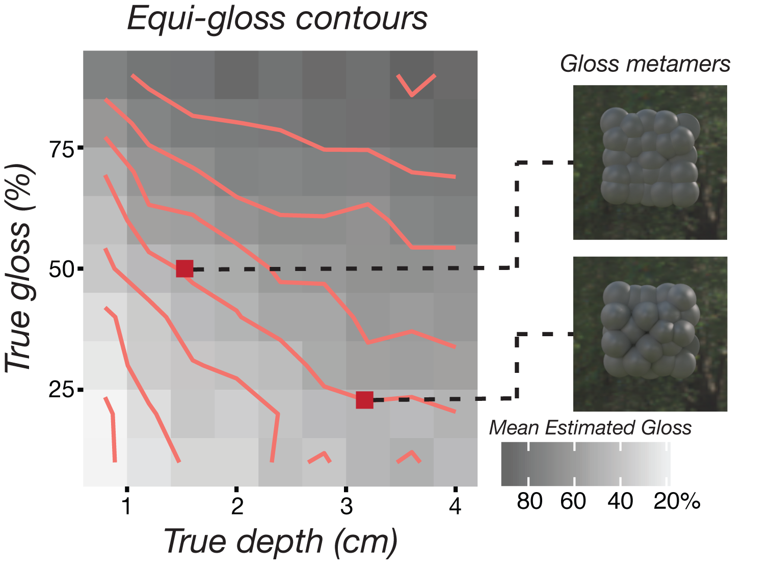
Figure #: Equi-gloss contours for each true gloss-depth pair averaged across all observers (N=11). The red lines represent the equi-gloss contour lines. Any two gloss-depth pair that falls on a given line are perceived to be equally glossy. The perceived gloss level is indicated by the gray shading in the background where darker shades mean higher gloss level. The two red squares show a pair of gloss metamers: The stimulus that has 20% gloss and 3.2 cm depth (bottom) is perceived to be as glossy as 50% gloss and 1.6 cm depth (top).

