Soft-reC
Design Recovery and Quality Assessment Report
Version 1.0

Ζουγιανός Γεώργιος, 2442

Table of Contents
Introduction 3
Design Recovery 3
Architecture 4
Detailed Design 4
Implementation 7
Quality Assessment 15

Introduction
The goal of this phase is to do a review on the legacy version of the software. This is the document that contains the diagrams of the architecture (UML) and a CRC card of each class in the project. It also contains general flaws found in the project.

Design Recovery

Architecture
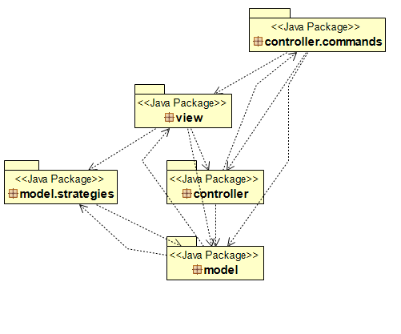

Detailed Design
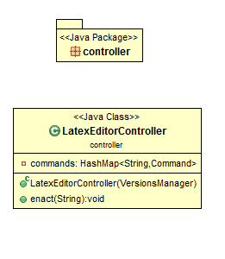

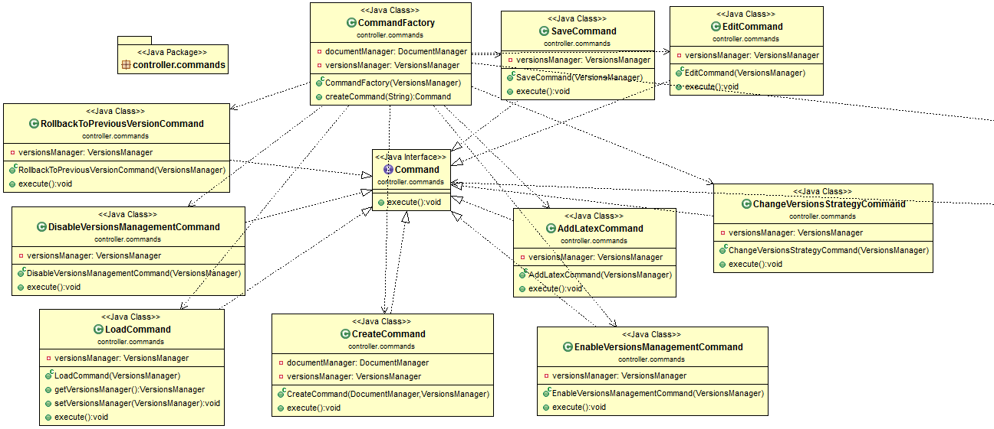

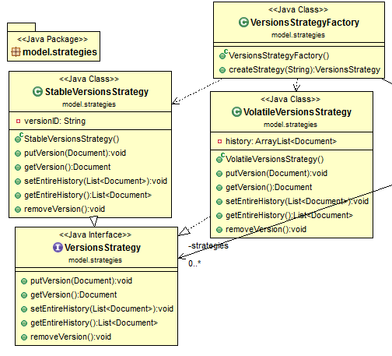
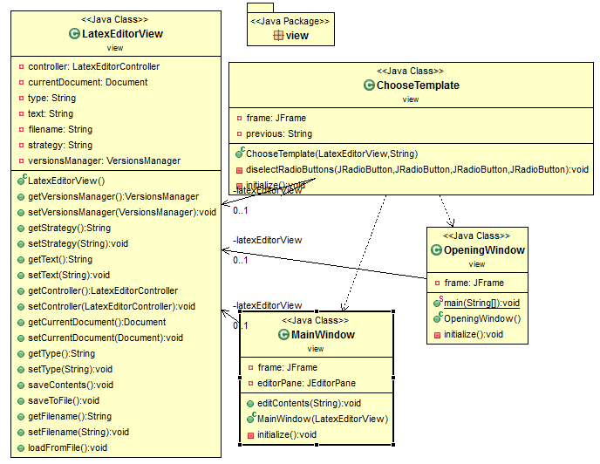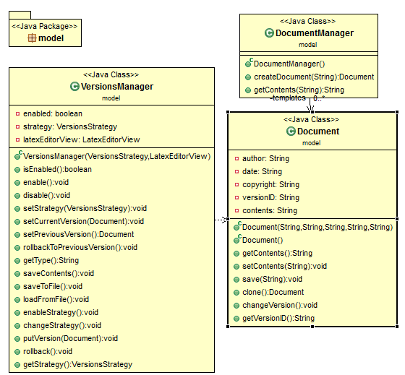

Implementation

Class Name: controller. LatexEditorController
Responsibilities | Collaborations
- Holds Command Interface implementation instances  - Executes commands | - controller.commands.Command  - controller.commands.CommandFactory  - model.VersionsManager

Class Name: controller.commands. AddLatexCommand
Responsibilities | Collaborations
- Implement Command Interface  - Saves the content of a Document | - model.VersionsManager

Class Name: controller.commands. DisableVersionsManagementCommand
Responsibilities | Collaborations
- Implement Command Interface  - Disables version manager. | - model.VersionsManager

Class Name: controller.commands. EditCommand
Responsibilities | Collaborations
- Implement Command Interface  - Saves the content of a Document | - model.VersionsManager

Class Name: controller.commands. EnableVersionsManagementCommand
Responsibilities | Collaborations
- Implement Command Interface  - Enables version strategy in VersionsManager | - model.VersionsManager

Class Name: controller.commands. CreateCommand
Responsibilities | Collaborations
- Implements Command Interface  - Create a new document  - Changes the current document of VersionsManager | - model.VersionsManager  - model. DocumentManager

Class Name: controller.commands. ChangeVersionsStrategyCommand
Responsibilities | Collaborations
- Implements Command Interface  - Changes the version strategy of a VersionsManager | - model.VersionsManager

Class Name: controller.commands. CommandFactory
Responsibilities | Collaborations
- Create instances of Command interface implementations | - model.DocumentManager  - model.VersionsManager

Class Name: controller.commands. LoadCommand
Responsibilities | Collaborations
- Implement Command Interface  - Asks user to give a file name and loads a document from it | - model.VersionsManager

Class Name: controller.commands. RollbackToPreviousVersionCommand
Responsibilities | Collaborations
- Implement Command Interface  - Rolls back to previous version the current document VersionsManager is managing | - model.VersionsManager

Class Name: controller.commands. SaveCommand
Responsibilities | Collaborations
- Implement Command Interface  - Saves the document in a file in hard disk. | - model.VersionsManager

Class Name: model.Document
Responsibilities | Collaborations
- Represent a latex document, having all the necessary properties. | - -

Class Name: model. DocumentManager
Responsibilities | Collaborations
- Implements the prototype design pattern in order to create new documents based on content templates.  - Create new documents based on templates. | - -

Class Name: model.VersionsManager
Responsibilities | Collaborations
- Handling the version strategy of the current version  - Rollback a document to its previous version  - Holds the versions of the document. | - model.strategies.StableVersionsStrategy;  - model.strategies.VersionsStrategy;  - model.strategies.VolatileVersionsStrategy;  - view.LatexEditorView;

Class Name: model.strategies. StableVersionsStrategy
Responsibilities | Collaborations
- Implement VersionStrategy interface | - model.Document

Class Name: model.strategies. VolatileVersionsStrategy
Responsibilities | Collaborations
- Implement VersionStrategy interface | - model.Document

Class Name: model.strategies. VersionsStrategyFactory
Responsibilities | Collaborations
- Holds one instance of all VersionStrategy implementations | - -

Class Name: view. ChooseTemplate
Responsibilities | Collaborations
- Show the user a window that lets him choose the template of the document he wants to create | - View.LatexEditorView

Class Name: view. LatexEditorView
Responsibilities | Collaborations
- Load document from a file on disk  - Save document to a file on disk  - Holds an instance of LatexEditorController class | - controller.LatexEditorController;  - model.Document;  - model.VersionsManager;

Class Name: view. MainWindow
Responsibilities | Collaborations
- Represents application’s main GUI window.  - Edit the contents of the document  - Save a document in a file.  - Changes the current version strategy | - model.Document

Class Name: view.OpeningWindow
Responsibilities | Collaborations
- Creates an instance of VersionsManager class  - Creates an instance of LatexEditorController class  - Creates an instance of LatexEditorView class  - Represent the welcome screen view | - controller.LatexEditorController;  - model.VersionsManager;  - model.strategies.VersionsStrategy;  - model.strategies.VolatileVersionsStrategy;

Quality Assessment

- Bad project structure.
  - Test files can be found inside a package of the main source code. Instead they should have a separated source folder that should not be included inside the source folder. Test files have no reason to be exported (included inside .jar) during the deployment phase.
  - All files that are being a part of tests should be inside a subfolder inside test directory, and not in project’s parent directory.
- The name of some classes does not represent their responsibilities. In specific:
  - LatexEditorController is named as a Controller and the only thing it is doing is to execute Commands. In a project where MVC is part of the architecture (or should be), it is better to use this naming convention for the Controllers of the design pattern.
  - CreateCommand. Create what? The name should specify what is being created. Something like CreateDocumentCommand fits better. Same applies to EditCommand, LoadCommand and to SaveCommand.
  - VersionsManager . It should be VersionManager. Singular, not plural.
- A lot of hard coded values.
  - Biggest problem is in DocumentManager#getContents. Instead of a String variable, an enumeration (with all document types) sounds way better and reliable to create documents. Also, having the contents of a template like this adds a lot of unnecessary lines to source code. Besides, it increased the code we must change if we would like to add new document templates in the future.
- Commands are not really commands. At least the ones from the command pattern.
  - Most of them depend on a VersionsManager object and each of them is ONLY calling methods to it. As a result, VersionsManager class has tons of responsibilities and each implementation of Command interface has no reason of existence.
  - Also, DocumentManager and VersionsManager do not seem like Model classes. Then why are they inside model package? Should be moved somewhere else.
- Model-View-Controller does not exist.
  - Naming a class Controller, another View and the next Model does not we have implemented MVC. As already mentioned, LatexEditorController is not even close to a MVController. Views are way off as well. Taking a look at MainWindow class, we can see that it is doing more things that it should.
  - Views should be split in order to decrease the size of the classes and controllers. For example, assuming for MainView we have MainViewController, a nested MenuBarView and a MenuBarViewController should be created, in order to remove some responsibilities from main view and its controller.
- Adding predefined latex commands should not be like that
  - See MainWindow#editContents. What if one day we decide to add 100 predefined latex commands? Having them all hard coded in source code does not sound correct, nor optimal. There are a lot of ways to improve this. I would create a new Model class named PredefinedLatexCommand, having properties like “description” (the description user sees), “text” (the text of the latex command) and probably a kind of structure with the allowed document types that can be added into. Then a AddPredefinedLatexCommand(JTextComponent, PredefinedLatexCommand) implements Command sounds appropriate.
- Duplicated code when it comes to read/write files.
  - Creating a class to manage file writing/reading sounds better and makes the IO debugging easier.
- VersionsStrategyFactory is not an actual factory.
  - It does not create version strategies. It creates them once and then return the already existing ones. It looks more like a repository.
- LatexEditorView is not a view class hence its name and its package is wrong.

