Soft-reC
Design Recovery and Quality Assessment Report
Version 1.0

Ζουγιανός Γεώργιος, 2442

Table of Contents
Introduction 3
Design Recovery 3
Architecture 4
Detailed Design 4
Implementation 7
Quality Assessment 15

Introduction
The goal of this phase is to do a review on the legacy version of the software. This is the document that contains the diagrams of the architecture (UML) and a CRC card of each class in the project. It also contains general flaws found in the project.

Design Recovery

Architecture
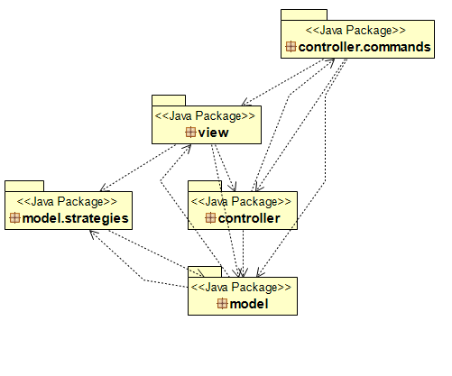

Detailed Design
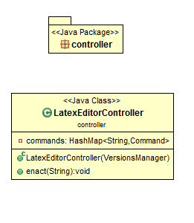

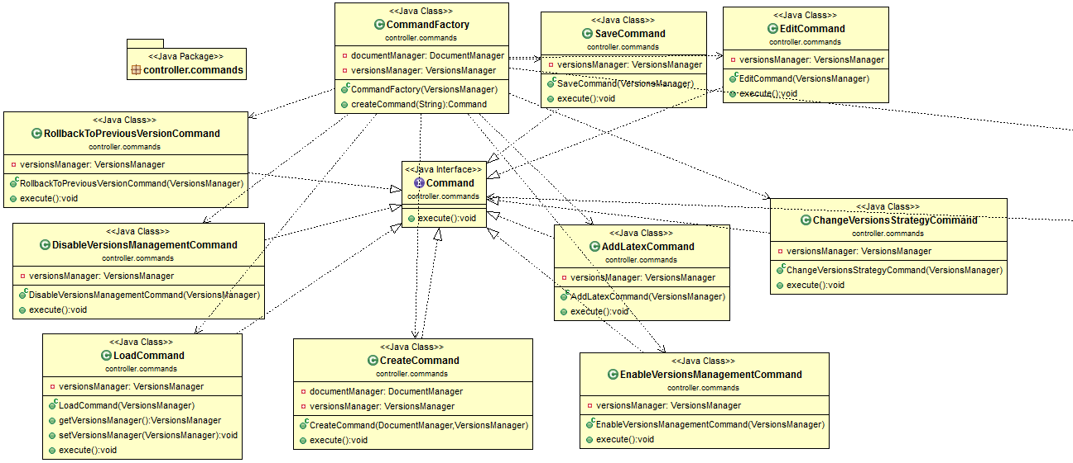

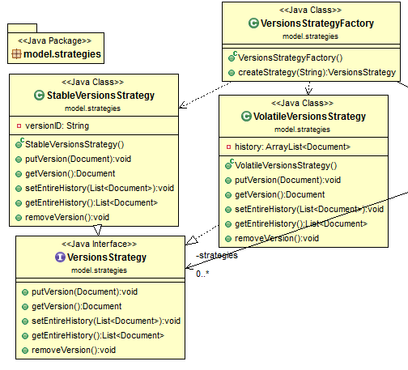
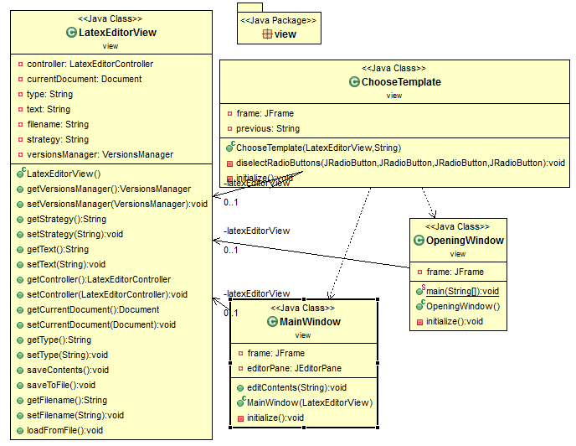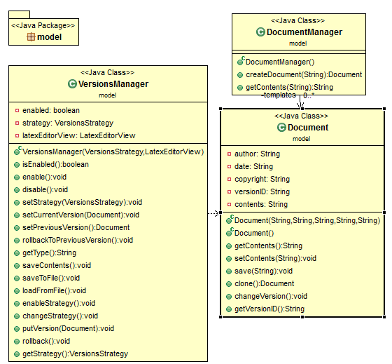

Implementation

Class Name: controller. LatexEditorController
Responsibilities | Collaborations
- Holds Command Interface implementation instances  - Executes commands | - controller.commands.Command  - controller.commands.CommandFactory  - model.VersionsManager

Class Name: controller.commands. AddLatexCommand
Responsibilities | Collaborations
- Implement Command Interface  - Saves the content of a Document | - model.VersionsManager

Class Name: controller.commands. DisableVersionsManagementCommand
Responsibilities | Collaborations
- Implement Command Interface  - Disables version manager. | - model.VersionsManager

Class Name: controller.commands. EditCommand
Responsibilities | Collaborations
- Implement Command Interface  - Saves the content of a Document | - model.VersionsManager

Class Name: controller.commands. EnableVersionsManagementCommand
Responsibilities | Collaborations
- Implement Command Interface  - Enables version strategy in VersionsManager | - model.VersionsManager

Class Name: controller.commands. CreateCommand
Responsibilities | Collaborations
- Implements Command Interface  - Create a new document  - Changes the current document of VersionsManager | - model.VersionsManager  - model. DocumentManager

Class Name: controller.commands. ChangeVersionsStrategyCommand
Responsibilities | Collaborations
- Implements Command Interface  - Changes the version strategy of a VersionsManager | - model.VersionsManager

Class Name: controller.commands. CommandFactory
Responsibilities | Collaborations
- Create instances of Command interface implementations | - model.DocumentManager  - model.VersionsManager

Class Name: controller.commands. LoadCommand
Responsibilities | Collaborations
- Implement Command Interface  - Asks user to give a file name and loads a document from it | - model.VersionsManager

Class Name: controller.commands. RollbackToPreviousVersionCommand
Responsibilities | Collaborations
- Implement Command Interface  - Rolls back to previous version the current document VersionsManager is managing | - model.VersionsManager

Class Name: controller.commands. SaveCommand
Responsibilities | Collaborations
- Implement Command Interface  - Saves the document in a file in hard disk. | - model.VersionsManager

Class Name: model.Document
Responsibilities | Collaborations
- Represent a latex document, having all the necessary properties. | - -

Class Name: model. DocumentManager
Responsibilities | Collaborations
- Implements the prototype design pattern in order to create new documents based on content templates.  - Create new documents based on templates. | - -

Class Name: model.VersionsManager
Responsibilities | Collaborations
- Handling the version strategy of the current version  - Rollback a document to its previous version  - Holds the versions of the document. | - model.strategies.StableVersionsStrategy;  - model.strategies.VersionsStrategy;  - model.strategies.VolatileVersionsStrategy;  - view.LatexEditorView;

Class Name: model.strategies. StableVersionsStrategy
Responsibilities | Collaborations
- Implement VersionStrategy interface | - model.Document

Class Name: model.strategies. VolatileVersionsStrategy
Responsibilities | Collaborations
- Implement VersionStrategy interface | - model.Document

Class Name: model.strategies. VersionsStrategyFactory
Responsibilities | Collaborations
- Holds one instance of all VersionStrategy implementations | - -

Class Name: view. ChooseTemplate
Responsibilities | Collaborations
- Show the user a window that lets him choose the template of the document he wants to create | - View.LatexEditorView

Class Name: view. LatexEditorView
Responsibilities | Collaborations
- Load document from a file on disk  - Save document to a file on disk  - Holds an instance of LatexEditorController class | - controller.LatexEditorController;  - model.Document;  - model.VersionsManager;

Class Name: view. MainWindow
Responsibilities | Collaborations
- Represents application’s main GUI window.  - Edit the contents of the document  - Save a document in a file.  - Changes the current version strategy | - model.Document

Class Name: view.OpeningWindow
Responsibilities | Collaborations
- Creates an instance of VersionsManager class  - Creates an instance of LatexEditorController class  - Creates an instance of LatexEditorView class  - Represent the welcome screen view | - controller.LatexEditorController;  - model.VersionsManager;  - model.strategies.VersionsStrategy;  - model.strategies.VolatileVersionsStrategy;

Quality Assessment

- Bad project structure.
  - Test files can be found inside a package of the main source code. Instead they should have a separated source folder that should not be included inside the source folder. Test files have no reason to be exported (included inside .jar) during the deployment phase.
  - All files that are being a part of tests should be inside a subfolder inside test directory, and not in project’s parent directory.
- The name of some classes does not represent their responsibilities. In specific:
  - LatexEditorController is named as a Controller and the only thing it is doing is to execute Commands. In a project where MVC is part of the architecture (or should be), it is better to use this naming convention for the Controllers of the design pattern.
  - CreateCommand. Create what? The name should specify what is being created. Something like CreateDocumentCommand fits better. Same applies to EditCommand, LoadCommand and to SaveCommand.
  - VersionsManager . It should be VersionManager. Singular, not plural.
- A lot of hard coded values.
  - Biggest problem is in DocumentManager#getContents. Instead of a String variable, an enumeration (with all document types) sounds way better and reliable to create documents. Also, having the contents of a template like this adds a lot of unnecessary lines to source code. Besides, it increased the code we must change if we would like to add new document templates in the future.
- Commands are not really commands. At least the ones from the command pattern.
  - Most of them depend on a VersionsManager object and each of them is ONLY calling methods to it. As a result, VersionsManager class has tons of responsibilities and each implementation of Command interface has no reason of existence.
  - Also, DocumentManager and VersionsManager do not seem like Model classes. Then why are they inside model package? Should be moved somewhere else.
- Model-View-Controller does not exist.
  - Naming a class Controller, another View and the next Model does not we have implemented MVC. As already mentioned, LatexEditorController is not even close to a MVController. Views are way off as well. Taking a look at MainWindow class, we can see that it is doing more things that it should.
  - Views should be split in order to decrease the size of the classes and controllers. For example, assuming for MainView we have MainViewController, a nested MenuBarView and a MenuBarViewController should be created, in order to remove some responsibilities from main view and its controller.
- Adding predefined latex commands should not be like that
  - See MainWindow#editContents. What if one day we decide to add 100 predefined latex commands? Having them all hard coded in source code does not sound correct, nor optimal. There are a lot of ways to improve this. I would create a new Model class named PredefinedLatexCommand, having properties like “description” (the description user sees), “text” (the text of the latex command) and probably a kind of structure with the allowed document types that can be added into. Then a AddPredefinedLatexCommand(JTextComponent, PredefinedLatexCommand) implements Command sounds appropriate.
- Duplicated code when it comes to read/write files.
  - Creating a class to manage file writing/reading sounds better and makes the IO debugging easier.
- VersionsStrategyFactory is not an actual factory.
  - It does not create version strategies. It creates them once and then return the already existing ones. It looks more like a repository.
- LatexEditorView is not a view class hence its name and its package is wrong.

Re-engineered Design

Architecture
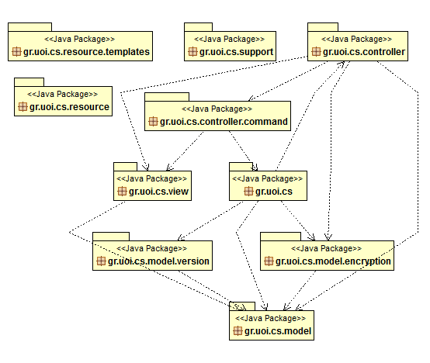

Detailed Design
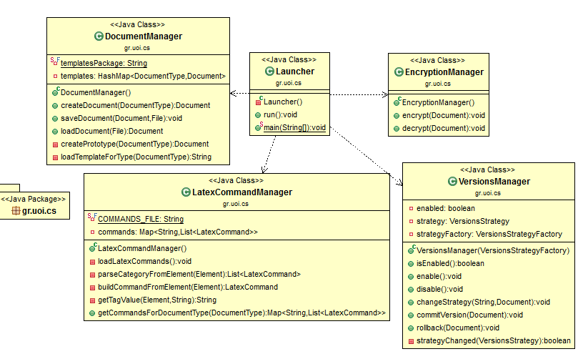

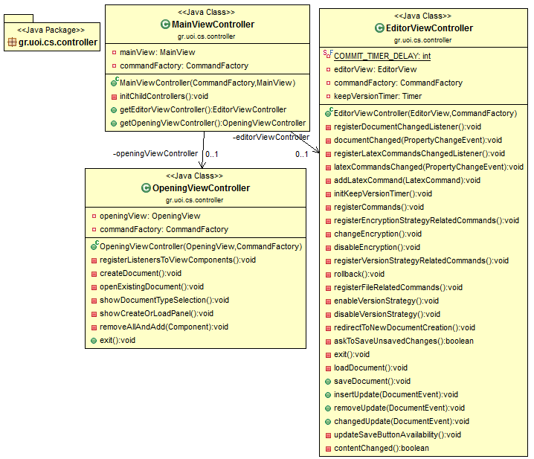

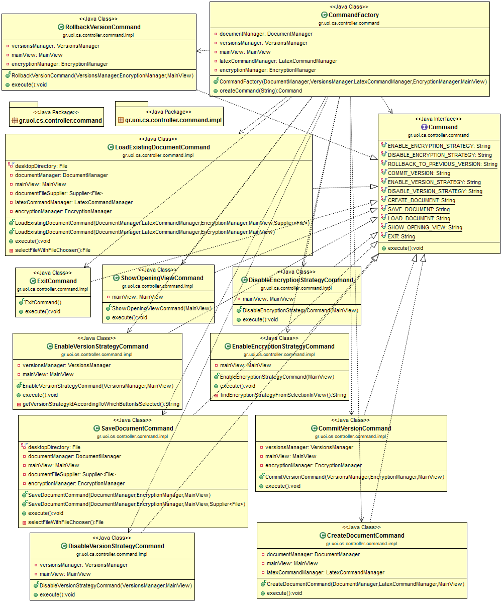
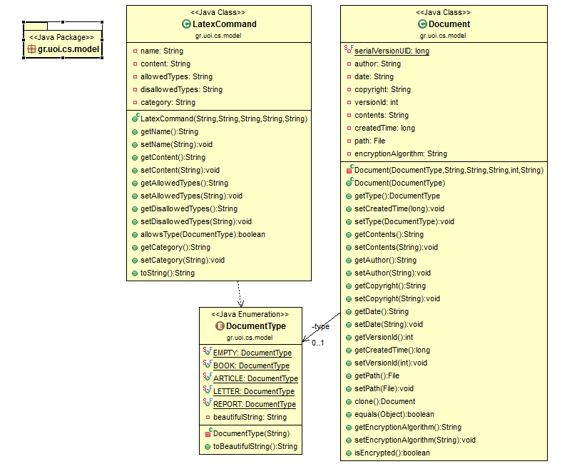
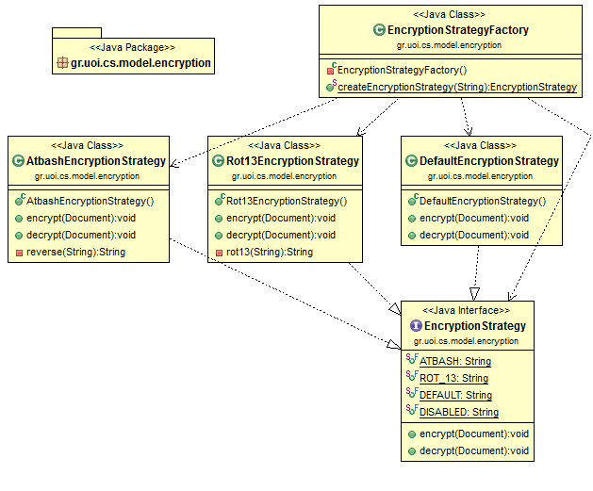

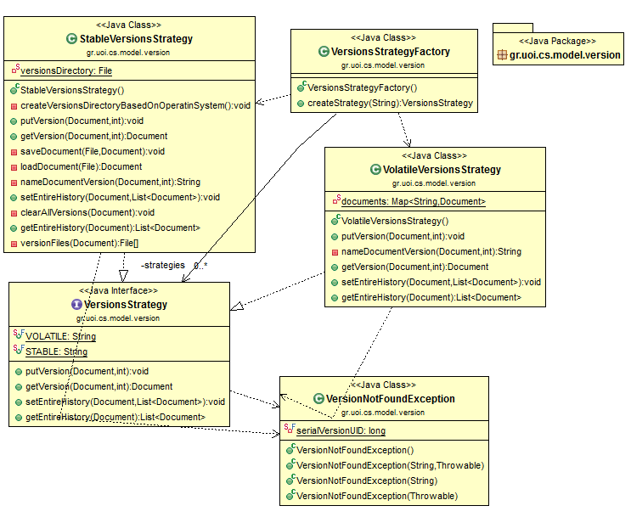
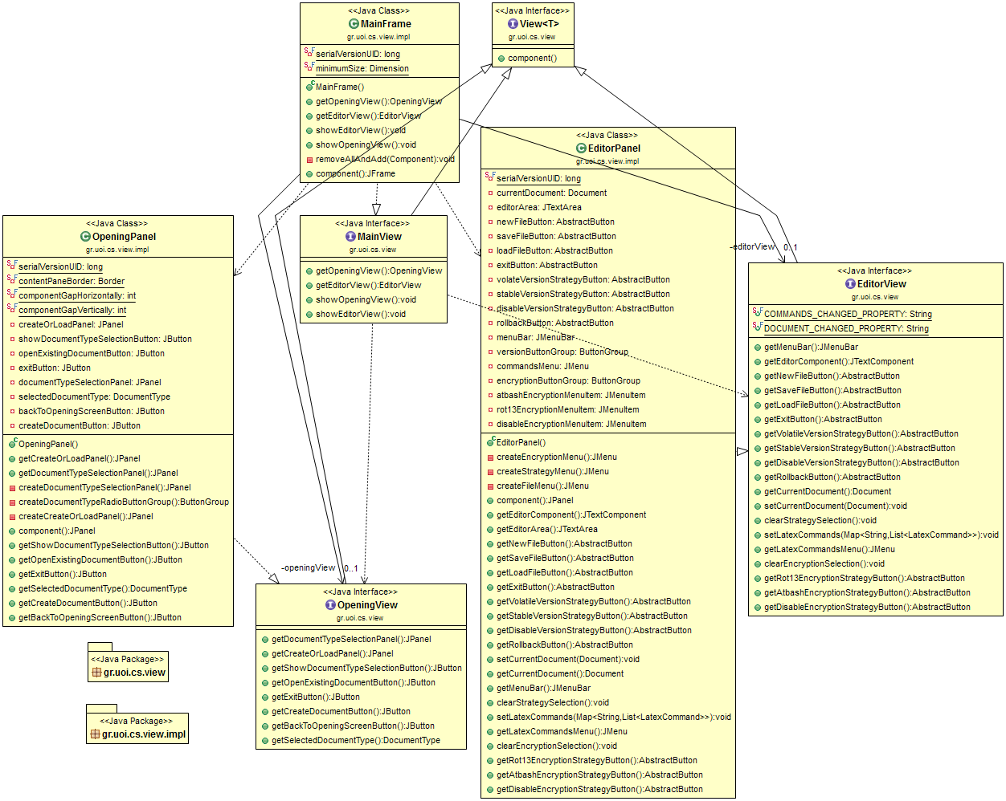
- Improved project’s structure. In specific a new source folder named “test” created with all test files in there. Also deleted rest of the files (mostly test-result files) from the parent directory. In addition, a package refactoring took place. All packages are based on the same parent package gr.uoi.cs. Project now looks like this: 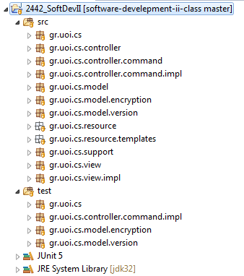
- Implemented the MVC pattern properly and each view class has its own controller class (MainView is controlled by MainViewController, OpeningView is controlled by OpeningViewController etc). All view classes are views. That means they do not respond to any user’s action, nor they are responsible to handle/manage backend data. For every user’s action the corresponding controller of the view will handle it.
- Command classes (of the command design pattern) will do something. In the legacy version of the software, many of them they were just calling a single method of another class.
- Huge naming and packaging refactoring. Class names are now improved and more detailed. For example, CreateCommand class which was responsible for a document creation renamed to CreateDocumentCommand. Manager classes will not be found under model package. They are moved to the main package of the software which is gr.cs.uoi. Also all names (of anything – classes/fields/packages) like “EnableStrategy”,”ChangeStrategy” include the word “Version” since they refer to version strategy. The project includes the extended use case which is strategies of encryption (following the strategy pattern).
- CommandFactory does not create commands with hard coded Strings. All command identifier Strings can be found in Command Interface. Instead of doing commandFactory.createCommand(“createdocument”), you will commandFactory.createCommand(Command.CREATE_DOCUMENT). It is always better to have final static constants instead of hard coded strings.
- Created the DocumentType class (under model package), which is an enumeration containing all the types of the document. This helps on identifying the type of the document and on creation based on prototypes. DocumentManager will create a document based on a template (prototype pattern) according to the document type argument. With other words, DocumentManager#createDocument(String type) is now DocumentManager#createDocument(DocumentType type).
- Added all getters and setters to Document class since objects of this class can be used as models in the view. (What if the view wants to show all the values of the documents?)
- Document templates will be loaded dynamically from files in disk (inside gr.cs.uoi.resource.templates package). DocumentManager will load the contents of each template at start up instead of having them hardcoded in source code. Then prototype pattern will take place. Each time a document is being created the file will NOT be loaded.
- Changed the way documents are being saved/loaded. They will now be serialized/deserialized with java’s standard way of serialization. In the legacy software they were raw text files that were keeping only the document contents and not other fields (like author, date, etc).
- Predefined latex commands removed from being hard coded in source code. They can be found now inside gr.cs.uoi.resource.latex_commands.xml file. If a next version of the software will require more of them, editing the source code will not be necessary. These commands are represented by model.LatexCommand class and managed by LatexCommandManager (see the CRC card below).
- Created Laucher class which is responsible to handle application launching (include the main method).
- Removed the dependency of LatexEditorView from VersionsManager. VersionsManager will now take a Document as argument in methods that affect a document. Decoupling a backend manager class from a view will increase its testability.
- Implemented the extended use case which is the availability to encrypt/decrypt a document based on an algorithm which is selected by the user. This problem solved by following the same solution as the versioning. Strategy design pattern applied with an EncryptionStrategy interface and all of its implementations be the encryption algorithms. Each document has an encryption algorithm (as field) and encryption manager will be able to encrypt/decrypt it. User is able to select the encryption strategy just like the version strategy (via a menu). Unfortunately, the encryption/decryption of the document cannot be seen directly in files since they are saved as serialized objects but the corresponding unit tests of the algorithms will make it clear.
- Removed useless comments and Eclipse IDE annoying auto-generated comments from source code.
- Rewritten from scratch all unit tests after changes have been applied.

Implementation
- For each class that has been ADDED or CHANGED give a brief description in terms of a CRC card (see the format below)
Class Name:
Responsibilities | Collaborations
- List the responsibilities of the class in simple precise statements - don't use passive voice.  - E.g., This class is responsible for this task.  - This class performs this activity... | - List the dependencies and associations of this class with the other classes of the project

