LatexEditor
Release Report (2nd Version)

Authors:
ΖΟΥΓΙΑΝΟΣ ΓΕΩΡΓΙΟΣ (ZOUGIANOS GEORGIOS), 2442
ΤΖΙΟΛΑΣ ΓΕΩΡΓΙΟΣ (TZIOLAS GEORGIOS), 2591
ΤΣΑΚΝΑΚΗ ΕΛΕΥΘΕΡΙΑ (TSAKNAKI ELEFTHERIA), 2559
Versions History
Date | Version | Description
18/03/2019 | Release  Plan | The first turnin concerning the Use Cases and the programming of the implementation of the project.
17/04/2019 | 1.0 | First project implementation regarding the following user stories: US-1, US-2, US-3, US-6, US-8, US-9.
19/05/2019 | 2.0 | Second (and final) project release. All user stories have been implemented with emphasis to missing ones which are related to “version control” of a LaTeX document. These are US-4, US-5 and US-7.

Introduction
This document provides information concerning the 2nd release of the project.

Purpose
Latex is a well known high quality document preparation markup language. It provides a large variety of styles and commands that enable advanced document formatting. Typically, a Latex document is compiled with a tool like MikTex, Lyx, etc. to produce a respective formatted document in pdf, ps, etc. Formatting documents with Latex is a programming like process as it involves the proper usage of Latex commands which are embedded in the document contents. The objective of this project is to develop a simple Latex editor for inexperienced Latex users. The goal of the editor is to facilitate the usage of Latex commands for the preparation of Latex documents. One of the prominent features that distinguishes the LatexEditor from other similar applications is its multi-strategy version tracking functionalities that enable undo and redo actions.

Document Structure
The rest of this document is structured as follows. Section 2 specifies the acceptance tests that have been employed for this release of the project. Section 3 specifies the main design concepts for this release of the project.

Tests
2.1 Tests for User Story <1> (since 1st release)

Test ID | 1
User Story | 1
Test Class | DocumentRelatedTests
Description | Validate that DocumentManager#createDocument method creates the
 | document properly with the selected template. If no template(document type)
 | is given the document is created empty. -- Two documents are created; one of
 | them is using the constructor of the document class with predefined
 | arguments and the other is created by document manager. The expected
 | result is that these two documents will be equal.
 | Page 3

2.2 Tests for User Story <2> (since 1st release)

Test ID | 2
User Story | 2
Test Class | -
Description | GUI related. It is not being tested automatically.

2.3 Tests for User Story <3> (since 1st release)

Test ID | 3
User Story | 3
Test Class | CommandsTest
Description | Validate that certain text commands can be used in certain documents only.
 | Validate also that the text command is being inserted in the text component
 | properly and in the proper position (caret’s index).

2.4 Design Tests for User Story <6> (since 1st release)

Test ID | 6
User Story | 6
Test Class | -
Description | GUI related. It is not being tested automatically

2.5 Tests for User Story <8, 9> (since 1st release)

Test ID | 8
User Story | 8, 9
Test Class | DocumentRelatedTests
Description | Validate that the DocumentManager can serialize and deserialize document
 | objects; A new document is being created, DocumentManager saves it. Then
 | DocumentManager loads a document with the same path and finally we
 | expect that these documents are equal.

Tests for User Story <4, 7>
Test ID | neverKeptAVersion
User Story | User Story – 4, 7
Test Class | StableVersionStrategyTests
Description | A document is being created. Its version strategy is being changed to stable. Then we call VersionsManager#rollToPreviousVersion and we expect a NoPreviousVersionException to be thrown since we have never kept a version before.

Test ID | main
User Story | User Story – 4, 7
Test Class | StableVersionStrategyTests
Description | A document is being created. Its version strategy is being changed to stable. After that, we change its content and we commit the version calling VersionsManager#commitVersion method. Then we change its content agai. and we call VersionsManager#rollToPreviousVersion expecting its content to be the same as the content it had before the second change. Finally we repeat this process, but moving ahead two versions instead of one.
(To be continued in the next page...)
Test ID | keepTwoAndGoBackThree
User Story | User Story – 4, 7
Test Class | StableVersionStrategyTests
Description | Similar to neverKeptAVersion test, but instead of trying to go to previous version without keeping one, it keeps two versions, but asks to go back three versions. Our expecting result is a NoPreviousVersionException.

Test ID | previousVersions
User Story | User Story – 4, 7
Test Class | StableVersionStrategyTests
Description | A document is being created. Its version strategy is being changed to stable. At first, we expect VersionsManager#getPreviousVersions to return an empty list. Then we commit a version of the document and finally we expect that VersionsManager#getPreviousVersions will return a list with size equals to 1.

Tests for User Story <5>
Test ID | -
User Story | User Story – 5
Test Class | -
Description | GUI related. It is not being tested automatically.

Note that tests described in section 2.6 are taking place for Volatile version strategy as well.

Design

Architecture
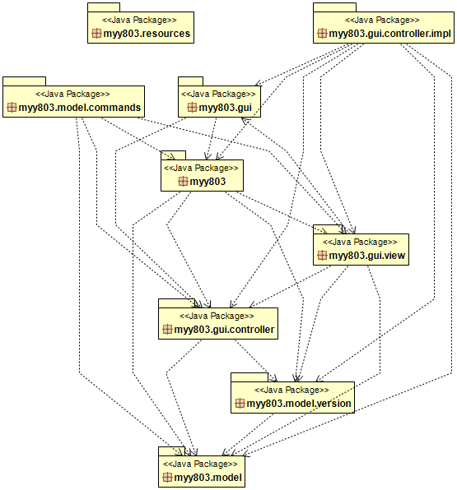

Design

(Image online: https://raw.githubusercontent.com/gzougianos/software-engineering-class/master/UML/uml_class_diagram_v2.png)
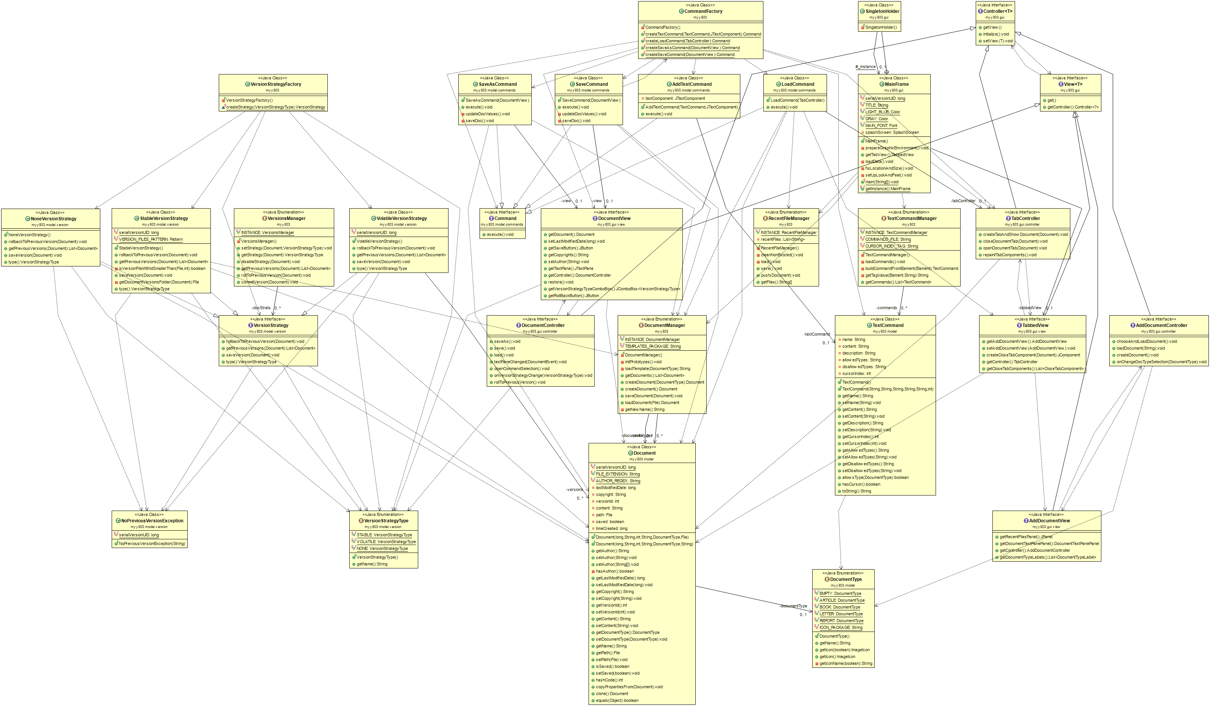

CRC cards for core classes

Class Name: myy803.CommandFactory
Responsibilities:  - Factoring commands | Collaborations:  - All implementations of Command  - TextCommand

Class Name: myy803.DocumentManager
Responsibilities:  - Hold all opened documents  - Create Document  - Save Document  - Load Document | Collaborations:  - Document  - Classes of java.io package

Class Name: myy803.RecentFileManager
Responsibilities:  - Hold all recently opened documents | Collaborations:  - Classes of java.io package

Class Name: myy803.TextCommandManager
Responsibilities:  - Hold all predefined LaTeX commands (TextCommand) that user is able to choose and add. | Collaborations:  - Resources (commands.xml)  - Classes of org.w3c.dom package  - Classes of javax.xml.parsers package

Class Name: myy803.gui.MainFrame
Responsibilities:  - Load the backend data  - Initialize GUI | Collaborations:  - DocumentManager  - TextCommandManager  - RecentFileManager  - TabbedView  - TabbedController  - Web look and feel

Class Name: myy803.gui.controller.impl.AddDocumentControllerImpl
Responsibilities:  - Control an AddDocumentView  - Load a document when user asks it from the view  - Create a document when user asks it from the view | Collaborations:  - AddDocumentView  - DocumentType  - TabController  - CommandFactory  - DocumentManager  - RecentFileManager

Class Name: myy803.gui.controller.impl.DocumentControllerImpl
Responsibilities:  - Control a DocumentView  - Save, save as, load the document  - Change the version strategy of the document  - Return the document to a previous version | Collaborations:  - DocumentView  - AddDocumentView  - TabController  - CommandFactory  - TextCommand  - VersionsManager

Class Name: myy803.gui.controller.impl.TabControllerImpl
Responsibilities:  - Control a TabbedView | Collaborations:  - TabbedView  - AddDocumentController  - DocumentController  - DocumentManager

Class Name: myy803.gui.view.AddDocumentPanel
Responsibilities:  - Implement AddDocumentView  - Allow the user to create a document based on a template  - Allow the user to load a document  - Allow the user to load a recently opened document | Collaborations:  - AddDocumentController

Class Name: myy803.gui.view.DocumentPanel
Responsibilities:  - Implement DocumentView  - Allow the user to edit the content of the document...  - Allow the user to save, save as and load a document  - Allow the user to select a predefined TextCommand  - Allow the user to roll the document back to a previous version  - Allow the user to change the version strategy of the document. | Collaborations:  - DocumentView  - DocumentController  - Document

Class Name: myy803.gui.view.TabbedPanel
Responsibilities:  - Implement TabbedView  - Allow the user to edit multiple documents simultaneously in a tabbed environment  - Close the tab which is currently selected | Collaborations:  - TabbedController  - TabbedView  - AddDocumentView

Class Name: myy803.model.Document
Responsibilities:  - Holds the last modified date, copyrights, version id, content, document type, path and if it is saved | Collaborations:  - DocumentType

Class Name: myy803.model.DocumentType
Responsibilities:  - ARTICLE  - BOOK  - EMPTY  - REPORT  - LETTER | Collaborations:  - Resources

Class Name: myy803.model.TextCommand
Responsibilities:  - Hold the name, content, description, allowed types and disallowed types of a predefined text command | Collaborations:  - DocumentType

Class Name: myy803.model.commands.AddTextCommand
Responsibilities:  - Implement command interface....  - Insert the content of a text command to the TextComponent | Collaborations:  - TextCommand  - JTextComponent

Class Name: myy803.model.commands.LoadCommand
Responsibilities:  - Load a document via a file chooser  - Notify the controller to update his view  - Implement CommandInterface | Collaborations:  - TabController  - FileChooser  - Document  - DocumentManager

Class Name: myy803.model.commands.SaveAsCommand
Responsibilities:  - Implement CommandInterface  - Allow the user to save the document of the current DocumentView in a specific path | Collaborations:  - JFileChoose  - DocumentView  - Document  - DocumentManager

Class Name: myy803.model.commands.SaveCommand
Responsibilities:  - Implement CommandInterface  - Allow the user to save the document of the current DocumentView | Collaborations:  - DocumentView  - Document  - DocumentManager

Class Name: myy803.model.version.NoneVersionStrategy
Responsibilities:  - Represent disabled version strategy  - Implement VersionStrategy Interface | Collaborations:  - VersionStrategyType

Class Name: myy803.model.version.StableVersionStrategy
Responsibilities:  - Implement VersionStrategy Interface  - Represent the stable version strategy, by managing (hold, save, load) document versions in hard disk | Collaborations:  - DocumentManager  - Document  - VersionStrategyType

Class Name: myy803.model.version.VolatileVersionStrategy
Responsibilities:  - Implement VersionStrategy Interface  - Represent the volatile version strategy, by managing (hold, save, load) document versions in memory | Collaborations:  - DocumentManager  - Document  - VersionStrategyType

Class Name: myy803.model.version.VersionStrategyType
Responsibilities:  - STABLE  - VOLATILE  - NONE | Collaborations:

Class Name: myy803.VersionsManager
Responsibilities:  - Hold for each document the its version strategy  - Return a document to its previous version  - Commit a version for a document  - Change the active version strategy for a document | Collaborations:  - VersionStrategyType  - VersionStrategyFactory

Class Name: myy803.VersionStrategyFactory
Responsibilities:  - Factoring version strategies | Collaborations:  - VersionStrategyType

