sim_favor_masigpro

zhu

11/12/2018

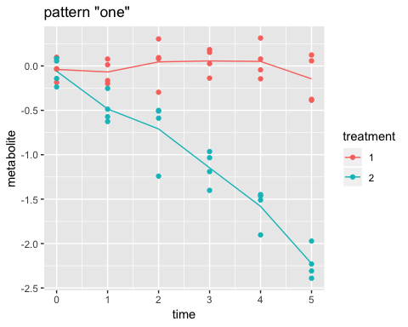 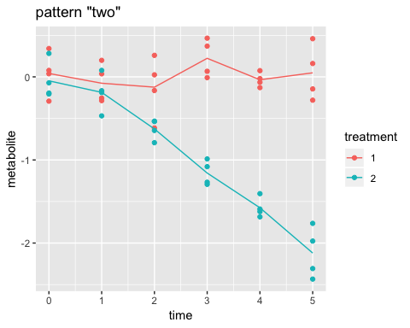 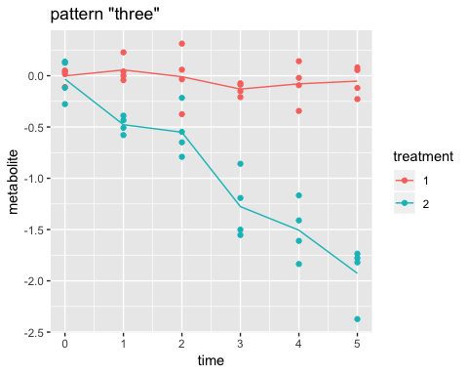

## treatment1 treatment2vstreatment1  
## 1 one 5 one 1  
## 2 one 6 one 2  
## 3 one 9 one 3  
## 4 one 12 one 4  
## 5 one 13 one 5  
## 6 one 14 one 6  
## 7 one 15 one 7  
## 8 two 4 one 8  
## 9 two 12 one 9  
## 10 two 14 one 10  
## 11 three 1 one 11  
## 12 one 12  
## 13 one 13  
## 14 one 14  
## 15 one 15  
## 16 two 1  
## 17 two 2  
## 18 two 3  
## 19 two 4  
## 20 two 5  
## 21 two 6  
## 22 two 7  
## 23 two 8  
## 24 two 9  
## 25 two 10  
## 26 two 11  
## 27 two 12  
## 28 two 13  
## 29 two 14  
## 30 two 15  
## 31 three 1

all the patterns are identified by masigpro. 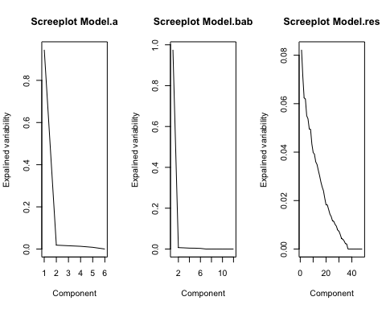

## [,1] [,2]  
## [1,] 9.756840e-01 0.9756840  
## [2,] 6.997044e-03 0.9826810  
## [3,] 5.783206e-03 0.9884642  
## [4,] 4.419767e-03 0.9928840  
## [5,] 4.065574e-03 0.9969496  
## [6,] 3.050427e-03 1.0000000  
## [7,] 1.795447e-16 1.0000000  
## [8,] 3.405366e-17 1.0000000  
## [9,] 3.905083e-18 1.0000000  
## [10,] -8.928654e-18 1.0000000  
## [11,] -2.935459e-17 1.0000000  
## [12,] -3.165557e-17 1.0000000

Screeplot shows that 1 PC to be included for submodel b.ab(treatment+interaction).

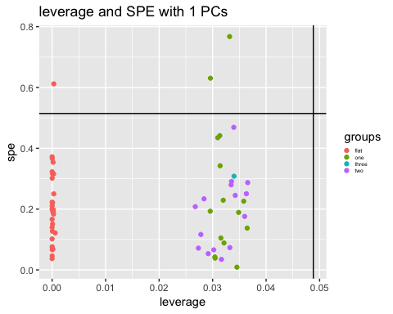

## character(0)

With 1 PCs selected, all the patterns are within the leverage limits.

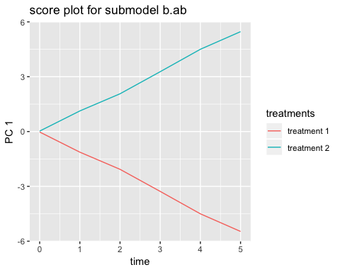

score plot of submodel b.ab shows a clear seperation between treatment1 and treatment2.

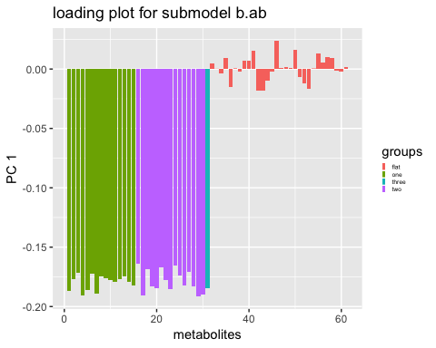

a clear pattern can be seen for pattern ‘three’ in residual plot. so the pattern needs to be analysed seperately.