User manual of  
fbNotex 1.2.3

*Copyright Massimo Nardello, Modena 2020*

# 

# Introduction

fbNotex is a free software for macOS able to manage a large amount of textual notes and tasks on a single computer or in a local network using the open source database Firebird ([firebirdsql.org](http://firebirdsql.org/)). fbNotex is a fork of sqlNotex compiled for macOS.

The notes are divided into *notebooks* and, within them, in *sections*, and it is possible to associate to each note a list of activities to be done, a series of attachments (files of any kind), tags and links to other notes. The search function may find the wished notes starting from the title, the text content, the modification date, the tags, the name of the attachments or activities. Files of Microsoft Word (*docx*), LibreOffice Writer (*odt*) and in plain text (*txt*) can be imported as plain text in a new note, while in the first two cases the original file is attached to it.

The text of the notes, if it is written by the user in *Markdown* format, may be displayed in the browser or inserted into a new Microsoft Word or LibreOffice Writer document, thus obtaining a regularly formatted text. The markers are shown in a different color changeable by the user in the options of the software. Anyway, if the text exceeds the 100,000 characters – or a different value specified by the user in the options of the software –, markers formatting and titles compilation, discussed below, are made ineffective for performances reasons activating automatically the menu item *Tools – Simple text*.

The possible formatting options of the text of the notes are the following:

* headings (six levels);
* bold, italics, strikethrough, underline;
* ordered and unordered list;
* tables;
* footnotes;
* words or paragraphs in code format (with mono-space font);
* quotations;
* highlighted;
* links to web sites;
* pictures embedded in the text;
* horizontal lines.

The aims of fbNotex that explains the use of the mentioned database and the *Markdown* format are the followings:

* the software has to work on Linux, macOS and Windows without incompatibilities between the different ways of these platforms to manage textual data formats;
* the software has to work both on a single computer and in a local network, giving many users the access to the data;
* the software has to guarantee maximum reliability and excellent performance even in the presence of a very consistent database.

The use of the Firebird database grants the required reliability with respect to file-based solutions, while maintaining excellent performance even with many data. The use of the *Markdown* format for the text of the notes allows to store them in the database exactly as they are written, speeding up their saving and loading and allowing a very quick search within them. Furthermore, this format is unique on all platforms and gives the possibility to export data to other software very easily.

fbNotex has been written with Lazarus ([www.lazarus-ide.org](http://www.lazarus-ide.org/)) and accesses the Firebird database through the Zeos components ([sourceforge.net/projects/zeoslib](http://sourceforge.net/projects/zeoslib)).

*fbNotex is free software, as it is released under the GPL version 3 license or following*, available on [www.gnu.org/licenses/gpl-3.0.html](http://www.gnu.org/licenses/gpl-3.0.html), which the user must accept in order to use it.

# Installation

To install and run fbNotes:

1. Download and install Firebird 3 for macOS from <https://firebirdsql.org/en/firebird-3-0/#MacOS>.
2. Download the fbNotex app (*fbNotex.app* ) from the website and move it to the Applications folder.
3. Copy the database, contained in the source folder *Data*, into a directory of your choice in the home (e.g. */Users/fred/Data*).
4. Ctrl + click on the app, choosing to open it even if not signed.
5. After launching the app, open the options of the software (menu item *Tools - Options*), specify the path and name of the data file in the *Database file* box (e.g. */Users/fred/data/fbNotex.fdb*) and click the *OK* button.
6. Type *SYSDBA* as user name and *masterkey* as password, then press *Enter*.

If access to data is not allowed, check in the software options that the contents of the *Firebird library path* field point correctly to the *libfbclient.dylib* file.

# General notes

## Interface

The main interface looks like this:

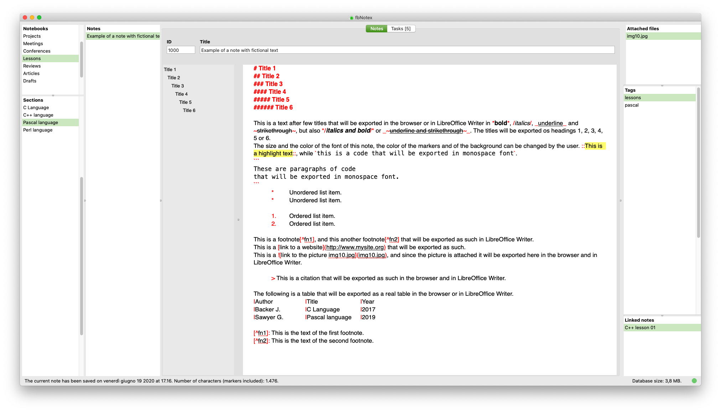

Data are divided into notebooks (grid on the top left). Each notebook contains many sections (bottom left grid), and each section contains many notes. Notebooks, sections and notes are identified by an identification number (ID), i.e. a number of 4 or more digits assigned automatically by the software and not editable by the user. It is used to indicate a specific notebook under which to move the current section, or a specific section under which to move the current note, or to link two different notes.

When a notebook or section are created, the software shows the details form, which allows to indicate its title and possibly some explanatory notes. In the field of explanatory notes, *Meta + Return* saves the data and closes the form. These notes are visible only within this form, and can be viewed again with the *Details* menu item (see below).

Typing *Meta + Return* in the *Title* field, the software inserts the title of the note in its text as first paragraph and formats it as a heading 1. Note that only the text of the note can be exported in Word or Writer, not its title, so it’s useful to replicate this title at the beginning of the text of the note as heading 1.

The name of the attachments to the current note (top right grid) and of the tags (center right grid) can be changed also by selecting them in their own grid and pressing *F2*. On the other hand, it is not possible to modify a link between two different notes because it is reciprocal - that is, the software automatically inserts a further link in the note to which the one in use is connected - so that any change in one of the two links would leave the other orphaned. For this reason to modify a link it’s necessary to delete it and create it again.

Double click on the grid of notebooks or sections opens the details form. The same action on the grid of attachments opens the current attachment, while on the links grid brings to the linked note.

It is possible to add a bookmark to the current note with the shortcut *Meta + Alt* and a number from 1 to 9. To move to that note, type *Meta* and the previously assigned number. Bookmarks can also be viewed, set, and deleted using the form displayed with the *Edit - Bookmarks* menu item.

The four columns of the grid visible in this form show the bookmark number (1 to 9), the title of the notebook, of the section and of the note associated to the bookmark. The *Set* button associates the current note with the bookmark number of the selected row, *Clear* deletes the content of the selected row, *Close* closes the form without doing anything and *Go to* – like with double click or pressing *Return* – finds the note to which the bookmark of the selected row is linked. Bookmarks are remembered by the software after exiting the software.

In the text of the notes the following shortcuts are available:

* *Meta + Shift + Y*: delete the current paragraph.
* *Meta + “+”* (“plus” character): enlarge the character of the text of the note and of the list of titles (see below).
* *Meta + “-”* (“less” character): reduce the character of the text of the note and of the list of titles (see below).
* *Meta + Alt + Z:* undo the last changes made to the text of the current note and not yet saved.
* *Meta + Z:* undo the last change to the text of the note.
* *Meta + Shift + Z:* redo the last change to the text of the note.
* *Meta + Alt + Up arrow*: move the current paragraph up.
* *Meta + Alt + Down arrow*: move the current paragraph down.
* *Meta + Alt + “.”* (*dot*): format the current paragraph and those above and below after and before an empty line or a heading as a list, using subsequently the asterisk, the line, the plus, the number and nothing as beginning of the list items.
* *Meta + Alt + F*:
  + within the footnote reference in the text (e.g. [^1]): move the cursor to the footnote;
  + within the footnote (e.g. [^1]: This is the footnote): move the cursor to the footnote reference in the text;
  + in other positions: create a new footnote reference and a new footnote, both properly numbered.

Furthermore, it’s possible to move to the previous or next note with *Meta + Page Up* and *Meta + Page Down*.

To renumber the footnote references in the text use the *Edit – Reformat* menu item. On the contrary, the footnotes must be reordered manually by the user, if necessary, using the *Alt + Meta + Up arrow* and *Alt + Meta + Down arrow* keys. Possible footnotes that had not a reference in the text of the note will be renumbered adding 10000 to their number to let the user identify them.

*The* *Edit – Reformat* menu item is useful also to correctly renumber the numbered lists if the user has changed its headers, for instance by moving some of its items up or down.

The status bar shows the date and time of the last modification to the current note and the number of its characters (markers included), and on the right, the database size. The green or red circle on the right indicates if data have been saved or if there are changes not yet saved.

In the login form, if the backup file is more recent than the one in use a message will be shown, at the bottom. A couple of minutes of difference are not considered, so that a backup file just copied, although more recent than the one in use, does not make the message to appear.

## Tasks

Tasks section looks like this:

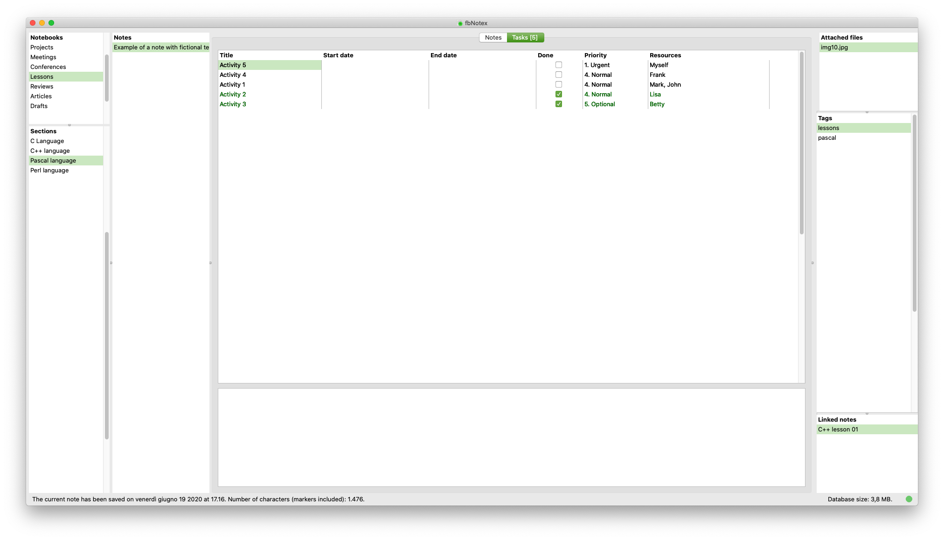

Each note can be associated with different activities shown in the *Tasks* section in the tab at the top. The number of activities already present is shown next to the title of the tab in square brackets. In the activity grid it is possible to indicate the name of an activity, the possible start and end date (i.e., the deadline), if it has been completed, its priority and the resources, i.e. the people who are in charge of carrying it out. By typing a space in the date fields, the initial one is filled with the current date, while the final one is postponed by 30 days. Using the arrows left and right while holding down *Shift*, the two dates move forward and backward. Finally, the activities carried out are displayed in green, those without date or not started are in black, those started in blue and those that have expired and not completed in red.

The activities can be inserted and deleted with the proper menu items (see below), but with *Ctrl + Del* the current one can be quickly deleted. In the field below the activity grid, it’s possible to enter explanatory notes related to the current activity. Finally, the activities are sorted automatically by final date (deadline), start date and priority, leaving at the bottom those which have been done. To move up and down an activity, change its dates or priority accordingly.

To display a grid containing the activities of all the notes, use the menu item *Notes - Show all tasks*. It looks like that:

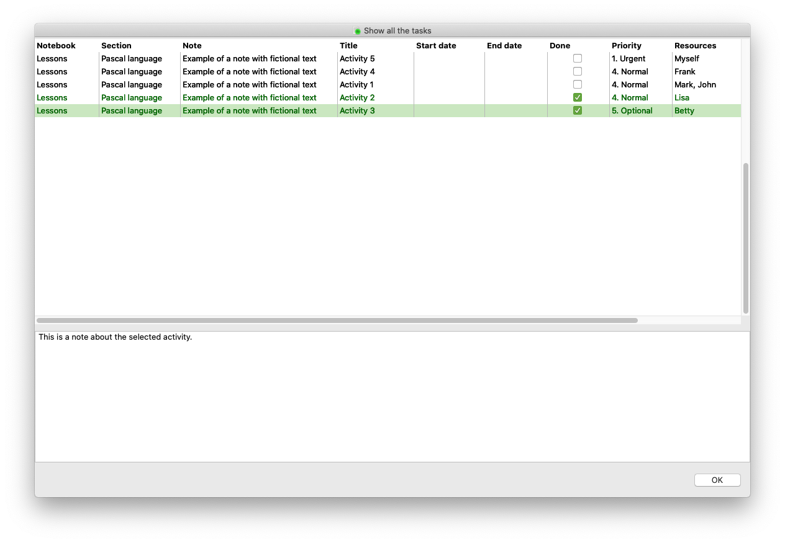

By double-clicking or pressing *Return* on one of them, the software selects the note to which it belongs and then shows the activity itself.

## Titles

At the left of the text of the notes there is a section that is automatically filled in by the software with the titles contained in the note and defined in *Markdown* format, that is preceded by one to six hashes (#) followed by a space. Clicking on a title name in this section selects it in the note text. This list is also useful to allow the user to get the main contents of a note at a glance.

# Menu items

The functions related to the menu items are summarized here. Note that pop-up menus, displayed with a right-click, are available on some grids, and replicates some of the items of the main menus.

## File menu

*Save*: save all data in the database.

*Undo changes*: undo any change made to the data and recover the last saved version.

*Refresh*: update the database data, to view the changes made by other users in a local network.

*Export notes of current section*: create a text file containing the data of the notes of the current section, of the related tasks, tags and attachments; these attachments, if present, are saved in a folder with the same name of the file.

*Import notes in current section*: import a file created with the previous functionality, containing notes with the related tasks, tags and attachments, into the current section.

*Close database*: close the database and return to login; this condition is necessary to backup, recover and compact the data, as indicated below.

*Quit*: exit fbNotex.

## Edit menu

*Cut*: cut the selected in text in the clipboard.

*Copy*: copy the selected text in the clipboard.

*Paste*: paste the text in the clipboard.

*Select all*: select all the text of the current note.

*Reformat*: format correctly the titles, lists and markers in the text of the current note, and renumber the numbered lists and the footnotes.

*Preview*: open the text of the current note in the default browser converting any *Markdown* marker, except for the footnotes that appear as links between different parts of the document.

*Open note in Word*: open the text of the current note with any possible activity as a new Word document, converting any *Markdown* markers; the footnotes appear as such and not as links between different parts of the document, and the headers are formatted according to fbNotex own style sheet. Each header 1, beginning with one hash, starts a new page. The file is placed in the temporary directory and is in HTML format; it is therefore advisable to save it with a different name and in Word's own format.

*Open section in Word*: open the text of all the noes of the current section with any possible activity as a new Word document, converting any *Markdown* markers; the footnotes appear as such and not as links between different parts of the document, and the headers are formatted according to fbNotex own style sheet. Each header 1, beginning with one hash, starts a new page. The file is placed in the temporary directory and is in HTML format; it is therefore advisable to save it with a different name and in Word own format.

*Open note in Writer*: open the text of the current note with any possible activity as a new Writer document, converting any *Markdown* markers; the footnotes appear as such and not as links between different parts of the document, and the headers are formatted according to fbNotex own style sheet. Each header 1, beginning with one hash, starts a new page. The file is placed in the temporary directory and is in HTML format; it is therefore advisable to save it with a different name and in Writer's own format.

*Open section in Writer*: open the text of all the noes of the current section with any possible activity as a new Writer document, converting any *Markdown* markers; the footnotes appear as such and not as links between different parts of the document, and the headers are formatted according to fbNotex own style sheet. Each header 1, beginning with one hash, starts a new page. The file is placed in the temporary directory and is in HTML format; it is therefore advisable to save it with a different name and in Word own format.

*Show bookmarks*: show the form for managing bookmarks (see above).

## Notebooks menu

*New*: create a new notebook and open the details form to type its title and any comment.

*Delete*: delete the current notebook, with all the sections and notes related to it.

*Sort by*: sort the notebooks as set by the user (*Custom* item) or by title (*Title* item); the user can indicate the position of a notebook in the notebooks grid with the following menu item.

*Move*: move the current notebook up (*Up* item) or down (*Down* item) in the notebook grid.

*Details*: open the details form with the data of the current notebook, containing its ID, its title and some notes.

*Copy ID*: copy the ID of the current notebook in the clipboard.

## Sections menu

*New*: create a new section and open the details form to type its title and any comment.

Delete: delete the current section, with all the notes related to it.

*Sort by*: sort the sections as set by the user (*Custom* item) or by title (*Title* item); the user can indicate the position of a section in the sections grid with the following menu item.

*Move*: move the current section up (*Up* item) or down (*Down* item) in the sections grid.

*Details*: open the details form with the data of the current section, containing its ID, its title and some notes.

*Change notebook*: open a form to enter the ID of a notebook in order to move the current section under it; the *Paste* button or the shortcut *Meta + V* allow to paste the ID already copied in the clipboard, and to show the name of the associated notebook in a label.

*Copy ID*: copy the ID of the current section.

## Notes menu

*New*: create a new note.

*Delete*: delete the current note, with any possible attachments, tags and links.

*Sort by*: sort the notes as set by the user (*Custom* item), by title (*Title* item) or by modification date (*Modification date* item); the user can indicate the position of a note in the notes grid with the following menu item.

*Move*: move the current note up (*Up* item) or down (*Down* item) in the notes grid.

*Attachments*: attach one or more files of any kind to the current note (*New* item), delete the current one (*Delete* item), open it (*Open* item) and save it (*Save as* item); it’s possible to attach files also by dragging them onto the main form of the software when a note is active.

*Tags*: create a new tag related to the current note (*New* item), delete the current one (*Delete* item) and rename a tag in all the notes of the database (*Rename tag* item); it’s possible to add a new tag selecting it in the tags list within the *Search* section, doing a right click on it and selecting the popup menu *Insert tag in current note*.

*Links*: open a form to enter the ID of an existing note to link it to the current one, simultaneously creating a link to the latter in the first one (*New* item), delete the current link and the corresponding one in the linked note (*Delete* item) and find the linked note (*Locate linked note* item); this last operation can also be carried out by double-clicking on the link.

*Tasks*: create a new activity (*New* item), delete the current one (*Delete* item) and hide the completed activities (*Hide done tasks* item).

*Show all tasks*: open a grid containing all the activities of all the notes in the database; the notes are not editable, but double clicking on one of them brings to the note that contains it.

*Import from file*: import a Microsoft Word file (with the extension .docx and not .doc), LibreOffice Writer file (with the extension .odt) or a file in plain text (with the extension .txt) into a new note; except in this last case, the original file is attached to the note, while its content is always imported as note text, without formatting.

*Change section*: open a form to enter the ID of a section in order to move the current note under it; the *Paste* button or the shortcut *Meta + V* allow to paste the ID already copied in the clipboard, and to show the name of the associated section in a label.

*Copy ID*: copy the ID of the current note .

*Search in note*: find the first occurrence – with the proper button or pressing *Return* in the field *Text to find* – or the following – with the proper button or pressing *Meta +* *Return* in the field *Text to find* – of a text within the current note, or replace all its occurrences with another text; search and replace are not case sensitive; when the replace functionality is used, the code \n is a substitute for the paragraph break, while the code \t of the tabulation, both in the *Text to find* and in the *Replace with* fields.

*Find*: open the section of the software dedicated to data search (see below some notes on its use).

## Tools menu

*Show editor only*: display only the text of the current note and the list of titles, to focus on what is written.

*Full screen*: display the interface of the software at full screen.

*Simple text*: hide the list of titles and deactivates the color of the markers to make much faster the management of the text of the note; this option may be necessary to manage wide notes and is activated automatically if the text exceeds 100,000 characters or a different value specified by the user in the options of the software; then the user must reactivate it manually with the current menu item.

*Backup database*: make a physical copy of the database in use (therefore not a backup in the proper sense performed by Firebird) and copy it with the name and in the folder indicated in the software options, in the *Backup and restore file* field (e.g. /home/username/backup/fbNotex-backup.fdb); any existing file is renamed as * .bak; this option is active only if the database is closed and the IP of the server is *localhost*.

*Restore database*: replace the current database with the file indicated in the software options, in the *Backup and restore file* field; the file currently in use is renamed as * .bak; this option is active only if the database is closed and the IP of the server is *localhost*.

*Compact database*: create a backup copy of the database with the extension .backup in the data folder and restore the data in the file in use cleaning the deleted elements (notes, attachments, etc.); the user is required to enter both the *sudo* and the SYSDBA password. This option is active only if the database is closed and the IP of the server is *localhost*.

*Options*: open the options form, which looks like this:

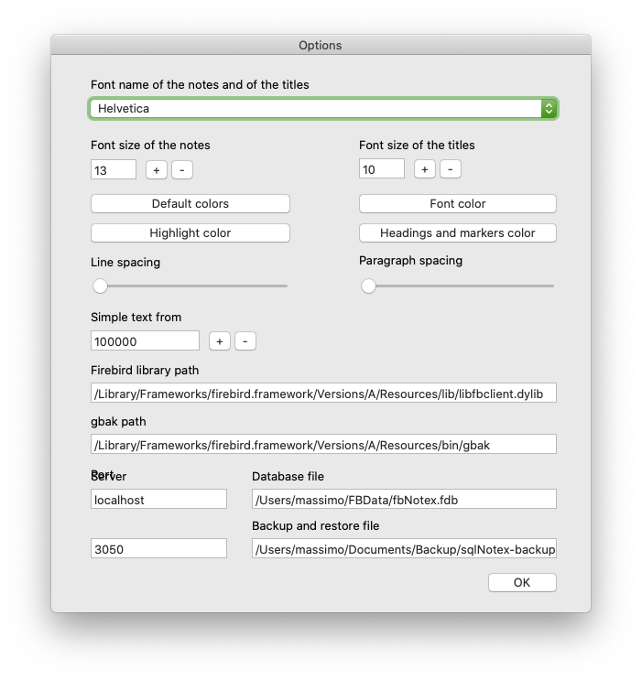

In this mask it’s possible:

* specify the font name of the notes and titles text (*Font name of the notes and of the titles* box); only the fonts having italics, bold and bold-italics are available;
* specify the font size of the text of the notes (*Font size of the notes* field);
* specify the font size of the titles (*Font size of the titles* box);
* restore the default colors (*Default colors* button)
* specify the color of the font of the notes (*Font color* button);
* specify the color of the highlight of the text included among two “::” (*Highlight color* button);
* specify the color of the headings and markers (*Headings and markers color* button);
* specify the line space and the space among paragraphs (*Line spacing* and *Paragraph spacing* track bars);
* specify the number of characters of a note beyond which the software activates automatically the “simple text” mode with *Tools – Simple text* menu item (*Simple text from* box);
* specify the path of the client library of firebird (*Firebird library path* box);
* specify the path of the gbak file, for Firebird backup (*gbak path* box);
* specify the server address, which is *localhost* for the use of fbNotex on a single computer, the IP address of the server in a local network (*Server* field);
* specify the path and name of the database (*Database file* field);
* specify the port on which the database receives connections, 3050 by default (*Port* field);
* specify the backup and recovery file (*Backup and restore files* field).

# Search

The *Notes - Find* menu item opens the form to find the notes, which looks like this:

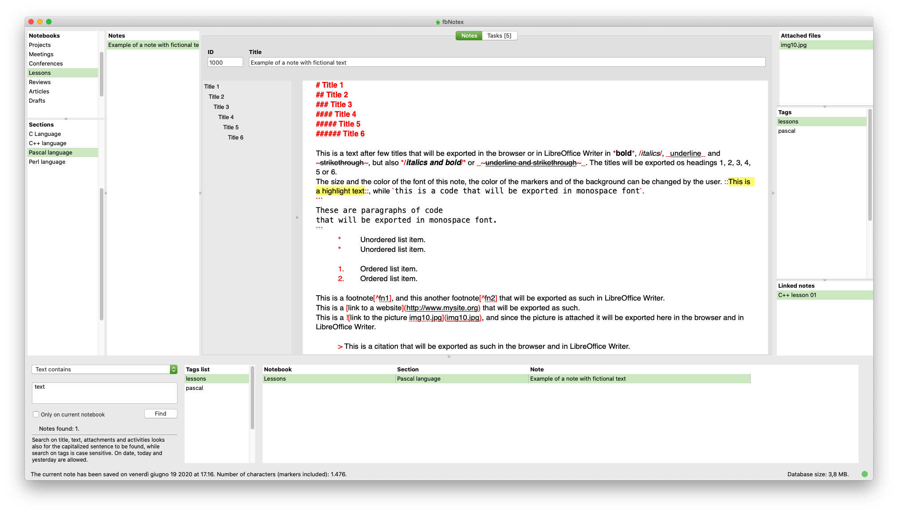

In the box at the top left of the find section may be specified the field in which to search:

* *Title contains*, to select the notes whose title contains the text inserted in the field below;
* *Text contains*, to select the notes whose text contains the one inserted in the field below;
* *Modification date among*, to select the notes whose modification date is among those inserted in the field below with the following format: 1/1/2019 - 2/1/2019 (therefore, the two dates are separated by space - dash - space); it’s possible to insert also *today* to select the notes edited on the current day, or *yesterday* to select the notes edited on the previous day.
* *Tags equal to*, to select the notes of which at least one of the tags corresponds to one of those indicated in the field below, separated by commas and spaces (e.g. *meetings*, *projects*, *elaborations*);
* *Attachment name contains*, to select all the notes in which the name of at least one of the attachments contains the text entered in the field below;
* *Activity name contains*, to select all the notes in which the name of at least one of the activities contains the text entered in the field below;
* *SQL Where clause*, to insert directly a SQL Where clause in the field below.

The SQL clause must not include the word *where*, and can involve all the fields used in the database. Their list is this:

notebooks.id *integer*

notebooks.title *varchar*

notebooks.comments *blob*

sections.id *integer*

sections.id_notebooks *integer*

sections.title *varchar*

sections.comments *blob*

notes.id *integer*

notes.id_sections *integer*

notes.title *varchar*

notes.text *blob*

notes.modification_date *timestamp*

tasks.id *integer*

tasks.id_notes *integer*

tasks.done *smallint*

tasks.title *varchar*

tasks.start_date *date*

tasks.end_date *date*

tasks.priority *varchar*

tasks.resources *varchar*

tasks.comments *blob*

attachments.id *integer*

attachments.id_notes *integer*

attachments.title *varchar*

tags.id *integer*

tags.id_notes *integer*

tags.tag *varchar*

links.id *integer*

links.id_notes *integer*

links.link_note *integer*

Note that the blob fields indicated here are textual, and therefore can be inserted in the SQL clause. For example, this clause may be:

notebooks.title like ‘%meetings%’ and notes.title like ‘%report%’

to select all the notes whose title contains *report* and in which the title of the relative notebook contains *meetings*. Consult the Firebird guide for further indications on the use of SQL syntax.

By activating the option *Only on current notebook*, the search will be limited to the notes of the current notebook.

At the right of the search field there is a list of all the tags used in the database sorted by name. With a double click or pressing *Return* on the list, the selected tag will be added to the text to be found. To update the list, use the menu item *File – Refresh*.

Pressing *Enter* in the search field or clicking the *Find* button, all the notes that meet the entered criteria are displayed in the grid on the right sorted by notebooks, sections and notes titles. Pressing *Ctrl + Enter* instead inserts a new row in the search field, useful for entering fairly complex SQL clauses. Pressing *Enter* in the search grid or double-clicking on it shows the corresponding note in the main interface of the software, so that it can be read or modified.

# Markdown formatting

In the text of the notes it is possible to insert *Markdown* markers in order to have a properly formatted text when exporting it in the browser or opening it as a new Microsoft Word or LibreOffice Writer file. The markers used by fbNotex comply basically with *Markdown* guidelines. Here is the complete list of possible formats.

|  |  |  |
| --- | --- | --- |
| Format | Example | Notes |
| Italics | /*This text is in italics*/ | Only within a paragraph. |
| Bold | \***This text is in bold**\* | Only within a paragraph. |
| Underline | _This text is underline_ | Only within a paragraph. |
| Strikethrough | ~~~This text is strikethrough~~~ | Only within a paragraph. |
| Highlighted | ::This text is highlighted:: | Only within a paragraph. This marker is not part of the Markdown standard. |
| Code: | `This text is in code format` |  |
| Paragraphs of code: | ``` These paragraphs are in code format. ``` | Each ``` must be at the beginning of a paragraph. |
| Unordered list | *[tab]Element of a list. -[tab]Element of a list. +[tab]Element of a list.  *[tab][space]Indented element.  -[tab][space]Indented element.  +[tab][space]Indented element. | Only at the beginning of a paragraph. The indented item syntax is not part of the Markdown standard. |
| Ordered list | 1.[tab]Element of a list.  2.[tab]Element of a list.  1.[tab][space]Indented element. | Only at the beginning of a paragraph. The indented itam syntax is not part of the Markdown standard. To renumber all the lists of the current note, use the *Edit – Reformat* menu item (*Meta + R*). |
| Heading 1 | # This is a heading 1 | Only at the beginning of a paragraph. |
| Heading 2 | ## This is a heading 2 | Only at the beginning of a paragraph. |
| Heading 3 | ### This is a heading 3 | Only at the beginning of a paragraph. |
| Heading 4 | #### This is a heading 4 | Only at the beginning of a paragraph. |
| Heading 5 | ##### This is a heading 5 | Only at the beginning of a paragraph. |
| Heading 6 | ###### This is a heading 6 | Only at the beginning of a paragraph. |
| Citation | > This is a citation. | Only at the beginning of a paragraph. |
| Table | |  |  | | --- | --- | | |Mark | |Twain | | |Tom | |Sawyer | | Only at the beginning of a paragraph. A row must no*t* be closed with a pipe (|). The heading of tables specified by *Markdown* is not accepted, but the |--- or the | --- markers insert an empty line. |
| Footnote | Body of the text[^1]  [^1]: Text of the footnote. | The text of the footnote must be in a single paragraph, at the beginning of it and placed after the corresponding reference in the body of the text. |
| Picture | ![Title of picture](picture.jpg) | The image file must be attached to the current note in order to be viewed in Writer and in the browser. |
| Link | [Website name](link.com) | Do not insert spaces between ] and (. Links that are not formatted as in this example and the paths must be placed between code markers so that the slashes are not mistaken for italic markers. |
| Horizontal line | --- | Three or more dashes are accepted, although only the first three are highlighted as markers. |

Website addresses and paths that contain the slash character ("/"), the asterisk, the underline or the tilde ("~") must be formatted as a link or as a code (i.e. included between two "`" or between two lines containing "```"), because otherwise these characters would be interpreted by the software as *Markdown* markers when exported to HTML. On the contrary, within these sections the bars are correctly interpreted.

The markers for bold, italics, underline and strikethrough are interpreted as common characters if they are preceded and followed by a space. Note that it’s not possible to use the backslash (\) to have a marker recognized as a standard character.

Note also that in the text of the notes paragraphs must not be separated by empty lines to be recognized as such when exported in HTML. Furthermore, empty lines can be freely inserted to better highlight some parts of it (titles, lists, etc.), as well as spaces or tabs inside the cells of the tables. They will not be displayed in the browser nor in Word.

# Maintenance

fbNotex integrates a minimal backup function, which just copies the data file, also containing the attachments, into a folder specified by the user. However, note that Firebird does not physically remove from the data file the elements that have been deleted by the user (notes, attached files, etc.), so over time it may need to be optimized. For this purpose, if the software is used on a single computer, it’s possible to use the menu item *Tools – Compact database* (see below).

The menu items *Backup database*, *Restore database* and *Compact database* are active only if the database is closed and the IP of the server specified in the *Options* of the software is *localhost*.