User manual of
sqlNotex 1.0.10

Copyright Massimo Nardello, Modena 2020

Introduction
sqlNotex is a multi-platform software able to manage a large amount of textual notes on a single computer or in a local network using the open source database Firebird (firebirdsql.org).
The notes are divided into notebooks and, within them, in sections, and it is possible to associate to each note a list of activities to be done, a series of attachments (files of any kind), tags and links to other notes. The search function may find the wished notes starting from the title, the text content, the modification date, the tags, the name of the attachments or activities. Files of Microsoft Word (docx), LibreOffice Writer (odt) and in plain text (txt) can be imported as plain text in a new note, while in the first two cases the original file is attached to it.
The text of the notes can be formatted if it is written by the user in Markdown format, presented later. The titles are displayed in bold and with a larger font than the rest of the text, while the various markers (asterisk, slash, etc.) are formatted with their own color. It is also possible to copy the text of a note with any possible activities in HTML format and paste it into a word processor, or display it in the browser, or automatically insert it into a new LibreOffice Writer document, thus obtaining a regularly formatted document.
The possible formatting options of the text of the notes, some of which are visible only after exportation, are the following:

- headings (six levels);
- bold, italics, strikethrough, underline;
- ordered and unordered list;
- tables;
- footnotes;
- words or paragraphs in code format (with mono-space font);
- quotations;
- highlighted;
- links to web sites;
- pictures embedded in the text;
- horizontal lines.

The aims of sqlNotex that explains the use of the mentioned database and the Markdown format are the followings:

- the software has to work on Linux, macOS and Windows without incompatibilities between the different ways of these platforms to manage textual data formats;
- the software has to work both on a single computer and in a local network, giving many users the access to the data;
- the software has to guarantee maximum reliability and excellent performance even in the presence of a very consistent database.

The use of the Firebird database grants the required reliability with respect to file-based solutions, while maintaining excellent performance even with many data. The use of the Markdown format for the text of the notes allows to store them in the database exactly as they are written, speeding up their saving and loading and allowing a very quick search within them. Furthermore, this format is unique on all platforms and gives the possibility to export data to other software very easily.
sqlNotex has been written with Lazarus (www.lazarus-ide.org) and a modified version of the RichMemo component (wiki.freepascal.org/RichMemo), whose modified source code is included in the source code of sqlNotex, and accesses the Firebird database through the Zeos components (sourceforge.net/projects/zeoslib).
sqlNotex is free software, as it is released under the GPL version 3 license or following, available on www.gnu.org/licenses/gpl-3.0.html, which the user must accept in order to use it.

Installation and maintenance on Linux distributions
The sqlNotex installation is currently available only for Linux, both for Debian and Debian-derived distribution (Ubuntu, Mint, etc.,) and for Fedora (tested on version 31).

Installation on Debian and Debian – derived distributions
To use the software, just install the deb installation package, which will automatically install Firebird 3 from the repository of the distribution in use, sqlNotex and the database file, assigning the necessary permissions to it. During the installation of Firebird, the user will be asked to enter a password of the administrator user, that is, SYSDBA. This password must be remembered, because it will be used to access the database.

Installation on Fedora 31
On Fedora 31, Firebird must be installed from the website of the software and not from the repositories. These are the steps:

1. In the terminal, type these commands:

sudo cp /usr/lib64/libtommath.so.1 /usr/lib64/libtommath.so.0
sudo cp /usr/lib64/libncurses.so.6 /usr/lib64/libncurses.so.5

2. Download the Linux AMD64 file Firebird-3.0.x.xxxxx-x.amd64.tar.gz from the web site of Firebird (https://firebirdsql.org/en/firebird-3-0).
3. Extract the compressed file in a folder (e.g. Download).
4. Install Firebird with:

cd Download
sudo ./install.sh

During the installation of Firebird, the user will be asked to enter a password of the administrator user, that is, SYSDBA. This password must be remembered, because it will be used to access the database.
Then install the rpm installation package, which will automatically install sqlNotex and the database file, assigning the necessary permissions to it.

How to fix installation problems
In any case, for the correct functioning of the software, the sqlNotex.fdb file, which will contain the data, must be placed in a folder (e.g. /usr/share/sqlnotex-data) whose owner must be both the user and the group firebird; both are automatically created when Firebird is installed. Finally it’s necessary to add the username of the current user to the group firebird. If the installation is not successful, it may be necessary to set the permissions manually from the terminal with the following commands:

sudo chown -R firebird:firebird /usr/share/sqlnotex-data/
sudo chmod -R g+w /usr/share/sqlnotex-data/
/sbin/usermod -aG firebird $USER

Then the installed software can be run. If the name of the file or data folder has been changed from what was set by the installation package, the new values must be specified in the program options (menu item Tools - Options), specifically in the field Database file. The Backup and restore file field contains the name of the backup file which can be created periodically to make a backup copy of the data. The default name is /usr/share/sqlnotex-data/sqlNotex-backup.fdb, but it is better to change the folder in order to save the backup file on a cloud.
Once these operations are completed, to access the database and start using the software, run it and enter the password in the Password field leaving SYSDBA as the user name, and press Enter.
If the database and the data have been installed on a local network server, indicate its IP address in the Server field of the Options. Otherwise leave the default content, i.e. localhost.
However, note that to manage sqlNotex in a local network, sharing the database between multiple users, it is necessary to open the port (by default, 3050) of the possible firewall of both the clients and the server. It is also advisable to create several users in Firebird, assigning to each of them the permissions to access the database and to modify it.

Maintenance
sqlNotex integrates a minimal backup function, which just copies the data file, also containing the attachments, into a folder specified by the user. However, note that Firebird does not physically remove from the data file the elements that have been deleted by the user (notes, attached files, etc.), so over time it may need to be optimized. For this purpose, if the software is used on a single computer, it’s possible to use the menu item Tools – Compact database (see below).
The menu items Backup database, Restore database and Compact database are active only if the database is closed and the IP of the server specified in the Options of the software is localhost.

The backup and restore can be made also in a local network using the command line or tools such as FlameRobin (www.flamerobin.org). Before doing this, however, it is necessary to verify that no user is connected to the database. In a local network, it is necessary to interrupt the connections to Firebird, following the instructions given in its documentation, while on a personal computer it is sufficient to close the database.
To backup and restore from the terminal, type the following commands (tested on Debian 10 stable).

For backup (replace masterkey with one’s password):

/usr/bin/gbak -USER sysdba -PAS masterkey /usr/share/sqlnotex-data/sqlNotex.fdb /usr/share/sqlnotex-data/sqlNotex-backup.fdb

For restore (replace masterkey with one’s password):

/usr/bin/gbak -USER sysdba -PAS masterkey -rep /usr/share/sqlnotex-data/sqlNotex-backup.fdb /usr/share/sqlnotex-data/sqlNotex.fdb

To set again permissions of the folder and the data file to the user and group firebird:

sudo chown -R firebird:firebird /usr/share/sqlnotex-data/
sudo chmod -R g+w /usr/share/sqlnotex-data/

Obviously these examples assume that the data file is in the default folder, that is, /usr/share/sqlnotex-data.
Note that the password remains stored in the history of the terminal, and that it could therefore be recovered by those who had access to it. To avoid this, start each command with a space, or remove it from the history modifying the file .bash_history in the Home folder.
See the Firebird documentation for further information on database backup and restore.

General notes

Interface
The interface looks like this. This is the form in which the notes are written:

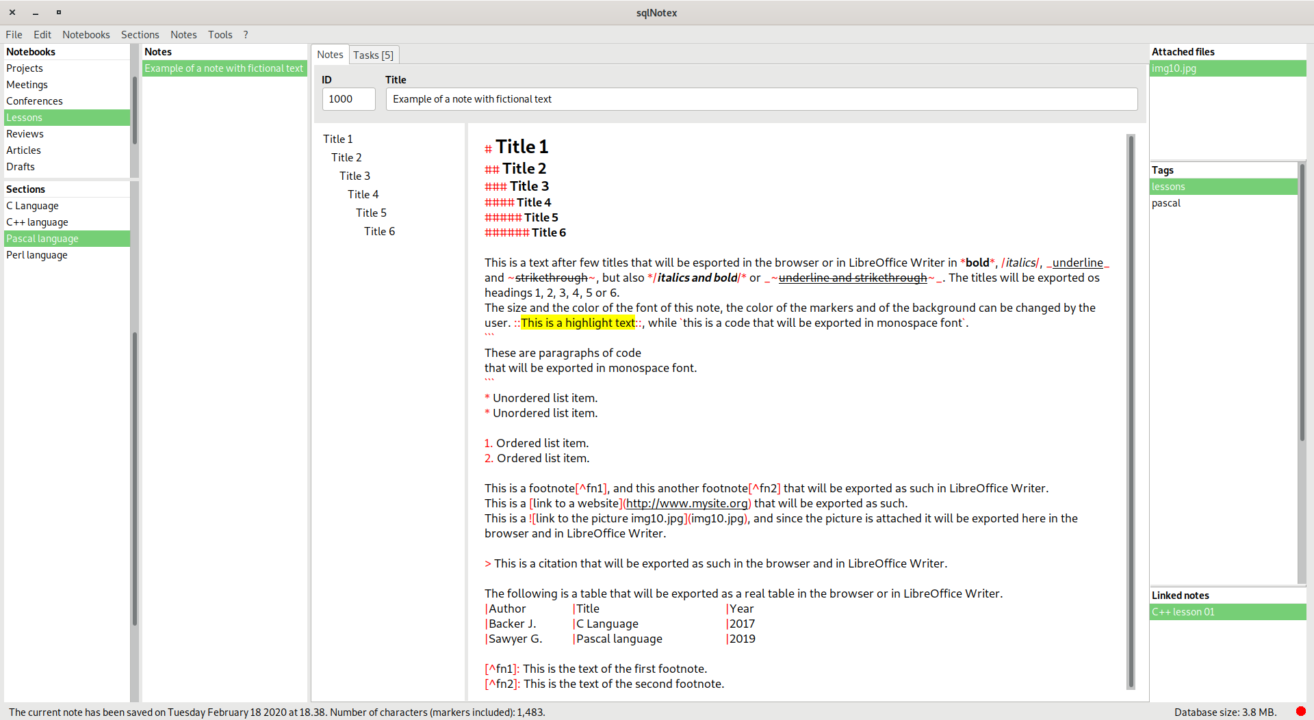
This is the form in which the tasks related to a note are written:

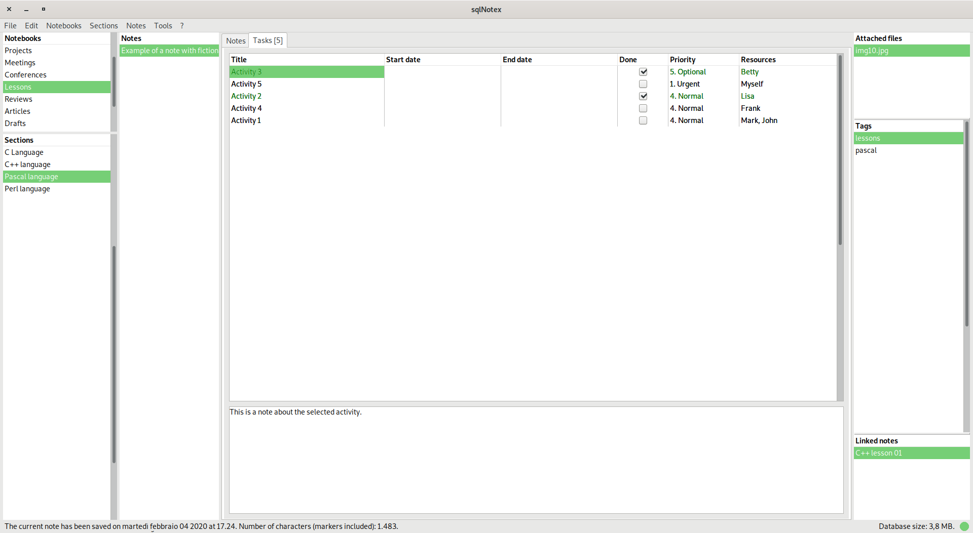
Data are divided into notebooks (grid on the top left). Each notebook contains many sections (bottom left grid), and each section contains many notes. Notebooks, sections and notes are identified by an identification number (ID), i.e. a number of 4 or more digits assigned automatically by the software and not editable by the user. It is used to indicate a specific notebook under which to move the current section, or a specific section under which to move the current note, or to link two different notes.
When a notebook or section are created, the software shows the details form, which allows to indicate its title and possibly some explanatory notes. In the field of explanatory notes, Ctrl + Return saves the data and closes the form. These notes are visible only within this form, and can be viewed again with the Details menu item (see below). Typing Ctrl + Return in the Title field, the software inserts the title of the note in its text as first paragraph and formats it as a heading.
The name of a notebook or section can be changed also by selecting it in its own grid and pressing F2. The same happens for the name of the attachments to the current note (top right grid) and for the tags (center right grid). On the other hand, it is not possible to modify a link between two different notes because it is reciprocal - that is, the software automatically inserts a further link in the note to which the one in use is connected - so that any change in one of the two links would leave the other orphaned. For this reason to modify a link it’s necessary to delete it and create it again.
Double click on the grid of notebooks or sections opens the details form. The same action on the grid of attachments opens the current attachment, while on the links grid brings to the linked note.
It is possible to add a bookmark to the current note with the shortcut Ctrl + Shift and a number from 1 to 9. To move to that note, type Ctrl and the previously assigned number. Bookmarks can also be viewed, set, and deleted using the form displayed with the Edit - Bookmarks menu item, that looks like this:

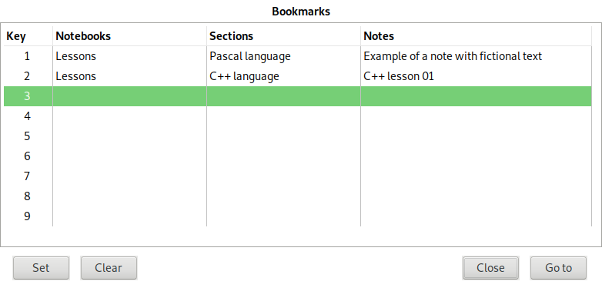
The four columns of the grid visible in this form show the bookmark number (1 to 9), the title of the notebook, of the section and of the note associated to the bookmark. The Set button associates the current note with the bookmark number of the selected row, Clear deletes the content of the selected row, Close closes the form without doing anything and Go to – like with double click or pressing Return – finds the the note to which the bookmark of the selected row is linked. Bookmarks are remembered by the software after exiting the software.
In the text of the notes the following shortcuts are available:

- Ctrl + Y: delete the current paragraph.
- Ctrl + “+” (“plus” character): enlarge the character of the text of the note.
- Ctrl + “-” (“minus” character): reduce the character of the text of the note.
- Ctrl + Shift + “+”: enlarge the character of the list of titles (see below).
- Ctrl + Shift + “-”: reduce the character of the list of titles (see below).
- Ctrl + Z: undo the last changes made to the text of the current note and not yet saved.
- Alt + Right arrow: in titles, which in Markdown begin with one or more hashes followed by a space, remove the first of them, in order to make the title higher.
- Alt + Left arrow: in titles, add a hash, in order to make the title lower.
- Alt + Up arrow: move the current paragraph up; if it’s a heading, all the related content will be moved with it before the previous heading of any level.
- Alt + Down arrow: move the current paragraph down; if it’s a heading, all the related content will be moved with it after the next heading of any level.
- Alt + D: insert the current date in the text of the note.
- Alt + Shift + D: insert the current date and time in the text of the note.
- Alt + “.” (dot): format the current paragraph and those above and below after and before an empty line or a heading as a list, using subsequently the asterisk, the line, the plus, the number and nothing as beginning of the list items.
- Alt + F:
  - within the footnote reference in the text (e.g. [^1]): move the cursor to the footnote;
  - within the footnote (e.g. [^1]: This is the footnote): move the cursor to the footnote reference in the text;
  - in other positions: create a new footnote reference and a new footnote, both properly numbered.

To renumber the footnote references in the text use the Edit – Reformat menu item. On the contrary, the footnotes must be reordered manually by the user, if necessary, using the Alt + Up arrow and Alt + Down arrow keys.
Links to websites typed according to Markdown rules (see below) are automatically underlined and can be opened in the browser by Ctrl + click on them.
Markdown markers and text titles are automatically formatted by the software, but some changes made by the user may not be detected. To reformat the text correctly, use the Edit – Reformat menu item. This item also serves to correctly renumber the numbered lists if the user has changed its headers, for instance by moving some of its items up or down.
While typing at the very end of the text, the software may change slightly the space among the letters when the space bar is pressed. To avoid this, press Return to create an empty line at the end of the text and then click on Edit – Reformat menu item.
The status bar shows the date and time of the last modification to the current note and the number of its characters (markers included), and on the right, the database size. The green or red circle on the right indicates if data have been saved or if there are changes not yet saved.
In the login form, if the backup file is more recent than the one in use a message will be shown, at the bottom. A couple of minutes of difference are not considered, so that a backup file just copied, although more recent than the one in use, does not make the message to appear.

Tasks
Each note can be associated with different activities shown in the Tasks section in the tab at the top. The number of activities already present is shown next to the title of the tab in square brackets. In the activity grid it is possible to indicate the name of an activity, the possible start and end date (i.e., the deadline), if it has been completed, its priority and the resources, i.e. the people who are in charge of carrying it out. By typing a space in the date fields, the initial one is filled with the current date, while the final one is postponed by 30 days. Using the arrows left and right while holding down Shift, the two dates move forward and backward. Finally, the activities carried out are displayed in green, those without date or not started are in black, those started in blue and those that have expired and not completed in red.
The activities can be inserted and deleted with the proper menu items (see below), but with Ctrl + Del the current one can be quickly deleted. In the field below the activity grid, it’s possible to enter explanatory notes related to the current activity. Finally, the activities are sorted automatically by final date (deadline), start date and priority, leaving at the bottom those which have been done. To move up and down an activity, change its dates or priority accordingly.
To display a grid containing the activities of all the notes, use the menu item Notes - Show all tasks. By double-clicking or pressing Return on one of them, the software selects the note to which it belongs and then shows the activity itself.

Titles
At the left of the text of the notes there is a section that is automatically filled in by the software with the titles contained in the note and defined in Markdown format, that is preceded by one to six hashes (#) followed by a space. Clicking on a title name in this section selects it in the note text. This list is also useful to allow the user to get the main contents of a note at a glance.

Menu items
The functions related to the menu items are summarized here. Note that pop-up menus, displayed with a right-click, are available in the text of the notes and on some grids, and replicates some of the items of the main menus.

File menu
Save: save all data in the database.
Undo changes: undo any change made to the data and recover the last saved version.
Refresh: update the database data, to view the changes made by other users in a local network.
Export notes of current section: create a text file containing the data of the notes of the current section, of the related tasks, tags and attachments; these attachments, if present, are saved in a folder with the same name of the file.
Import notes in current section: import a file created with the previous functionality, containing notes with the related tasks, tags and attachments, into the current section.
Close database: close the database and return to login; this condition is necessary to backup the data or to recover it, as indicated below.
Quit: exit sqlNotex.

Edit menu
Reformat: format correctly the titles, lists and markers in the text of the current note, and renumber the numbered lists and the footnotes.
Copy as Markdown: copy in the clipboard the text of the current note in Markdown format.
Copy as HTML: copy the text of the current note with any possible activity in HTML format, properly converting any Markdown marker; if the text in the clipboard is pasted into a word processor, it retains all user-specified formatting, except for footnotes that appear as links between different parts of the document; the headers will be formatted according to the style sheet in use.
Copy for Word: copy the text of the current note with any possible activity in HTML format, properly converting any Markdown marker, to be suitable to be pasted in Microsoft Word; when pasted in this word processor, the footnotes appear as such and not as links between different parts of the document, and all the elements of the text are formatted according to the default Word style sheet for HTML files. For instance, the normal text will be formatted with the Normal (Web) style. If all the text that is pasted is formatted as Normal style and the titles are not formatted as such, undo the paste with the menu item Edit – Undo (o the like) and paste again the text.
Preview: open the text of the current note in the default browser converting any Markdown marker, except for the footnotes that appear as links between different parts of the document.
Open current note in Writer: open the text of the current note with any possible activity as a new LibreOffice Writer document called sqlNotex.odt, converting any Markdown markers; the footnotes appear as such and not as links between different parts of the document, and the headers are formatted according to sqlNotex own style sheet, not using the default one of Writer. Each header 1, beginning with one hash, starts a new page. The file is placed in the temporary directory and, despite the .odt extension, it is in HTML format; it is therefore advisable to save it with a different name and in LibreOffice Writer's own format.
Open notes of section in Writer: open the text of all the noes of the current section with any possible activity as a new LibreOffice Writer document called sqlNotex.odt, converting any Markdown markers; the footnotes appear as such and not as links between different parts of the document, and the headers are formatted according to sqlNotex own style sheet, not using the default one of Writer. Each header 1, beginning with one hash, starts a new page. The file is placed in the temporary directory and, despite the .odt extension, it is in HTML format; it is therefore advisable to save it with a different name and in LibreOffice Writer's own format.
Show bookmarks: show the form for managing bookmarks (see above).

Notebooks menu
New: create a new notebook and open the details form to type its title and any comment.
Delete: delete the current notebook, with all the sections and notes related to it.
Sort by: sort the notebooks as set by the user (Custom item) or by title (Title item); the user can indicate the position of a notebook in the notebooks grid with the following menu item.
Move: move the current notebook up (Up item) or down (Down item) in the notebook grid.
Details: open the details form with the data of the current notebook, containing its ID, its title and some notes.
Copy ID: copy the ID of the current notebook in the clipboard.

Sections menu
New: create a new section and open the details form to type its title and any comment.
Delete: delete the current section, with all the notes related to it.
Sort by: sort the sections as set by the user (Custom item) or by title (Title item); the user can indicate the position of a section in the sections grid with the following menu item.
Move: move the current section up (Up item) or down (Down item) in the sections grid.
Details: open the details form with the data of the current section, containing its ID, its title and some notes.
Change notebook: open a form to enter the ID of a notebook in order to move the current section under it; the Paste button or the shortcut Ctrl + V allow to paste the ID already copied in the clipboard, and to show the name of the associated notebook in a label.
Copy ID: copy the ID of the current section.

Notes menu
New: create a new note.
Delete: delete the current note, with any possible attachments, tags and links.
Sort by: sort the notes as set by the user (Custom item), by title (Title item) or by modification date (Modification date item); the user can indicate the position of a note in the notes grid with the following menu item.
Move: move the current note up (Up item) or down (Down item) in the notes grid.
Attachments: attach one or more files of any kind to the current note (New item), delete the current one (Delete item), open it (Open item) and save it (Save as item); it’s possible to attach files also by dragging them onto the main form of the software when a note is active.
Tags: create a new tag related to the current note (New item), delete the current one (Delete item) and rename a tag in all the notes of the database (Rename tag item).
Links: open a form to enter the ID of an existing note to link it to the current one, simultaneously creating a link to the latter in the first one (New item), delete the current link and the corresponding one in the linked note (Delete item) and find the linked note (Locate linked note item); this last operation can also be carried out by double-clicking on the link.
Tasks: create a new activity (New item), delete the current one (Delete item) and hide the completed activities (Hide done tasks item).
Show all tasks: open a grid containing all the activities of all the notes in the database; the notes are not editable, but double clicking on one of them brings to the note that contains it.
Import from file: import a Microsoft Word file (with the extension .docx and not .doc), LibreOffice Writer file (with the extension .odt) or a file in plain text (with the extension .txt) into a new note; except in this last case, the original file is attached to the note, while its content is always imported as note text, without formatting.
Change section: open a form to enter the ID of a section in order to move the current note under it; the Paste button or the shortcut Ctrl + V allow to paste the ID already copied in the clipboard, and to show the name of the associated section in a label.
Copy ID: copy the ID of the current note.
Search in note: find the first or following occurrence of a text within the current note, or replace all its occurrences with another text; search and replace are not case sensitive; when the replace functionality is used, the code \n is a substitute for the paragraph break, while the code \t of the tabulation, both in the Text to find and in the Replace with fields.
Find: open the section of the software dedicated to data search (see below some notes on its use).

Tools menu
Show editor only: display only the text of the current note and the list of titles, to focus on what is written.
Backup database: make a physical copy of the database in use (therefore not a backup in the proper sense performed by Firebird) and copy it with the name and in the folder indicated in the software options, in the Backup and restore file field (e.g. /home/username/backup/sqlNotex-backup.fdb); any existing file is renamed as * .bak; this option is active only if the database is closed and the IP of the server is localhost.
Restore database: replace the current database with the file indicated in the software options, in the Backup and restore file field; the file currently in use is renamed as * .bak; this option is active only if the database is closed and the IP of the server is localhost.
Compact database: create a backup copy of the database with the extension .backup in the data folder, restore the data in the file in use cleaning the deleted elements (notes, attachments, etc.) and set again the correct permissions on the data folder; the user is required to enter both the sudo and the SYSDBA password. This option is active only if the database is closed and the IP of the server is localhost.
Options: open the options form, which looks like this:

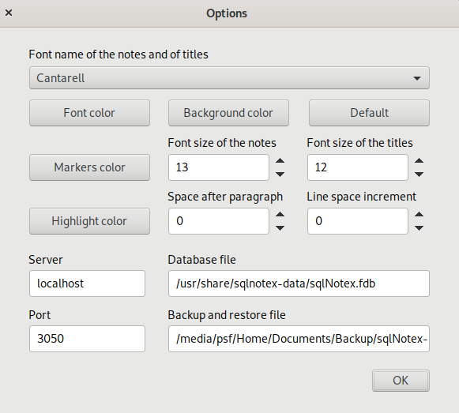
In this form it’s possible to

- specify the font name of the notes and titles text (Font name of the notes and of titles box)
- specify the color of that font (Font color button);
- specify the background color of the text of the notes and titles (Background color button);
- restore the default values ​​of the font and background color of the text of the notes and titles (Default button);
- specify the font size of the text of the notes (Font size of the notes field);
- specify the font size of the titles (Font size of the titles box);
- specify the color of the Markdown markers (Marker color button);
- specify the color of highlight (Highlight color button);
- specify the additional space between paragraphs (Space after paragraphs field);
- specify the additional space in the line spacing inside the paragraphs (Line space increment field);
- specify the server address, which is localhost for the use of sqlNotex on a single computer, the IP address of the server in a local network (Server field);
- specify the path and name of the database (Database file field);
- specify the port on which the database receives connections, 3050 by default (Port field);
- specify the backup and recovery file (Backup and restore files field).

Search
The Notes - Find menu item opens the form to find the notes, that looks like this:

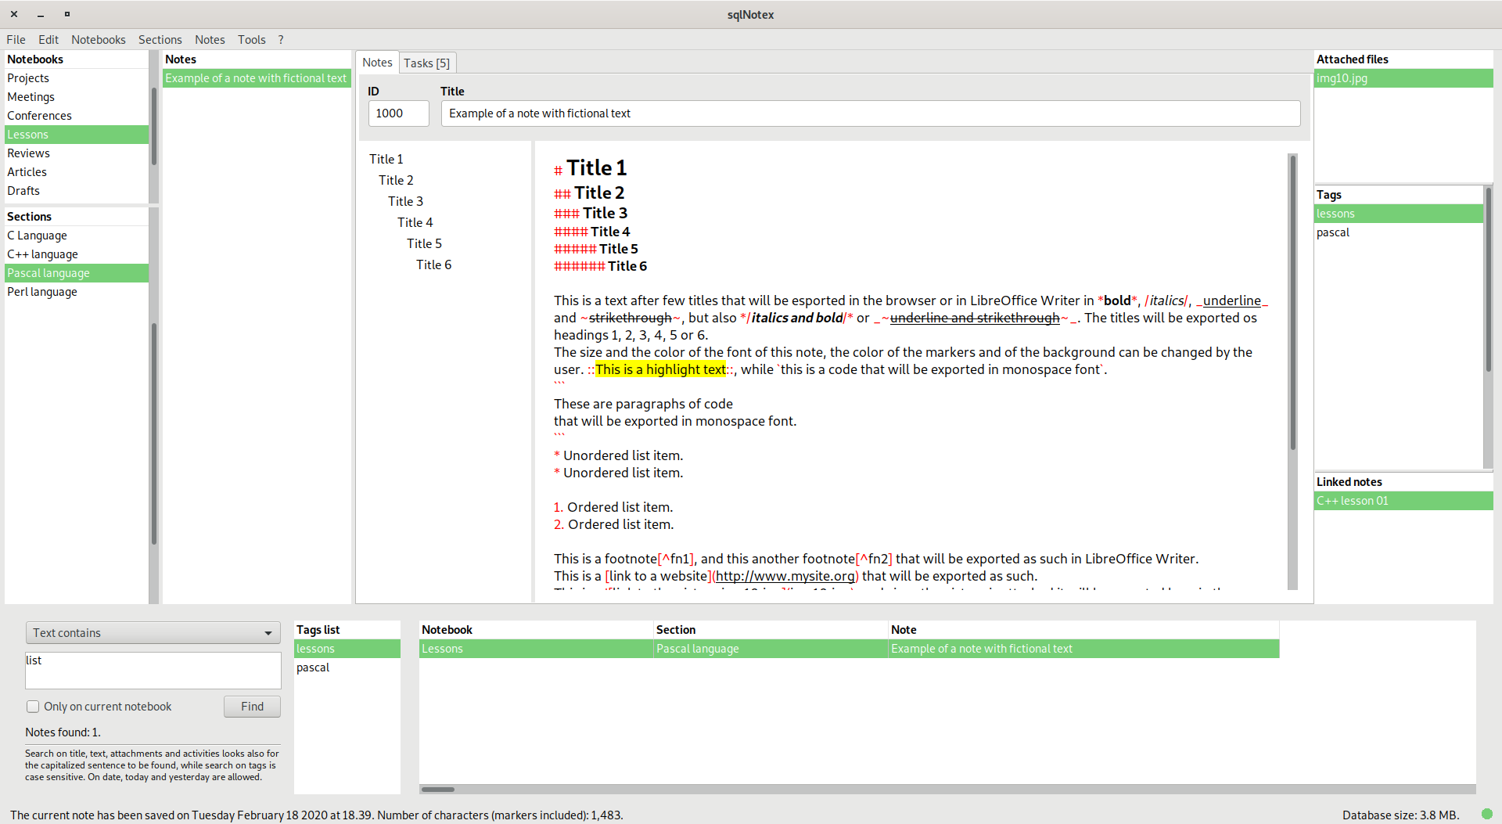
In the box at the top left of the find section may be specified the field in which to search:

- Title contains, to select the notes whose title contains the text inserted in the field below;
- Text contains, to select the notes whose text contains the one inserted in the field below;
- Modification date among, to select the notes whose modification date is among those inserted in the field below with the following format: 1/1/2019 - 2/1/2019 (therefore, the two dates are separated by space - dash - space); it’s possible to insert also today to select the notes edited on the current day, or yesterday to select the notes edited on the previous day.
- Tags equal to, to select the notes of which at least one of the tags corresponds to one of those indicated in the field below, separated by commas and spaces (e.g. meetings, projects, elaborations);
- Attachment name contains, to select all the notes in which the name of at least one of the attachments contains the text entered in the field below;
- Activity name contains, to select all the notes in which the name of at least one of the activities contains the text entered in the field below;
- SQL Where clause, to insert directly a SQL Where clause in the field below.

The SQL clause must not include the word where, and can involve all the fields used in the database. Their list is this:

notebooks.id integer
notebooks.title varchar
notebooks.comments blob
sections.id integer
sections.id_notebooks integer
sections.title varchar
sections.comments blob
notes.id integer
notes.id_sections integer
notes.title varchar
notes.text blob
notes.modification_date timestamp
tasks.id integer
tasks.id_notes integer
tasks.done smallint
tasks.title varchar
tasks.start_date date
tasks.end_date date
tasks.priority varchar
tasks.resources varchar
tasks.comments blob
attachments.id integer
attachments.id_notes integer
attachments.title varchar
tags.id integer
tags.id_notes integer
tags.tag varchar
links.id integer
links.id_notes integer
links.link_note integer

Note that the blob fields indicated here are textual, and therefore can be inserted in the SQL clause. For example, this clause may be:

notebooks.title like ‘%meetings%’ and notes.title like ‘%report%’

to select all the notes whose title contains report and in which the title of the relative notebook contains meetings. Consult the Firebird guide for further indications on the use of SQL syntax.
By activating the option Only on current notebook, the search will be limited to the notes of the current notebook.
At the right of the search field there is a list of all the tags used in the database sorted by name. With a double click or pressing Return on the list, the selected tag will be added to the text to be found. To update the list, use the menu item File – Refresh.
Pressing Enter in the search field or clicking the Find button, all the notes that meet the entered criteria are displayed in the grid on the right sorted by notebooks, sections and notes titles. Pressing Ctrl + Enter instead inserts a new row in the search field, useful for entering fairly complex SQL clauses. Pressing Enter in the search grid or double-clicking on it shows the corresponding note in the main interface of the software, so that it can be read or modified.

Markdown formatting
In the text of the notes it is possible to insert Markdown markers in order to have a properly formatted text when pasting it in a word processor, exporting it in the browser or opening it as a new LibreOffice Writer file. The markers used by sqlNotex comply basically with Markdown guidelines. Here is the complete list of possible formats.

Format | Example | Notes
Italics | /This text is in italics/ | Only within a paragraph.
Bold | *This text is in bold* | Only within a paragraph.
Underline | _This text is underline_ | Only within a paragraph.
Strikethrough | ~This text is strikethrough~ | Only within a paragraph.
Highlighted | ::This text is highlighted:: | Only within a paragraph. This marker is not part of the Markdown standard.
Code: | `This text is in code format`
Paragraphs of code: | ```  These paragraphs  are in code format.  ``` | Each ``` must be at the beginning of a paragraph. To reformat the included text, so that the possible markers are not formatted as such, use the Edit – Reformat menu item (Ctrl + R).
Unordered list | * Element of a list.  - Element of a list.  + Element of a list. | Only at the beginning of a paragraph. Nested (more indented) list are not accepted.
Ordered list | 1. Element of a list.  2. Element of a list | Only at the beginning of a paragraph. Nested (more indented) list are not accepted. To renumber all the lists of the current note, use the Edit – Reformat menu item (Ctrl + R).
Heading 1 | # This is a heading 1 | Only at the beginning of a paragraph.
Heading 2 | ## This is a heading 2 | Only at the beginning of a paragraph.
Heading 3 | ### This is a heading 3 | Only at the beginning of a paragraph.
Heading 4 | #### This is a heading 4 | Only at the beginning of a paragraph.
Heading 5 | ##### This is a heading 5 | Only at the beginning of a paragraph.
Heading 6 | ###### This is a heading 6 | Only at the beginning of a paragraph.
Citation | > This is a citation. | Only at the beginning of a paragraph.
Table |  | Only at the beginning of a paragraph. A row must not be closed with a pipe (|). The heading of tables specified by Markdown is not accepted, but the |--- or the | --- markers insert an empty line.
  |Mark | |Twain
  |Tom | |Sawyer
Footnote | Body of the text[^1]  [^1]: Text of the footnote. | The text of the footnote must be in a single paragraph, at the beginning of it and placed after the corresponding reference in the body of the text.
Picture | ![Title of picture](picture.jpg) | The image file must be attached to the current note in order to be viewed in Writer and in the browser.
Link | [Website name](link.com) | Do not insert spaces between ] and (. Links that are not formatted as in this example and the paths must be placed between code markers so that the slashes are not mistaken for italic markers.
Horizontal line | --- | Three or more dashes are accepted, although only the first three are highlighted as markers.

Website addresses and paths that contain the slash character ("/"), the asterisk, the underline or the tilde ("~") must be formatted as a link or as a code (i.e. included between two "`" or between two lines containing "```"), because otherwise these characters would be interpreted by the software as Markdown markers when exported to HTML. On the contrary, within these sections the bars are correctly interpreted.
The markers for bold, italics, underline and strikethrough are interpreted as common characters if they are preceded and followed by a space. Note that it’s not possible to use the backslash (\) to have a marker recognized as a standard character.
Note also that in the text of the notes paragraphs must not be separated by empty lines to be recognized as such when exported in HTML. Furthermore, empty lines can be freely inserted to better highlight some parts of it (titles, lists, etc.), as well as spaces or tabs inside the cells of the tables. They will not be displayed in the browser nor in LibreOffice Writer.

