Lab 1
Part 1 (Basic, 50%)
You need Docker and Docker-compose for this lab! Follow the steps, do everything by yourself and give screenshot with your personal identity, e.g. student ID/name.
In this lab, we will set up a 3-datanode Hadoop cluster using Docker on one machine:
1. Ready-made Docker-Hadoop composition with 3 datanode + 1 namenode + 1 historyserver + 1 nodemanager + 1 resourcemanager
2. First download and extract the docker zip file (docker-hadoop-master.zip) from Canvas, extract the file to your folder

To deploy an example HDFS cluster, unzip the file, enter the zip file folder, and run:

# docker-compose up -d

Docker-Compose is a powerful tool used for setting up multiple containers at the same time. The -d parameter is used to tell Docker-compose to run the command in the background and give you back your command prompt so you can do other things. With just a single command above, you are setting up a Hadoop cluster with 3 slaves (datanodes), one HDFS namenode (or the master node to manage the datanodes), one YARN resourcemanager, one historyserver and one nodemanager.
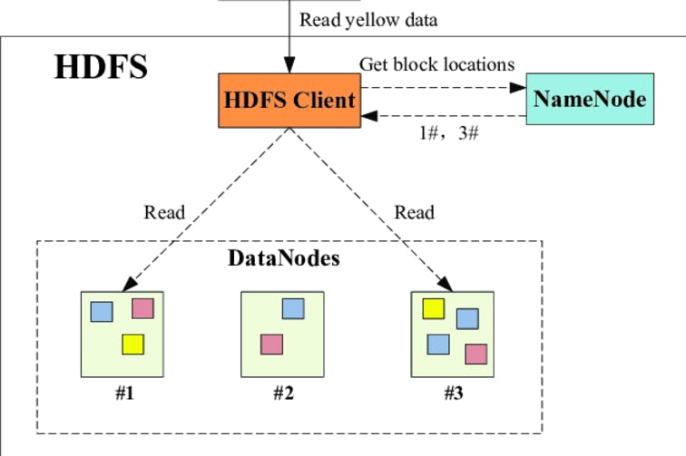

Docker-Compose will try to pull the images from the Docker-Hub library if the images are not available locally, build the images and start the containers.
NOTICE: Several container files will be downloaded, totally hundreds of MBs. If you get stuck, you can use “Ctrl-C” to stop download, and restart the “docker-compose up -d” process.
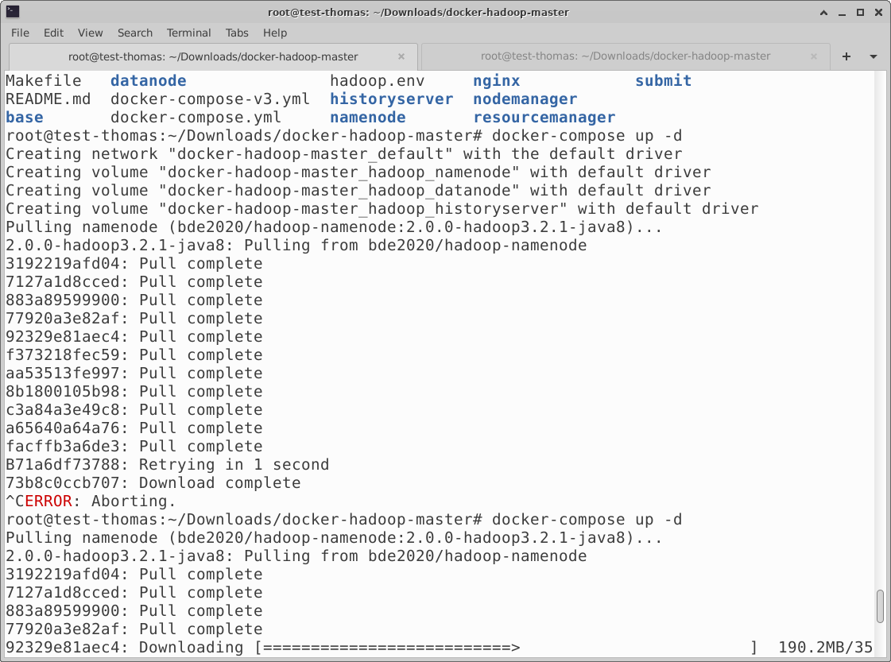

After it finishes, you can use this command to check for currently running containers:

# docker ps

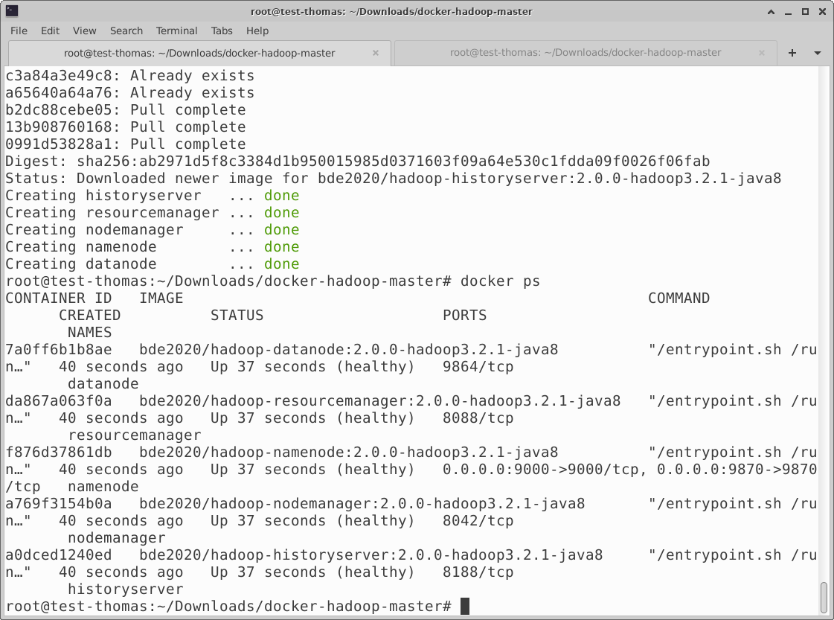

Go to http://localhost:9870 to view the current status of the system from the namenode:
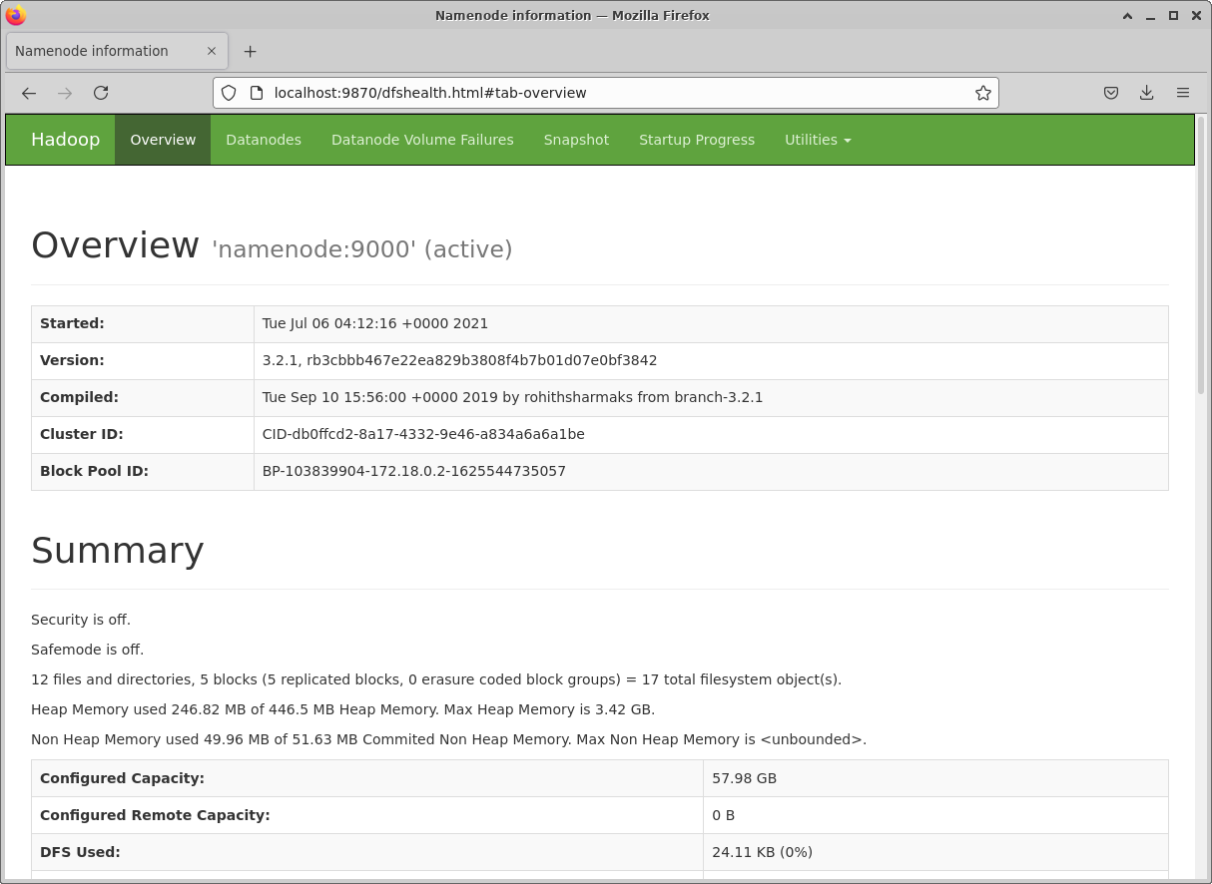

docker-compose creates a docker network that can be found by running docker network list, e.g., docker-hadoop-master_default.

Run docker network inspect docker-hadoop-master_default to find the IP the hadoop interfaces are published on.

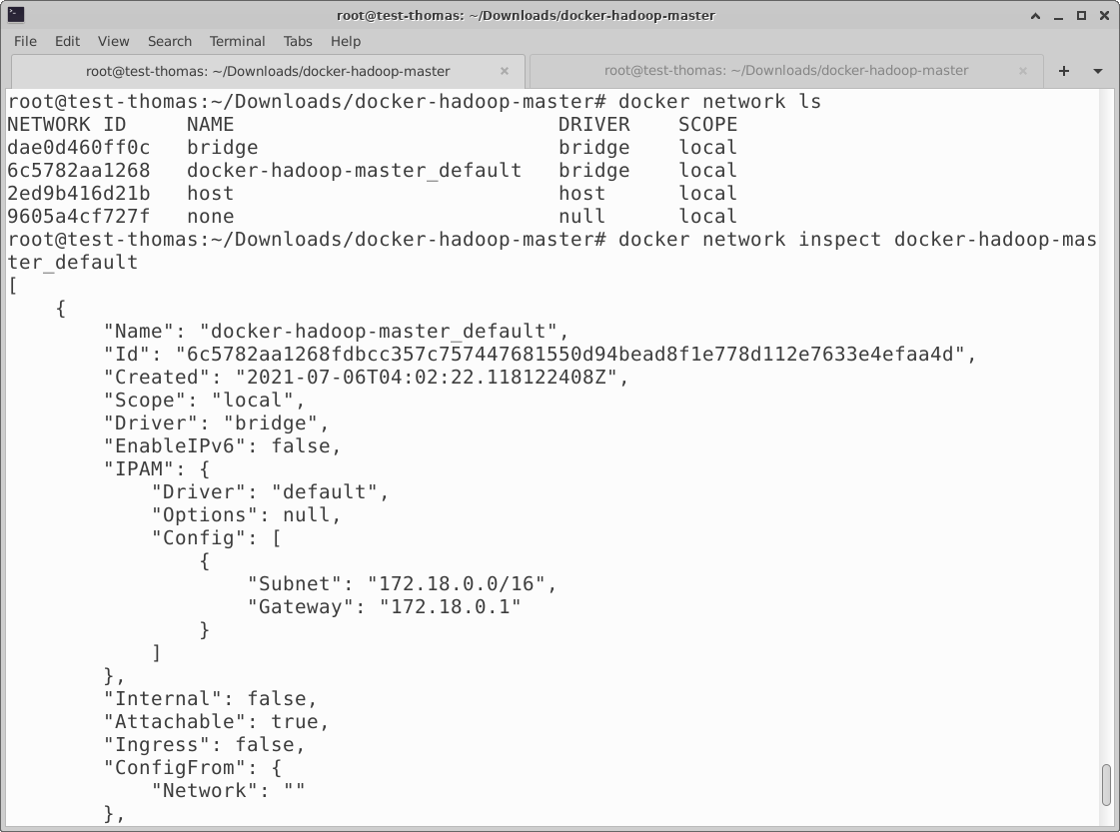

Access these interfaces with the following URLs:
- Namenode: http://<dockerhadoop_IP_address>:9870/dfshealth.html#tab-overview
- History server: http://<dockerhadoop_IP_address>:8188/applicationhistory
- Datanode: http://<dockerhadoop_IP_address>:9864/
- Nodemanager: http://<dockerhadoop_IP_address>:8042/node
- Resource manager: http://<dockerhadoop_IP_address>:8088/
In my case:
- Namenode: http://172.18.0.3:9870/dfshealth.html#tab-overview
- History server: http://172.18.0.4:8188/applicationhistory
- Datanode: http://172.18.0.5:9864/
- Nodemanager: http://172.18.0.2:8042/node
- Resource manager: http://172.18.0.6:8088/
Use this command to find out your docker images:

# docker images

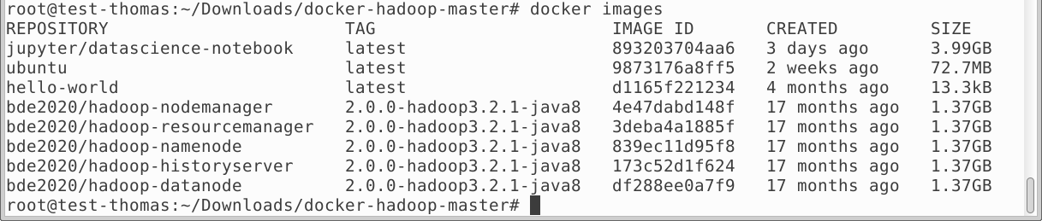

Part 2 (Intermediate, 50%)
Follow the steps, do everything by yourself and give screenshot with your personal identity, e.g. student ID/name. Create some of your own simple text files, create your own HDFS directory, and copy the text files to HDFS.
Now we can test the Hadoop cluster. Enter into the running namenode container by executing this command:

# docker exec -it namenode bash

First, we will create some simple text files:

root@1b0e0a202667:/# mkdir input
root@1b0e0a202667:/# echo "Hello World" >input/f1.txt
root@1b0e0a202667:/# echo "Hello Docker" >input/f2.txt

Now create the input directory on HDFS:

root@1b0e0a202667:/# hadoop fs -mkdir -p input-thomaschxu

To put the input files to all the datanodes on HDFS, use this command:

root@1b0e0a202667:/# hdfs dfs -put ./input/* input-thomaschxu

If you want to leave the container:

root@1b0e0a202667:/# exit

Use this command to find out the ID of your namenode container:

# docker container ls

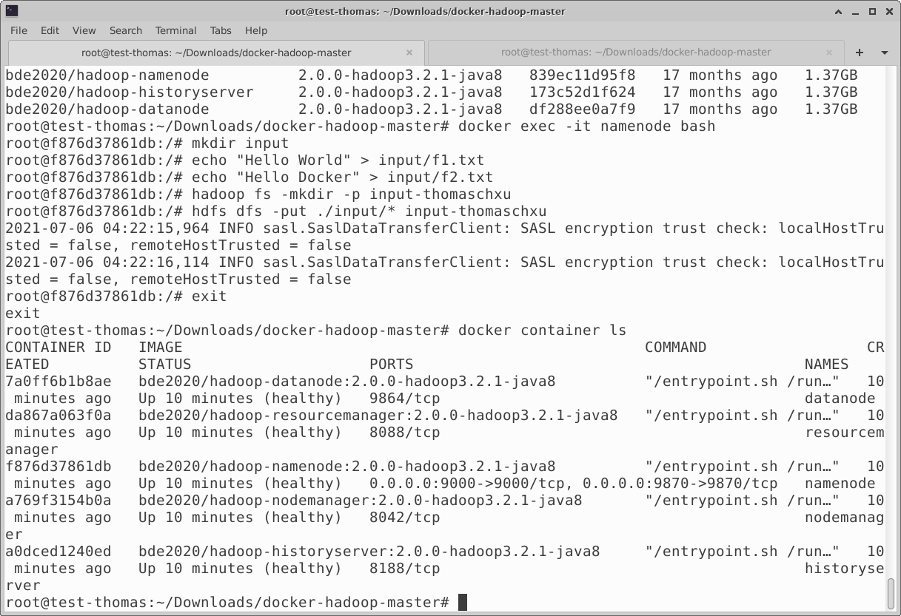
Congratulations, you just successfully set up a Hadoop cluster using Docker!
To safely shut down the cluster and remove containers, use this command:

# docker-compose down

