Lab 2
Part 1 (50%)
You need to have the HDFS directory and text files for this lab! Follow the steps, do everything by yourself and give screenshot with your personal identity, e.g. student ID/name, etc.
1, If your Docker containers are off, you have to restart:

# docker-compose up -d

When you try to start docker container above, you may got the following error (especially you have installed python3):

TypeError: kwargs_from_env() got an unexpected keyword argument ‘ssl_version’

To solve this error, you can reinstall docker in python3:

$ python3 –m install docker==6.1.3

It will solve this problem.

2, Make sure the namenode is running by accessing the web interface http://localhost:9870.
3, Make sure you have the HDFS directory “input” and related text files!

Testing the Hadoop Cluster
Now we can run the classic WordCount program (WordCount.java). Here is the Java source code:

import java.io.IOException;
import java.util.StringTokenizer;

import org.apache.hadoop.conf.Configuration;
import org.apache.hadoop.fs.Path;
import org.apache.hadoop.io.IntWritable;
import org.apache.hadoop.io.Text;
import org.apache.hadoop.mapreduce.Job;
import org.apache.hadoop.mapreduce.Mapper;
import org.apache.hadoop.mapreduce.Reducer;
import org.apache.hadoop.mapreduce.lib.input.FileInputFormat;
import org.apache.hadoop.mapreduce.lib.output.FileOutputFormat;

public class WordCount {

public static class TokenizerMapper
extends Mapper<Object, Text, Text, IntWritable>{

private final static IntWritable one = new IntWritable(1);
private Text word = new Text();

public void map(Object key, Text value, Context context
) throws IOException, InterruptedException {
StringTokenizer itr = new StringTokenizer(value.toString());
while (itr.hasMoreTokens()) {
word.set(itr.nextToken());
context.write(word, one);
}
}
}

public static class IntSumReducer
extends Reducer<Text,IntWritable,Text,IntWritable> {
private IntWritable result = new IntWritable();

public void reduce(Text key, Iterable<IntWritable> values,
Context context
) throws IOException, InterruptedException {
int sum = 0;
for (IntWritable val : values) {
sum += val.get();
}
result.set(sum);
context.write(key, result);
}
}

public static void main(String[] args) throws Exception {
Configuration conf = new Configuration();
Job job = Job.getInstance(conf, "word count");
job.setJarByClass(WordCount.class);
job.setMapperClass(TokenizerMapper.class);
job.setCombinerClass(IntSumReducer.class);
job.setReducerClass(IntSumReducer.class);
job.setOutputKeyClass(Text.class);
job.setOutputValueClass(IntWritable.class);
FileInputFormat.addInputPath(job, new Path(args[0]));
FileOutputFormat.setOutputPath(job, new Path(args[1]));
System.exit(job.waitForCompletion(true) ? 0 : 1);
}
}

Assume you have the Java file in your Ubuntu host machine, e.g., “~/Downloads/WordCount.java”. Use this command to find out the ID of your namenode container:

# docker container ls

Copy the container ID of your namenode (yellow highlighted code below) in the first column and use it in the following command to start copying the java file to your Docker Hadoop cluster:

# docker cp ~/Downloads/WordCount.java c6464c7f4337:WordCount.java

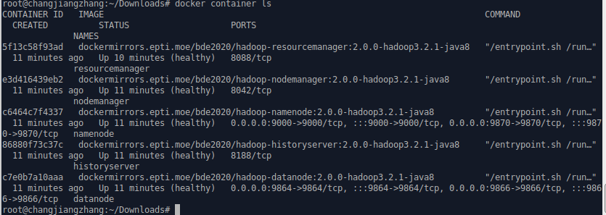
Now you are ready to run the WordCount program from inside namenode:

# docker exec -it namenode bash
# export HADOOP_CLASSPATH=${JAVA_HOME}/lib/tools.jar

Compile WordCount.java and create a jar

# hadoop com.sun.tools.javac.Main WordCount.java
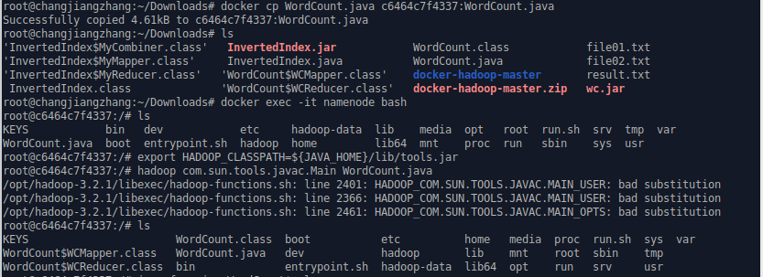

# jar cf wc.jar WordCount*.class
Now you should have the “wc.jar” file, and ready to run the WordCount program:
In lab1, you have uploaded a few txt files to /input directory.Now, run WordCount on these txt files.

# hadoop jar wc.jar WordCount input output
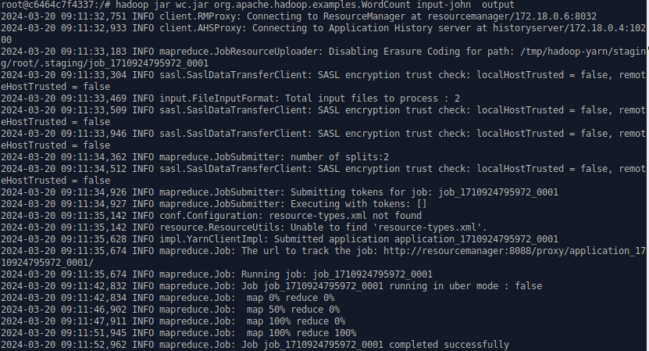
It takes few seconds to execute, you should see output of: “map 100% reduce 100%”
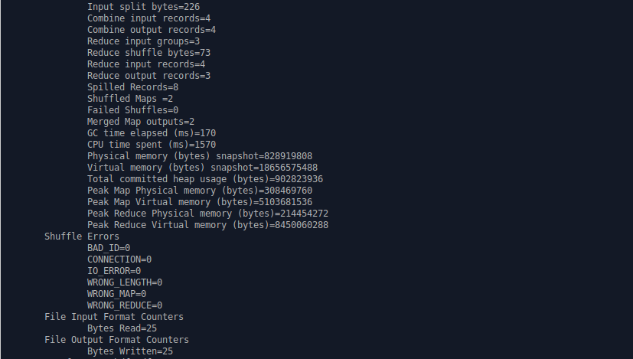
You can also check the Hadoop Resource Manager for the status of your task:
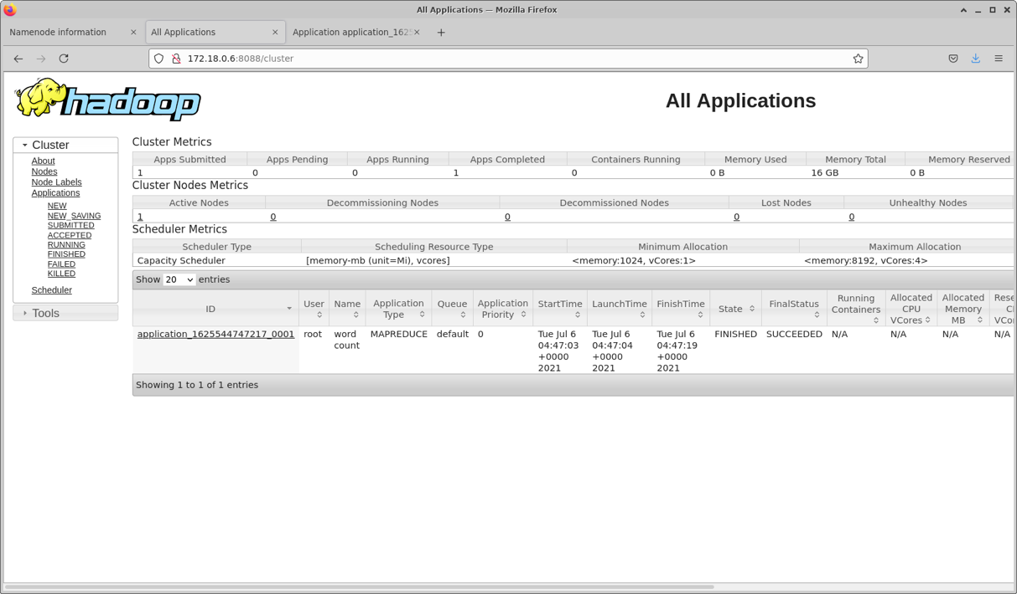
And more details:
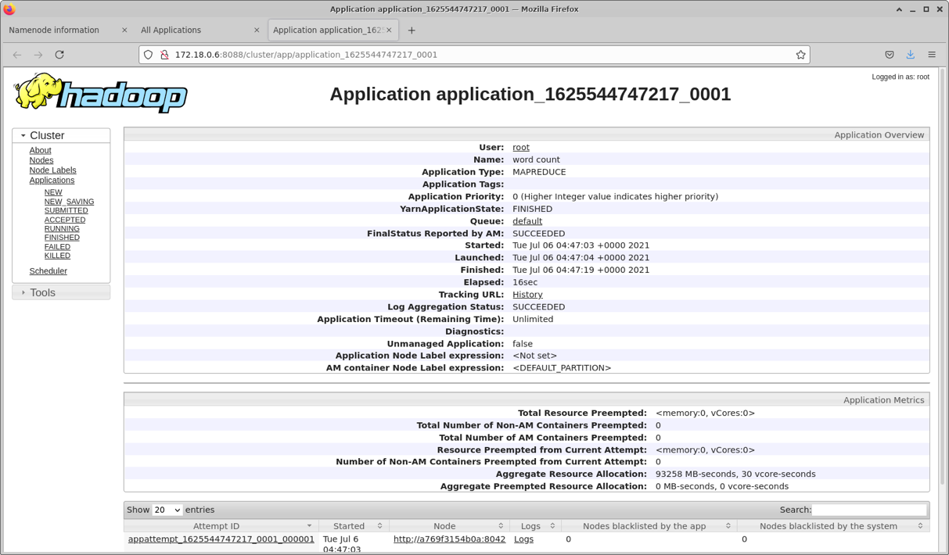
To print out the WordCount program result:

# hdfs dfs -cat output/part-r-00000

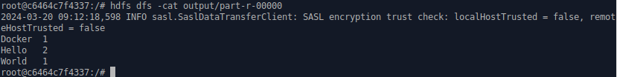
Congratulations, you just successfully executed a Hadoop MapReduce WordCount program!
If you want to leave the container:

# exit

To safely shut down the cluster and remove containers, use this command:

# docker-compose down

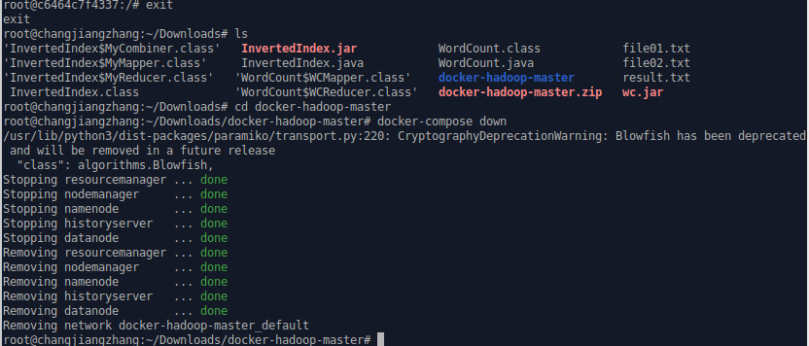
Part 2 (50%)
You need to have the HDFS directory and text files for this lab! Follow the steps, do everything by yourself and give screenshot with your personal identity, e.g. student ID/name, etc.
1, If your Docker containers are off, you have to restart:

# docker-compose up -d

2, Make sure the namenode is running by accessing the web interface http://localhost:9870.
3, Make sure you have the HDFS directory “input”!
4, Make sure you have the WordCount Java program “wc.jar”

Testing the Hadoop Cluster with larger text files
We’ll provide you with a dataset of Gutenberg books, e.g., “books.zip”, unzip the file (e.g., use command “unzip books.zip”)
Assume you have the book file in your Ubuntu host machine, e.g., “~/Downloads/books”
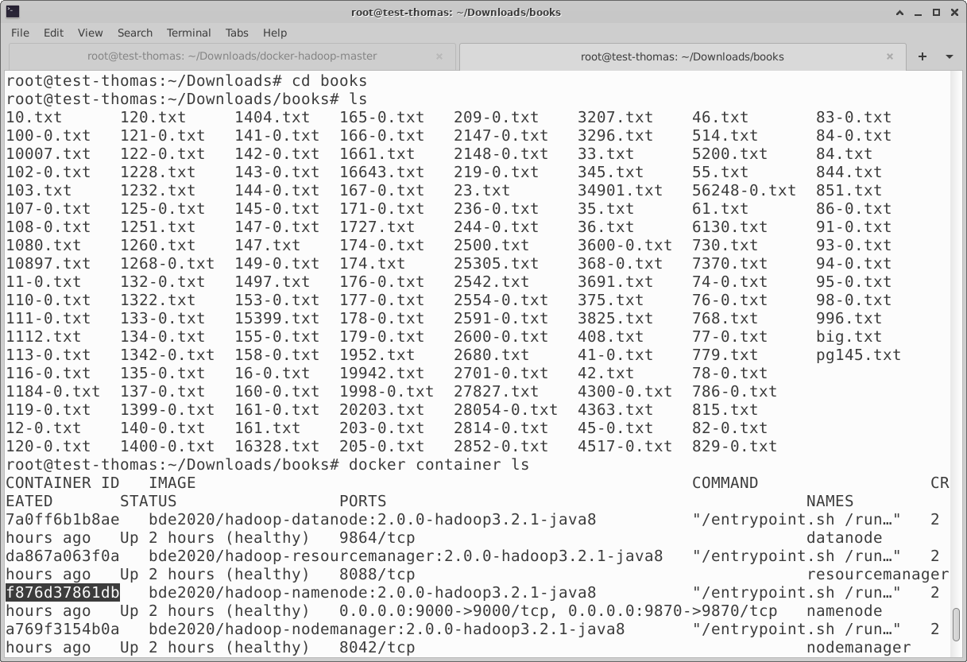
Use the following command to start copying the book file to your Docker Hadoop cluster, then enter the namenode:

# docker cp ~/Downloads/books/. f876d37861db:/input/
# docker exec -it namenode bash

Now you should be able to see the files in the container’s “input” directory, then you should copy the files to the HDFS:

# hdfs dfs -put ./input/* input

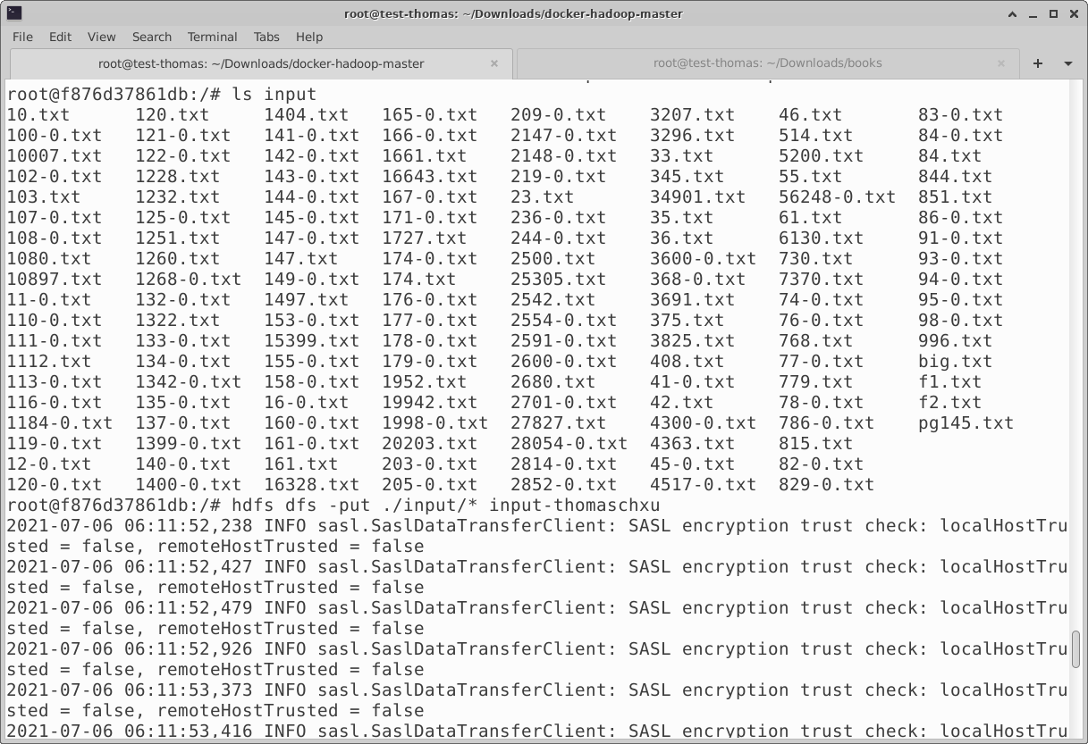
In fact, you can see these files from the web file browser:
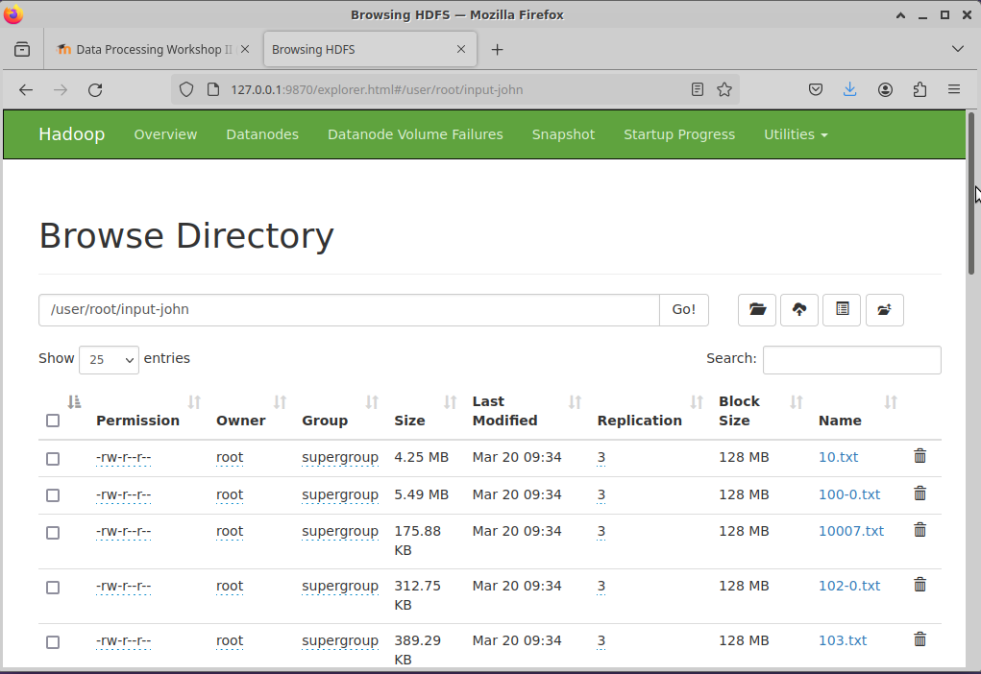
Now you are ready to run the WordCount, notice we changed the output directory:

# hadoop jar wc.jar org.apache.hadoop.examples.WordCount input output-book

In my case:
# hadoop jar wc.jar WordCount input output-book

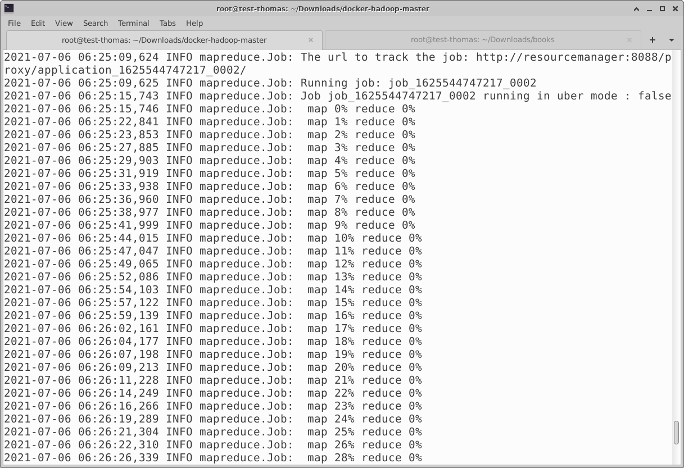
It may take several minutes to execute, you should see output of: “map 100% reduce 100%”
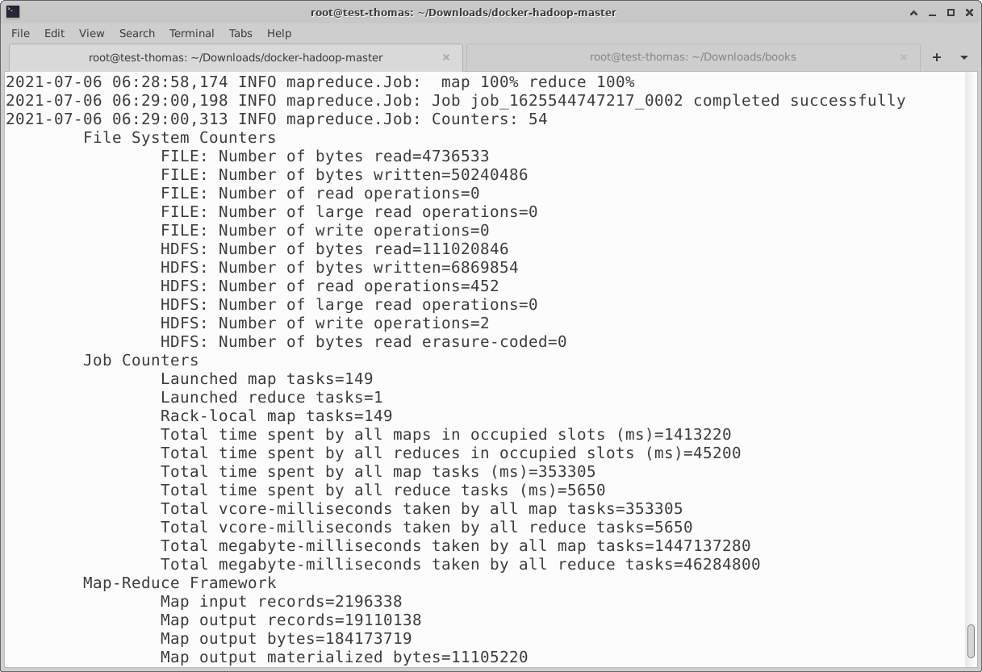
You can also check the Hadoop Resource Manager for the status of your task (3min 48sec):
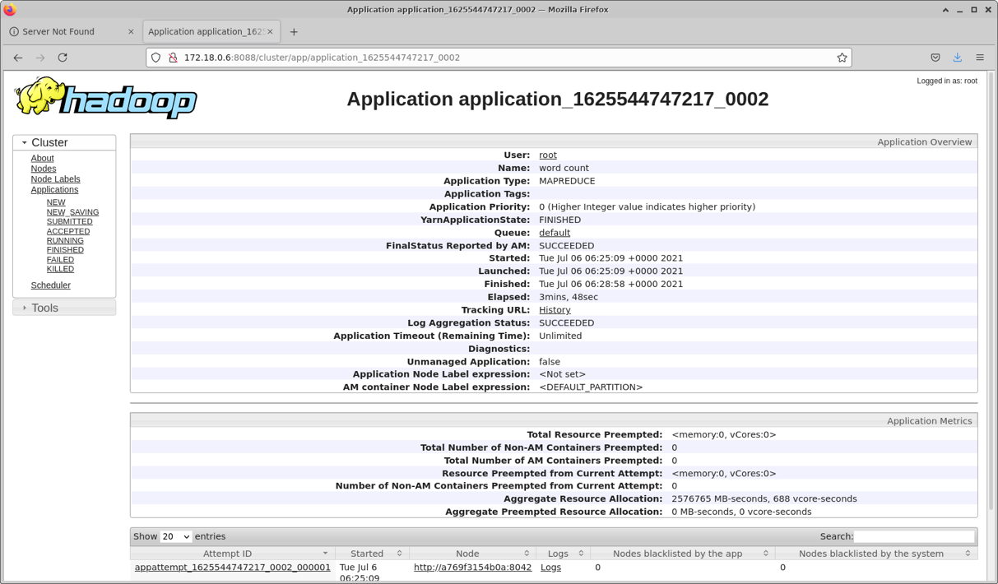
You can also find the WordCount program result from web interface:
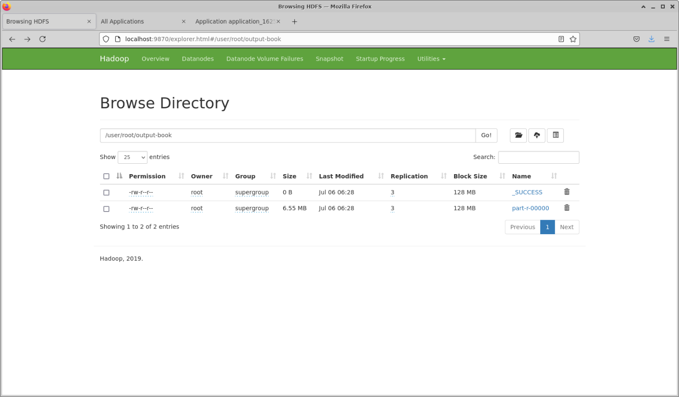
Also download to your host computer:

# hdfs dfs –get output-book/part-r-00000 result2.txt

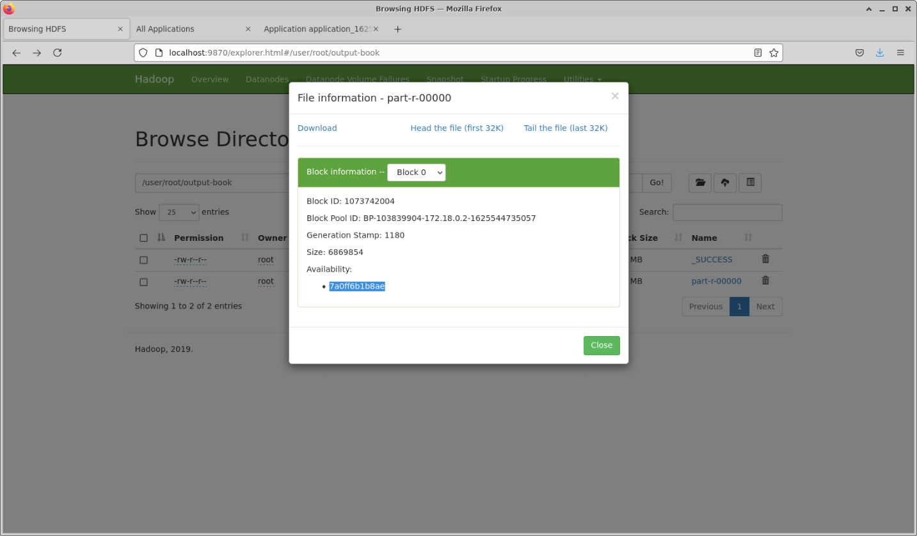
NOTICE!
When you click “Download”, the link may be unavailable due to hostname resolution. One solution is simply replacing the datanode hostname (7a0ff6b1b8ae) in the following with related IP address (e.g., 172.19.0.5 in my case), and re-download.
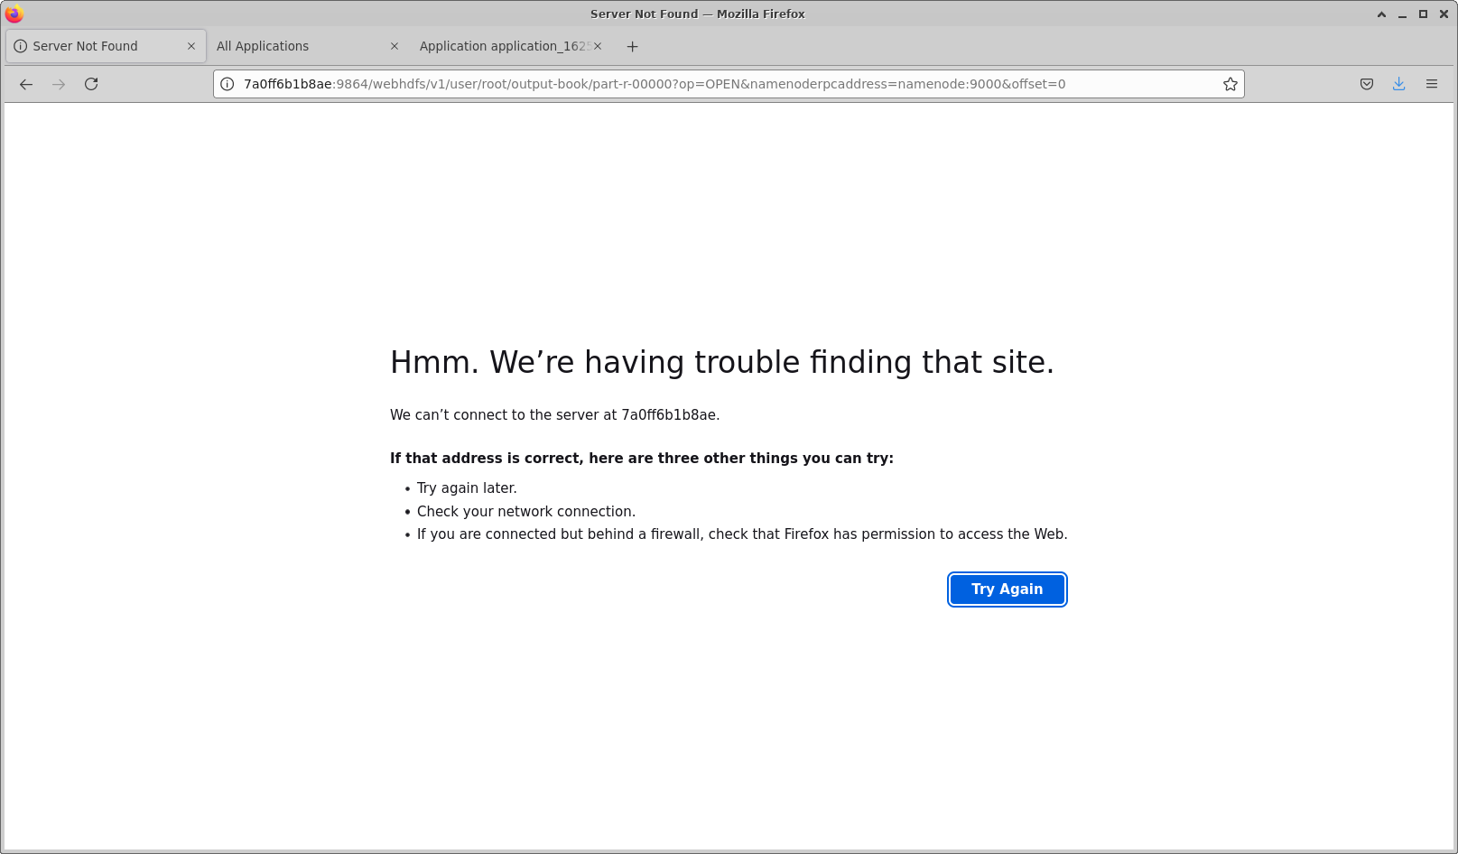
(NOTE: Another method is to add the datanode host “7a0ff6b1b8ae” and related IP address to your “/etc/hosts” file, so that you have the host name <-> IP resolution.)
After download, you can check the content of the output in your Downloads directory:
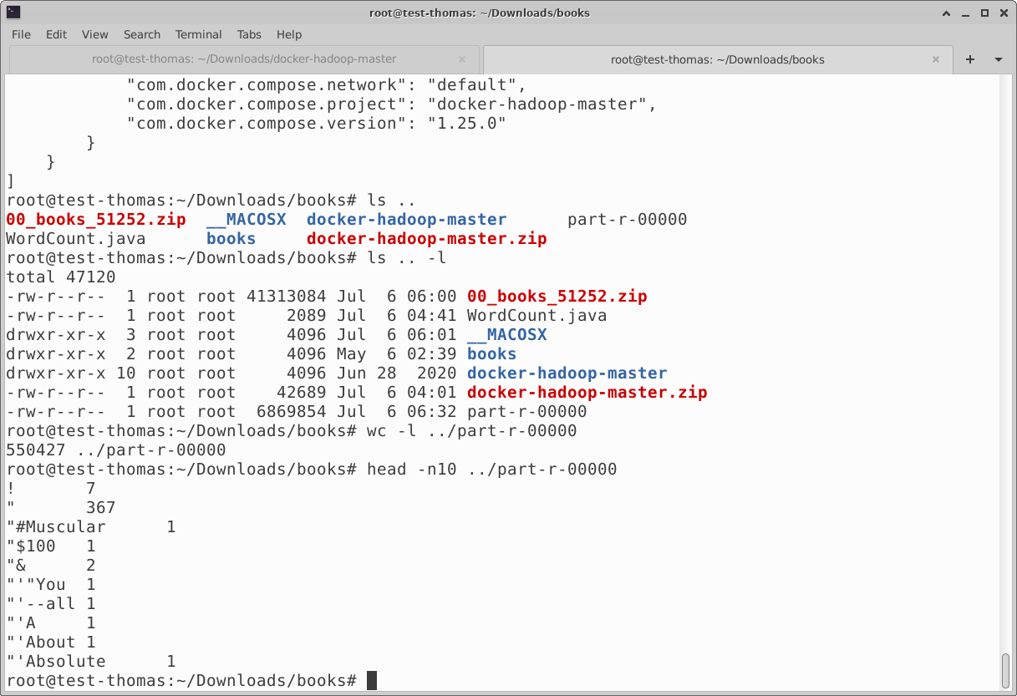
Congratulations, you just successfully executed a Hadoop MapReduce WordCount program!
If you want to leave the container:

# exit

To safely shut down the cluster and remove containers, use this command:

# docker-compose down

