Project 1 (Basic) – Search System based on Spark TF-IDF with Web Interface

- Install Django if you haven’t:

# pip3 install django -i https://pypi.mirrors.ustc.edu.cn/simple

- Time to start the “CPS4982_Project” project:

# django-admin startproject CPS4982_Project

If everything goes well, this command will create the following directory tree:

CPS4982_Project/
manage.py
CPS4982_Project/
__init.py__
setting.py
urls.py
wsgi.py

Now let’s create the search app minisearch:

# cd CPS4982_Project
# python3 manage.py startapp minisearch

That’ll create a directory minisearch, which is laid out like this:

minisearch/
__init__.py
admin.py
apps.py
migrations/
__init__.py
models.py
tests.py
views.py

Now we need to add the app in CPS4982_Project/settings.py in the INSTALLED_APPS list

INSTALLED_APPS = [
'minisearch.apps.MinisearchConfig',
'django.contrib.admin',
'django.contrib.auth',
'django.contrib.contenttypes',
'django.contrib.sessions',
'django.contrib.messages',
'django.contrib.staticfiles',
]

- Time to write the view: Open the file minisearch/views.py and add the following Python code.

from django.shortcuts import render
from .search_call import search

def search_index(request):
results = []
search_term = ""
context = {'results': {}, 'count': 0, 'search_term': 'empty'}
if request.GET.get('keyword'):
search_term = request.GET['keyword']
results = search(query = search_term, topN = 20)
print(results)
context = {'results': results[1], 'count': results[0], 'search_term': search_term}
return render(request, 'index.html', context)

To call the view, we need to map it to a URL — and for this we need a URLconf. To create a URLconf in the minisearch directory, edit the file minisearch/urls.py:

from django.urls import path
from . import views

app_name = 'minisearch'
urlpatterns = [
path('', views.search_index, name='search_view'),
]

The next step is to point the root URLconf, e.g., CPS4982_Project/urls.py:

from django.contrib import admin
from django.urls import include, path

urlpatterns = [
path('search/', include('minisearch.urls')),
path('admin/', admin.site.urls),
]

The include() function allows referencing other URLconfs. Whenever Django encounters include(), it chops off whatever part of the URL matched up to that point and sends the remaining string to the included URLconf for further processing. In my case I used “search/” route. You can also use an empty route string as the search site will do just one thing which is query the TF-IDF index and returns the resulting documents that match the user search. You can use whatever string you like if you wish or in case you have other apps.

- For search kernel, the script search_call.py (the code is basically the same as Part TWO of your Lab Jupyter notebook) is created inside the minisearch/ app folder:

from pyspark import SparkConf, SparkContext
from pyspark.sql import SparkSession, SQLContext
import os, re, sys, math

sc = SparkContext.getOrCreate(SparkConf().set("spark.hadoop.dfs.client.use.datanode.hostname", "true"))
sql = SQLContext(sc)

tfidf_RDD = sql.read.parquet('hdfs://johnzhang20230:9000/user/output/bookpico-tfidf').rdd.map(lambda x: (x['_2'],(x['_1'],x['_3'])))

def tokenize(s):
return re.split("\\W+", s.lower())

def search(query, topN):
tokens = sc.parallelize(tokenize(query)).map(lambda x: (x, 1) ).collectAsMap()
bcTokens = sc.broadcast(tokens)

joined_tfidf = tfidf_RDD.map(lambda x: (x[0], bcTokens.value.get(x[0], '-'), x[1]) ).filter(lambda x: x[1] != '-' )

scount = joined_tfidf.map(lambda a: a[2]).aggregateByKey((0,0),
(lambda acc, value: (acc[0] + value, acc[1] + 1)),
(lambda acc1, acc2: (acc1[0] + acc2[0], acc1[1] + acc2[1])) )

scores = scount.map(lambda x: ( x[1][0]*x[1][1]/len(tokens), x[0]) ).top(topN)

return topN, scores

- Now let’s build the index HTML template. We create the file index.html inside the templates folder CPS4982_Project/minisearch/templates/. In this case I chose to assign to the strings in the tuple an icon to distinguish them. The images are saved inside the folder CPS4982_Project/minisearch/static/img/

Below shows the HTML template file:

{% load static %}
<!doctype html>
<html>
<nav class="navbar navbar-light bg-light">
<center>
<img src="{% static "img/booksearch.jpg" %}" width="450" height="250"">
<form class="form-inline">
<input
class="form-control mr-sm-2"
type="search" placeholder="Keyword"
aria-label="Keyword"
name = 'keyword'
value = "">
<button class="btn btn-outline-success my-2 my-sm-0" type="submit">Search</button>
</form>
</center>
</nav>

{% if results %}
<div class="txtCentrado margenSup20 grisDC">
<h3>We found {{ count }} result{{ count|pluralize }} for your search "<i>{{ search_term }}</i>", showing top hits according to TF-IDF score: </h3>
</div>
<div class="search results">
{% for mytuple in results %}
<div class="images">
<img src="{% static "img/score_icon.png" %}"hspace=5">{{ mytuple.0 }}
<img src="{% static "img/book_icon.png" %}"hspace="5">{{ mytuple.1 }}
<img src="{% static "img/linenum_icon.png" %}"hspace="5">{{ mytuple.2 }}
<img src="{% static "img/text_icon.png" %}"hspace="5">{{ mytuple.3 }}
</div>
<p></p>
{% endfor %}
</div>
{%elif not search_term %}
<h3>Insert your search here.</h3>
{%elif not results %}
<p>No results found.</p>
{% endif %}
</html>

- Run the final test search! Make sure the index has been generated by TF-IDF. In your project root directory run the following command:

# python3 manage.py runserver

Open your web browser and browse to http://127.0.0.1:8000/search/ or whichever port you want to launch your django app on:

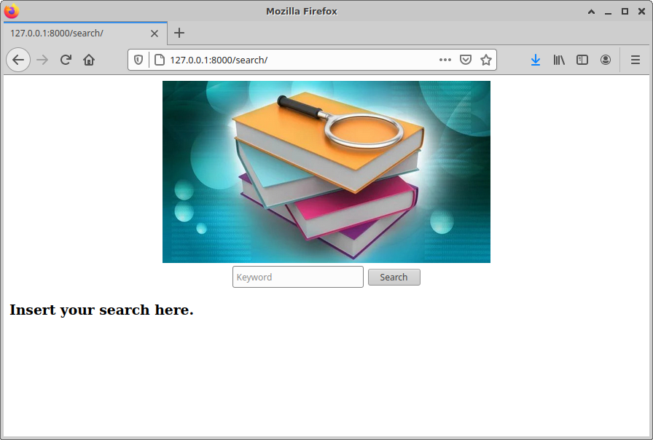

Now let’s search for something we know belongs to our index, for example a simple word, the word “is”. If you get something like this, congrats yourself because you made it!

