CPS4982

2026 Fall Project
There are two projects
Project group
You will form a three-person group and work together to finish the project. Therefore, cooperation is very crucial to the success of this project. However, you should clearly specify the role and contribution percentage of each member in the project report. The grading will consider the overall result of the teamwork, as well as the workload, output quality, and presentation of each member in a team.
- Project deliverable
- Codes with proper comments.
- A written report in PDF format with name “GROUP_#_GROUP_NAME.pdf” recording what you did, how you do it and what result you get in each step. Please include important code and screenshot with comments.
- Prepare a presentation of ~8 minutes each group, clearly list the contribution percentage of each member.
- Zip your code, report, and presentation as GROUP_#_GROUP_NAME.zip and submit to Canvas.

Project 1: Text Search with Hadoop/Spark

- Goal: Retrieve text contents (which are stored at different nodes in a Hadoop/HDFS cluster) related to the query and order them according to relevance

- Detailed Task Description:
Step 1: Text files collection:
Prepare a set of English text files (could be from eBooks, websites, social media, existing datasets) in any file format that is convenient for later use (.txt, .xml, .html, etc.). The total file size for system performance measurement and demo should be ~100MB. Possible ways of preparing such file:
- Project Gutenberg, a free e-book database: http://www.gutenberg.org/ebooks/
- GitHub collection of datasets: https://github.com/awesomedata/awesome-public-datasets
- Kaggle collection of datasets: https://www.kaggle.com/datasets
- Other methods you can come up with
You can start with smaller datasets at the beginning for testing purpose and demo the performance of your system with larger ones.
Please describe in detail the method you use to collect the data in the report. Think about methods to speed up your data collection process.

Step 2: Indexing and ranking:
With the collected text files, you may start to do next steps:
- Indexing, which means you go through all the files and create an index file containing all the words (or more complicated phrases) and the location of their appearance:
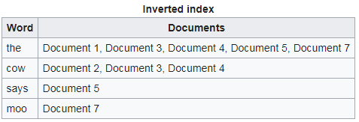
- Write a program using Hadoop/Spark MapReduce to generate the inverted index. Algorithm improvement and performance improvement are considered as a bonus.
- Ranking, is to decide the position at which a particular document appears in the results of a search engine query. There are many different ranking algorithms for searching, see https://en.wikipedia.org/wiki/Tf%E2%80%93idf or
https://zhuanlan.zhihu.com/p/31197209 or
https://en.wikipedia.org/wiki/PageRank.
If you are searching on a lot of text files, you can implement the TF-IDF ranking algorithm to rank the result for your query depending on the relevance of your txt file where your key word is found. Algorithm improvement and performance improvement are considered as a bonus.

Step 3: Interface:
You need to provide the users with an interface to enter their queries to your system, something as simple as this:
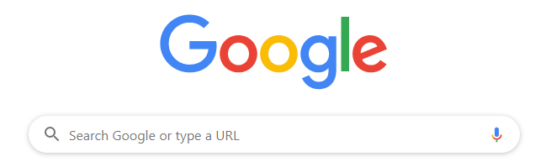
The search result should be collected by a web server returned to the querying user, which may look like this:
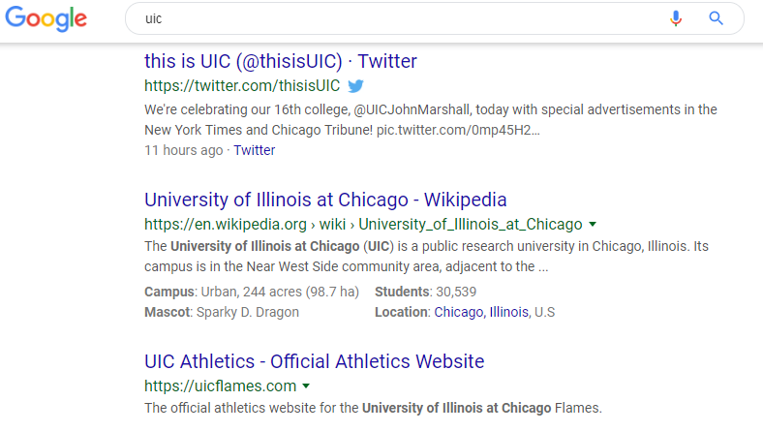
You can implement the interface by using Jupyter notebook; or your own front-end interface such as python Django.

Project 2: Hadoop/Spark project

- Goal: Choose ONE of the following Hadoop/Spark project and finish according to the document and requirement. Different project has different Difficulty Level (3-5), which will be considered in the final marking. Show your code and screenshot with comments in the report and presentation.

- Options:

  - Data analytics for the Bilibili website (Difficulty Level 5): (1) follow the document and implement everything, (2) retrieve the latest data from Bilibili website and redo the previous step, (3) analyze the data which are related to “WKU”.
  - CO2 emissions analysis (Difficulty Level 4): (1) follow the document and implement everything, (2) retrieve the carbon emission data in 2024, 2025 and 2026 and redo the previous step.
  - Music album analytics (Difficulty Level 3): (1) follow the document and implement everything, (2) retrieve another album data from Kaggle and redo the previous step.
  - Weather analysis (Difficulty Level 4): (1) follow the document and implement everything, (2) retrieve the latest data from NMC website and redo the previous step, (3) analyze the data which are related to “Zhejiang” and “Wenzhou”.
  - Movie data analytics (Difficulty Level 5): (1) follow the document and implement everything, (2) retrieve another TMDB dataset (size>5000) from Kaggle website and redo the previous step, (3) analyze the movie data which are related to China and Chinese.
  - Credit card data analysis (Difficulty Level 4): (1) follow the document and implement everything, (2) retrieve a different credit risk dataset from Kaggle website and redo the previous step.
  - Earthquake data analysis (Difficulty Level 3): (1) follow the document and implement everything, (2) retrieve a dataset of earthquake 1900-2026 from Kaggle website and redo the previous step.
  - Advanced earthquake data analysis (Difficulty Level 5): (1) follow the document and implement everything, (2) retrieve a dataset of earthquake 1900-2026 from Kaggle website and redo the previous step.
  - E-Commerce data analytics (Difficulty Level 4): (1) follow the document and implement everything, (2) retrieve another e-commerce dataset from Kaggle website and redo the previous step.

