WAKE UP
Full Game Overview · How It Works · Uniqueness
Wenzhou-Kean University · Building C · Lockdown 03:33 AM
First-Person 3D Horror Survival · Hackathon Project
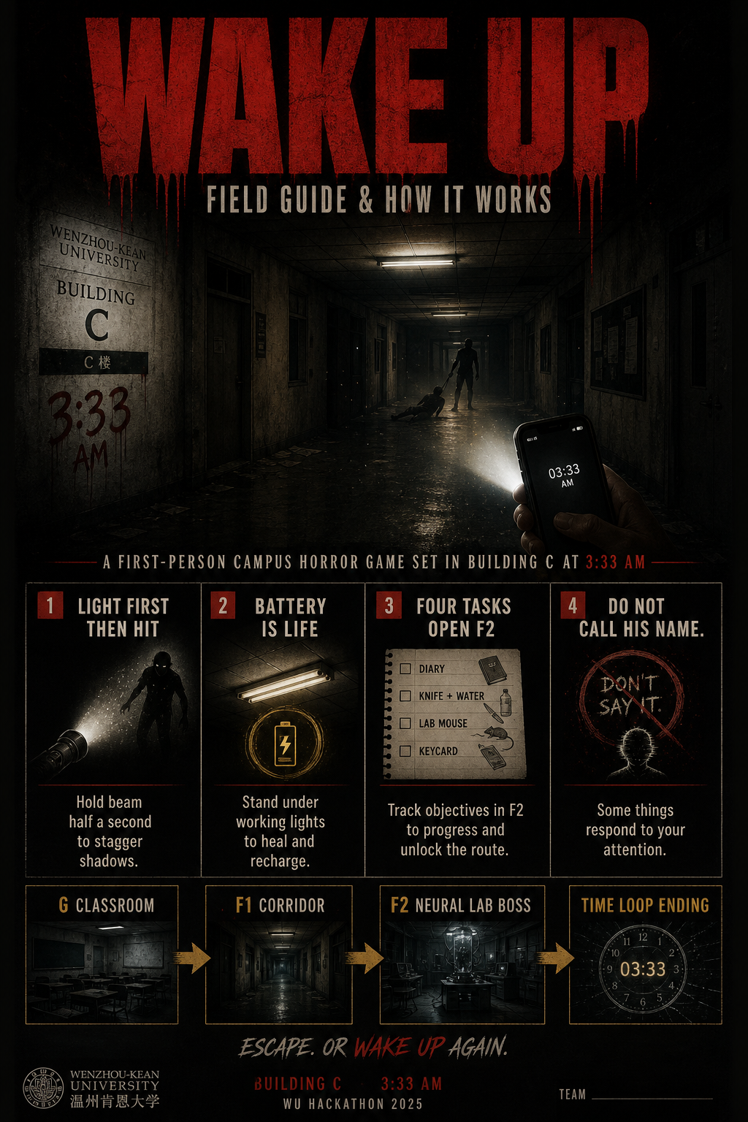

1. What the game is
Wake Up is a browser-based first-person survival horror game set inside Wenzhou-Kean University’s Building C during a failed campus lockdown at 3:33 AM. You wake at your desk. Your friend Luke is missing. Your phone is the only light. You must explore three floors, complete gated tasks, survive shadows that hunt noise and darkness, and confront the Neural Lab — only to discover that winning may not mean escape.
The game runs entirely in the browser (Three.js). No install, no Unity client for players — open the GitHub Pages link or run locally with a simple static server.

2. How to run / play
- Online: open the GitHub repository Pages link (index.html).
- Local: run start-server.ps1, then open http://localhost:8080
- Read the Field Guide: guide.html (controls, tasks, combat rule, spoilers).
- Enter your name on the start screen, then Play. Click once to lock the mouse.
- Headphones recommended. Flashing lights and loud sounds.

3. Story flow (no ending spoiler)
- Ground Floor classroom: phone buzzes → missed calls from Luke → campus alert.
- Read the note under the phone. Luke went to Floor 1.
- Scripted opening: Luke appears at the doorway, screams your name, is dragged away; lights die.
- Exit to the corridor and climb to Floor 1 — rooms are open, shadows hunt.
- Complete the four stairwell tasks, then use the F2 keycard.
- Floor 2 Neural Lab: boss fight built around light-stagger combat.
- The ending is a closed loop — designed as theme, not a bug.

4. Core systems — how the game works

4.1 The one combat rule: Light first. Then hit.
Shadows (and especially the boss) respect light more than weapons. Hold the flashlight beam on a target for about half a second to stagger it. Only then does melee deal full value. The boss is immune while not staggered — swinging blind does nothing. Throws (water bottle / lab mouse) can buy stun time without the light, but the knife window is the main rhythm.

4.2 Battery economy
Battery is the real resource. It drains faster while moving and on higher floors. Below ~35% the torch flickers; near empty it nearly dies. Standing still under a working ceiling light recharges battery and regenerates health. Spare batteries exist in the building (+55 each). Until Luke’s event, the phone runs at half power.

4.3 Health, stamina, noise
- Health: restored by the single medkit (+35) or standing under working lights.
- Stamina: sprint (Shift) burns quickly; recovers while walking/standing.
- Noise: sprinting, trips, and thrown impacts alert nearby shadows — decoys are intentional.
- Walking with the light on makes trip hazards harmless.

4.4 Task gate to Floor 2
The F1 stairwell keycard reader stays red until required tasks are done:
- Read Dr. Chen’s logbook (Faculty Office)
- Take knife + water bottle (Kitchen)
- Take the lab mouse (Lab Prep)
- Take the F2 keycard (Library)
- Optional: first-aid kit (Restroom)

5. Floors & map design
- G — Classroom / locked corridor: tutorial + cinematic opening. No combat.
- F1 — Main corridor: enterable rooms (office, kitchen, bath, lab prep, library, store, dark classrooms); 3 roaming shadows.
- F2 — Neural Lab: boss (high HP), telegraphed charges, phase minions, light-stagger loop.
You arrive on each floor at the end opposite the stairwell you need, so every floor is a full-length walk. Stairs hard-reset chase state.

6. Items
- Phone light — always with you; toggle with G.
- Kitchen knife — durable melee; use only after stagger.
- Water bottles (limited) — throw for stun + damage + noise decoy.
- Lab mouse (one use) — long stun; pulls shadows to investigate.
- Medkit — +35 HP, unique.
- Spare batteries — +55 battery.
- Keycard — opens F2 after tasks clear.
- Papers / journal — notes file into Tab journal.

7. Controls
- WASD — move · Mouse / arrows — look · Shift — run
- E — interact · Left click / Space — use / swing / throw
- 1–4 — select items · G — flashlight · Tab — journal · Esc — pause

8. What makes Wake Up unique
- Campus-specific horror: not a generic haunted house — WKU Building C, bilingual EN/中文 UI, student identity (your name is spoken into the story).
- Resource horror over ammo horror: battery + working lights replace the usual gun economy. Darkness is the enemy’s ally.
- Asymmetric combat rule: light is a verb. The game trains a Resident Evil-like rhythm (expose → strike → retreat) without firearms.
- Noise as design: sprinting is a choice with consequences; throws are weapons and decoys.
- Task-gated vertical progression: exploration order is free on F1, but the stairwell is an objective checklist — clarity without a quest arrow.
- Time-loop ending as theme: “winning” advances a loop counter; escape is not promised. The rule “do not call his name” treats the player as someone who might break the cycle.
- Zero-install 3D: full Three.js first-person experience in one HTML package + Field Guide, shareable via GitHub Pages for judges and teammates.
- Dual deliverable: playable game + Field Guide (guide.html) + this overview + poster — judges can understand systems in under a minute.

9. Technical stack
- HTML5 + CSS + JavaScript (single advanced index.html build)
- Three.js (CDN) for 3D scene, lighting, meshes, camera
- Web Audio API for procedural / layered horror audio
- Pointer lock FPS controls with drag fallback
- Quality settings (post-process / grain / vignette)
- Optional photo upload for scare personalization
- Local static hosting via start-server.ps1 (Python http.server)
- Legacy raycaster prototype kept as index-raycast.html for reference

10. Production notes (hackathon)
Built for a short hackathon cycle: rapid iteration from early 2D top-down / raycaster prototypes into a polished first-person Three.js experience. Art and atmosphere lean on lighting, silhouette, and sound rather than large asset packs. The Field Guide documents balance numbers (damage, stun windows, battery times) so teammates and judges can evaluate design intent, not only vibes.

11. Files in this repository
- index.html — main 3D game
- guide.html — Field Guide (controls, tasks, combat, spoilers)
- Wake_Up_Poster.png — poster + how-it-works visual
- Wake_Up_Game_Overview.docx — this document
- start-server.ps1 — local run script
- index-raycast.html / js/ — earlier engine version (optional)

12. One-line pitch
At 3:33 AM in Building C, your phone is the only light — and the thing that took Luke only freezes when you point it.
Wake Up · Wenzhou-Kean University · Loop ∞

