AnafiPlanToGPX   |  | Summary  "AnafiPlanToGPX" is an application to convert JSON flight plan files from Parrot's "Anafi" quad-copter into GPX files for review by map services.  Installation  No installation needed, this is a portable application. But you need write access to the directory where the application located. "AnafiPlanToGPX" will store its settings in an XML file there.  Usage  Open file "savedPlan_*.json". A list of waypoints will be shown on page "Waypoints" and some meta data (such as POI) on "Info" page. The related GPX file will be created and saved in the same folder as the flight plan file is.  I is possible the create additional trackpoints between waypoints in the target GPX file.  Enjoy.

Overview
Rate [1..100] of additional trackpoints. Smaller value
means more additional trackpoints between waypoints.
Rate 1 is aproximately one trackpoint per
3D-distance in meter (optimal rate: 10 to 40).
Allow/disallow
additional trackpoints
between waypoints.
Open a flight plan file by button "Open".
A file select dialog will appear.
Select the file you need to convert.

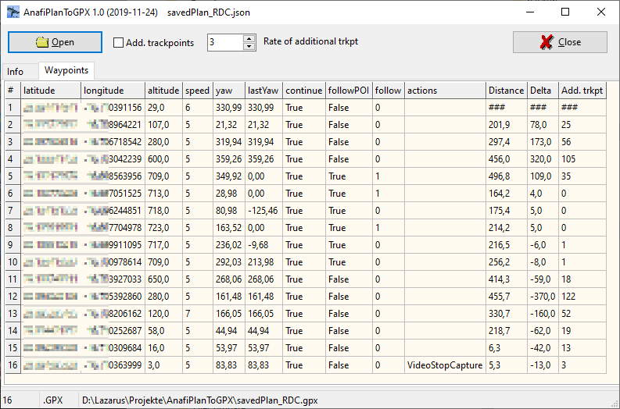
List of waypoints.
Latitude, longitude and
altitude will be used
for GPX tracks.
Preview number
of additional trackpoints
between waypoints.

Distance between waypoints
Delta altitude
(ascent/descent)
between waypoints.
Number additional trackpoints = (square root of (distance² + delta²) divided by rate_of_additional_trkpt) - 1.

Meta data

This is just for information and reference.
Close application
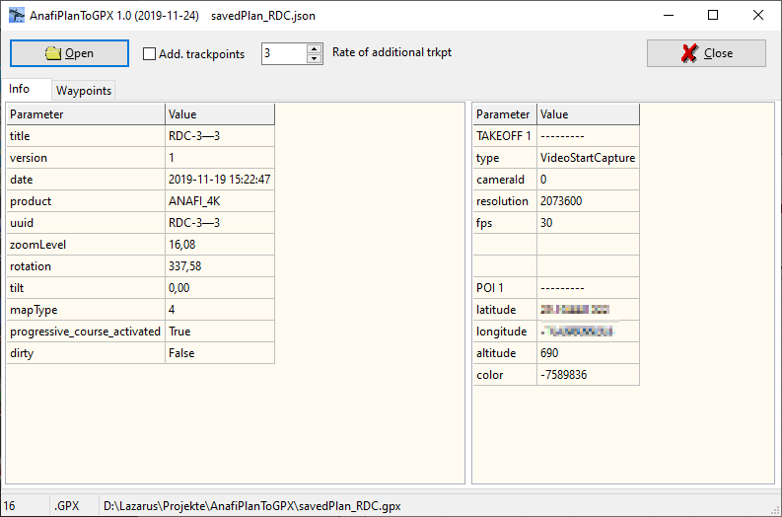
Different points from from
JSON flight plan file.
CTRL+C to copy whole
table to clipboard.
List of meta data from
JSON flight plan file.
CTRL+C to copy whole
table to clipboard.
Output file name.
Double click to open
file explorer.
Number of trackpoints
Number of waypoints.

