Battery check tool

This program was made for fast evaluation of flight batteries under real load.
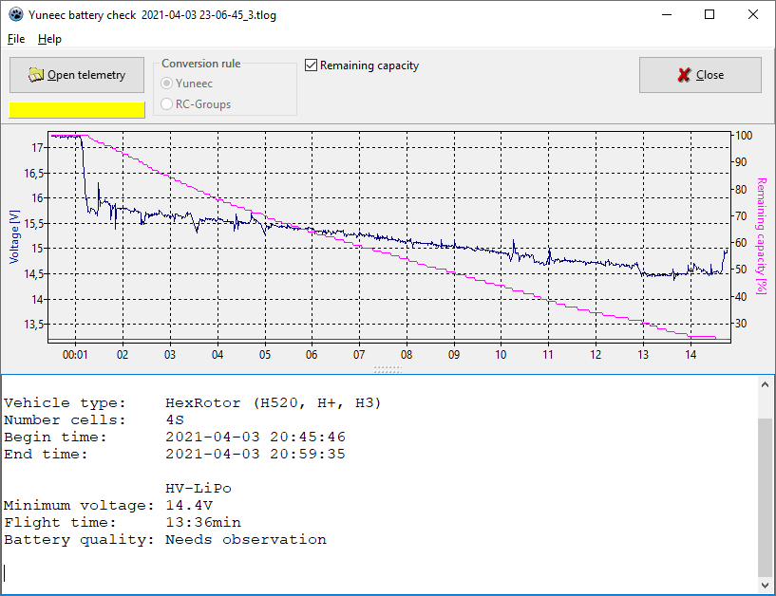
The check requires an entire flight with a fully charged battery. The assessment is (and can be) only very superficial and is dependent on or influenced by many factors. Nevertheless, it can be seen intuitively, at least on the diagram, how the discharge behavior of the battery is.

The advantage over pure voltage measurement is that you can see the voltage curve under load. If the voltage drops sharply under load, this indicates a high internal resistance of the battery. This happens gradually with aging or relatively quickly with defects.
In any case, it is questionable to fly batteries that can no longer be fully trusted. Therefore I consider a constant observation of the batteries necessary (post-flight-check).
This tool should simplify that.

To see the voltage history, you have to load the telemetry data from the flight. Usable are:

- TLOG Dateien from PX4 Autopilot,
- Telemetry CSV-Dateien from legacy Yuneec drones,
- the related pedants from Mantis Q,
- Breeze,
- Blade Chroma,
- Blade 350QX (if controlled by ST10).

Assessment for a voltage chart

In the attached screenshot we see the evaluation of a TLOG file from the H520, which contains three flights with three different batteries, here called segments of the file.

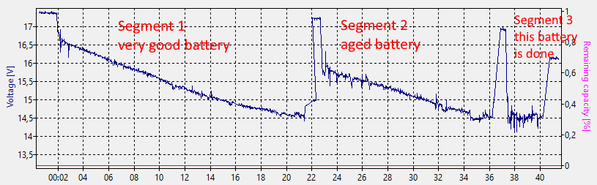

- Segment 1 shows the typical course of a good battery with long flight time and low voltage drop.
- Segment 2 shows an aged battery, which should be inspected continuously.
- Segment 3 shows a defective or at least very old battery that belongs in the scrap. This battery actually caused a crash.

