CGO3control user manual

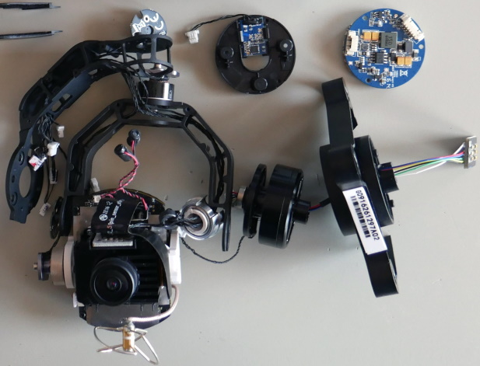

Controlling Yuneec cameras CGO3(+) or CGO-ET
Version 1.0

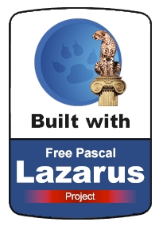

Author: Helmut Elsner
Issue: 03/2022

Table of content
1 Introduction 3
1.1 Features (short description) 3
1.2 Installation 3
2 Detailed description of the features 4
2.1 CGO3 control 4
2.2 CGO3 test 7
2.3 Geotagging 8
3 Appendix 9
3.1 Sources and additional information 9
3.2 IP addresses for video streams 9
3.3 Format CGI commands 9
3.4 Possible commands (not all can/should be used!) 10

Introduction

This application belongs to the tool-set of Q500log2kml. It was exported from this to this extra tool in order to reduce complexity for usage. This application has two main functions:

- Control a CGO3, CGO3+ or CGO-ET camera,
- Geotagging of JPG-pictures from CGO3 camera.

Important note: Use this application on your own risk. There is no guaranty for correctness and/or completeness of the used data.

Because this all was done by own tests and private researches, the interpretation of the data may be wrong.

On the other hand, this application is freeware. Have fun…

The source code, binaries and docuumentation is available here:
https://github.com/h-elsner/CGO3control

Remark: Camera control will not work with Yuneec C23 or newer cameras.

Features (short description)
- CGO3 control: A simple GUI to control the camera by CGI commands via HTTP.
- CGO3 test: Test environment for commands to CGO3 via 5G WLAN connection.
- GeoTagging: Add coordinates and altitude from telemetry files to meta data of JPG-pictures from CGO3 that do not have this in EXIF meta. Assignment of data to pictures is based on time stamp.

Installation
No installation necessary, it is a portable application (only the binary needed). Simply unzip the downloaded file and store it to a directory where you have write access. This can also be a USB stick or a removable drive.
Download updates and user manual from my homepage.
To run the application, you might have to suppress Microsoft SmartScreen warnings: Click on "more info" and then "run anyway".

Detailed description of the features

CGO3 control

This is for testing commands to CGO3 and a raw interface to control the camera. Of course, this is only possible if a WiFi connection on 5GHz is established.

The camera creates a WiFi hot-spot. Any capable device can connect to this hot-spot. More devices increase the latency of the connection.
The SSID starts with CGO3_ or CGO3P_ (P for plus) followed by a unique number.

The default password for CGO3 WLAN is 1234567890. To get connection, a SD card must be in the camera because the password is saved there in a file "MISC\wireless.conf".

To test if WiFi hot-spot of the camera works and check the signal strength a WiFi analyzer app is a good tool.

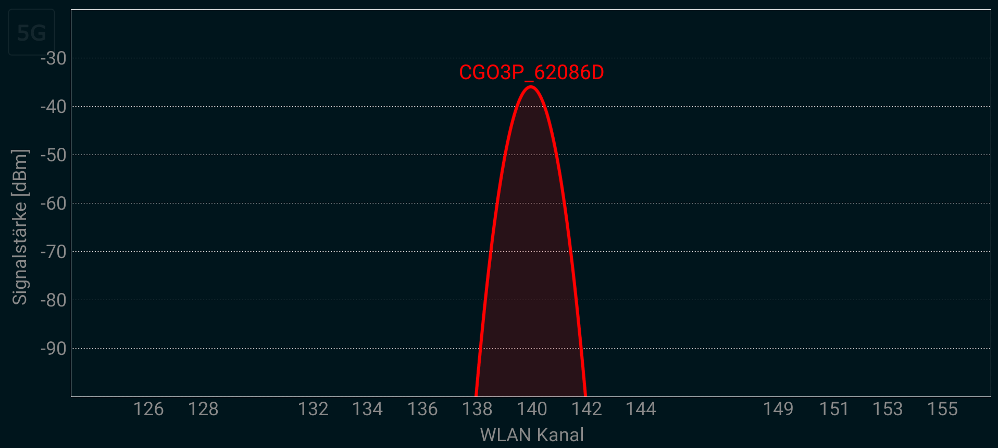

To initialize and check the connection to the camera hit button Status on CGO3 page first. Traffic light has to go green.

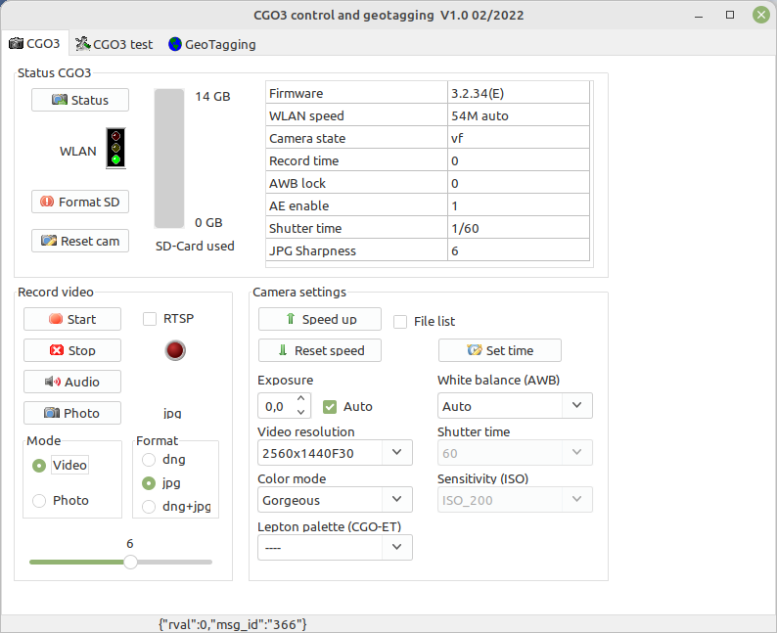

Status CGO3: Status will initialize the camera and starts a query to get status of the CGO3. Some results are in the table on the right side. Status query needs to be done first to enable the functions.
The traffic light shows the status of the WLAN connection if the Status button was clicked.

Format SD is doing a formatting of the SD card in the CGO3. It deletes all files and recreates the needed directories. Also, a new configuration file will be created with standard password for WLAN connection (1234567890).

Reset cam resets all settings of the CGO3 to factory default values.

Record video: Start / Stop controls video recording. If 'RTSP' is checked the command 'rtsp://192.168.42.1/live' will be sent to local browser. The internet browser must be able to play the RTSP stream. The protocol RSTP must be registered in the browser to make this happen (best is to redirect to VLC player).

Audio: With Audio button, you can toggle between Audio on and off.

Photo: Take a shot with Photo button.

Mode: You can switch between video and photo mode of the camera. For photo, it is recommended to switch to photo mode. Take a photo in video mode results in bad quality and only jpg.

Format: Select output format of the pictures: .dng is raw format, .jpg is compressed format. With the slider below, the sharpness for picture post processing to jpg format can be set between 1 and 10 (default is 6).

Other settings: To increase the WLAN speed to 56MBit/s, use Speed up. This useful if you want to download or check pictures from the CGO3. Large videos take too long to download via WLAN. If 'File list' is checked then the file system in browser will be opened, offer the possibility to browse and download files from SD card. After those action, it is recommended to set the default WiFi speed by Reset speed. This will set the WLAN speed to default 6MBit/s.
Set time: This will send a command to the camera to set camera internal time to current time.

If exposure is set to automatic (check box ‘Auto’ checked), then the exposure can be corrected from -2.0 to +2.0 in 0.5 steps.
If exposure is set to manual, then it is possible to select ISO sensitivity and shutter time using related drop down boxes.
You can also select video resolution from full HD, 2K up to 4K, the white balance and color mode (color mode only for jpg pictures).

CGO3 test

This is a test environment for commands to CGO3, CGO3+ or CGO-ET. Enter only the body of the command (i.e. 'GET_PHOTO_FORMAT'). Prefix 'http://192.168.42.1/cgi-bin/cgi?CMD=' will be automatically added. Below is the field for the return value. "rval":0​ means, command checked and executed successful. By double click on this output field, the return value will be copied to the clipboard.

To initialize and check the connection to the camera hit button Status on CGO3 page first. Traffic light has to go green. Button Send command will be enabled.

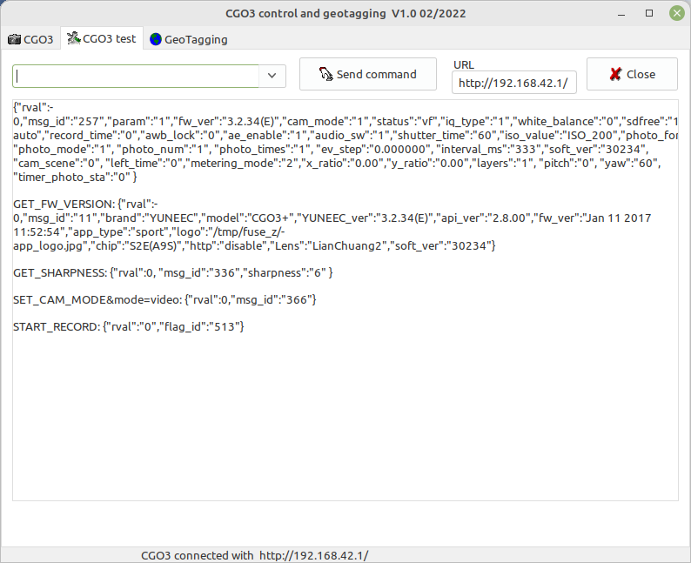
Send command will send the given command to the camera. Result will be shown in the text field.

CGO3 Standard URL: IP-address of CGO3 with trailing slash (default: http://192.168.42.1/). This address is used to send CGI- commands via HTTP protocol to CGO3 and receive results.

Geotagging

ToDo: Coming soon

Appendix

Sources and additional information

An older description of the commands is here: https://github.com/racerxdl/CGO/blob/master/Docs/commands.md

See also:
https://bitbucket.org/denis_loh/cgocameralibrary/wiki/Home

IP addresses for video streams

CGO2+/CGO3/CGO3+
Media files: http://192.168.42.1/DCIM/100MEDIA/
Live stream: rtsp://192.168.42.1/live

CGO-ET
Natural live stream: rtsp://192.168.42.1:554/live
Thermal stream: rtsp://192.168.42.1:8554/live

MK58/GoPro
Live stream: rtsp://192.168.110.1/cam1/h264

Lumix/GCO4
Live stream: rtsp://192.168.73.254:8557/PSIA/Streaming/channels/2?videoCodecType=H.264

Format CGI commands

IP address and prefix Command Parameter values

Examples for CGI commands:
http://192.168.42.1/cgi-bin/cgi?CMD=INDEX_PAGE
http://192.168.42.1/cgi-bin/cgi?CMD=SET_WIFI_SPEED&rate=9

Result starts with return value rval. This indicates if the command was successful or not.

In case the CGI command was received and accepted rval is 0 and message ID is > 0.
Example: {"rval":0, "msg_id":1, …}

rval < 0 are error codes,
msg_id:0 means unknown message – check if all was proper written, no wrong spaces and so on. Not all commands will be accepted by your camera.

Possible commands (not all can/should be used!)

CGO camera CGI commands | Parameter
INDEX_PAGE
GET_TIME
SET_TIME | time=(%Y-%m-%d_%H:%M:%S)
QUERY_SD_FIRMWARE
DECOMPRESS_UPLOADED_FILE
GET_DECOMPRESS_PROGESS | FW Update
SET_UPDATE_FILE_TYPE | FW Update
UPGRADE_PKG | FW Update
GET_UPGRADE_PROGESS | FW Update
DEL_ALL_FIRMWARE | FW Update
DEL_MEDIA_FILE
rtsp
GET_FW_VERSION
START_RECORD
STOP_RECORD
TAKE_PHOTO
STOP_SHUTTER
GET_SHUTTER_STATE
SET_PHOTOMODE_BURST | photonum=
GET_PHOTOMODE
SET_PHOTOMODE_TIMELAPSE
SET_PHOTOMODE_PANORAMA | type=
SET_PHOTOMODE_SINGLE
GET_STATUS
DETECT_CARD
FORMAT_CARD
GET_REC_TIME
REST_VF
STOP_VF
SET_PHOTO_SIZE | MODE=
GET_PHOTO_SIZE
GET_BATTERY_LEVEL
SET_SETTING | resolution=
GET_SETTING
SET_VIDEO_STANDARD | PARAM=
GET_VIDEO_STANDARD
SET_FOV | PARAM=
GET_FOV
DETECT_CARD
GET_SPACE
GET_SPACE_FREE
GET_TOTAL_SPACE
GET_CARD_FORMAT
SET_PHOTO_MODE | MODE=
GET_PHOTO_MODE
RESET_DEFAULT
SET_AUDIO_SW | mode= (0: on, 1: off)
GET_AUDIO_SW
SET_PHOTO_FORMAT | format= (dng, raw, jpg, dng+jpg, jpg+dng, jpg+raw)
GET_PHOTO_FORMAT
SET_AE_ENABLE | mode=
GET_AE_ENABLE
SET_SH_TM_ISO | time= &value=
GET_SH_TM_ISO
SET_IQ_TYPE | mode=
GET_IQ_TYPE
SET_WHITEBLANCE_MODE | mode=
GET_WHITEBLANCE_MODE
SET_EXPOSURE_VALUE | mode=
GET_EXPOSURE_VALUE
SET_VIDEO_MODE | video_mode=
GET_VIDEO_MODE
SET_CAM_MODE | Mode= (0..4)  0..Center  1..Spot  2..Partial  3..Evalnative  4..Average
GET_CAM_MODE
GET_CAM_SCENE
SET_CAM_SCENE
RESET_STATUS
request_bind | client_mac_address=
get_bind_state
SET_RTSP_VID | Resolution=
GET_RTSP_VID
GET_METERING_MODE
SET_METERING_MODE | Mode= (0..2)  0 Spot Metering  1 Center Metering  2 Average Metering
SET_SPOT_METER_COORDS | x= &y=
GET_PANORAMA_STATUS
GET_CAM_SCENE
GET_CAMERA_PKG_SOFT_VERSION
SET_FTP_INFO
GET_FTP_STATUS
SET_WIFI_SPEED | speed_rate= (1..9)
GET_WIFI_SPEED
SET_SHARPNESS | value= (1..10, 6: default)
GET_SHARPNESS

Additional commands for CGO-ET

CGO camera CGI commands | Parameter
GET_FREE_SPACE
GET_LEPTON_COMM_STATE
GET_LEPTON_SYS_STATUS
GET_LEPTON_CAMERA_SERIAL_NUM
GET_LEPTON_UP_TIME
GET_LEPTON_FPA_T
GET_LEPTON_SHUTDOWN_COUNT
GET_LEPTON_FRAME_NUM
SET_LEPTON_PALETTE_TYPE | val= (0..10)  FUSION(0)  RAINBOW(1)  GLOBOW(2)  ICE_FIRE(3)  IRONBLACK(4)  MAPLIN(5)  MAPLOG(6)  GRAYFUSION(7)  PCOLOR(8)  NoName9 (9)  NoName10 (10)
GET_LEPTON_PALETTE_TYPE
GET_LEPTON_LOCK_RANGE_STATE
SET_LEPTON_LOCK_RANGE_STATE | val= (1, 0)
SET_LEPTON_TAKE_PHOTO_TIME | val=
GET_LEPTON_TIMING_TAKE_PHOTO_INFO
STOP_TAKE_PHOTO
RUN_LEP_FCC_MAINED
SET_LEPTON_AUTO_RUN_FCC_ENABLE | val=
SET_AIR_PARAMS | enable= (1, 0) value1= (rateOfLaunch) value2= (tOfAir) value3= (tempOfAir)
SET_TEMP_PARAMS | enable= (1, 0) max_temp= min_temp=

