CGO3+ UART tool (CGO3PUARTtool)

Abstract
This tool provides UART (serial) connection to the CGO3+ or CGO-ET for Typhoon H (not the CGO-ET for H520) camera.

Once connected the tool offers three functions:
- Act as gimbal checker. With this function you can read and record a lot of data coming from gimbal or camera itself. And you can try to calibrate the gimbal.
- Act as flight controller to tilt and rotate the camera. This offers the possibility to reuse the camera for other purposes. This part is only a demo.

The gimbal checker provides a possibility to fully calibrate the gimbal of the CGO3+. This functionality is experimental. Use it on your own risk.

Download this tool at download page: http://h-elsner.mooo.com/html/downl.htm
Binaries for Windows (.zip) and LINUX (.tar.gz) are available.

Installation: No installation, simply unzip the file. It is a portable application. You need only the executable for your OS. Copy it somewhere in the home file system or to an USB stick.

CGO3+ gimbal calibration
NOTE: This is an experimental process, not an official tool. This may work or not, no warranty. You use it on your own risk.

Preparation
You need a mount for the CGO3+ where it can rotate and tilt freely. Connect a Serial-USB converter (also known as programmer cable) to Gound, Rx and Tx. Do not connect power on the USB-Serial converter (for YUNA100 this pin is already open). You can use The USB cable YUNA100 from Q500 if you have one or any other converter that has 3.3V level. Rx and Tx must have 3.3V level.

This is a camera mount YUNTYH108. You need one with contact PCB.
Connect Ground to GND converter Tx to mTx/PWM and converter Rx to mRx.
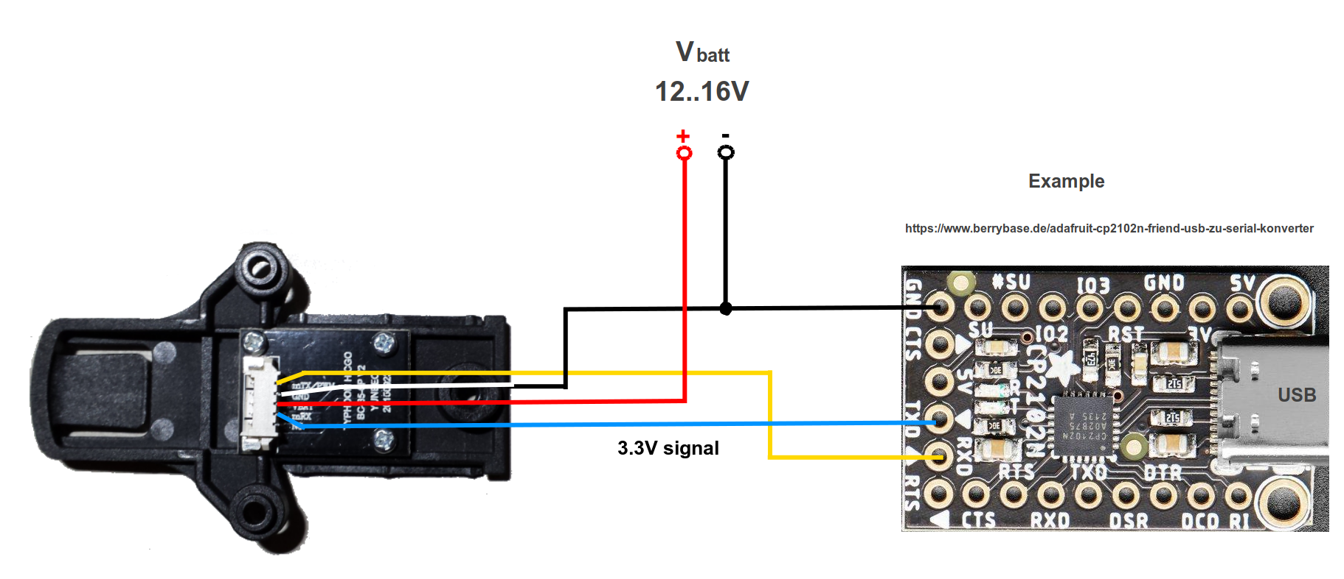
My setup is a wooden mount for the camera and a serial to USB converter with a CP2104 chip.
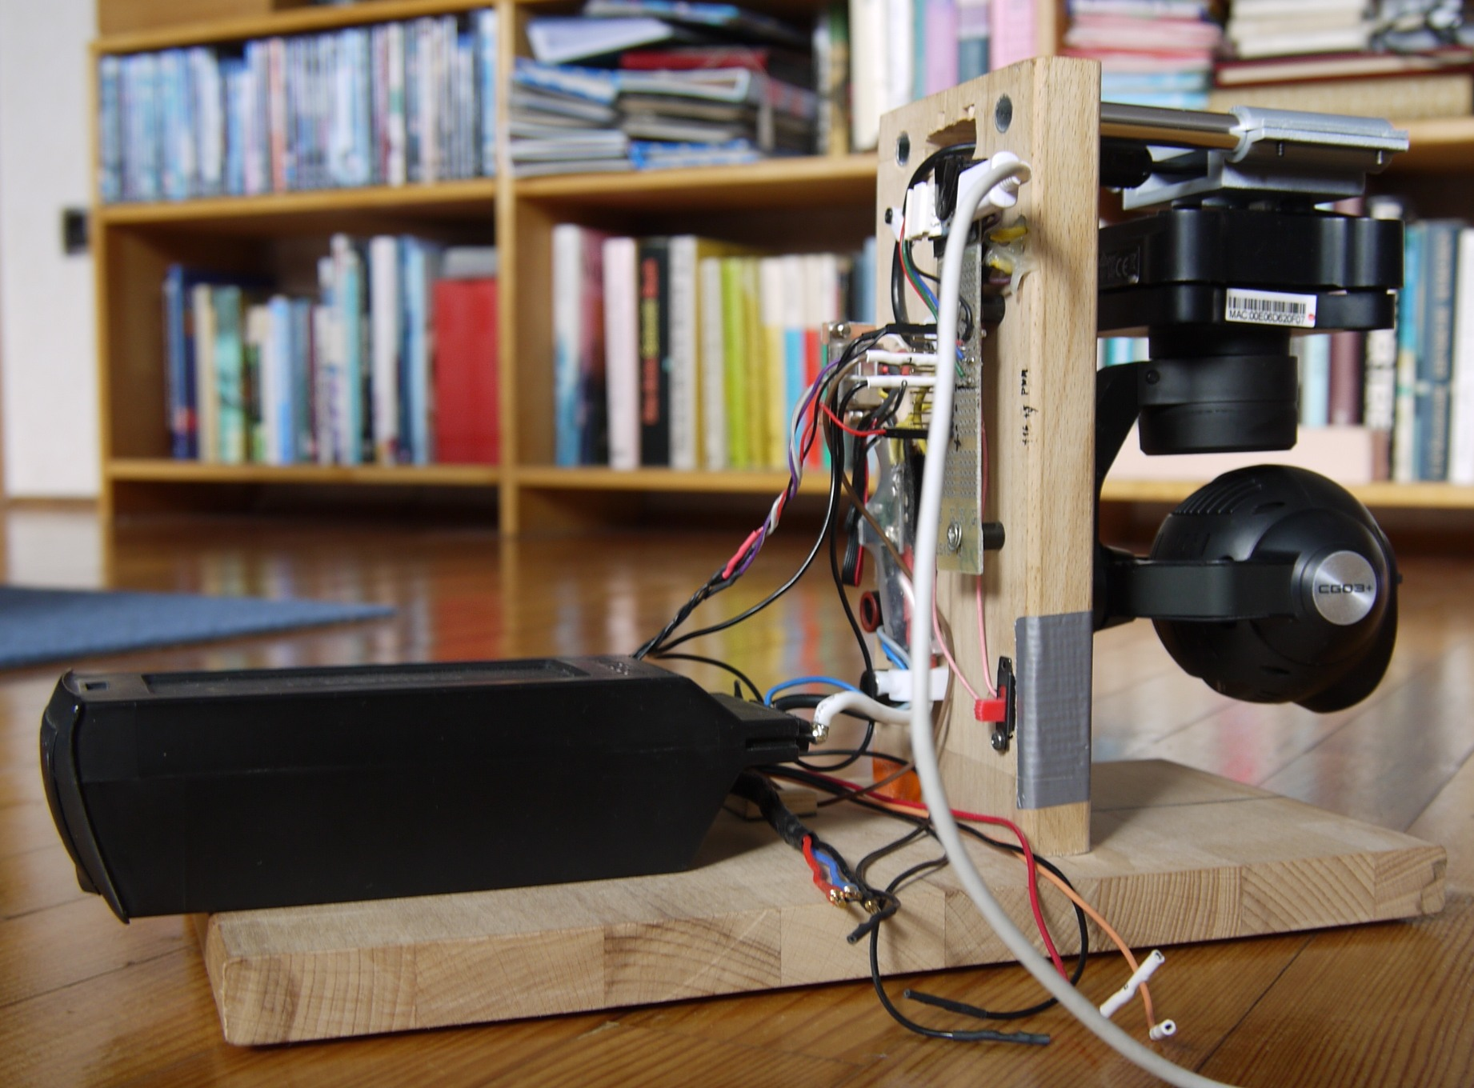

This training video from Yuneec describes the calibration process:
https://www.youtube.com/watch?v=sATbbMajMCk

Please watch it before you try your first calibration.

Calibration process is also described in the service Manual:
https://yuneecpilots.com/threads/repair-information.23394

Calibration - brief description
- Power on the camera.
- Connect Serial to USB converter to CGO3+ UART.
- Start this application.

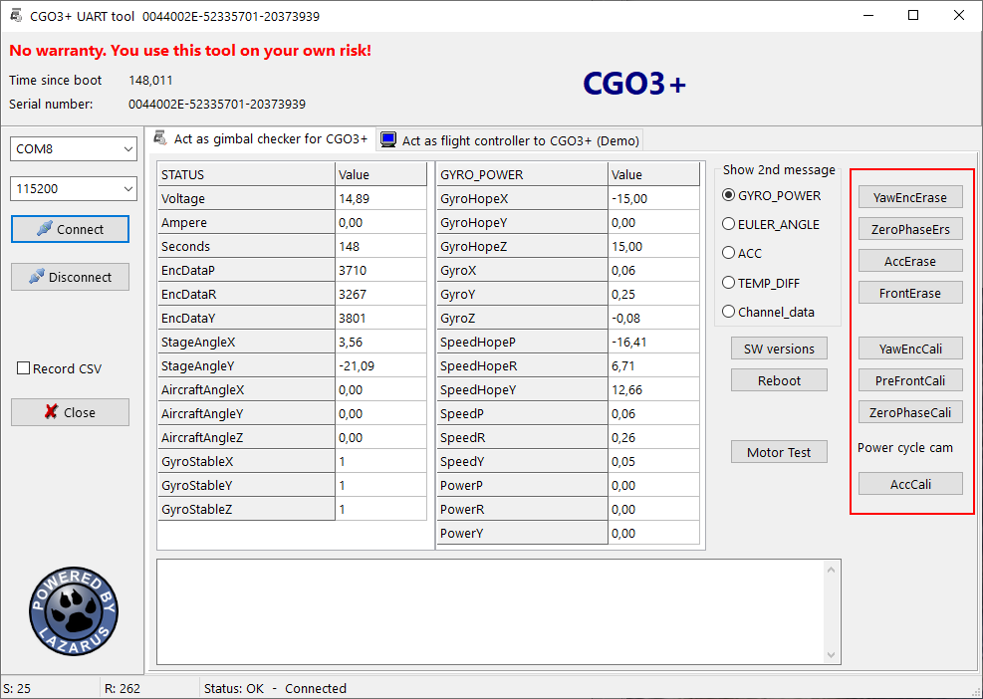
- Select the proper serial port.
For Windows OS this is usually the last one in the list. It will be selected by default. If the COM
port is missing double click on the port selection to refresh the list.
For LINUX select ‘/dev/ttyUSB0’.
- Baud rate for those cameras is 115200 as default.
- Click on 'Connect‘
- Erase:
- Yaw encoder
- Zero phase
- Acc
- Front
- Begin with Yaw encoder calibration, wait until success message will appear.
- Hold the camera faced forward and leveled (I use the CGO3+ gimbal lock)
and start Pre-front calibration.
- Then Zero phase calibration.
- Click on 'Disconnect'.
- Power cycle the camera.
- Click on 'Connect‘ again.
- Do Accelerometer calibration.
- Power cycle the camera.

Note: If „No ACC Offset„ will be reported or Accelerometer calibration never ends, then try a Camera Calibration on the drone started by ST16. If successful it will result in „ACC Offset OK“.

Simply buttons from up to down, always wait on success message.

YTHtool as Flight controller (demo)

This is a demo project how to control tilt and pan by your own application. It offers all possibilities that ST16 has including Gimbal Calibration as it would be initiated from ST16 menu.
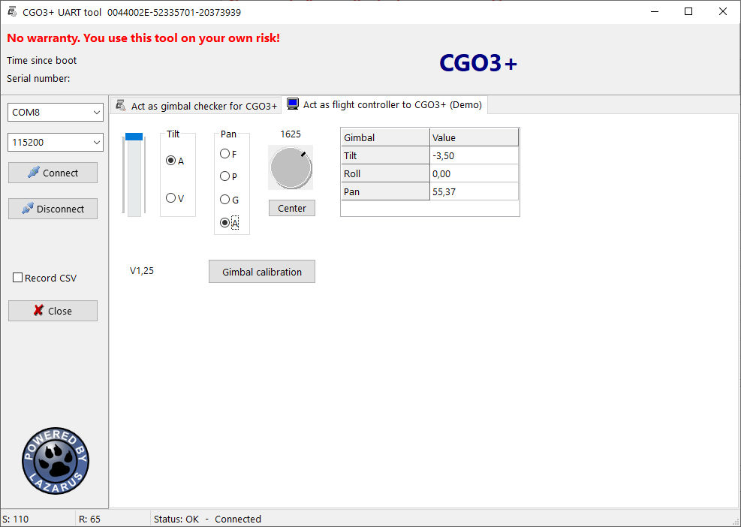
This tool offers an additional Pan mode: Angle mode – this is the same mode as C23/E90 gimbal has, the camera points to an angle depending on position of the pan knob.

You can record the messages that come from camera (SysID=3) and gimbal (SysID=2). Data from MessageID=3 (Gimbal position) will be displayed in the 3 charts.

More information about communication between flight controller and gimbal/camera in "Format_CamUART_messages.ods".
See also the tool, described here: https://github.com/h-elsner/H480_UART_reading

CGO3+ pan modes:
F: 683 Camera points forward as i would be mounted fix.
A: 830 Camera points to an angle depending on position of the pan knob.
T: 1433 Team mode. Don't know exactly what it is doing but this values is visible
in the logs in team mode.
P: 1503 Camera rotates until you put the pan knob in middle position.
Then the camera keep the angle relative to the drone.
G: 3412 Camera rotates until you put the pan knob in middle position.
Then the camera keep the angle relative to the environment (called global mode).

Troubleshooting

UART connection problems
- If you start the app before you you connect the camera double click on the port selection field to update port list.
For Windows usually the last (highest) COM port number is the one you need. It will be selected automatically.
For LINUX the port /dev/ttyUSB0 is for the gimbal. If more then ACM ports are in use again the highest port number is probably the one you need.
- For other connection problems unplug und plug again of the USB cable may help.
- Also a reboot of the connected device may help. Do reboot always when USB is disconnected.
- Disconnect the UART in the app if you power off drone or the camera. It takes 2s before the app recognizes that the connection was cut.
- Check baud rate for the serial connection. Below a list of known baud rates.

No reaction on buttons
- Power cycle camera with and without connected calibration tool.
- Disconnect and connect again the serial connection with the buttons in the calibration tool.
- Combine the two points above in different variation until it works.
- If you switch from calibration page to demo page you must power cycle the camera to change from calibration mode to normal mode.

Gimbal calibration
- If „No ACC Offset„ will be reported or Accelerometer calibration never ends, then try a Camera Calibration on the drone started by ST16.

Baud rates for serial connection from/to different Yuneec cameras:
CGO-ET (H480 version), CGO3+, CGO3 with new FW: 115200
GB203, CGO3 with old FW: 230400
CGO-ET (H520 version), C23, E90 and probably all other newer cameras: 500000

