C23/E90 camera family calibration

Abstract
This tool provides UART (serial) connection to the C23/E90 and possibly other modern Yuneec cameras.
Additional functions are Motor test and Vibration test of the camera. Do not touch anything during vibration test.

This tool provides a possibility to fully calibrate the gimbal of the C23/E90. This functionality is experimental. Use it on your own risk.

Download this tool at download page: http://h-elsner.mooo.com/html/downl.htm
Binaries for Windows (.zip) and LINUX (.tar.gz) are available.

Installation: No installation, simply unzip the file. It is a portable application. You need only the executable for your OS. Copy it somewhere in the home file system or to an USB stick.

C23/E90 gimbal calibration
NOTE: This is an experimental process, not an official tool. This may work or not, no warranty. You use it on your own risk.

Preparation
You need a mount for the CGO3+ where it can rotate and tilt freely. Connect a Serial-USB converter (also known as programmer cable) to Gound, Rx and Tx. Do not connect power on the USB-Serial converter (for YUNA100 this pin is already open). You can use The USB cable YUNA100 from Q500 if you have one or any other converter that has 3.3V level. Rx and Tx must have 3.3V level.

This is a camera mount YUNTYH108. You need one with contact PCB.
Connect Ground to GND converter Tx to mTx/PWM and converter Rx to mRx.
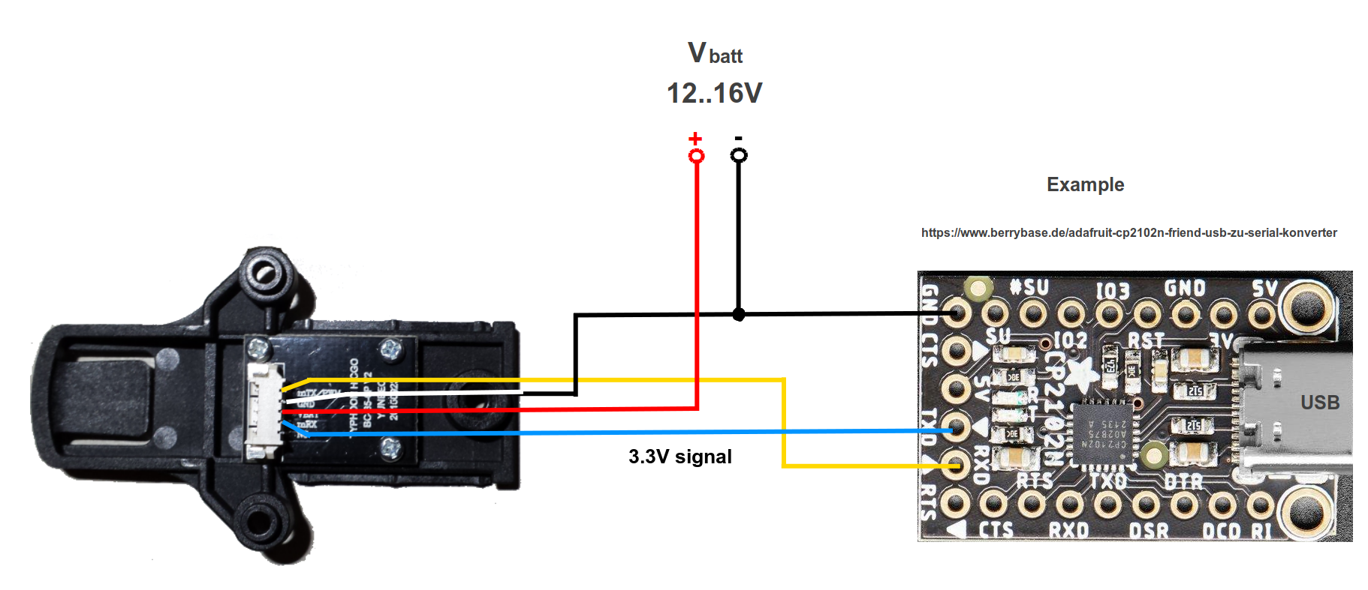
My setup is a wooden mount for the camera and a serial to USB converter with a CP2104 chip.
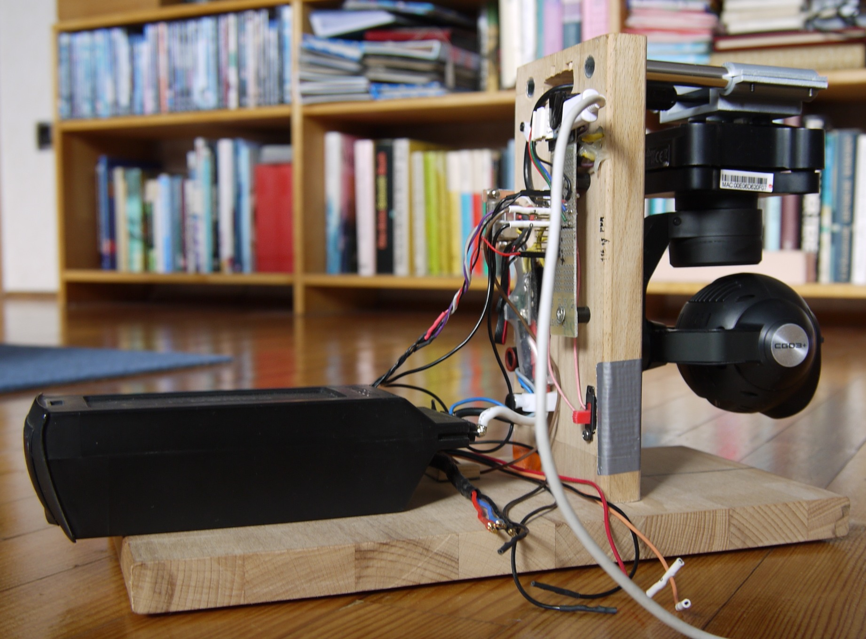
This training video from Yuneec describes the calibration process for CGO3+:
https://www.youtube.com/watch?v=sATbbMajMCk

The process for C23/E90 is probably similar. Please watch it before you try your first calibration.

Calibration - brief description

- Power on camera;
- Connect Serial to USB converter to camera UART;
- Start YTHtool;
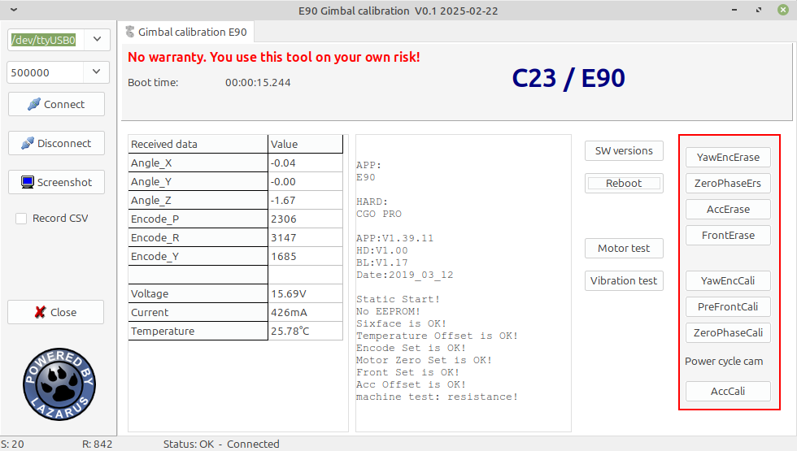
- Select the proper serial port. For Windows OS this is usually the last one in the list.
It will be selected by default. If the COM port is missing double click on the port selection to
refresh the list.
For LINUX select ‘/dev/ttyUSB0’.
- Click on 'Connect‘
- Erase:
- Yaw encoder
- Zero phase
- Acc
- Front
- Begin with Yaw encoder calibration, wait until success message will appear;
- Hold the camera faced forward and leveled and start Pre-front calibration;
- Then Zero phase calibration;
- Click on 'Disconnect';
- Power cycle the camera;
- Click on 'Connect‘ again;
- Do Accelerometer calibration;
- Power cycle the camera;

Note: Simply buttons from up to down, always wait on success message.

Troubleshooting

UART connection problems
- If you start the app before you you connect the camera double click on the port selection field to update port list.
For Windows usually the last (highest) COM port number is the one you need. It will be selected automatically.
For LINUX the port /dev/ttyUSB0 is for the gimbal. If more then ACM ports are in use again the highest port number is probably the one you need.
- For other connection problems unplug und plug again of the USB cable may help.
- Also a reboot of the connected device may help. Do reboot always when USB is disconnected.
- Disconnect the UART in the app if you power off drone or the camera. It takes 2s before the app recognizes that the connection was cut.
- Check baud rate for the serial connection. Below a list of known baud rates.

No reaction on buttons
- Power cycle camera with and without connected calibration tool.
- Disconnect and connect again the serial connection with the buttons in the calibration tool.
- Combine the two points above in different variation until it works.

Baud rates for serial connection from/to different Yuneec cameras:
CGO-ET (H480 version), CGO3+, CGO3 with new FW: 115200
GB203, CGO3 with old FW: 230400
CGO-ET (H520 version), C23, E90 and probably all other newer cameras: 500000

