Update EXIF data of JPG/JPEG pictures
from Yuneec Typhoon H (CGO3+)

Brief description
Collected data

- Path to FlightLog,
- Flight number in FlightLog,
- Complete data lines from Telemetry, Remote and RemoteGPS for,
- Take-off,
- Took picture.
- Exported Model without the icon file (analog, curves, manifest, switches),
- Gimbal pitch, roll and yaw from XMP data,
- Distance or drone position from take-off to first picture and then from picture to picture [m],
- Own text added with additional information.

Data correlation done by timestamp. Additional simple crosscheck by GPS position, to be near. How near, this can be tuned by a slider “Variance” between 10cm and 200cm.
The related object in JSON data will only appear if data available.

Input: Folder with JPG pictures,
FlightLog, original file structure, folder name must contain “FlightLog”,
Exported model from ST16 (same level or deeper as FlightLog in file system),
XMP data package from original EXIF meta data,
own entries in the text fields of the application.
Output: Updated EXIF data in JPG pictures from CGO3+.

All data will be written in EXIF “UserComment” as JSON to JPG/JPEG picture file. You can keep the original “UserComment” or overwrite it (default).

Developed with Lazarus IDE 2.0.10
Compiled with FPC 3.2.0
https://www.lazarus-ide.org/
Needed component: https://sourceforge.net/p/lazarus-ccr/svn/HEAD/tree/components/fpexif/

EXIF tags: https://exiftool.org/TagNames/EXIF.html
JSON schema: http://json-schema.org/

Contact: Helmut Elsner
Mailto: helmut.elsner@live.com
Homepage: http://h-elsner.mooo.com

Settings
Before processing picture files, check and choose appropriate settings.
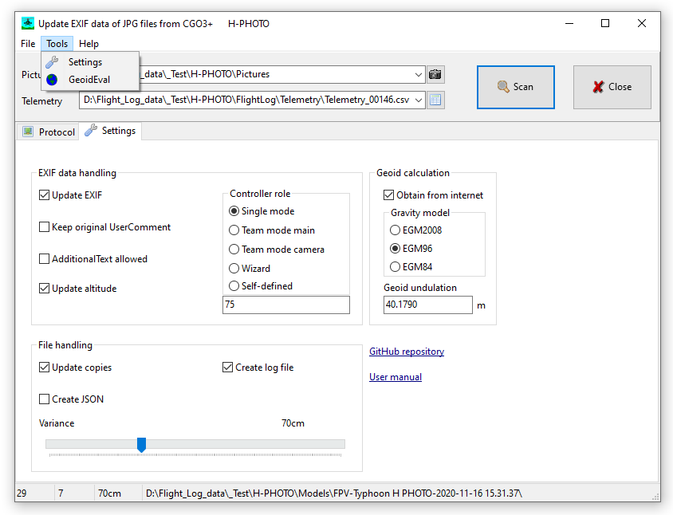
Figure 1: Settings

EXIF data handling

Update EXIF: Allow write EXIF mata data into the picture files. If unchecked you can do a test run without touching the picture files.
Default: Checked = EXIF data will be updated.

Keep original UserComment: If there was already a UserComment package in the EXIF meta data, this package can be overwritten or added to the updated UserComment package.
Default: Unchecked = UserComment will be overwritten.

AdditionalText allowed: Add free text to UserComment in EXIF meta data. Too much text is not recommended but good to use keywords related to the project (example: customer name).
Default: Unchecked = Additional text not used.

Update altitude: Altitude values are originally relative to take-off position. To get absolute altitude it needs to be updated by the application.
Default: Checked = Use absolute altitude provided by the application.

Controller role: Select one of the possible roles of the RC device. You can define you own keyword by using option “Self-defined”.
Default: Single mode = Stand alone RC, no team mode.

File handling

Update copies: If checked the original picture files will be untouched. Updated files will be created in an extra folder “/pics_upd”. If unchecked the original files will be changed and XMP data package in EXIF meta data will be lost. Update only copies of the picture files is strongly recommended.
Default: Checked = Original picture files untouched.
Create JSON: Additional JSON files will be created that contain the same information as would be added to UserComment in EXIF meta data.
Default: Unchecked = no additional JSON files.

Create log file: Add a detailed log file to telemetry file in FlightLog. See chapter “Logging” below.
Default: Unchecked = no log file.

Variance: Slider to set up threshold of variance of positions in picture meta data and related telemetry data set. This is used for plausibility check to match picture meta data and telemetry data from FlightLog. Picture files could be included or excluded from processing depending on variance of position.
Default: 30cm distance between coordinates included at picture meta data and telemetry position.

Geoid calculation

This settings are only active if “Update altitude” is checked.

Obtain from internet: If a take-off was detected in telemetry the online utiliy GeoidEval will be used to obtain the correction value between WGS84 and geoid for altitude above sea level.

Gravity model: Select the gravity model you want to use. Default is EGM2008.

Geoid undulation: Correction value to get altitude above sea level depending on position. To find the correction value for your area, double-click on input field to open online-tool GeoidEval. If valid coordinates from take-off position in telemetry file are available it will be submitted to the tool.
Default: 0 = no correction.

Links
GitHub repository: Source for updates https://github.com/h-elsner/EXIFupdate

User manual: This link points to the local PDF copy of this manual in the same directory
as the executable file.

Main window
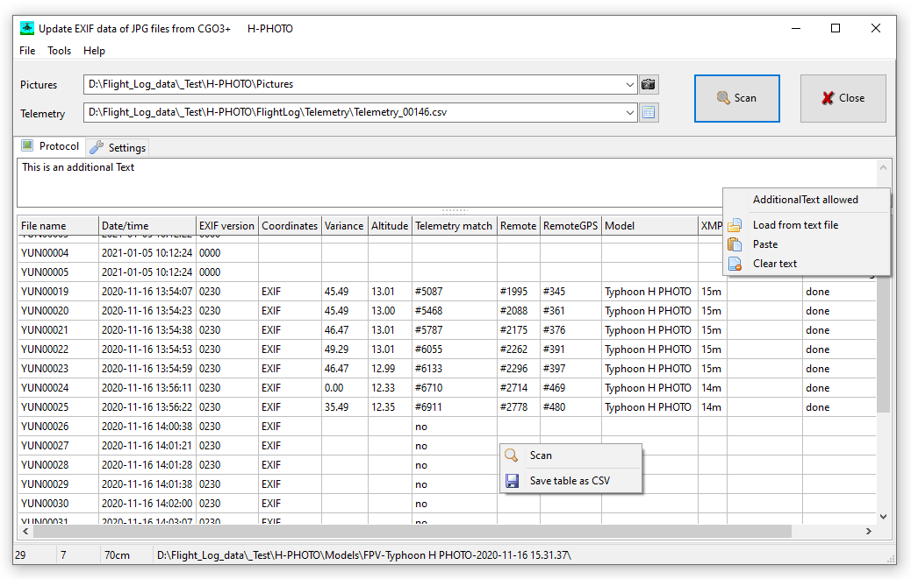
Figure 2: Main window with protocol table.

Telemetry: Select telemetry file in FlightLog related to picture files.
Pictures: Select folder that contains pictures for processing.

Scan, Alt+S: Process picture files.
Close, Alt+C: Close application.

Input field for additional text that will be added to “UserComment” in EXIF meta data.
It has a pop-up menu on right mouse button.
Protocol table has also a pop-up menu on right mouse button (see figure 2).

Status bar: Number picture files | number matching pictures | variance setting | text messages.

Hold the mouse over a control to get more information about it.

Processing
Processing of the picture files starts with plausibility checks. Processing stops and goes to the next picture file if the condition is not met.

- Check if additional text is available as file or in text input field.
- Search Exported Model (file “manifest.csv”). Load Exported Model if available.
- Check if pictures are in the picture folder and how many. Number of pictures is shown in the status bar, file names and file date/time are listed in the protocol table.
- Check if telemetry file is available and if this file has flight modes different to initialization flight mode 16. If yes, the first change from flight mode 16 to another flight mode will be taken as indication for take-off. Time, position and data of take-off will be stored.
If allowed the online calculation tool GeoidEval will be called to obtain the geoid undulation.
- Check if FlightLog files Remote and/or RemoteGPS related to telemetry file are available. If RemoteGPS is available the GPS altitude from the RC controller will be taken as average of 40 data points time stamps after take-off time. This altitude will be corrected by Geoid undulation value.
- Check if picture file has EXIF meta data. If yes, in protocol table the EXIF version will be shown. If EXIF version is shown as ‘0000’ then there are EXIF meta data but no EXIF version tag. The file date/time will be overwritten by EXIF date/time.
- Check if camera mentioned in EXIF data is made by Yuneec.
- Check if the EXIF time matches a time stamp in the telemetry file. If yes, store the relates data values from the FlightLog.
- Check if EXIF meta data has valid coordinates. If not, the coordinates and altitude will be taken from telemetry. In protocol table this will be indicated by “Telemetry” instead of “EXIF” in the Coordinates column.
- Check if variance of picture and telemetry position is below variance threshold from Settings.
- Find picture-related data in Remote ans RemoteGPS data from FlightLog.
- Process and compute all supplementary data values for the picture and fill protocol table.
- Find and store XMP data package from EXIF meta data.
- Create additional JSON file if requested by settings.
- If allowed by settings, write EXIF mata data to picture file and set updated flag in protocol table. Create backup files if needed.

Logging
A more detailed logging file will be created if requested by settings. It will be stored in Telemetry folder as CSV file. Following data will be collected:

Header | Telemetry file | RemoteGPS file | Picture files
File name: | File name of the related telemetry file in the FlightLog | File name of the related RemoteGPS file from FlightLog | List of all file names in the selected picture folder. Files are *.JPG or *.JPEG.
File date | File date/time | File date/time | File date/time
EXIF date | Date/time of detected take-off | Date/time of detected take-off | Date/time from EXIF meta data
Type | Vehicle type of the aircraft from telemetry | Supposed type of RC controller | Camera type from EXIF meta data
Sequence No | If picture matches to Telemetry data, line number of match | Line number of match in FlightLog/RemoteGPS | Sequence number of processed picture files.
Variance [cm] | Threshold from settings for variance | Accuracy value from RemoteGPS file. | Distance between telemetry and EXIF positions.
Latitude | Latitude take-off position | Latitude RC position | Latitude from EXIF meta data
Longitude | Longitude take-off position | Longitude RC position | Longitude from EXIF meta data
Altitude [m] | Absolute altitude from telemetry | GPS altitude from RemoteGPS data | Altitude from telemetry plus reference for absolute altitude
Ascent [m] | Reference for absolute altitude | Reference for absolute altitude | Difference in altitude between last and current picture
Distance [m] | Zero to indicate take-off as reference position | Distance between Take-off postion and RC position | Distance between position of last and current picture
Bearing [°] | Yaw value from telemetry file | Angle value from RemotGPS | Bearing from last to current picture position

Tools

Most of the functionality of the application can be called by Main menu as usual. Main menu also offers a Tool section.

Settings: Simply jumps to Settings page.

Geoid Eval: This menu item covers the web tool GeoidEval by a GUI for easy usage.

GeoidEval computes the height of the geoid above the WGS84 ellipsoid using interpolation in a grid of values for the earth gravity models EGM84, EGM96 or EGM2008.

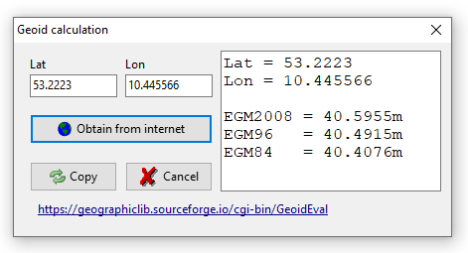
Figure 3: GUI for web tool GeoidEval.

Used service
Online geoid calculation utility GeoidEval: https://geographiclib.sourceforge.io/cgi-bin/GeoidEval

JSON definition (with some data as example)
{ "FlightLog":{
"Path":"",
"Number":"",
"Controller role":"Single mode"
},
"Model":{
"manifest":{
"fpv":"",
"version":"",
"name":"",
"type":"",
"f_mode_key":"",
"analog_min":"",
"switch_min":"",
"rx_analog_num":"",
"rx_switch_num":"",
"alias":"" },
"analog":["",""],
"curves":["",""],
"switches":["",""]
},
"AdditionalText": "",
"DataHeaders": {
"Telemetry":"Date/time,...",
"Remote":"Date/time,...",
"RemoteGPS":"Date/time,..."
},
"TakeOff":{
"Telemetry":{
"LineNumber":0,
"Data":""},
"Remote":{
"LineNumber":0,
"Data":""},
"RemotGPS":{
"LineNumber":0,
"Data":""}
},
"CameraShoot":{
"SequenceNo":1,
"Telemetry":{
"LineNumber":0,
"Data":""},
"Remote":{
"LineNumber":0,
"Data":""},
"RemotGPS":{
"LineNumber":0,
"Data":""},
"DistanceToPreviousPosition":0,
"Bearing":0,
"Ascent":-0.001,
"XMPdata":{
"GPSaltutude":"",
"CameraYaw":"",
"CameraPitch":"",
"CameraRoll":""}
}
}

Provided data

Telemetry, Remote and RemoteGPS are untouched rawdata from FlightLog.

Model is a copy of Exported model without icon.

XMPdata is a copy of the non-standard EXIF package:
http://ns.adobe.com/xap/1.0/
<?xpacket begin="?" id="W5M0MpCehiHzreSzNTczkc9d"?>
<rdf:RDF xmlns:rdf="http://www.w3.org/1999/02/22-rdf-syntax-ns#">
<xmp:GPSAltitude>6</xmp:GPSAltitude>
<xmp:CameraYaw>-85.580353</xmp:CameraYaw>
<xmp:CameraPitch>-13.905984</xmp:CameraPitch>
<xmp:CameraRoll>0.002856</xmp:CameraRoll>
</rdf:RDF>
<?xpacket end="w"?>
The XMP package will be searched in the first 8kBytes of the picture file. Keyword is '/rdf:'.

DistanceToPreviousPostion is the distance between the previous coordinates (lat1, lon1) and the current coordinates (lat2, lon2). For the first picture the previous coordinates are taken from Take-off telemetry dataset. Picture coordinates are taken from EXIF data of the picture.
{Distance between two coordinates in m
Haversine formula, Earth radius: 6,371km depending on latitude
https://rechneronline.de/erdradius/
6365.692 optimized for 50° lat and 60m altitude over ellipsoid}
function DeltaCoord(lat1, lon1, lat2, lon2: double): double;
begin
result:=100; {No match at all, exclude}
try
result:=6365692*arccos(sin(lat1*pi/180)*sin(lat2*pi/180)+
cos(lat1*pi/180)*cos(lat2*pi/180)*cos((lon1-lon2)*pi/180));
if IsNan(result) then
result:=100; {'nan' shall not match, dist>=100m}
except
end;
end;

Bearing is the direction angle 0..360° from previous coordinate (lat1, lon1) to the current coordinate (lat2, lon2). For the first picture the previous coordinates are taken from Take-off telemetry dataset.
{https://www.movable-type.co.uk/scripts/latlong.html}
function Bearing(lat1, lon1, lat2, lon2: double): double;
{From lat/lon1 to lat/lon2 [°]}
var delta, cosl2: double;
begin
result:=0;
try
delta:=lon2-lon1;
cosl2:=cos(lat2);
result:=-arctan2(cosl2*sin(delta), cos(lat1)*sin(lat2)-
sin(lat1)*cosl2*cos(delta));
result:=RadToGrad360(result); {+/-180° in rad --> 0..360°}
except {Ignore exceptions, result remains 0}
end;
end;
If the coordinates are close to each other the bearing may be unusable inaccurate.
Ascent is the difference between the current altitude and the previous altitude. Altitudes are taken from telemetry datasets. For the first picture the previous altitude was taken from the take-off telemetry dataset. Negative ascent means descent.

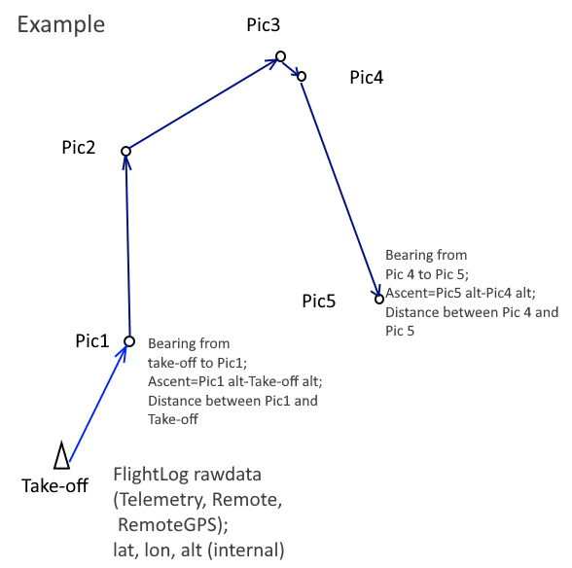
Figure 4: Computed data values

