GPS tool

This is the start for some specialized tools to analyze TLOG files and Sensorfiles from Yuneec drones.
This tool was made to check the GPS related MAVlink messages. It uses following messages to collect useful information:

1 0x01 SYS_STATUS
2 0x02 SYSTEM_TIME
24 0x18 GPS_RAW_INT
25 0x19 GPS_STATUS
33 0x21 GLOBAL_POSITION_INT
253 0xFD STATUSTEXT

The following data will be written into a CSV file for further analysis:

Idx Data From Message
-----------------------------------------------------------
0 'Time since boot' 2, 24, 33
1 'SYSTEM TIME UTC' 2
2 'Time UTC per Message' all
3 'Latitude (WGS84 EGM96 ellipsoid)' 24, 33
4 'Longitude (WGS84 EGM96 ellipsoid)' 24, 33
5 'Altitude (MSL)' 24, 33
6 'Altitude (above WGS84 EGM96 ellipsoid)' 24
7 'Altitude above home' 33
8 'GPS ground speed' 24
9 'Ground X Speed' 33
10 'Ground Y Speed' 33
11 'Ground Z Speed' 33
12 'Course over ground' 24
13 'Heading' 33
14 'Yaw in earth frame from north' 24
15 'Number of satellites visible' 24, 25
16 'GPS fix type' 24
17 'GPS HDOP' 24
18 'GPS VDOP' 24
19 'Position uncertainty' 24
20 'Altitude uncertainty' 24
21 'Speed uncertainty' 24
22 'Heading / track uncertainty' 24
23 'Battery voltage' 1
24 'Usage of the mainloop time' 1

The bad news: As far as I have seen, Yuneec does only provide empty or invalid GPS_STATUS messages (25). So, the whole data from this message are missing.
Also the message format for some messages is different from standard message format. This means, not all interpretations may be correct. However, I did my best.
'Time UTC per Message' comes from a set of 8 trailing bytes after the CRC at each MAVlink message V2 (Message Magic 0xFD). This time stamp is not available in MAVlink messages V1 in Sensor files from Typhoon H.
The tool should be mostly self-explainable. If you hold the mouse pointer over an element, a hint shall explain a bit more.

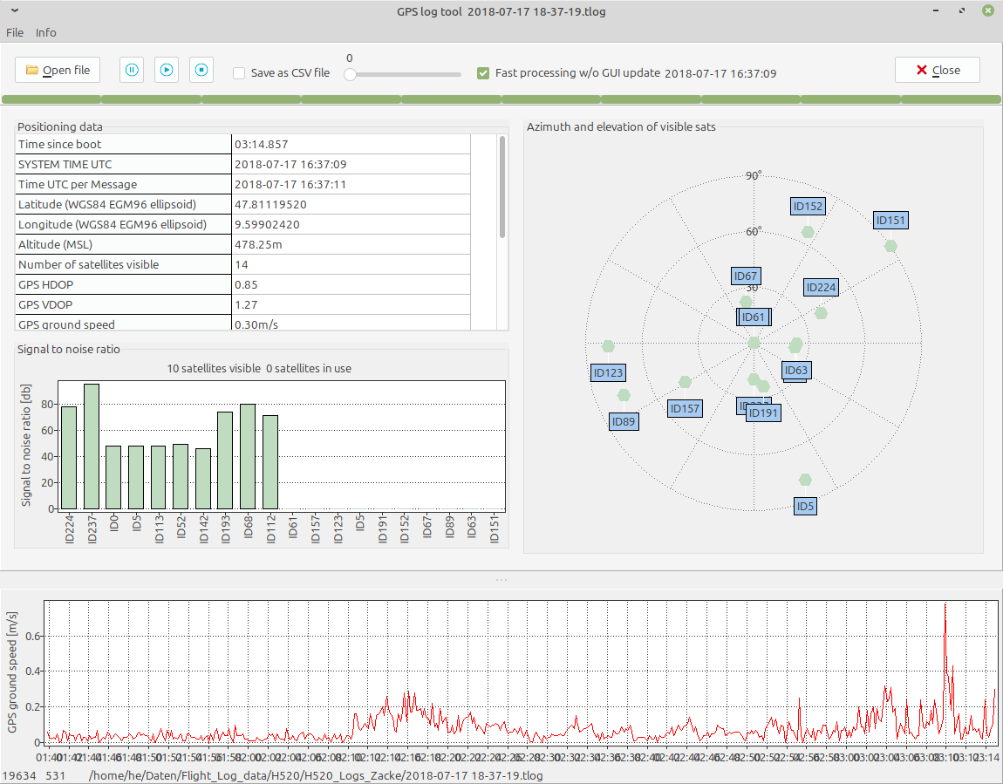
You can drop a file on the application window to process it. Because I do not expect data from satellites (GPS_STATUS message) you should always prefer ‘Fast processing without GUI update’.
A click on the item name in the table above will create the related chart on the bottom of the application window. So far, this and the generation of a CSV file from those data are the only functionality that we can use with Yuneec stuff. But it is easier to use for GPS related analysis compared to Q500log2kml which also can decode the MAV messages provided by TLOG or Sensor files.

Source code and download:
https://github.com/h-elsner/GPStool

References:
https://mavlink.io/en/guide/mavlink_version.html
https://mavlink.io/en/guide/serialization.html
https://github.com/mavlink/c_library_v2/tree/master/common

http://h-elsner.mooo.com/pdf/Q500log2kml_en.pdf
http://h-elsner.mooo.com/downloads/q500log2kml_en.zip
http://h-elsner.mooo.com/downloads/q500log2kml_en.tar.gz

