Typhoon H GUI replacement - the better GUI (H480GUI)

Abstract
This tool provides a replacement for the Typhoon H GUI. It offers a deep insight how the flight controller interacts with its sensors. It is a good tool for a first diagnosis in case of problems.

Download this tool from download area in my homepage: http://h-elsner.mooo.com/html/downl.htm
Binaries for Windows (.zip) and LINUX (.tar.gz) are available.

Installation: No installation, simply unzip the file. It is a portable application. You need only the executable for your OS. Copy it somewhere in the home file system or to an USB stick.

Start

Power up the drone. Once fully booted connect the drone to PC via data-capable micro USB cable to the PC and start the YTHtool. Select the proper COM port.
For Windows OS this is usually the last one in the list. It will be selected by default. If the COM port is missing double click on the port selection to refresh the list.
For LINUX select ‘/dev/ttyACM0’.

Once connected we have three pages:
- Sensor information,
- GPS information,
- System / Settings.

Sensor information

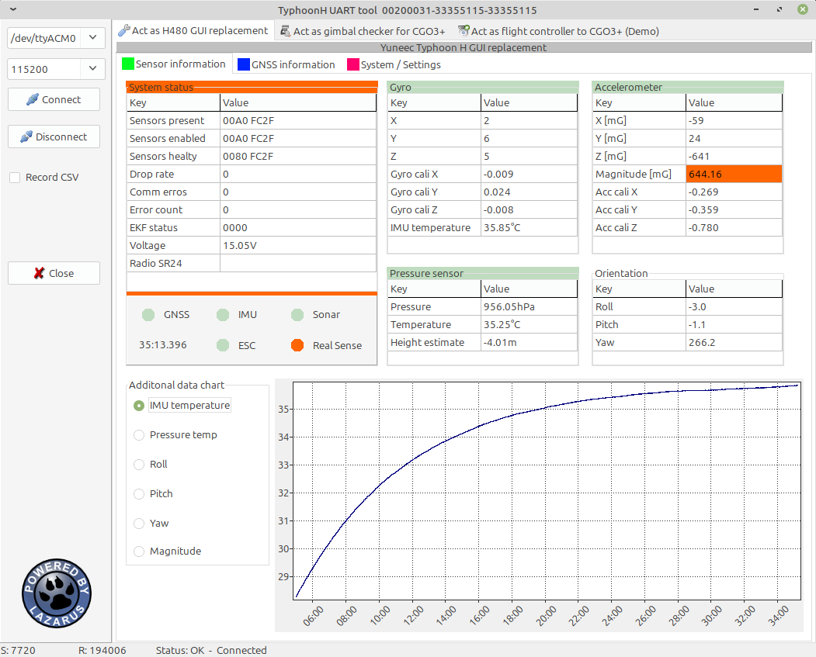
This page shows the values from IMU (Gyro and accelerometer), pressure sensor (Barometer) and the Orientation as output from the AHRS (Attitude Heading Reference System). For some values you can create a chart.

Sensor status (present, enabled, healty) for a Typhoon H should be 00A0 FC2F and for a Typhoon H with RealSense module 02A0 FC6F. The status represents a bitmap with flags for different internal systems. All three values should be the same.
The EKF (Extended Kalman Filter) status should always be 00A5. The example in the screenshot above represents a flight controller with defective IMU.

GNSS information
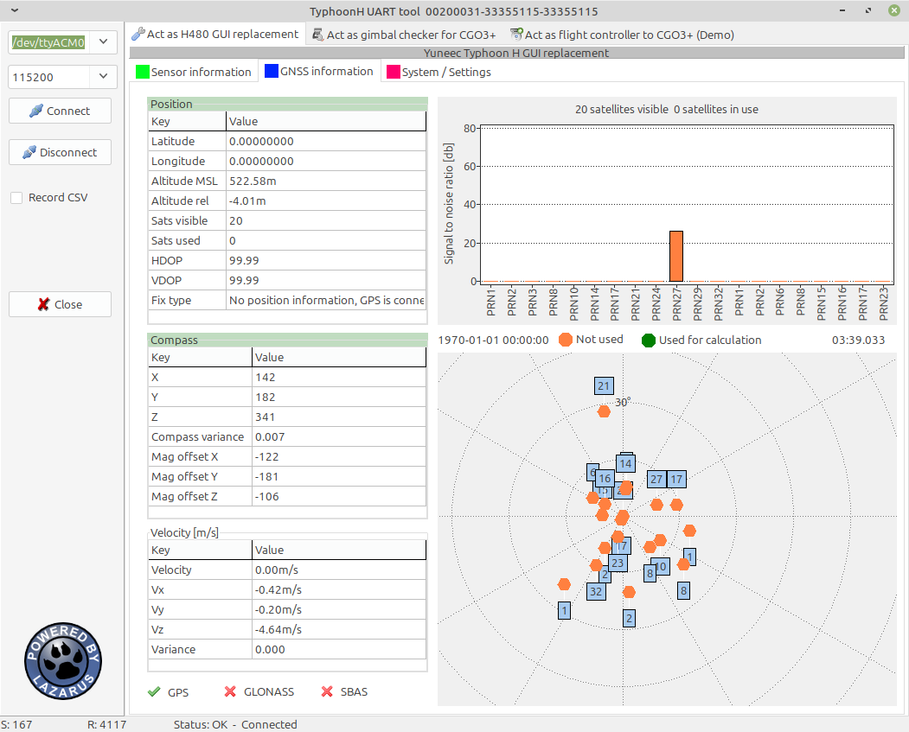
This page shows the values from GPS module and magnetometer (Compass) and the velocity.
Comprehensive information about the satellites gives us the possibility to estimate the status of the backup battery and the antenna of the module. More on this later...

SBAS (Satellite Based Augmentation System) satellites should be included in the calculation for accurate positioning. Check if SBAS is green.

System / Settings
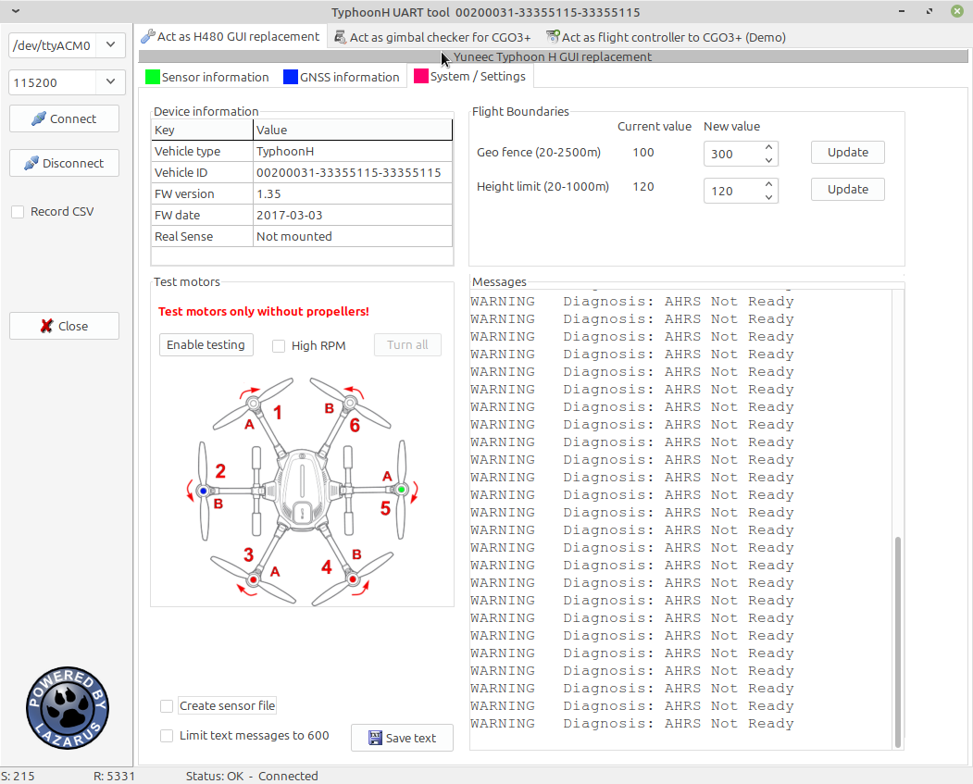

This page contains the system information, settings, text messages, and motor test.
High RPM means the motor(s) spinning faster and have another sound.

Troubleshooting

UART connection problems
- If you start the app before you you connect the drone double click on the port selection field to update port list.
For Windows usually the last (highest) COM port number is the one you need. It will be selected automatically.
For LINUX the port /dev/ttyACM0 is for the drone. If more then ACM ports are in use again the highest port number is probably the one you need.
- For other connection problems unplug und plug again of the USB cable may help.
- Also a reboot of the connected device may help. Do reboot always when USB is disconnected.
- Disconnect the UART in the tool if you power off drone or the camera. It takes 2s before the app recognizes that the connection was cut.

Power cycling the drone
- Switch off and switch on is only correctly working if the USB cable is unplugged. Because the flight controller is supplied by USB 5V it will never fully shut down when connected to USB.

