Reverse engineering serial connections at Yuneec Typhoon H

It's interesting to understand the message format of the communication between remote controller ST16 and drone H480 as well as the communication from flight controller to gimbal/camera CGO3+. This may help to create or improve projects to use camera or remote controller for other systems and further development of Thunderbird firmware (see here).
A first setup using a Raspberry Pi is described here: https://github.com/h-elsner/SR24_decode

Now I tried to bring together the communication of
- ST16 <-> SR24 and
- Autopilot (FC = Flight controller) <-> CGO3+.

I got a Saleae Logic Analyzer with four channels. To record I use this analyzer software: https://www.saleae.com/pages/downloads

The setup is as following (with color coding of my wiring to reproduce this setup):

Analyzer  channel | connected to |  | Analyzer color | Cam color | Adapter color | SR24 color | Adapter color
Channel 0 | Cam Rx |  | black | purple/green | grey
Channel 1 | Cam Tx |  | brown | grey/blue | purple
Channel 2 | SR24 Rx |  | red |  |  | yellow | blue
Channel 3 | SR24 TX |  | orange |  |  | orange | green
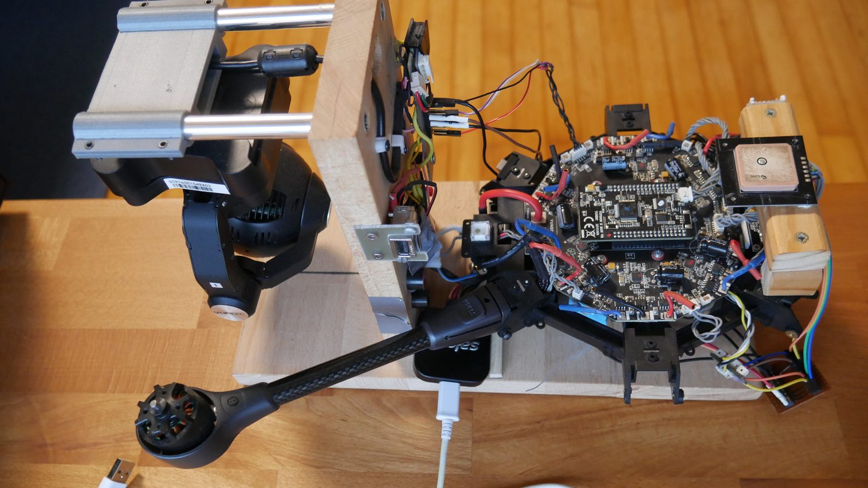
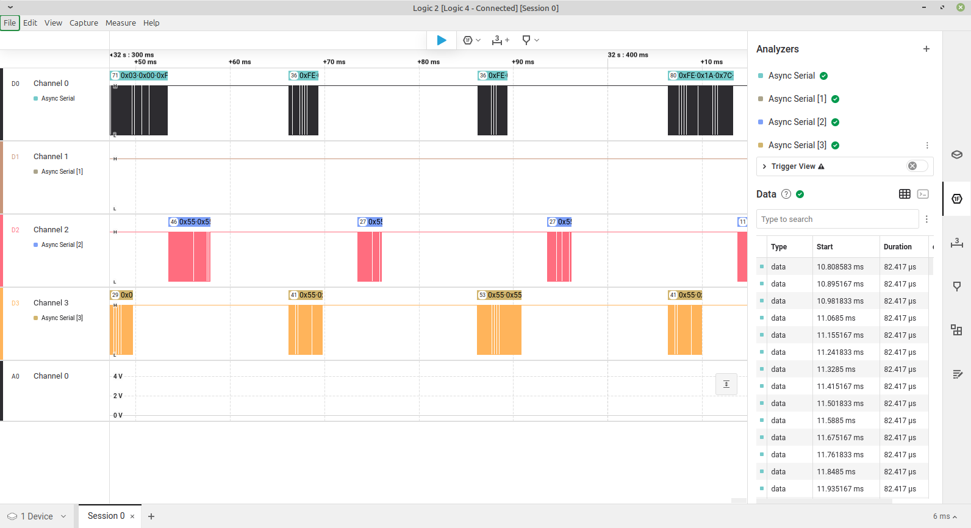
The Logic Analyzer records Async Serial in following format:

Time [s],Value,Parity Error,Framing Error
0.001172500000000,0xFE,,
0.001259166666667,0x1A,,
0.001345833333333,0x20,,
0.001432500000000,0x01,,
etc ...

The converter tool "cam_uart" converts this to messages from camera or SR24 which can be stored as CSV files and in some cases can decode it. The CSV files can be checked in any chart tool like Libre Office Calc or Excel.
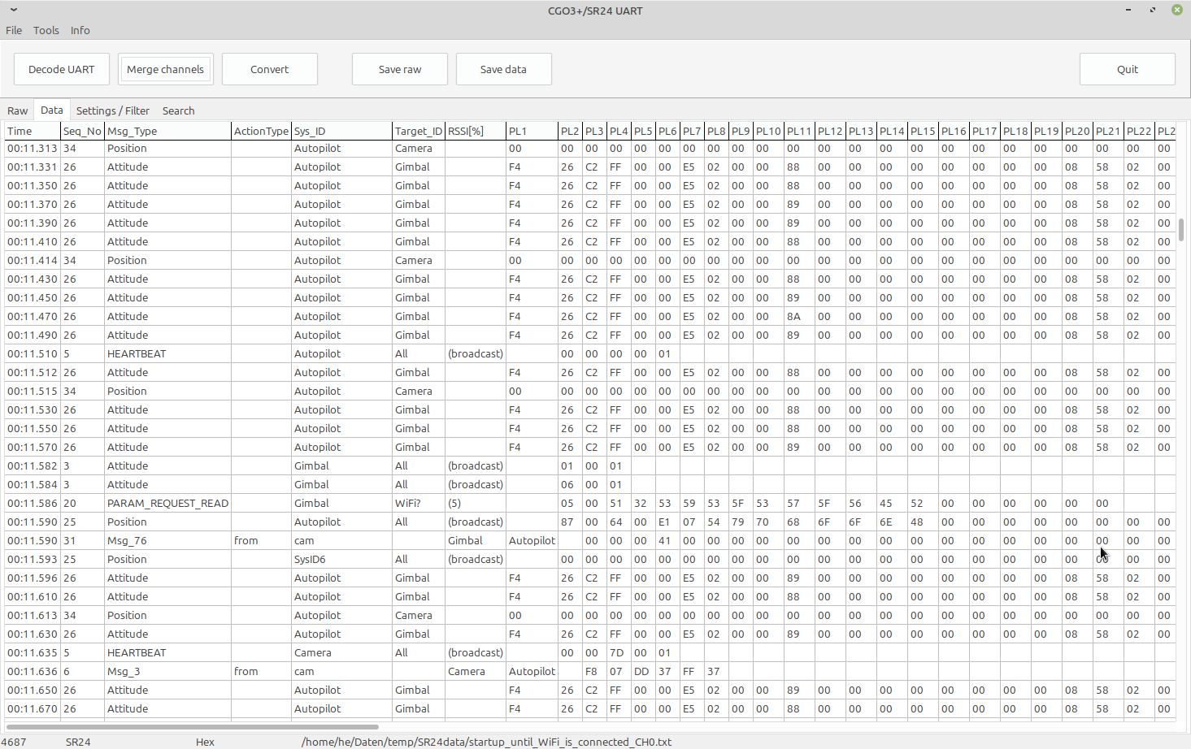

With the tool you can inspect single files or merge the files from two or four channels together to see what is going up and down.
One interesting point is that there are messages, Msg_ID=255 from/to cam (magic byte 0xFE) where another message format is nested in. Those nested messages with magic byte 0xBC are recorded in FlightLogs on ST16 as Sensor_xxxxx.bin. Sensor files from FlightLogs can be extracted with q500log2kml.

SR24 to Autopilot communication:

The basics are pretty clear. ST16 sends Channel data messages (Msg_type 0, 1 or 3) up to drone (Autopilot) and receives Telemetry messages (Msg_type 2). Bind message is Msg_type 4. All those messages are well documented and are enough to use STxx for other projects.

The tricky part is Msg_type 20. Those are H480 specific. Some are clear, some not. Surprisingly I see no messages when I start calibration, also GPS switch looks strange. Here we need to dive deeper.

Autopilot to Gimbal/Camera/5GHz WiFi:
For feature "Dual Band Control Redundancy" Channel data will be sent via WiFi (and then camera UART). Backwards Telemetry messages are sent to Remote control. Both messages are pretty clear (Msg_ID=8), Telemetry over 5GHz is Msg_ID=2.
We can also exclude the Sensor messages (Msg_ID=255). In this messages is another message format nested that is recorded in FlightLog files Sensor_xxxxx.bin. I think this is only for troubleshooting. Only Yuneec knows what there is in.

