MPU650 test tool for raspberry Pi

Background information
https://invensense.tdk.com/wp-content/uploads/2015/02/MPU-6000-Datasheet1.pdf
https://invensense.tdk.com/wp-content/uploads/2015/02/MPU-6000-Register-Map1.pdf
https://www.raspberry-pi-geek.de/ausgaben/rpg/2017/08/3-achsen-lage-und-beschleunigungssensor-mpu6050/
https://github.com/Blokkendoos/mpu-calibration

Preparations
Enable I2C: sudo raspi-config > Interface Options > I2C > Yes
Connect MPU and check wiring.
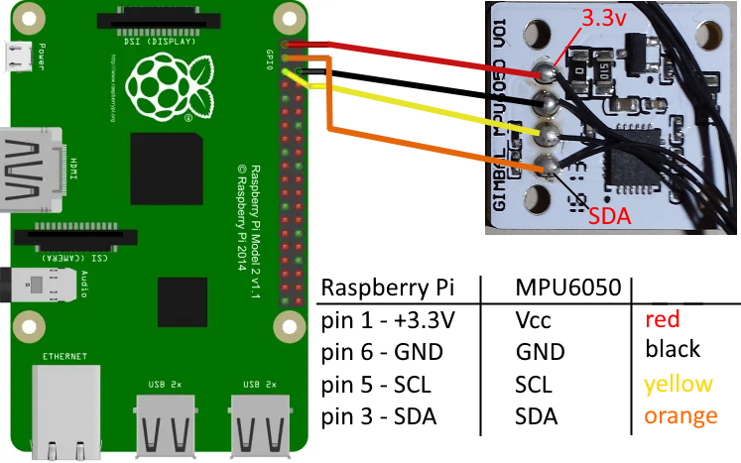
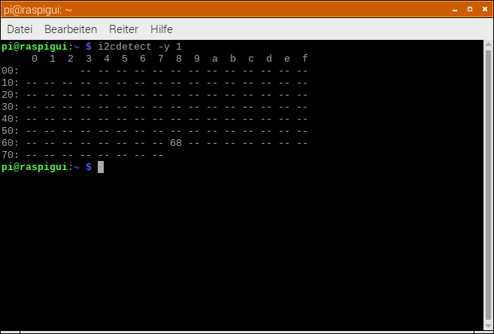
Check if MPU6050 is available: i2cdetect -y 1 > should be appear at address 0x68

IMU_test

This is a test tool to check and learn something about the Motion Processing Unit MPU6050.
One can read all register and save the settings to a CSV file just as test.
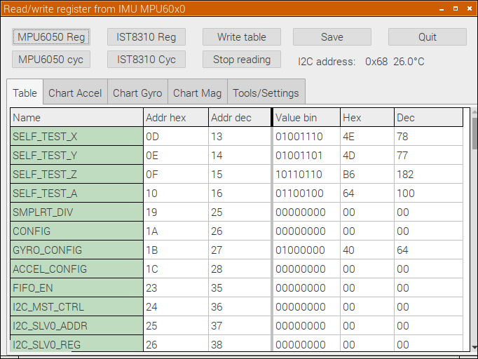
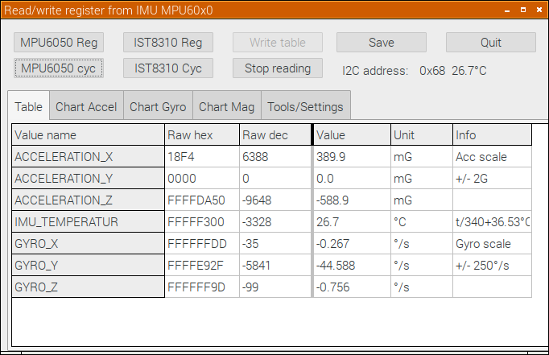
It's also possible to cyclic read the Accelerometer, Temperature and Gyroscope values.
You will also see the current scale setting for Accelerometer and Gyroscope in Info column.
The same can be seen in a rolling chart.
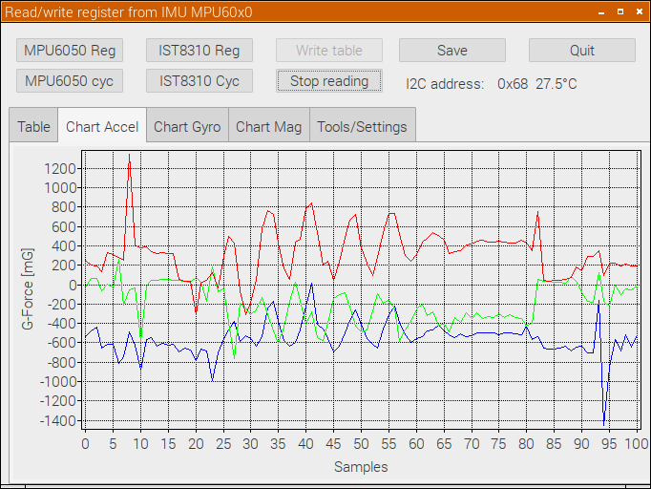
For testing and settings it is possible to write into a register or overwrite all write-able with zero.
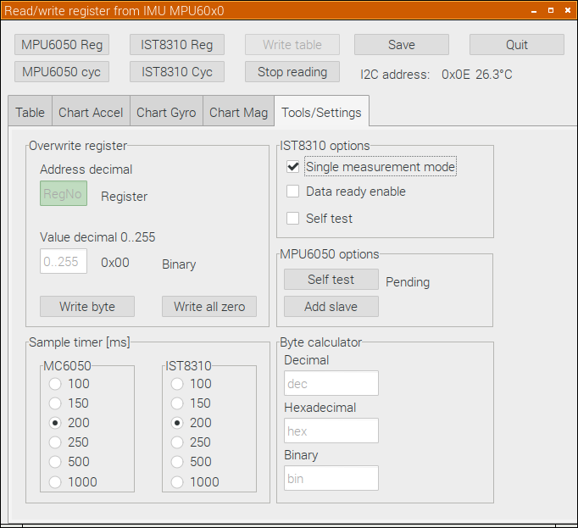
Some options, settings and special actions are on the Tools/Settings page too.
Some terminal commands – good to know:
Read a byte from MPU: i2cget -y 1 0x68 0x75 (Who am I, it's own address)
Read a word from MPU: i2cget -y 1 0x68 65 w (result comes as big endian)
Write a byte to MPU register: i2cset y 1 0x68 107 0 (wake-up command)
Read temperature cyclic (raw): watch -n 0.5 'i2cget -y 1 0x68 65 w'

