Preparations
Enable I2C: sudo raspi-config > Interface Options > I2C > Yes
Install i2cdetect:
sudo apt-get install i2c-tools

Connect Sensor and check wiring.
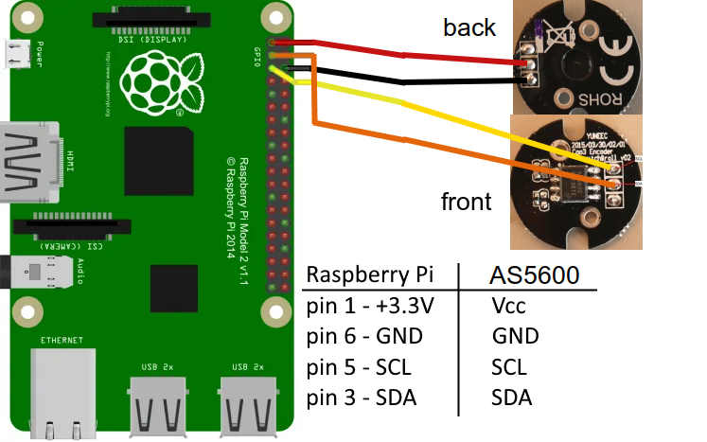
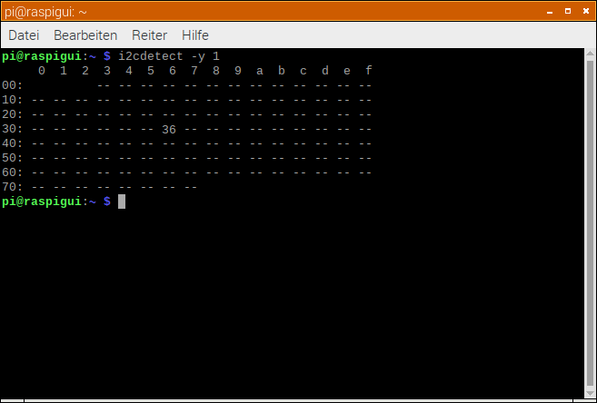
Check if AS5600 is available: i2cdetect -y 1 > should be appear at address 0x36

Download "AS5600_cali_tool.zip" from GitHub and unzip it. The executable binary is "imu_test".
Maybe you have make it executable:
chmod +x ./imu_test

AS5600 Register
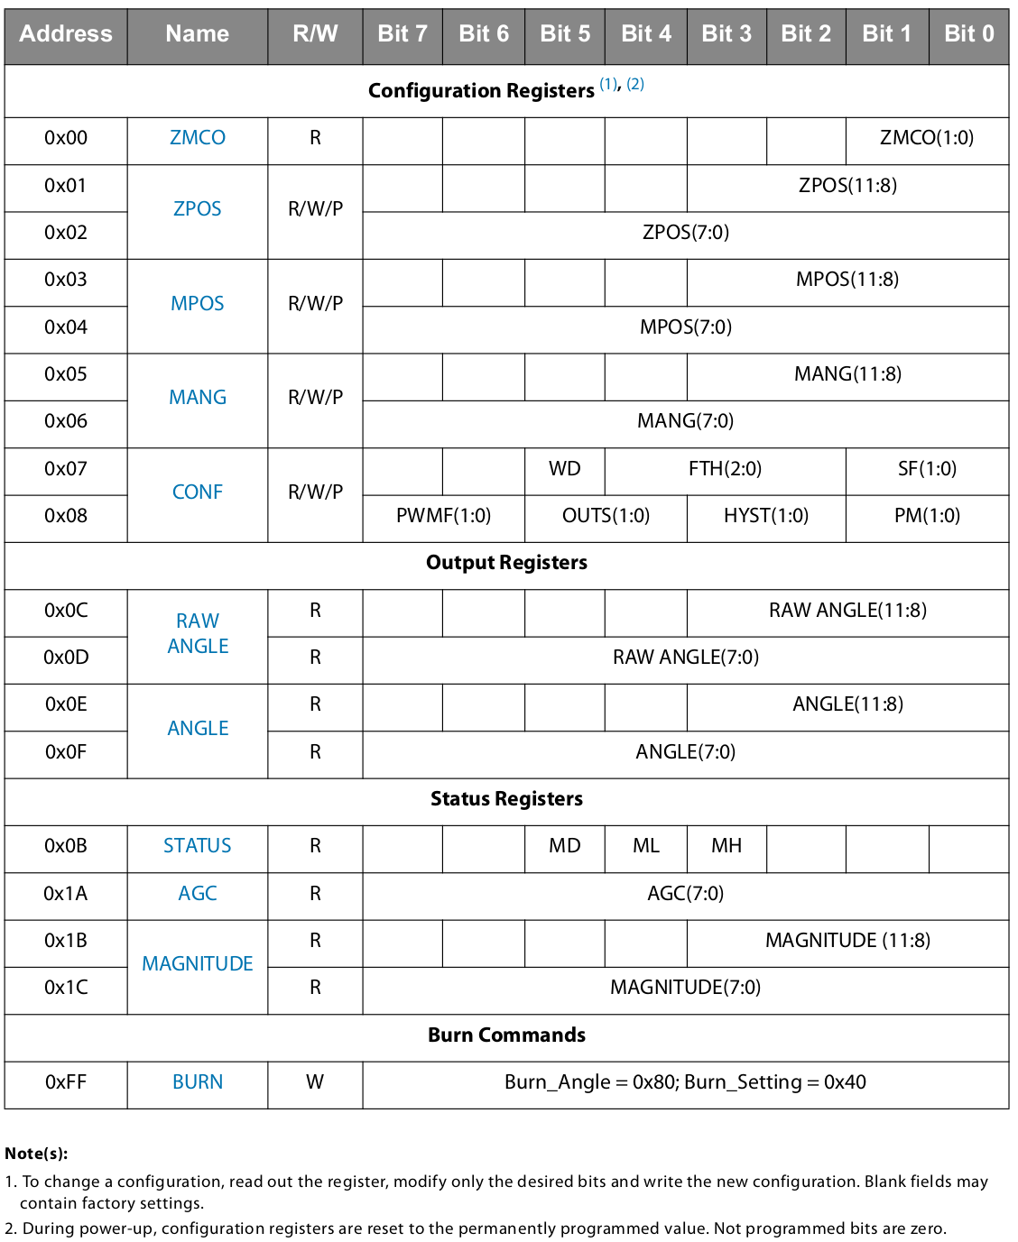
Read Register with button "AS5600 Reg". Same as button Read CONF but jumps to Table to see all register values for verification.

To read values from data registers click on "AS5600 Cyc" (Read cyclic).

Yuneec settings (without magnet)

Conf Register: 0000 0000 1110 0000
Power mode: 00 NOM
Hysteresis: 00 OFF
Output stage: 01 Analog (reduced range from 10% to
90% between GND and VDD
PWM frequency: 11 920Hz
Slow filter: 00 16x
Fast filter threshold: 00000 Slow filter only
Watchdog: 0 OFF
n/a: 00

Status Register: 0000 0000 Sensor without magnet near by
n/a: 011 (factory settings? Ignore)
MH: 0 AGC minimum gain OK
ML: 1 AGC maximum gain overflow, magnet too weak
MD: 0 Magnet was not detected
n/a: 00

Magnet Detection
As a safety and diagnostic feature, the AS5600 indicates the absence of the magnet. If the measured magnet field strength goes below the minimum specified level (Bz_ERROR), the output is driven low, without regard to which output mode has been selected (analog or PWM) and the MD bit in the STATUS register is 0.

Maximum angular range Start and end position
MANG = 0x0000 ZPOS = 0x0000 MPOS = 0x0000

DIR pin
GND CW (clockwise)

Note: To change Conf register do not change n/a bits. Those may contain factory settings.

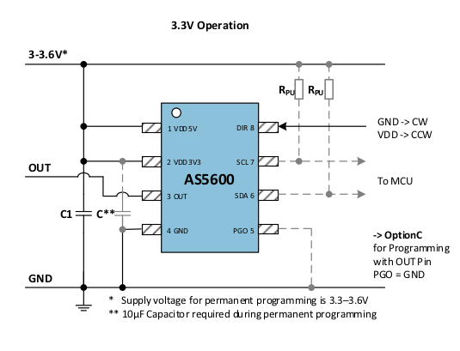
Programming (Option A with I²C)

Use the correct hardware configuration (Option A and C).

Option A: Write CONF register
Option C: Set Maximum Angle

Burn: Permanently save both.

Connect AS5600 to Raspberry Pi with I²C interface and power up the AS5600.
Start the tool "imu_test". Go to Page "AS5600". It will go to "AS5600" page if this is the only detected sensor on I²C bus.
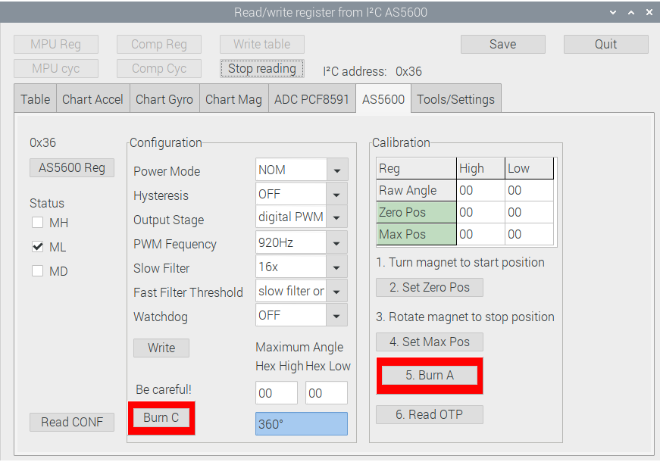
Read the register of AS5600.
- Button "AS5600 Reg" or button "Read CONF"

Calibration procedure:
Step 1: Turn the magnet to the start position.
Step 2: Read the RAW ANGLE register. Write the RAW ANGLE value into the ZPOS register. Wait at least 1 ms.
- Button "2. Set Zero Pos"
Step 3: Rotate the magnet in the direction defined by the level on the DIR pin (GND for clockwise, VDD for counterclockwise) to the stop position. The amount of rotation must be greater than 18 degrees.
Step 4: Read the RAW ANGLE register. Write the RAW ANGLE value into the MPOS register. Wait at least 1 ms. Proceed with Step 6 to permanently program the configuration.
- Button "4. Set Max Pos"

Step 5: Perform a BURN_ANGLE command to permanently program the device. Wait at least 1 ms.
- Button 5. Burn A
Step 6: Verify the BURN_ANGLE command: Write the commands 0x01, 0x11 and 0x10 sequentially into the register 0xFF to load the actual OTP content. Read the ZPOS and MPOS registers to verify that the BURN_ANGLE command was successful.
- Button "6. Read OTP"

Step 7: Read and verify the ZPOS and MPOS registers again after a new power-up cycle.
- Button "AS5600 Reg"

Note: Do not touch Configuration, at least do not burn config.
Basically, do only something when you exactly know what you are doing,
especially "Burn" actions.
Before perform a burn-command read carefully the rules and restictions
for the OTP mentioned in AS5600 datasheet.

HW settings
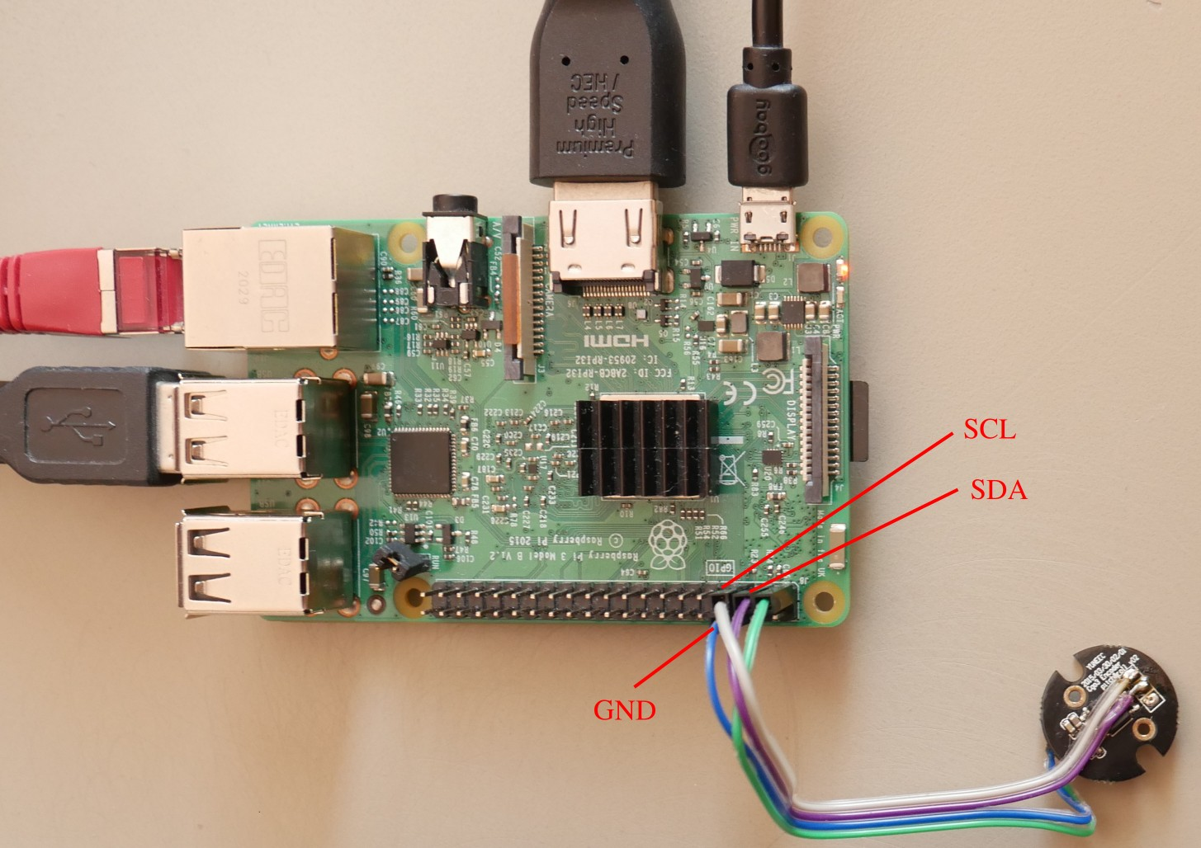
Sensor connected to Raspberry Pi by I²C interface.

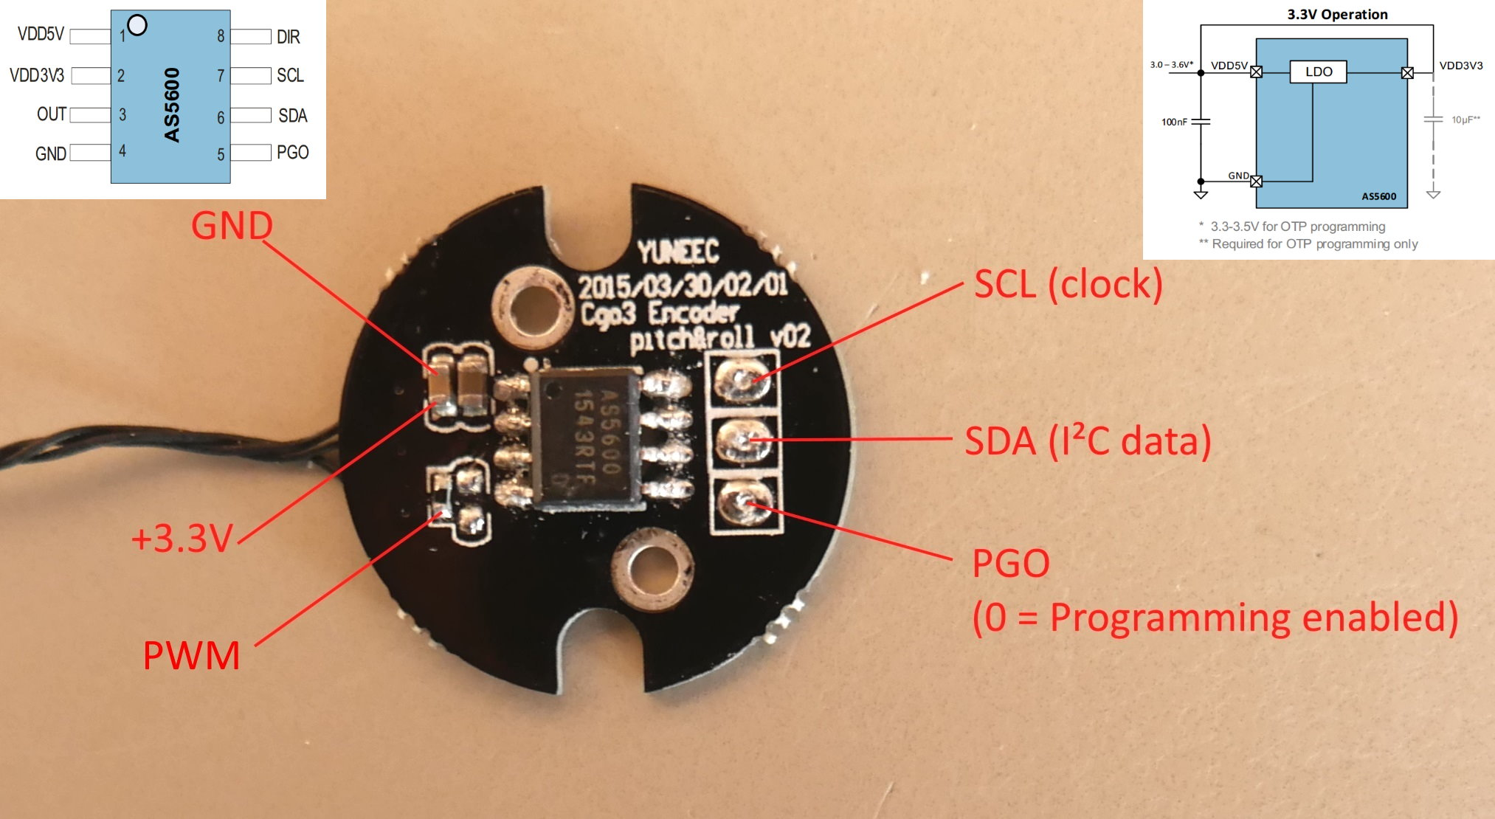

I²C bus SCL and SDA is 3.3V signal.
PGO pin is not needed when programming via I²C.

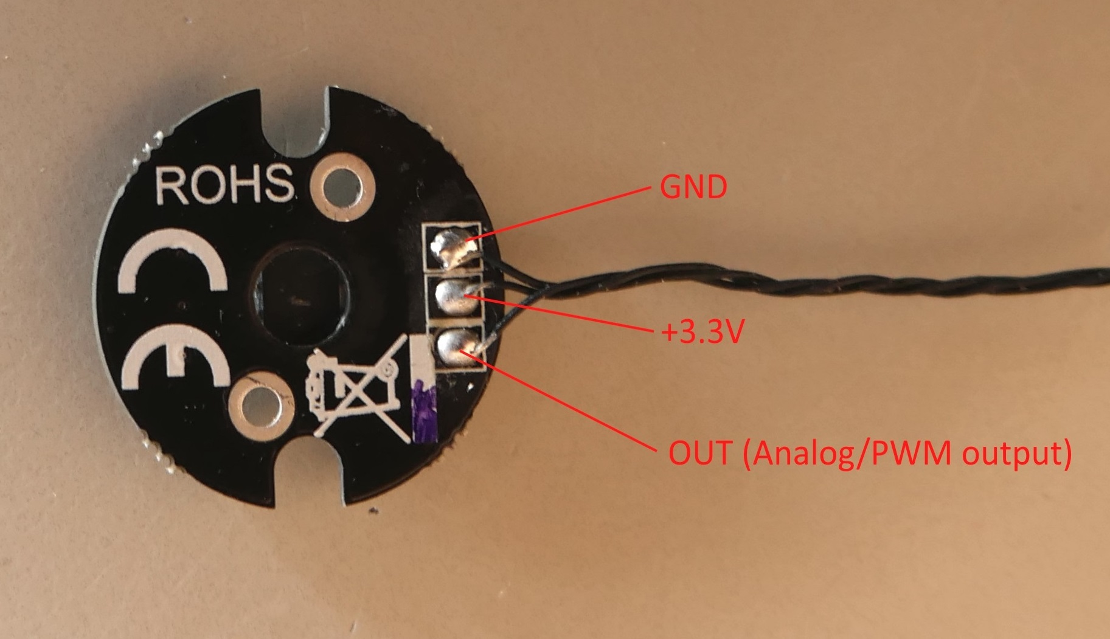

Power supply is 3.3V. It canbe done by camera or Raspberry PI.
GND must be connected to Raspberry Pi.

