LINUX: Add text layer to PDF files

Abstract
For most printers under LINUX, there are no tools supplied by the manufacturer to obtain searchable PDF files when scanning documents. The texts are only embedded as images in the PDFs. This makes it difficult to find something in your scans.
Of course, there are also tools for that under LINUX, but these are often command line tools. This makes it difficult for GUI spoiled users. In addition, the commands are often forgotten.
Therefore, here is a simple graphical user interface to do this work with just a few clicks.

Preparation
Install needed tools:
- ImageMagick (often already part of the LINUX distribution)
- pdfsandwich
- tesseract-ocr

sudo apt install pdfsandwich tesseract-ocr-de -y

Give ImageMagick read|write rights for PDF files:
sudo nano /etc/ImageMagick-6/policy.xml

Replace line
<policy domain="coder" rights="none" pattern="PDF" />
with
<policy domain="coder" rights="read|write" pattern="PDF" />
save with Ctrl+O close with Ctrl+X.

Unzip the downloaded archive and put it somewhere in your home directory, for example in a directory /tools.

If you want create a .desktop file for it.

More:
pdfsandwich http://www.tobias-elze.de/pdfsandwich/
tesseract-ocr https://github.com/tesseract-ocr/tesseract/
tesseract language codes
https://tesseract-ocr.github.io/tessdoc/Data-Files-in-different-versions.html

PDFTXT usage

This GUI is simple and (hopefully) self-explanatory:
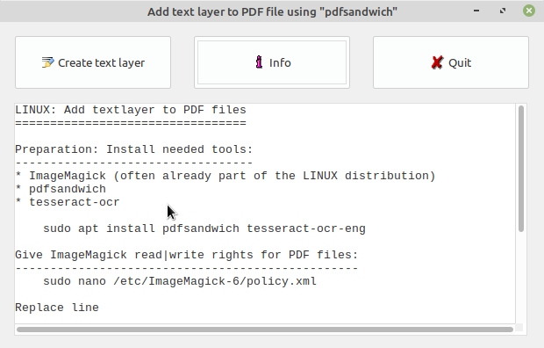
With "Create text layer" you are prompted to select PDF files for processing. You can select several PDF files and process them all in one go.
It's also possible to drag and drop PDF files from the file manager onto the program window and process them all.

The result of processing is saved in the same directory as the original file in a file indicated with "_ocr" in the file name.

