Telemetry from Yuneec H520

Download latest ArduPilot Mission Planner:
http://ardupilot.org/planner/docs/common-install-mission-planner.html

Load *.tlog file to Mission Planner:

http://ardupilot.org/copter/docs/common-mission-planner-telemetry-logs.html

HowTo in Youtube:

https://www.youtube.com/watch?v=4IRRN5YMHJA

https://www.youtube.com/watch?v=ThVUXxOGHAE

=====================================================

How to download FlightLogs

 | ST10+ (same for ST10 or ST12) | ST16, ST16S
 | Power on RC-Controller, wait until booted up. | Power on RC-Controller, wait until booted up.
(1) | Connect to PC via micro USB data cable. Wait until MCU device “ST10+” appears. | Connect to PC via micro USB data cable. Wait until MCU device “anzhen….” appears.
 | Double click on connected device “ST10+” to open it. | Double click on connected device ST16 to open it.
(2) | Double click on “SD Card”. | Double click on “Internal Storage” and look for folder “FlightLog” or “Flight2Log” (H Plus).
(3)  (4) | Select folder “FlightLog” and copy (Crtl+C) or move (Crtl+X) it to your PC into a folder where you collect your FlightLogs (Crtl+V). | Select folder “FlightLog” or “Flight2Log” and copy (Crtl+C) or move (Crtl+X) it to your PC into a folder where you collect your Flight Logs (Crtl+V).
(5) | Select the directory “FlightLog” to open it with Q500log2kml. | Select the directory “FlightLog” or “Flight2Log” to open it with Q500log2kml.
(6) | Rename the latest FlightLog directory to avoid overwriting files with next FlightLog. Use “Archive” button in Q500log2kml to do this. | Rename the latest FlightLog directory to avoid overwriting files with next FlightLog. Use “Archive” button in Q500log2kml to do this.

Download and open flight logs – example: ST16
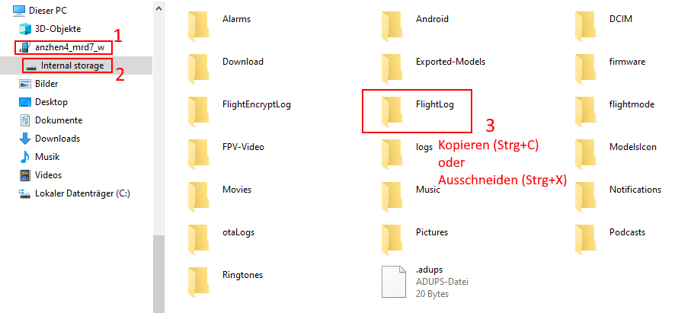
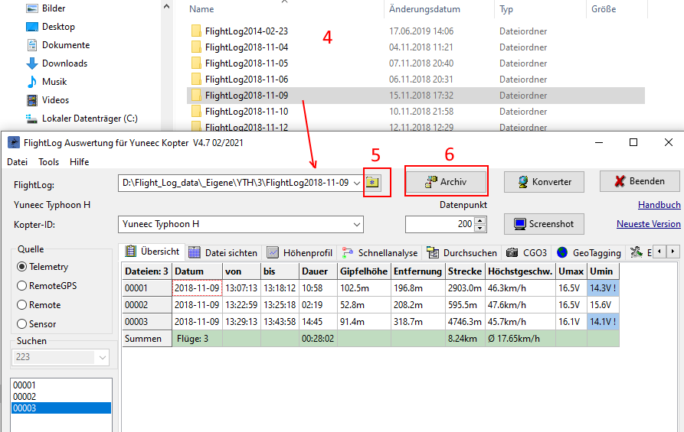
Tool:

Windows64bit: http://h-elsner.mooo.com/downloads/q500log2kml_en.zip
LINUX 64bit: http://h-elsner.mooo.com/downloads/q500log2kml_en.tar.gz
Source code, binaries and documentation: https://github.com/h-elsner/Q500log2kml

