Q500log2kml
user manual

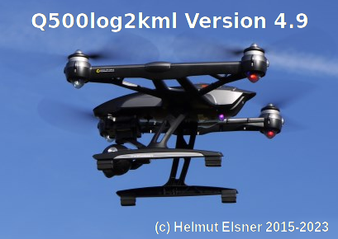

FlightLog data evaluation
for Yuneec quad or hexa drones
Version 4.9



Author: Helmut Elsner
Issue: 11/2023

Table of content
1 Introduction 3
1.1 Features (short description) 4
1.2 Installation 4
2 Detailed description of the features 5
2.1 Load/Read data 5
2.1.1 Main controls 5
2.1.2 Main menu 6
2.1.3 File name rules 7
2.2 Overview 8
2.3 Display files 9
2.3.1 Telemetry, Remote, RemoteGPS 9
2.3.2 Sensor files 13
2.4 Find/Select 16
2.5 Archive 16
2.6 Convert data 17
2.7 Elevation histogram 18
2.8 Data analysis 20
2.9 Quick analysis 21
2.10 Scanning 23
2.10.1 Flight record 23
2.10.2 Search problem case 24
2.11 Additional Tools 24
2.11.1 Clean telemetry 24
2.11.2 List MAVlink messages 24
2.11.3 Hex dump 24
2.12 Settings 25
2.12.1 Data conversions 25
2.12.2 Data analysis 27
2.12.3 Other settings 29
2.13 AppLog 30
3 Appendix 31
3.1 Error Flags (set bit by bit) 31
3.2 Vehicle types 31
3.3 Status bytes (set bit by bit) 31
3.4 Description Raw data (CSV files) 32
3.4.1 Yuneec legacy 32
3.4.2 Examples channel value settings 34
3.4.3 Yuneec Breeze raw data 34
3.4.4 Raw data from Tom's flight data recorder for Hubsan 35
3.4.5 PX4 Sensor data CSV format 36
3.5 Flight Modes 39
3.5.1 Flight modes Yuneec legacy and Blade Chroma 39
3.5.2 Flight Modes Yuneec Typhoon H Plus 39
3.5.3 Flight Modes Blade 350QX (found by try and error) 40
3.5.4 Flight modes H480 Thunderbird (PX4 Autopilot) 40
3.5.5 Flight Modes Yuneec Breeze 41
3.6 Thresholds / color coding 41
3.7 Short description – Prepare telemetry for DashWare 41

Introduction
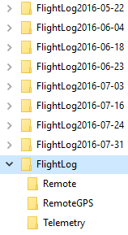
This application was made to display and analyze FlightLog data (including Telemetry) from Yuneec drones Q500, Typhoon H, Typhoon H Plus, H3, H520, H920, Breeze, Mantis Q/G, but also Blade Chroma or Blade 350QX with ST10).
Additionally the CSV files from Tom's flight data recorder for Hubsan can be displayed and analyzed.

The FlightLog data are available on RC-Controller or smart device used to control the aircraft. The FlightLog can be downloaded via micro USB connector.
The ST10(+) controller needs an external SD card located under the battery to save FlightLogs.

For a proper analysis the whole FlightLog directory with all sub directories needs to be copied unchanged to your PC.

Only directories will be opened by the application, not files. The only exception are sensor files from Typhoon H Plus which needs to be opened as single file.

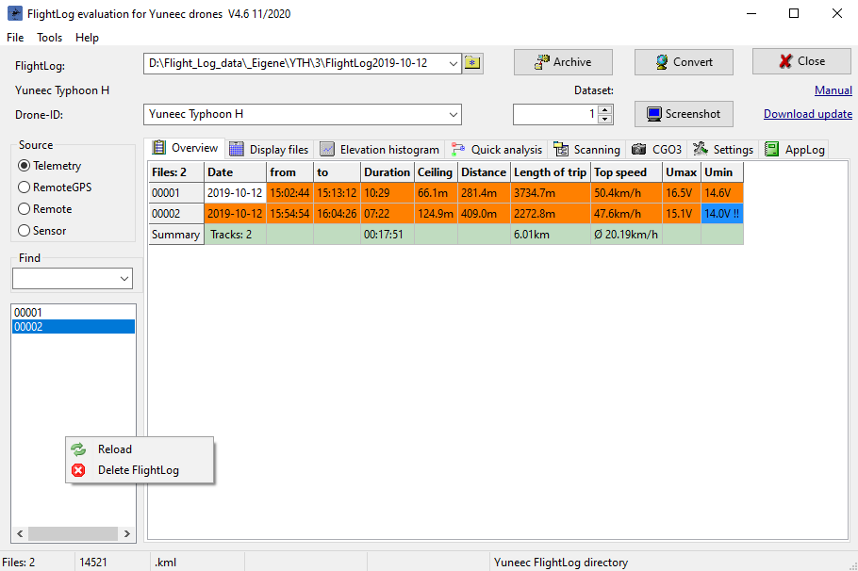
In overview table, FlightLogs with error flags during the flight are marked with orange background. Those needs a deeper view. Most of those error flags are Compass Calibration Warnings. For this analysis, the application can be used as all-in-one solution.

Important note: Use this application on your own risk. There is no guaranty for correctness and/or completeness of the results of the evaluation of flight log data.

Because this all was done by own tests and private researches, the interpretation of the data may be wrong.

On the other hand, this application is freeware. Have fun...

Features (short description)
- Archive: Rename the FlightLog directory by using a time stamp to avoid overwriting older data. This should be the first action if you move the FlightLog data from ST10 to your PC.
- Convert: Convert telemetry data from drones to KML- or KMZ-files (flight path for Google Earth), GPX for other map services, for import to DashWare in order to get telemetry data in videos, as CSV file for RaceRender or as CCC waypoint file.
- Overview: Some important information for the flights in a table form (ceiling, max. air speed, max. distance, warnings, etc).
- Flight record: Scan a whole directory for telemetry files and generate a flight record.
- Search problem cases: Scan a whole directory with FlightLogs for predefined known problem cases (like crashes or compass warnings). This is not available for Yuneec Breeze.
- Display files: Browse raw data of Telemetry, Remote, RemoteGPS or Sensor files. Use this for deeper analysis. Sensor or TLOG files from PX4 controllers will be partially analyzed. There is only a basic support.
- Search: Search in a column of file display table. Depending on values in the columns, part of the search string or whole search string will be used to find something.
- Elevation histogram: Graphic elevation histogram and voltage curve. Cursor for analysis functionality.
- Quick analysis: Three different and select-able Histograms on the same tab sheet for quick overview and compare. Some useful profiles are available to speed-up your checks.
- Cut files: This function provides the possibility to cut out parts of the FlightLog and save it in a new FlightLog file set.
- Analysis: Analyze a predefined data area to see i.e. average speed, climb rate…
- Control CGO3: Test environment for commands to CGO3 via 5G WLAN connection.
- Settings: Three tab sheets for commission settings of the application.
- AppLog: Listing of actions, messages and errors from the application. For sensor files from the Typhoon H Plus, H520 or Mantis Q, text messages (MAV link "statustext") and some other data from different messages will be listed too.
- Hex dump: Show an unknown flight log (or any other file) file as hexadecimal values in AppLog.

Installation
No installation necessary, it is a portable application (only the binary needed). Simply unzip the downloaded file and store it to a directory where you have write access. This can also be a USB stick or a removable drive.
Download updates and user manual from my homepage.
To run the application, you might have to suppress Microsoft SmartScreen warnings: Click on "more info" and then "run anyway".
Installation auf MAC OS X (MAC version is outdated):
Download and unzip archive. Start q500log2kml_EN.dmg. Open the DMG, read ReadMe file and drop both files q500log2kml into the Programs folder. Done, DMG can be closed and deleted.

Start application q500log2kml.app in program folder. If the application will not start, execute following script in terminal as administrator (Admin password is needed):
sudo xattr -r -d com.apple.quarantine /Applications/q500log2kml.app

Detailed description of the features

Load/Read data

Main controls
In the header of the application window are the main input fields and controls.

- FlightLog: Select directory of FlightLog for analysis. The application saves the last six FlightLog directories that have been used in a drop-down list.
- Drone-ID: Free text, selectable from "Saved models" (see Settings/Other settings/Saved models), used for ID in flight paths, flight records and protocols.
- Archive: Renames the FlightLog directory for archiving
- Convert: Starts batch converting of telemetry to selected output format
- Data point: Indicated the selected data set
- Screenshot: Takes a screenshot of the application window (not available for MAC OS X)
- Manual: Link to this manual (either local if available as local file, otherwise to internet)
- Download update: Link to application download repository
- Close: Quits the application
- Double click on a free space in the header calls the about box.
- Double click on status bar below will copy the text part to clipboard.
- Hold mouse pointer over a data cell, value or control to get hints and more information.

On the left side of the application are following controls:

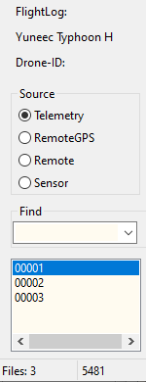
Between “FlightLog” and “Drone-ID”, the Vehicle type will be shown. This is unlike the Drone-ID not editable.

Source: Select the file type you want to see. The data table remains empty if the related file is not available.
Some drone types have only one log file containing telemetry and settings. Thus, source selection is not available.

Find: Input field to enter a value (text or numbers) to search for in the selected column or to filter data sets or records according search rules.

Below the “Find” section is a list field containing the list of file numbers that are available in the FlightLog directory. Each number will be counted as one flight although in a single file maybe more than one flight if only flight battery was changed.
Click on a file number to load the related FlightLog.

With right mouse click you will get a menu with two items:
- reload all and
- delete selected FlightLog item (all related files will be deleted).

Main menu
The main functions can also be called by main menu in application header. Some elements have context sensitive menu, called by right mouse button.

File
Select FlightLog directory…
Open working directory… (opens the file manager, same as double click on input field)
Select flight record directory...
Open flight record directory... (where the flight record was saved)
Open Sensor file from PX4… (to open a single PX4 TLOG or sensor file)
Convert
Archive
Close

Tools
Screenshot: Takes screenshot from the whole application window.
Not available for MAC OS X, please use CMD+Shift+4 instead)
Make flight record (only if a valid flight record directory was selected before)
Reset start/end (the next four menu items belong to FlightLog-cutting function)
Set start
Set end
Cut files
Clean telemetry Remove datasets sent via 5GHz WiFi connection (RSSI=0).
List MAVlink messages… List all types of MAVlink messages in a PX4 sensor file.
Hex dump Show an unknown file as hexadecimal in AppLog for later analysis.

Help
Manual
Homepage (my homepage)
About Q500log2kml (same as double click on empty area of application header)

To load data to the application, select the main directory (usually /FlightLog, /Flight2Log or /FlyLog) where the FlightLog data are located. The FlightLog may contain sub directories (i.e. /Remote, /RemoteGPS, /Sensor and /Telemetry).

You can also Drag & Drop the directory from a file manager to the application window. Files will be checked and an overview in table form will be shown at tab sheet “Overview”. Files or directories must not be write-protected.

The numbering of sensor files for Typhoon H Plus meets not the numbers of the FlightLog. Those sensor files can only be opened and displayed as single file by menu item “Open Sensor file from PX4...”.

File name rules

Like sub directories the file names have to follow rules to be identified as data files:

Legacy Yuneec:
- FlightLog/Remote/Remote_*.csv
- FlightLog/RemoteGPS/RemoteGPS_*.csv
- FlightLog/Telemetry/Telemetry_*.csv

or for old ST10 without Plus only
- FlightLog/Telemetry_*.csv

Typhoon H:
- Flight2Log/Remote/Remote_*.csv
- Flight2Log/RemoteGPS/RemoteGPS_*.csv
- Flight2Log/Sensor/Sensor_*.bin
- Flight2Log/Telemetry/Telemetry_*.csv

Typhoon H Plus:
- Flight2Log/Remote/Remote_*.csv
- Flight2Log/RemoteGPS/RemoteGPS_*.csv
- Flight2Log/Sensor/Sensor_*.txt
- Flight2Log/Telemetry/Telemetry_*.csv

Breeze:
- *.log

Mantis Q:
- Sensor_*.txt
- yuneec_*.log

H520:
- *.tlog

Hubsan H501 (Tom's flight data recorder for Hubsan):
- H501_*.csv

Note: '*' is wildcard for any character, mostly numbers or date/time codes.

Overview
The row ‘Total’ contains:
- Number of flights. Each telemetry file will be counted as one flight no matter if there was an additional landing in between.
- Duration of the real flight without times on the ground. Time will be added if there is valid flight mode in the telemetry data.
- Then sum of the length of all trips. This will be computed only from GPS data and may not be exact.
- The average ground speed computed from trip length and flight times.

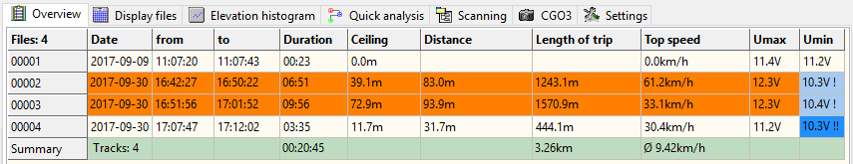
Flights where error flags appeared will be marked as colored line. Voltage warnings are indicated by a “!“ in the column "Umin".
Overview remains empty for H520 and Mantis Q.

To get additional information put the mouse pointer on a cell.

Keyboard shortcuts:
Ctrl + c | Copy table to clipboard

The status bar at the bottom of the application window shows the following context-dependent data from left to right:
- number of files with telemetry data,
- number of data sets or selected data set in the file,
- output format for file conversion,
- state, messages or analysis results.

Usually there are for each flight three files in different sub-directories:
- Telemetry_*.csv in directory "\Telemetry": contains telemetry data sent by drone (selection: Copter).
- RemoteGPS_*.csv in directory "\RemoteGPS": contains GPS data from STxx ground station (Selection: RC).
- Remote_*.csv in directory "\Remote": contains the values, that are transmitted over the RC connection (selection: Radio). Stick values greater that neutral (2048) are marked with blue color, stick values smaller than neutral position are green.

Each address field and also the find criteria field contains a drop-down list with the last used values. It can be deleted by holding the CTRL key and clicking on the field.

Display files

You can see those raw data at tab sheet "Display files". Flight modes, Error flags, GPS accuracy and RC signal strength (fsk_rssi) are indicated by different colors. Maximum values for speed (tas) and altitude will be marked as yellow to find those highlights faster.

Telemetry, Remote, RemoteGPS

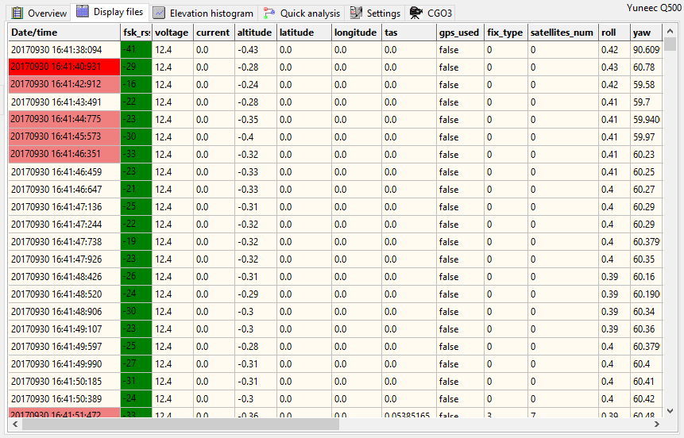

With "Source" (Telemetry, RemoteGPS, Remote or Sensor) you can select what file from the FlightLog shall be displayed (if file is available).

Sensor files of Typhoon H Plus (*.txt, *.tlog) are no more related to Telemetry file numbers and can only opened by main menu item "Open PX4 Sensor file...".

Also self-defined CSV files with selected PX4 sensor data (see Appendix "PX4 sensor data CSV format") can be opened and displayed in the table by main menu item "Open PX4 Sensor file...".

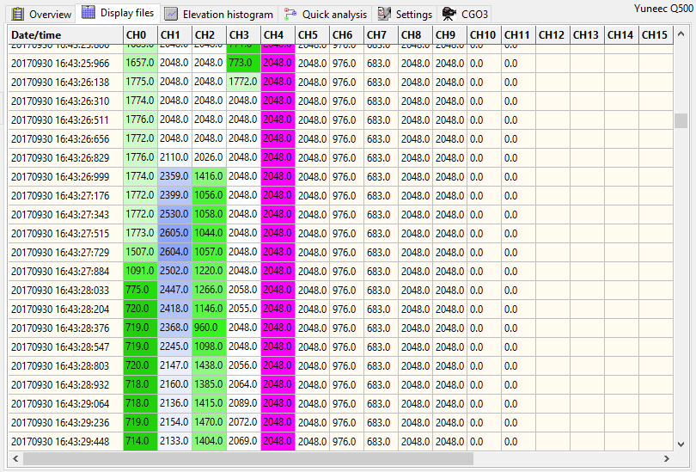
Example: Remote_xxxxx.csv

By click on right mouse button, you will get a context menu for following functions:

- Show at Google Maps: GPS coordinates of the selected data set will be shown at Google Maps in Hybrid View.
- Show at OpenStreetMap: GPS coordinates of the selected data set will be shown at OpenStreetMap.
- Data analysis: As at Elevation histogram this performs an analysis for a predefined number of data sets, results are in status bar.
- Go to data point: Scrolls down the table to the selected data set. The selection may come from Elevation histogram if the cursor is switched on.
- Go to error flags: Scrolls down to the next error flags in the table.
- Reset start/end: Deletes saved start and end time stamps for cutting FlightLog files.
- Set start: Sets a beginning time point where cutting of files starts.
- Set end: Sets the end time point where cut out of data sets will be finished.
- Cut files: Creates a new set of FlightLog files limited by start and end point.
- Save as CSV: Save table "Display Files" as CSV file (Data separator is semicolon) for use in other applications or for documentation purposes.

Double click on a cell shows additional information in the status bar below (explains flight modes, motor status and so on). The same information will appear as hint if you hold the mouse pointer on a cell.

Keyboard shortcuts:
Ctrl + c | Copy selected cells to clipboard
Ctrl + b | Set begin point to cut files or measure time intervals
Ctrl + e | Set end point to cut files or measure time intervals
Ctrl + n | Cut files and create new FlightLog limited by start and end point
Ctrl + f | Start or continue search (see chapter "Find" below)
Ctrl + s | Filter data table by search value (same functionality as "Find")
F3 | Start or continue search (see chapter "Find" below)
F4 | Filter data table by search value (same functionality as "Find")
F5 | Reset filter, renew data table
Escape | Reset filter, renew data table

In column Date/Time cells will be marked with color, if the interval between the time stamps is bigger than expected. This may be normal, but it indicates possibly bad radio conditions or high processor load in flight controller. Good to have an eye on it...

Threshold 1: salmon - 600 ms
Threshold 2: red - 2 sec
For Yuneec Breeze and RemoteGPS the thresholds are: 1..2sec, 2..5sec

Additional detailed view:

For Telemetry, Remote or RemoteGPS, a click on the header of a column opens another window with statistics or charts. This makes it easier to identify and understand what values there are and how things go in the raw data files.

Example:

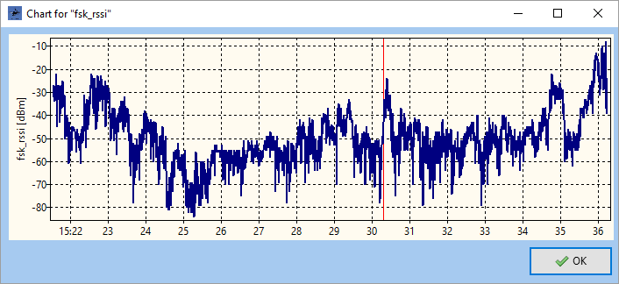

If header of columns with coordinates was clicked, then the chart shows the distance from home point.

You will see a vertical red line as cursor for the cell that you have clicked in the table of raw data on the position in the timeline of the chart.

A double click on the chart will show marker when telemetry data packets were received. This was made to find communication drop outs of the RC connection.

Or, for some columns with countable values you will get simple statistics:

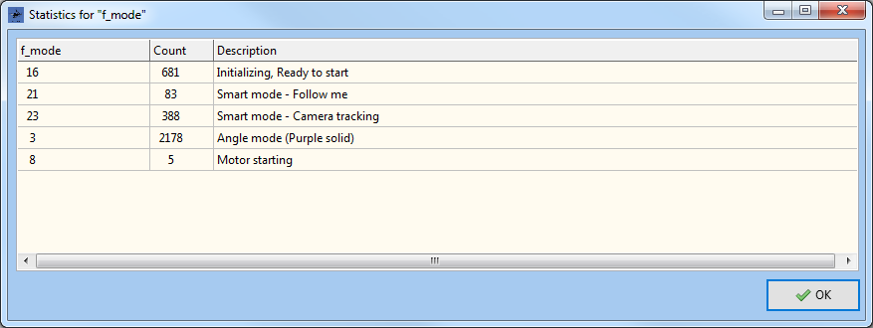

If it makes sense the statistics came up as detailed statistics in timely order:

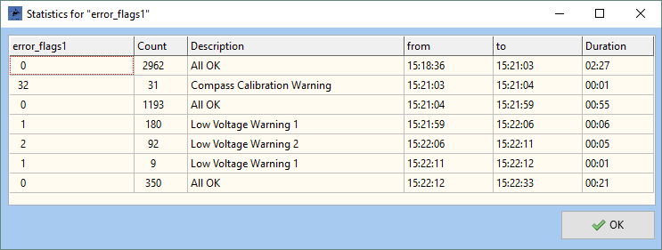

A double click on a line of this detailed statistics let you jump to the related data block in the data table. For error flags, this is a faster and better way to navigate compared to context menu „Go to error flags“.

The same functionality is available for Tom's flight data recorder for Hubsan. It gives CSV formatted log files which records the data stream between the receiver and the MCU inside the Hubsan H901A RC controller.

Details see here (in German):
Discussion: https://www.rc-drohnen-forum.de/thread/10002
Project page: https://gitlab.com/flaretom/hubsan-flightrecorder
Manual: https://gitlab.com/flaretom/hubsan-flightrecorder/-/raw/master/Documents/Handbuch.odt

Sensor files

Sensor files are binary byte streams. Each data record consists of header and payload. The record header (light green) is shown as decimal number, the payload (PL1..n) is displayed as hexadecimal bytes but without 2 byte checksum (CCITT X25 CRC16).

If you hold the mouse pointer on a cell the value will be displayed as decimal and as ASCII character set.

Show Sensor data from Typhoon H:

Select sensor files as source on the left side.

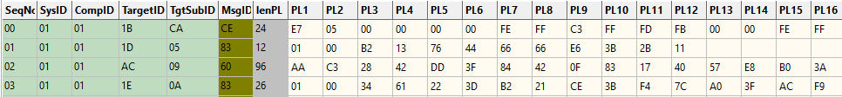

RecordID: $BC
Header length: 8 Byte
Payload length: 0 to minimum 96 bytes (the longest record I have seen up to now)

Byte no | Meaning | Values | Status
0 | Record ID | $BC (= decimal: 188) | checked
1 | Length Payload | 0 to n | checked
2 | Sequence Number | 0 to 255, starts again with 0 | checked
3 | Target ID | undocumented/unknown | supposed
4 | Target Sub ID | undocumented/unknown | supposed
5 | Message ID | undocumented/unknown | supposed
6 | Payload 1 (possibly Payload Data Type) | undocumented/unknown | supposed
... | Payload n | undocumented/unknown | ...
n-1 | CRC16 (CCITT X25) | CRC16 with Header and Payload but without Record ID | checked
n | CRC16 (CCITT X25) | CRC16 with Header and Payload but without Record ID | checked

Due to missing documentation by Yuneec, no interpretation is available for those data records.

Show sensor files from Typhoon H Plus, H520 and Mantis Q:

The concept and format of sensor data for Typhoon H Plus has changed. The file name numbers of sensor files cannot assigned to the other files in FlightLog.
Thus, sensor data only can be opened and displayed as single file by menu item “Open Sensor file from PX4...” in main menu.

There are big gaps in Sequence numbers, means there are messages missing (not recorded in sensor file).

Show TLOG files from H520 or sensor files from Mantis Q:

Yuneec H520 and Mantis Q have only Sensor files (for H520 *.tlog) as FlyLog, but in the same format as Typhoon H Plus (all three PX4). Overview table remains empty. Only the file numbers will be displayed.

H520: *.tlog
Mantis Q: Sensor_*.txt or yuneec_*.log (there are some more log file types, but those can only opened via main menu > Filer > Open PX4 Sensor file)

All other files in the selected directory will be ignored.

All PX4 compatible files have following format:

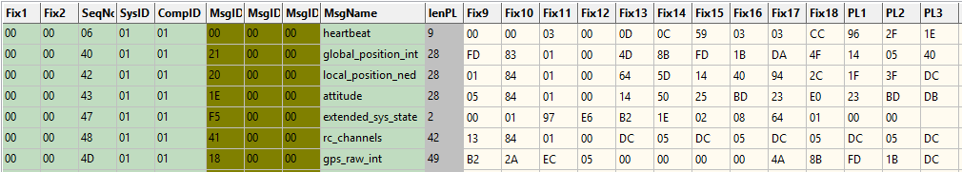

RecordID: $FD
Header length: 20 Byte
Payload length: 0 to minimum 156 bytes (the longest record I have seen up to now)

Byte no | Meaning | Values | Status
0 | Record ID | $FD (= decimal: 253) | checked
1 | length Payload | 0 to n | checked
2 | Fix1 | always zero
3 | Fix2 | always zero
4 | Sequence number | 0 to 255, after 255 starts with zero again | checked
5 | System ID | MAV Link System ID 1 (always 1) | checked
6 | Component ID | 1-Autopilot1; 100-Camera; 154-Gimbal | checked
7..9 | Message ID (3 byte) | MAV link messages common | supposed
10..19 | Fix9 bis Fix18 | Payload (part 1)
20 | Payload 1 | Payload part 2; first variable byte
... | Payload n | Payload following variable bytes | ...
n-1 | CRC16 (CCITT X25) | CRC16 with Header and Payload; without Record ID; always zero | checked
n | CRC16 (CCITT X25) | CRC16 with Header and Payload; without Record ID; always zero | checked

For problem analysis following MAV Messages will be checked:
HEARTBEAT MAV_MODE_FLAG and MAV_STATE
PX4 and quadrotor will be identified as Mantis Q.
SYS_STATUS onboard_control_sensors_present,
onboard_control_sensors_enabled,
onboard_control_sensors_health,
SW Load, voltage und current (current zero from Mantis Q)
PARAM_VALUE_H Onboard parameter name, type, index, counter and value
GPS_RAW_INT Time since boot, altitude, Entfernung and
coordinates as Google Maps Link
ATTITUDE Selected data to CSV file
LOCAL_POSITION_NED Selected data to CSV file
GLOBAL_POSITION_INT Selected data to CSV file
RC_CHANNELS RSSI und Channels
VFR_HUD Climb rate to CSV file
POSITION_TARGET_GLOBAL_INT New target position – only used for AppLog
HIGHRES_IMU All to CSV file
ALTITUDE Verschiedene Höhenangaben
BATTERY_STATUS Battery voltage, current and remaining capacity
EXTENDED_SYS_STATE MAV_LANDED_STATE
STATUSTEXT Severity and text

The results are listed as text in AppLog. Additionally a CSV file can be created with all relevant data from the MAV messages. Which MAV messages will be used you can define in Settings > Data analysis. This was made for possibly needed data reduction in CSV file.

A summary of some main data will be listed:
- Begin: Coordinates as Google Maps link
- End: Coordinates as Google Maps link
- Absolute Ceiling: Height over sea level from GPS-data
- Relative Ceiling: Elevation relative to first GPS coordinate
- Distance: Maximum distance to first GPS coordinate
- Length of trip: Approximately flown route

If option "Flight path from PX4 sensor" is set, KML/KMZ or GPX files will be created and stored in the same directory as the sensor files.
This works also for sensor files from Typhoon H Plus and *.tlog files from H520.

If GPS data are available the Elevation histogram will be filled with relative ceiling and (instead of voltage) distance to first GPS coordinate.
Voltage, current and SW-load will be shown in Quick analysis page.

If option "Sensor data PX4 as CSV file" is set, an additional CSV file with selected values from sensor files will be created. Format is described in Appendix "PX4 sensor data CSV format".
Those CSV files can be opened and displayed in the table by main menu item "Open PX4 Sensor file...".

For more information regarding PX4 sensor files see:
https://developer.yuneec.com/documentation/125/Supported-mavlink-messages
https://docs.px4.io/v1.9.0/en/log/flight_review.html

Find/Select
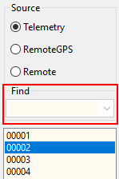
Use Find to search in whole columns of display file tables for a value. Depending on size of values the whole search string will be used or, if values are larger than 4 characters (i.e. Date/Time) or contains a dot, it is enough that a part of the value match the search string. Select the column to find in by click on a cell of the table. Search is only possible if a search string was entered and a column was selected. To search hit F3 or Ctrl+F. Find is never case sensitive.
This functionality can also be used for Scanning (see chapter “Search problem case”).

With same functionality, it is possible to select only matching data (filter the table) by F4 or Ctrl + s. F5 or change file brings you back to whole table (reset filter).

With left mouse button and Ctrl key you can take over values from the table to the search field.

Archive
The ST10 saves only 20 flights and deletes older ones. Once deleted it cannot recovered any more. That is why I pull from time to time the FlightLog data from the memory card located in the ST10 and delete the whole directory there. It will be automatically recreated during next flight by the ST10 SW. Because the directory name is then always the same, I rename it to put it into the archive on the PC. This can be done by the button Archive to avoid overwriting older files with newer ones with the same name. This function adds simply a time stamp at the end of the directory name. The format of the directory suffix depends on settings for archiving.

Convert data
- KML/KMZ
First intention of this application was to convert flight log data to KML files for Google Earth. For larger files Google recommends the format KMZ, which is nothing else than a zipped KML file. The output format can be defined in settings. KML/KMZ files can also be created from PX4 sensor files.
- GPX
Another supported file format is the GPX-format (GPS Exchange Format). This file format can be used to visualize your flight in services like Doarama (now Ayvri). GPX files can also be created from PX4 sensor files.
- dashw.csv
Additionally, it is now possible to create output files for DashWare (due to missing profile, this function is not available for Yuneec Breeze). The format is the same as "st2dash" from Tami:
http://www.drohnen-forum.de/index.php/Thread/12303-ST2Dash-der-Flightlog-Konverter-f%C3%BCr-die-ST10-Q500/
There you can find the related DashWare profile for the Q500 "Yuneec Q500 DashWare Profile v1.5". There will be converted only data from real flight modes. Calibration and initialization data will be suppressed. This may be then easier to synchronize it with the video.
- rr.csv
There is also an experimental output format for RaceRender but without a working profile.
- CCC Waypoints
You can convert telemetry to CCC waypoint files for Typhoon H.
Remark: Use CCC Waypoints on your own risk.

Set the output format in "Settings" > "Data conversion". The status bar on the bottom shows the selected output format. The results are saved in the FlightLog directory. To open file manager at this directory, double click on the address field "FlightLog".

If set, also the movement of the pilot (or better of the ground station) can be added to KML/KMZ files (as black line). GPS data from RemoteGPS are used for this.

It’s possible to replay KML/KMZ files by using navigation and settings of GoogleEarth:

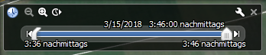
KML/KMZ tracks contain additional placemarks at places where GPS was lost, emergency cases happened or flight modes have been changed.

Elevation histogram

This page shows the elevation histogram with different colors depending on flight mode and a curve for the battery voltage of the drone.

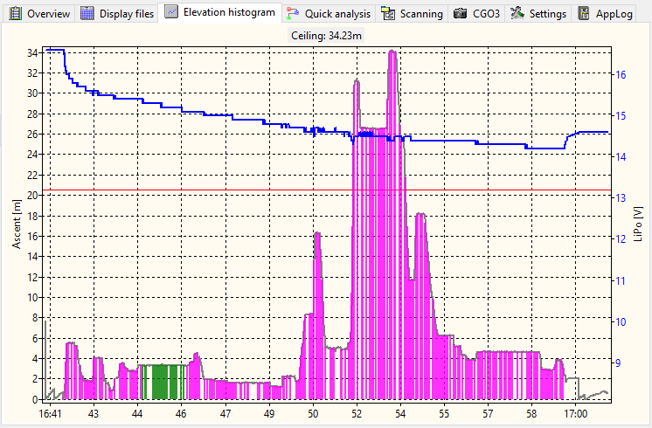

The elevation histogram is a bar chart with a bar for each data set, which has a color depending on the flight mode (f_mode):
- green: Smart mode (6, 21, 23),
- purple: Angle mode (3, 4),
- orange: without GPS support (2, 5, 7, 22, 24),
- blue: Stability mode (0, 1),
- red: RTH and Agility mode (13, 14, 20),
- maroon: Error, Calibrations (9, 10, 11, 12, 17, 18).

For Tom's flight data recorder for Hubsan the color of the bars depends on the frames that sent:
- green: all frames available (7),
- blue: no control frame but all others (3),
- maroon: all other frame combinations.

Because there are different time intervals between the telemetry data sets sent by drone, there may be gaps in the histogram between the bars.

As overlay, there is a curve for the voltage of the flight battery. The color of the curve has different meanings:
- blue: real flight with GPS support,
- red: real flight with GPS switched off,
- gray: flight by simulator UAV-Pilot (identified by values in column 'current').

Context menu, called by right mouse button:
- Copy to clipboard: Copy the picture of the elevation histogram to clipboard as bitmap.
- Save as picture...: The elevation histogram will be saved as *.png file.
- Cursor on/off: Switches on/off a vertical line following the mouse pointer as cursor to navigate in the diagram. With the cursor, you can select a data set as start for analysis.
- Go to table: Opens the table with raw data and jumps to the selected data set.
- Reset start/end: Deletes saved start and end time stamps for cutting FlightLog files.

Keyboard shortcuts:
Ctrl + c | Copy elevation histogram to clipboard
Ctrl + ‘+’ | Increment number of data sets for analysis
Ctrl + ‘-’ | Decrement number of data sets for analysis
Ctrl + n | Cut files and create new FlightLog limited by start and end point
Escape | Cursor off

With mouse wheel you can zoom in the histogram and shift it by hold left mouse button and move. Middle mouse button cancels the zoom function.

It's possible to replace the voltage chart by a chart for remaining capacity of the battery:
Settings > Other settings > Remaining capacity instead voltage.

Note: The remaining battery capacity cannot exactly determined by the battery voltage. It's only an assumption. It depends on a couple of parameters like characteristics, temperature and age of the battery. To compute the remaining battery capacity I have used a table with relationship between voltage and remaining capacity that was published at RC-Groups forum here: https://www.rcgroups.com/forums/showpost.php?p=29431951

Data analysis
The analysis functionality is available at tables in "Display files" and at "Elevation histogram". The results will be displayed in the status bar at the bottom of the application window.

Analysis at elevation histogram: Set the cursor to 'on' in context menu (activated by right mouse button) and navigate to desired data set. Start analysis by click on left mouse button. Results will be displayed in status bar at the bottom. If the CTRL-key is down when the left mouse button was clicked, then the results will be copied to clipboard too. The selected data set will be taken over to the "Data point" field in the header of the application. This is then the start of the interval of data sets defined in settings. This point can also be used as start point for analysis in table view (Display files). Following results will be shown:
- time interval depending on number of data sets for analysis defined in settings,
- average climbing or sinking rate if delta in altitude is > 2m inside the interval,
- distance between start and end point of the data interval,
- length of trip covered by data interval,
- average speed in the data interval.

Analyse at data table: Start analysis by context menu with right mouse button. Start point is the selected data set in field "Data point". It can be set / changed by click on a cell in the table. The data interval depends on settings (the same as for analysis in elevation histogram).

Output for telemetry data (Copter) is the same as described at Analysis at elevation histogram.

Analysis of ST10 data (GPS of the ground station) gets the following results:
- time interval depending on number of data sets for analysis defined in settings,
- average altitude over reference ellipsiod from GPS data,
- length of trip of the ground station covered by data interval,
- average speed of the ground station in the data interval.
Analysis of RC connection data (Radio) gets following results:
- time interval depending on number of data sets for analysis defined in settings,
- position of the flight mode switch,
- position/movement of the sticks – minimum, maximum position in the time interval.

In the Elevation histogram, it‘s possible to increase the number of data sets for analysis by CTRL and + or decrease by CTRL and - key.

Also, a double click on the status-bar will copy the results of the analysis to the clipboard.

Quick analysis

To have a quick overview three freely select-able histograms will be displayed on the same tab sheet.

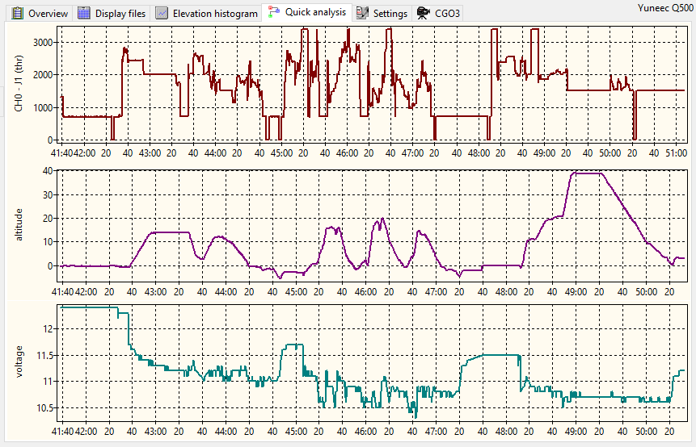
You can select data columns from all three files of a FlightLog (also mixed from different files like Telemetry, Remote or RemoteGPS) or use one of the predefined profiles. If mixed column selection will be used then it is a good idea to cut the files before in order to get same begin and end time stamps in all tree files.
The selection can be done on tab sheet "Settings/Data analysis" (see Settings).
Boolean values will be converted to numbers for histograms:
- true: +1
- false: -1

Among others with this function you can compare stick input with results in the telemetry (i.e. CH2 + tas + pitch). But also, all other combinations are possible, if useful or not.
Additionally, you can show a fourth histogram in another move-able window by double click on the header of the table (as described above). This is by the way the only possibility to convert and display the coordinates (longitude, latitude) into distance from start. This is not possible in Quick analysis histograms due to run-time problems.

Profiles are not available for H520 and Mantis Q. Histograms show voltage, current and SW load. This cannot be changed.

For Hubsan, there are also no profiles but you can select any column from the CSV file for the charts as it is also possible for Yuneec Breeze.

Histograms can be zoomed by mouse wheel and panned by holding left mouse button. Reset zoom and pan by middle mouse button or mouse click when Ctrl key is held down.

Context menu, called by right mouse button:
- Settings: Go to Settings > Data analysis to make your own assignments between freely selected data columns to the three histograms of Quick analysis.
- Default: Reset assignments to default values.
- Profiles: Available profiles are listed in a sub-menu for faster execution of frequently used data combinations.
- Show all profiles: Show all profiles as slide show (duration 3s) for fast overview.

With mouse wheel you can zoom in the histograms and shift it by hold left mouse button and move. Middle mouse button cancels the zoom function.

Scanning

Scanning means to search through a whole directory tree. This is useful for two different functions: Flight Record and Search problem cases in a large set of FlightLogs.

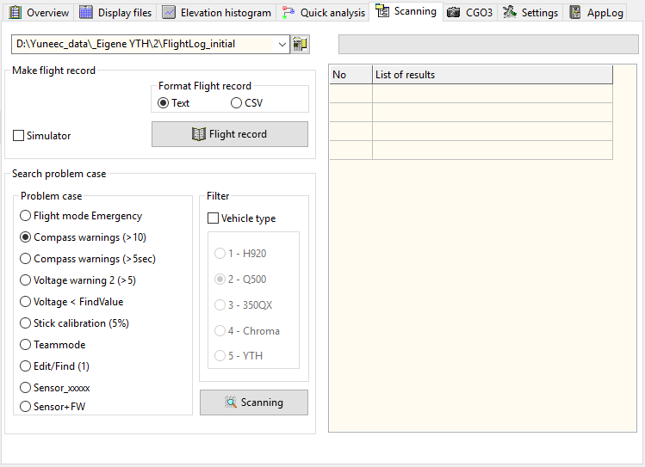
The selection field for the directory in use is common for both functions. As for the other directory edit fields, a double click opens this directory in the file manager. Previous used directories will be listed in the drop-down list.

Not working for Mantis Q and H520 and only partially for Typhoon H Plus (flight time incorrect).

Keyboard shortcuts:
Ctrl+c ---- Copy table of results to clipboard

Flight record
If you have discipline to save your own flight logs for each drone in a separate directory, you can generate a flight record file (in text or CSV format). Select the root directory for the flight logs and click on button Flight record. CSV files can be used in charts or databases.

Entries in the Copter-ID will be taken over to the header of the flight record. There is a list that will be filled from edit field “Saved models” in Settings.
The table of results shows number and overview (time or location) of the recorded flights.

Format flight record: Select output format as text or as CSV file (output in columns).

Simulator: If checked, the flight times with simulator (UAV Pilot) will be added to the total time in the flight record. (default: yes).

Not working for H520 and Mantis Q.

Search problem case

This function was made to find problematic cases in a large collection of FlightLogs. The selected directory will be recursive scanned for FlightLog that match predefined rules.
Following rules are available:

- Emergency: List FlightLogs with crashes (occurrence of flight mode 12).
- Compass warnings: List FlightLogs with more than ten consecutive Compass Calibration Warning flags.
- Compass warnings (>5sec): List FlightLogs with more five seconds consecutive Compass Calibration Warning flags. This should be alerted at the remote control unit by error message.
- Voltage warning 2: List FlightLogs with more than two Voltage Warnings 2.
- Voltage: List FlightLogs where voltage undercut the value in search field.
- Stick calibration: List FlightLogs where less than 5% of data sets in Remote have neutral position (2048). This may be an indicator of missing stick calibration.
- TeamMode: Search for Gimbal Pan Mode at control by right stick (1433.0).
- Edit/Find: List FlightLogs according the find/search rules described in chapter “Find/Select”. This is more flexible and aimed to find special cases.
- Sensor_xxxxx.bin: Find FlightLogs where Sensor file is available.
- Sensor+FW: Find FlightLogs where firmware issue is available in Sensor file.
- PX4 Emergency: Find in all Sensor files text messages with Severity "EMERGENCY" and MAV_state "critical" or "emergency" in MAVLink message HEARTBEAT.
- PX4 Textoverview: Show the text messages from all Sensor files and data from message POSITION_TARGET_GLOBAL_INT.

To filter the results for vehicle type the check box “Vehicle Type” must be checked.

The path to FlightLogs that match the rules will be listed in the table of results. By double click on the row the related FlightLog will be loaded and displayed.

Not useful for Hubsan, H520 and Mantis Q.

Additional Tools

Those tools are only reachable via main menu.

Clean telemetry
Removes all datasets from 5GHz WiFi connection (feature „Dual Band Control Redundancy“).

List MAVlink messages
Scans a PX4 sensor file for all used MAVlink message types.

Hex dump
Show unknown files as hexadecimal values for further analysis. The bytes in the file will be shown in data blocks per button hit.
Block size depends on setting in Settings > Other settings > Block size hex dump. Repeated clicks shows more blocks until end of file was reached. The block number will be shown left the button. This field can be used to jump to higher block number.

Settings
On tab sheet "Settings" it is possible to commission different parameter to define how the application works. Settings will be saved in an XML file related to the application.

Settings are separated to following tab sheets:
- Data conversions
- Data analysis
- Other settings

Data conversions
All settings for data conversions and like output format and how it will be displayed in GoogleEarth.

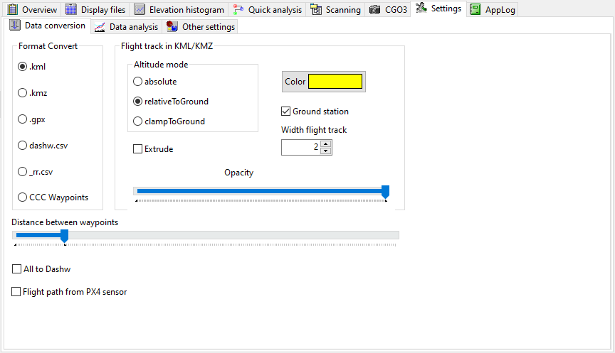

- Format - .kml ---> Convert creates for each flight a *.kml file, which can be imported to Google Earth and many other map services. The file can be read and edited by any text editor
- Format - .kmz ---> same as *.kml, but zipped.
- Format - .gpx ---> Convert creates for each flight a *.gpx file, which can be imported to many map services or applications like Doarama. The file can be read and edited by any text editor
- Format - dashw.csv ---> Convert creates *.csv files for DashWare import.
- Format - _rr.csv --> Convert creates *.csv files for RaceRender import (experimental, no profile available).
- Format - CCC waypoints ---> Convert telemetry to CCC waypoint files.

Remark: Use CCC Waypoints on your own risk.

Flight track in KML/KMZ - Color ---> Set colour for the flight track in Google Earth.
Flight track in KML/KMZ - Opacity ---> Set opacity for the flight track in Google Earth. Right is full opacity (=default).
Flight track in KML/KMZ - Width ---> Set width for the flight track in Google Earth (default 3).

Altitude mode:
- absolute: Height above sea level computed from altitude of telemetry plus altitude from GPS-data of the STxx at start point. No distortion of the flight path, but depending on accuracy of the GPS-data of the STxx and the accuracy of the map data, the flight path may be over the ground or parts of it under the ground (invisible on map).
- relativeToGround: Only altitude from telemetry. Good for flat terrain, but distortion of flight path over hilly ground.
- clampToGround: Flight path will be projected to the ground, no height displayed. It's good to find flown-away drones.

Extrude: If checked the flight path will be drawn with vertical lines to show the elevation.

Ground station: If checked the movements of the ground station (pilot) will be added to KML/KMZ flight path.

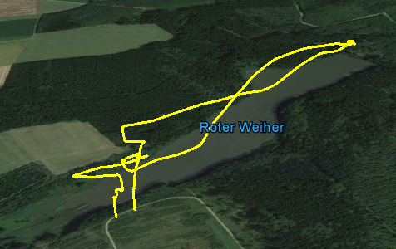
Example (relativeToGround):

Distance between waypoints: Sets the minimal distance between two sets of coordinates of flight path, where a new CCC waypoint will be set during conversion of telemetry to CCC waypoint file.

All to Dashw: Export all data to DashWare (initialization, calibration, no GPS), not only from real flight modes (default: no).

Flight path from PX4 sensor: If checked, a KML/KMZ or GPX file depending on format settings will be created during display of PX4 sensor files. Those files will be stored in the same directory as the sensor files.
This works also for *.tlog files from H520.

Data analysis
Settings for data analysis in table or elevation histogram.

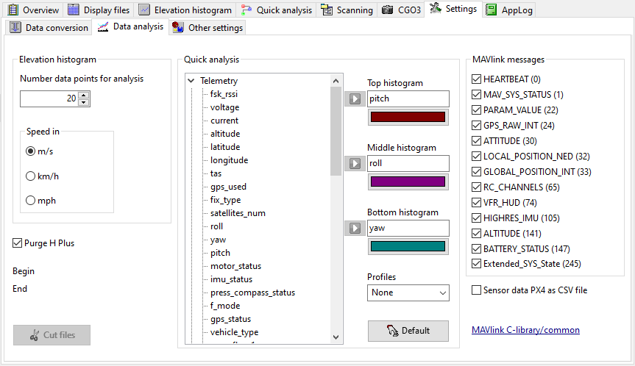

Elevation histogram: Settings for the analysis function by cursor (cursor on) in elevation histogram.

Number of data sets for analysis ---> set how many data sets (data interval) beginning with the selected start point will be checked.

Speed in - converts speed values in Overview and Analysis
- m/s ---> Speed (vertical and horizontal) in meter per second (default).
- km/h ---> Speed (vertical and horizontal) in kilometers per hour.
- mph ---> Speed (vertical and horizontal) in miles per hour.
If mph was selected, then also Overview and Flight record have output in mph or ft.

Purge H Plus: Typhoon H Plus sends a lot of unusable telemetry data with senseless values inside. Those will be suppressed if 'Purge H Plus' is checked (default).

Cut files: If start and end points are set, it is possible with this function to cut data sets between start and end time points and save it to another FlightLog file set. This new FlightLog can be analyzed easier and faster if it contains only the important part of the FlightLog. With this, it is for example possible to exclude the initializing phase.
A double click on the file list on left side re-scans the FlightLog and the new FlightLog set can be selected for analysis.

Quick analysis: Select columns from the FlightLog files for display in the tree histograms at Quick analysis tab sheet and assign colors to the line series. To do this select a column name (marked as selected in blue) and assign it by blue arrow to one of the three histograms. You have to assign different columns to the three histograms but a mix from different file sets of the same FlightLog (Telemetry, RemoteGPS or Remote) is possible. The list will be created as new for each FlightLog and contains only available values from the data columns.

Example – How to set altitude as top histogram:

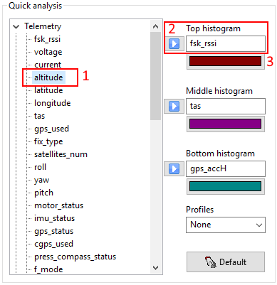

- Select altitude,
- assign to top histogram by blue arrow – done.
- Optional: change colour of the line series.

The assignment can also be done by drag&drop.

Default: reset column assignment and colors to default values. This is useful if you change between Yuneec Breeze and other Yuneec drones.

Profiles: A selection of predefined displays for quick analysis that are recently used. Profiles are not available for Yuneec Breeze or Hubsan.

MAVlink messages: Deselect MAV messages to reduce amount of data in PX4 CSV file. In doubt take all by double click (default).

Sensor data PX4 as CSV file: If checked, a CSV file will be created during display of PX4 sensor files containing some selected data from sensor, mainly GPS- and HW-related data. Those files will be stored in the same directory as the sensor files (Format see 'PX4 Sensor data CSV format' in Appendix).

Other settings
All other settings like behavior of the application.

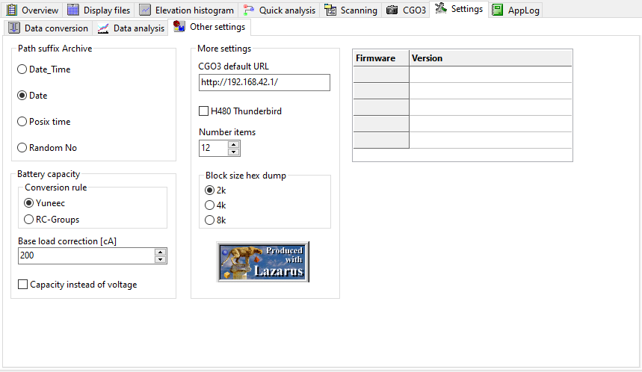

Path suffix: Set the format how the FlightLog directory will be renamed.
- Date_Time ---> the suffix appended after "FlightLog" has the format YYYY-MM-DD_hhmmss.
- Date ---> the suffix appended after "FlightLog" has the format YYYY-MM-DD.
- POSIX time ---> the suffix appended after "FlightLog" is a POSIX time stamp (aka UNIX time – count of seconds since 1.1.1970 00:00h).

Remaining capacity instead voltage: It's possible to replace the voltage chart in Elevation Histogram by a chart of remaining capacity of the battery.

More settings:

H480 Thunderbird: Force data reduction and reduced functionality for Thunderbird, a customized PX4 firmware for Typhoon H. Never use this for other types of aircrafts.
Number items: Indicates how many items will be stored in drop-down lists.
Block size hex dump: Defines size of blocks that will be displayed as hex values with one click on button ‘Hex dump’. Repentantly clicks shows more blocks.

Firmware version: Shows the installed firmware versions at the drone from the Sensor files. Firmware versions are not available in all files. Only ST16 has Sensor files in a separate directory. Table remains empty for ST10.
Yuneec Breeze delivers serial number and SW-/Firmware numbers. The serial number can be taken over to “Saved models” and is then available in the list at “Copter-ID” (as well as all other entries in the “Saved models”). This can be selected and will be used as entry in header of the Flight record.

Keyboard shortcuts:
Ctrl+c ---- Copy table to clipboard

AppLog

This page contains a protocol of actions, messages and error indications. This allows to follow the action done and list messages that are already gone.

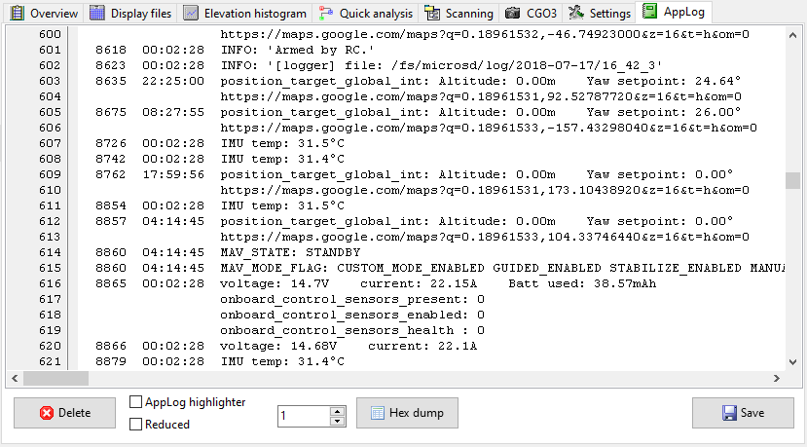
If sensor files from Typhoon H Plus, TLOG files from H520 or FlyLog files from Mantis Q were opened, those may contain text messages (MAV-Link message "statustext", MsgID=$FD). Text messages with severity will be stored in AppLog.

Also the results from some other MAV messages will be listed as text in AppLog,
A summary of some main data will be added:
- Begin: Coordinates as Google Maps link
- End: Coordinates as Google Maps link
- Absolute Ceiling: Height over sea level from GPS-data
- Relative Ceiling: Elevation relative to first GPS coordinate
- Distance: Maximum distance to first GPS coordinate
- Length of trip: Approximately flown route

Delete: Delete the whole AppLog without saving just to make it clear for new analysis actions.

Hex dump: Show blocks of unknown files as hexadecimal values for further analysis. Block size can be changed in settings. Repeated clicks shows more blocks until end of file was reached. The block number will be shown left. This field can be used to jump to higher block number.

Save: Save AppLog protocol to a simple text file.
In case of errors this log file should be saved and added to the error description.

AppLog highlighter: If selected only the most important information will be recorded in AppLog.
Reduced: If selected only the most important information will be recorded in AppLog.

Appendix

Error Flags (set bit by bit)
Bit | Error Flag | Value *
7 | ERROR_FLAG_AIRPORT_WARNING | 128
6 | ERROR_FLAG_FLYAWAY_CHECKER_WARNING | 64
5 | ERROR_FLAG_COMPASS_CALIBRATION_WARNING | 32
4 | ERROR_FLAG_TEMPERATURE_WARNING | 16
3 | ERROR_FLAG_COMPLETE_MOTOR_ESC_FAILURE | 8
2 | ERROR_FLAG_MOTOR_FAILSAFE_MODE | 4
1 | ERROR_FLAG_VOLTAGE_WARNING2 | 2
0 | ERROR_FLAG_VOLTAGE_WARNING1 | 1

If error flag 32 is solid longer than 3 sec during flight, then a Compass error message will appear on the ST16.

* Note: If more than one error flag is set, then the sum of value is displayed in the telemetry data (Example: 33 = ERROR_FLAG_COMPASS_CALIBRATION_WARNING and ERROR_FLAG_VOLTAGE_WARNING1).

Vehicle types
Value | Vehicle Type
1 | 1 = Yuneec H920
2 | 2 = Yuneec Q500
3 | 3 = Blade 350QX
4 | 4 = Blade Chroma (380QX)
5 | 5 = Yuneec Typhoon H or H Plus
6 | 6 = Yuneec H920+ (planned but not used)

Status bytes (set bit by bit)
Bit | Dec | Hex | imu_status | press_compass_status
0 | 1 | 1 | IMU | Pressure
1 | 2 | 2 | n/a
2 | 4 | 4 | Compass2 | Magnetometer/Compass
3 | 8 | 8 | n/a
4 | 16 | 10 | Sonar | GPS
5 | 32 | 20 | GPS2 | RealSense
6 | 64 | 40 | Controller Compass / cgps0 | Sonar
7 | 128 | 80 | Controller GPS / cgps1 | IPS? Something only YTH has

Description Raw data (CSV files)

Yuneec legacy
Column header | Description | Unit | Status
Telemetry (Copter) | Description | Unit | Status
Date / Time | Date / time including milliseconds | JJJJMMTT hh:mm:ss:zzz | checked
fsk_rssi | Received Signal Strength Indication from drone’s receiver | dBm | supposed
voltage | Voltage of flight battery | V | checked
current | Current from flight battery, if sensor available (not for Q500 or Typhoon H),  Remaining battery capacity in % for Typhoon H Plus | dA  % | supposed for H920  checked for H Plus
altitude | Ascent relative to start point | m | checked
latitude | Latitude - GPS coordinates of drone | decimal degrees | checked
longitude | Longitude - GPS coordinates of drone | decimal degrees | checked
tas | True Air Speed, Speed of the aircraft, computed from accelerator data. | m/s | checked
gps_used | GPS usage (true, false) | boolean | checked
fix_type | GPS Fix Type | 0..No GPS connected  1..No position information, GPS is connected  2..2D position  3..3D position  4..DGPS/SBAS aided 3D position  5..RTK float, 3D position  6..RTK Fixed, 3D position  7..Static fixed, typically used for base stations  8..PPP, 3D position
satellites_num | Number of detected satellites | number | checked
roll | Roll (see Wiki Roll-Nick-Gier), postive value indicates the drone tilts to the right | ° | supposed
yaw | Gier (see Wiki Roll-Nick-Gier), 0 is north, angle counts clockwise up to near 360° | ° | supposed
pitch | Nick (see Wiki Roll-Nick-Gier), postive value indicates nose up, negative nose down | ° | supposed
motor_status | Motor Status, bitwise. Motor numbers according the picture in the GUI | bits | supposed
imu_status | IMU Status (inertial measurement unit – see Wiki) | bits | supposed
gps_status | GPS unit status | bits | supposed
cgps_used | Controller GPS/Compass (2 highest bit from imu_status) | 2 bits (0..3) | supposed
press_compass_status | Sensor status (Barometer, Magnetometer) | bits | supposed
f_mode | Code for different flight modes (see table below) | code | checked
gps_pos_used | GPS position used (true, false) | boolean | checked
vehicle_type | drone type | code | checked
error_flags1 | Error flags, bitwise | bits | checked
gps_accH | Horicontal GPS accuracy. | cm? | supposed
RemoteGPS (STxx)
Date / Time | Date / time including milliseconds | JJJJMMTT hh:mm:ss:zzz | checked
lon | Longitude - GPS coordinates of the ground station | decimal degrees | checked
lat | Latitude - GPS coordinates of the ground station | decimal degrees | checked
alt | Height from GPS relative to sea level | m | checked
accuracy | Accuracy of GPS? | Unkown, lower is better, zero means no GPS
speed | Speed, unknown source (maybe computed from GPS coordinates), unknown unit | ?
angle | Angel of moving direction | -180° to +180° | supposed
Remote (Radio)
Date / Time | Date / time including milliseconds | JJJJMMTT hh:mm:ss:zzz | checked
CH0 [1] | Channel 1: J1 throttle/ascent (thr) | 0=Motor start/stop (B3)  2048=neutral | checked
CH1 [2] | Channel 2: J4 roll (ail) | 2048=neutral | checked
CH2 [3] | Channel 3: J3 nick (ele) | 2048=neutral | checked
CH3 [4] | Channel 4: J2 yaw (rud) | 2048=neutral | checked
CH4 [5] | Channel 5: S4 Flight mode | 3412=Smart  2048=Angle  683=RTH | checked
CH5 [6] | Channel 6: A02 - RTH | 2048=neutral  4095=RTH (Typhoon H)  3412=RTH (Q500) | checked
CH6 [7] | Channel 7: K2 Camera tilt | 683=horizontal (0°), 3413=vertical down  (-90°) | checked
CH7 [8] | Channel 8: K1 Camera pan |  | checked
CH8 [9] | Channel 9: S1 Gimbal Tilt Mode | A=2184, V=3412 | checked
CH9 [10] | Channel 10: S2 Gimbal Pan Mode | F=683, Team=1433, Center=1502, G=3412 | checked
CH10 [11] | Channel 11: S5 Landing gear | 0.0=up  4095.0, 1.0=down | checked
CH11 [12] | Channel 12: B2 Aux button | 3412=off  683=Button pressed
CH12 | Channel 13: A09
CH13 | Channel 14: A10
CH14 | Channel 15: A11
CH15 | Channel 16: A12
CH16 | Channel 17: A13
CH17 | Channel 18: A14
CH18 | Channel 19: A15
CH19 | Channel 20: A16
CH20 | Channel 21: A17
CH21 | Channel 22: A18
CH22 | Channel 23: A19
CH23 | Channel 24: A20

Examples channel value settings

Value | Remark | Value
0 | i.e. Motor off | -150%
683 | i.e. RTH stick min | -100%
1433 | i.e. Panmode team (pan on right stick) | -45%
1502 | i.e. Panmode 'Center' | -40%
2048 | neutral | 0%
2184 | i.e. Tilt mode A | 10%
3412 | i.e. Smart mode  Stick max | 100%
4095 | Max setting | 150%

* Note: Channel assignment is only valid for stock STxx with Mode 2. For ST16 assignment can be changed by user. Also the mode of the may be changed by user, which changes assignment to throttle, yaw, roll and pitch accordingly.
CH0 in FlightLog data means Ch1 in Channel settings on ST16 (and so on for all channels).

Yuneec Breeze raw data

Column header | Description | Unit | Status
FlightLog | Description | Unit | Status
UTC | Timestamp | YYYY-MM-DD hh:mm:ss | iOS: Local time  Android: UTC
TimeStamp | Timestamp number | 0..255 incremented
flightMode | Flight Mode | See Breeze Flight Modes
distance | Distance from Take Off point to center for Selfie, Orbit and Journey modes | 131 - 656 (13.1ft - 65.6ft)  40 - 200 (4m - 20m) | supposed
height | Standard height | 13 - 66 (1.3ft - 6.6ft)  7 - 20 (0,7m - 2m) | supposed
loseGPSAct | Fail Save Action | 0 or 1
goHomeHeight | RTH hight | 98 - 2625 (9.8ft - 262.5ft)  30 - 300 (3m - 30m) | supposed
maxHeight | Geo fence Maximum Height | 98 - 2625 (9.8ft - 328.1ft)  30 - 800 (3m - 80m) | supposed
maxDistance | Geo fence Maximum Distance | 328 - 3281 (32.8ft - 328.1ft)  100 - 1000 (10m - 100m) | supposed
maxSpeed | Maximum Speed | 328 - 1640 (3.28ft/s - 16.4ft/s)  100 - 500 (1m/s - 5m/s) | supposed
alt | Altitude | cm | supposed
IMU_Sta | IMU Status | Status bits
lat | Coordinates, Latitude | 518800483
lon | Coordinates, Longitude | 63090397
AutoTakeOFF | Flight rule | 0
roll | Roll angle | 308
pitch | Pitch angle | 344
yaw | Yaw | -8495
motorStatus | Motor Status | 15
errorFlags | Error Flags | 0
nsat | Number satelites, GPS fix | Signed decimal + GPS Fix Flag | supposed
voltage | LiPo remaining capacity | 0..255 (255=100%) | supposed

See also the guide by DoomMeister:
https://drive.google.com/open?id=1QxNGsjg01hMPw7x_1W-iwRedh0BPPnLx
from https://yuneecpilots.com/threads/guide-to-analyzing-breeze-cam-flightlogs-your-data-is-needed.11652/

Raw data from Tom's flight data recorder for Hubsan

Flight data recorder for H501S/SS.
The project was made to record sent commands and received telemetry data between transmitter module A7105 and the main control unit of the RC controller. Transmitter and MCU communicate via SPI-Bus. Datasheet for A7105 is here: https://datasheetspdf.com/parts/A7105.pdf?id=1328531

Discussion: https://www.rc-drohnen-forum.de/thread/10002
Project page: https://gitlab.com/flaretom/hubsan-flightrecorder
Manual: https://gitlab.com/flaretom/hubsan-flightrecorder/-/raw/master/Documents/Handbuch.odt

Index | Name | Description | Unit
0 | Time | Time stamp | hh:mm:ss
1 | frames | Received Frames: NavData, TeleData, Control | Bitmap
2 | Lat | GPS latitude
3 | Lon | GPS longitude
4 | Elev | Altitude relative | m
5 | Dist | Distance
6 | Heading | Heading | °
7 | Roll | Roll | °
8 | Pitch | Pitch | °
9 | Vbat | Voltage | V
10 | Sats | Number of satellites | #
11 | throttle | Throttle stick value
12 | rudder | Rudder stick value
13 | pitch | Pitch stick value
14 | yaw | Yaw stick value
15 | marker | Marker if recorder key was pressed
16 | video | Marker if video is active
17 | Photo | Marker when photo was made
18 | RSSI | Receive signal strength indicator | %
19 | Velocity | Speed | m/s

Frames | Color | Descrition
0 | red | No Frames received, synthetiic data set
1 | orange | One Frame received: NavData
2 | orange | One Frame received: TeleData
3 | blue | Two Frames received: NavData, TeleData
4 | orange | One Frame received: Control
5 | blue | Two Frames received: NavData, Control
6 | blue | Two Frames received: TeleData, Control
7 | green | All Frames received: NavData, TeleData, Control

PX4 Sensor data CSV format

This is a self-defined format to export some of the sensor data from PX4 based Yuneec drones (Typhoon H Plus, Mantis Q, H520).

Description MAV-link format:
https://github.com/mavlink/c_library_v2/tree/master/common

Index | Name | Description | Unit | from MsgID
0 | Time | Time since boot | hh:mm:ss:zzz | 24, 30, 32, 65, 105
1 | rssi | Receive signal strength indicator | % | 65
2 | Voltage | Battery voltage | V | 1/147
3 | Current | Battery current | A | 1/147
4 | Altitude | Altitude relative to ground | m | 24/33/141
5 | Lat | GPS latitude |  | 24/33
6 | Lon | GPS longitude |  | 24/33
7 | tas | True air speed (from xSpeed, ySpeed , zSpeed) | m/s | (32/33)
8 | 8 | Reserved
9 | GPS fix type | GPS fix type |  | 24
10 | Num sats | Number of satellites visible | # | 24
11 | roll | roll | rad | 30
12 | yaw | yaw | rad | 30
13 | pitch | pitch | rad | 30
14 | Drop rate | Dropped packages on all links | % | 1
15 | Sensor health | Onboard control sensors health | Hex (bitmap) | 1
16 | GPS enabled | Onboard GPS sensor enabled | true/false | (1)
17 | Custom mode | A bitmap for autopilot-specific flags | Hex (bitmap) | 0
18 | MAV state | System status flags | Hex (bitmap) | 0
19 | MAV mode flag | System mode bitmap | Hex (bitmap) | 0
20 | MAV landed state | MAV landed state from Extended_SYS_State |  | 245
21 | V_Acc | Altitude uncertainity | m | 24
22 | H_Acc | Postion uncertainity | m | 24
23 | HDOP | Horizontal dilution of position |  | 24
24 | VDOP | Vertical dilution of position |  | 24
25 | hSpeed | GPS ground speed | m/s | 24
26 | xAccl | X acceleration | m/s² | 105
27 | yAccl | Y acceleration | m/s² | 105
28 | zAccl | Z acceleration | m/s² | 105
29 | xGyro | Angular speed around X axis | rad/s | 105
30 | yGyro | Angular speed around Y axis | rad/s | 105
31 | zGyro | Angular speed around Z axis | rad/s | 105
32 | xMag | X magnetic field | gauss | 105
33 | yMag | Y magnetic field | gauss | 105
34 | zMag | Z magnetic field | gauss | 105
35 | Abs pressure | Absolute pressure | mbar | 105
36 | Diff pressure | Differential pressure | mbar | 105
37 | Pressure alt | Altitude calculated from pressure | m | 105
38 | xPosition | X Position | m | 32
39 | yPosition | Y Position | m | 32
40 | zPosition | Z Position | m | 32
41 | xSpeed | X Speed | m/s | 32/33
42 | ySpeed | Y Speed | m/s | 32/33
43 | zSpeed | Z Speed | m/s | 32/33
44 | COG | Course over ground (not heading, but direction of movement) | degree | 24
45 | IMU temp | Temperature Highres_IMU | deg C | 105
46 | Batt remain | Remaining battery capacity | % | 1/147
47 | Batt used | Used capacity from main battry | mAh | (1)
48 | Climb rate | Current climb rate | m/s | 74
49 | Throttle | Current throttle setting | % | 74
50 | Heading | Heading | degree | 33/74
51 | Altitude MSL | Altitude MSL | m | 33/74/141
52 | SW load | Maximum usage of the mainloop time | % | 1
53 | 53 | Reseved for further development
54 | 54 | Reseved for further development
55 | 55 | Reseved for further development
56 | 56 | Reseved for further development
57 | 57 | Onboard paramater name |  | 22
58 | 58 | Paramater value |  | 22
59 | MsgID | MAV message ID that sent updated values | as decimal | #
60 | CH used | Total number of RC channels being received | # | 65/253
61 | CH1 | RC channel 1 values | µs | 65
62 | CH2 | RC channel 2 values | µs | 65
63 | CH3 | RC channel 3 values | µs | 65
64 | CH4 | RC channel 4 values | µs | 65
65 | CH5 | RC channel 5 values | µs | 65
66 | CH6 | RC channel 6 values | µs | 65
67 | CH7 | RC channel 7 values | µs | 65
68 | CH8 | RC channel 8 values | µs | 65
69 | CH9 | RC channel 9 values | µs | 65
70 | CH10 | RC channel 10 values | µs | 65
71 | CH11 | RC channel 11 values | µs | 65
72 | CH12 | RC channel 12 values | µs | 65
73 | CH13 | RC channel 13 values | µs | 65
74 | CH14 | RC channel 14 values | µs | 65
75 | CH15 | RC channel 15 values (currently not used) | µs | 65
76 | CH16 | RC channel 16 values (currently not used) | µs | 65
77 | CH17 | RC channel 17 values (currently not used) | µs | 65
78 | CH18 | RC channel 18 values (currently not used) | µs | 65

The CSV will be saved in the same directory as the sensor files.

Currently following MAVlink messages will be extracted:

MAVlink Message MsgID

HEARTBEAT 0 $0
SYS_STATUS 1 $1
PARAM_VALUE_H 22 $16
GPS_RAW_INT 24 $18
ATTITUDE 30 $1E
LOCAL_POSITION_NED 32 $20
GLOBAL_POSITION_INT 33 $21
RC_CHANNELS 65 $41
VFR_HUD 74 $4A
POSITION_TARGET_GLOBAL_INT 87 $57 (only for AppLog)
HIGHRES_IMU 105 $69
ALTITUDE 141 $8D
BATTERY_STATUS 147 $93
EXTENDED_SYS_STATE 245 $F5
STATUSTEXT 253 $FD

Flight Modes

Flight modes Yuneec legacy and Blade Chroma
f_mode | class FModeData | Meaning | Display
0 | FMODE_BLUE_SOLID | Stability mode (Blue solid) | THR
1 | FMODE_BLUE_FLASHING | Blue flashing - GPS off | THR
2 | FMODE_BLUE_WOULD_BE_SOLID_NO_GPS | Blue - GPS lost | THR
3 | FMODE_PURPLE_SOLID | Angle mode (Purple solid) | Angle
4 | FMODE_PURPLE_FLASHING | Purple flashing - GPS off | Angle
5 | FMODE_PURPLE_WOULD_BE_SOLID_NO_GPS | Angle mode (Purple solid) -  GPS lost | Angle
6 | FMODE_SMART | Smart mode | Smart
7 | FMODE_SMART_BUT_NO_GPS | Smart mode - GPS lost | Angle
8 | FMODE_MOTORS_STARTING | Motor starting | Start
9 | FMODE_TEMP_CALIB | Temperature calibration | Temp
10 | FMODE_PRESS_CALIB | Pressure calibration | Pre Cali
11 | FMODE_ACCELBIAS_CALI | Accelerator calibration | Acc Cali
12 | FMODE_EMERGENCY_KILLED | Emergency/Killed | EMER
13 | FMODE_GO_HOME | RTH coming | Home
14 | FMODE_LANDING | RTH landing | Land
15 | FMODE_BINDING | Binding | Bind
16 | FMODE_READY_TO_START | Initializing, Ready to start | Ready
17 | FMODE_WAITING_FOR_RC | Waiting for RC | No RC
18 | FMODE_MAG_CALIB | Magnetometer calibration | Mag Cali
19 | FMODE_UNKNOWN | Unknown mode
20 | FMODE_RATE | Agility mode (Rate) | Rate
21 | FMODE_FOLLOW | Smart mode - Follow me | Follow
22 | FMODE_FOLLOW_NO_GPS | Smart mode - Follow me -  GPS lost | THR
23 | FMODE_CAMERA_TRACKING | Smart mode - Camera tracking | Watch
24 | FMODE_CAMERA_TRACKING_NO_GPS | Camera tracking - GPS lost | THR
26 | FMODE_TASK_CCC | Task Curve Cable Cam | CCC
27 | FMODE_TASK_JOUR | Task Journey | JOUR
28 | FMODE_TASK_POI | Task Point of Interest | POI
29 | FMODE_TASK_ORBIT | Task Orbit | ORBIT
32 | FMODE_ANGLE_MODE_IPS_ONLY | Indoor Positioning System | IPS
33 | ? | Waypoints | WAYPOINT

Flight Modes Yuneec Typhoon H Plus
f_mode | Meaning | Display | Status
4 | Manual mode (without GPS support) | Manual Mode | supposed
5 | Angle mode | Angle Mode | supposed
6 | Smart mode | Smart Mode | supposed
7 | Sport mode | Sport Mode | supposed
10 | unknown | ?
12 | RTH coming | ? | supposed
13 | RTH landing | ? | supposed
17 | unknown, very rare, possibly a wrong data set | ?

Flight Modes Blade 350QX (found by try and error)
f_mode | Chroma (380QX) | Display | Blade 350QX
0 | Stability mode (Blue solid) | Stab
1 | Blue flashing - GPS off | Stab
2 | Blue - GPS lost | Stab
3 | Angle mode (Purple solid) | AP | Waiting for RC
4 | Purple flashing - GPS off | AP | Initializing
5 | Angle mode (Purple solid) - GPS lost | AP | Motor starting
6 | Smart mode | Smart
7 | Smart mode - GPS lost | AP
8 | Motor starting | Start | Emergency
9 | Temperature calibration | Temp | RTH landing
10 | Pressure calibration | Pre Cali | Agility - GPS off
11 | Accelerator calibration | Acc Cali | Stability
12 | Emergency/Killed | EMER | Smart Mode
13 | RTH coming | Home | Agility Mode
14 | RTH landing | Land | RTH coming
15 | Binding | Bind
16 | Initializing, Ready to start | Ready
17 | Waiting for RC | No RC | Magnetometer calibration
18 | Magnetometer calibration | Mag Cali
19 | Unknown mode
20 | Agility mode (Rate) | Agil
21 | Smart mode - Follow me | Follow
22 | Smart mode - Follow me - GPS lost | Follow
23 | Smart mode - Camera tracking | Track | Binding
24 | Camera tracking - GPS lost | Track
25 |  |  | AP Mode

Flight modes H480 Thunderbird (PX4 Autopilot)
f_mode | Mode | Color in table | Color of bars in Elevation diagram
0 | Stabilized | blue | blue
1 | Altitude | orange | orange
3 | Position | purple | purple
8 | GPS acquiring | none | n/a
12 | Emergency | maroon | maroon
13 | RTH | dark red | dark red
16 | Ready to start | silver | n/a
20 | Rattitude | red | red
33 | Mission | green | green

PX4 flight modes overview: https://docs.px4.io/master/en/getting_started/flight_modes.html

Flight Modes Yuneec Breeze
flightMode | Breeze Flight modes | AutoTakeOFF | Breeze Flight modes
0 |  | 0 | On the ground
1 |  | 1 | Take off
2 | Selfie | 2 | Flying
3 | No Mode (No Task Selected)
4 | Follow Me
5 | Journey
6 | Pilot
7 | Orbit
8 | Return To Home | 16 | Self landing
9
10 | Pilot (No GPS) | 18 | Pilot landing

Thresholds / color coding
Meaning | Color | Date/time | fsk_rssk | gps_accH
Poor | Red | >2s | >85 | >2,5
Reasonable | Light red | 600ms-2s | 70-85 | 1,8-2,5
Good | Light green |  | 55-70 | 1-1,8
Very good | Green |  | <55 | <1
Maximum values | Yellow

All thresholds are self-defined and only for orientation in the raw data.

Short description – Prepare telemetry for DashWare

Step 1: Prepare DashWare (only once the first time):
- download and install latest DashWare from http://www.DashWare.net/DashWare-download/
- download profile "Yuneec Q500 v1.5" from
http://www.drohnen-forum.de/index.php/Thread/12303-ST2Dash-der-Flightlog-Konverter-f%C3%BCr-die-ST10-Q500/
- unzip "Yuneec Q500 v1.5.xml" and copy it to the Profile directory of DashWare: %HOMEPATH%\Documents\DashWare\DataProfiles\
- restart DashWare. Now the new profile for Yuneec telemetry data from ST2DASH or q500log2kml is available every time you use DashWare. Done.

Step 2: Convert telemetry file to DashWare format that fits the profile:
- download and install "q500log2kml" from here:
http://h-elsner.mooo.com/downloads/q500log2kml_en.zip
- read the description (OK, this you have done at this point)
- select Data conversion output format "dashw.csv" in tab "Settings"
- convert all the telemetry data of real flights in one step to DashWarefiles by click on Convert

Step 3: Use video files and fitting converted DashWarefile (i.e. Telemetry000xxdashw.csv):
- start DashWare - create a new project
- add one or more video files (I guess DashWare cannot use 4k videos, it must be downsized)
- add converted DashWarefile (i.e. Telemetry000xxdashw.csv) as data logger file
- select "Yuneec Q500 v1.5" as relating profile
- synchronize telemetry/video and do all the stuff that you want to do with your project...

