How to create flight path for GoogleEarth

Download FlightLogs
- Power on RC-Controller, wait until it booted up.
- Connect RC-Controller to PC via micro USB connector (usually used for charging).
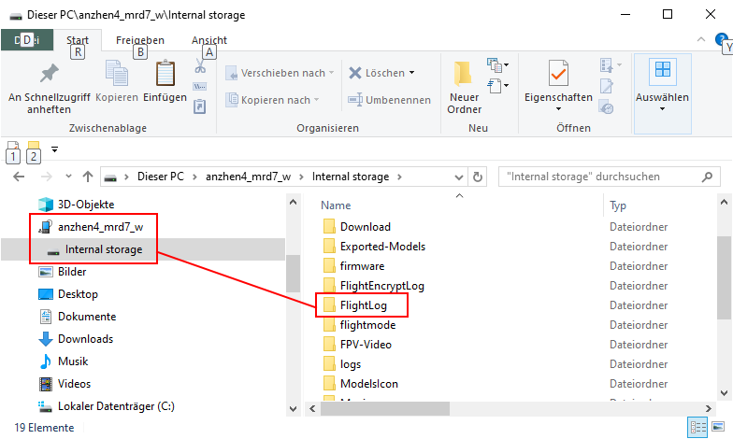
- Double click on connected MTP-device "anzhen_xyz" (each RC-Controller has its own ID) to open it.
- Select folder “FlightLog” or “Flight2Log” and copy (Crtl+C) or move (Crtl+X) it to your PC into a folder (Crtl+V) where you collect your Flight Logs.

See also: https://yuneecpilots.com/threads/how-to-get-h-plus-telemetry-files.13401/

Use Q500log2kml
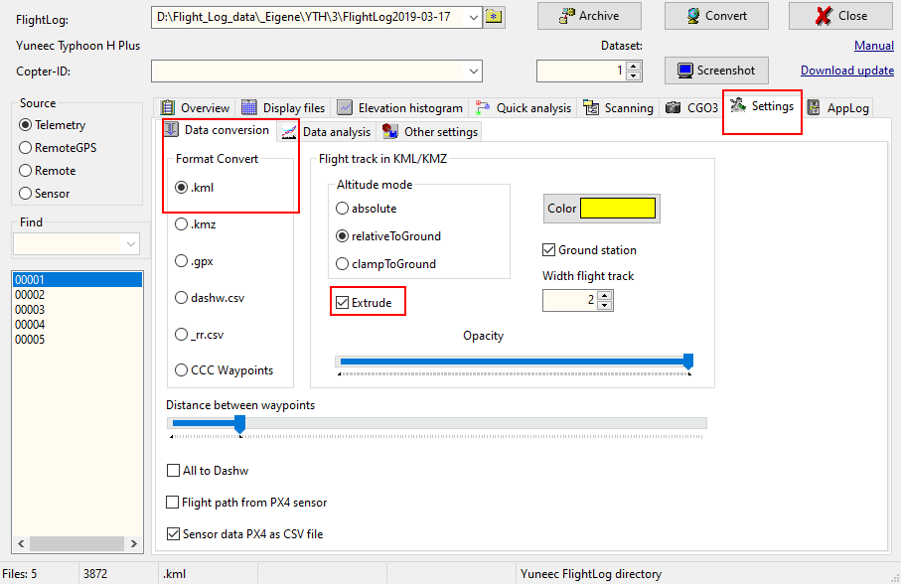
- Open tool Q500log2kml. Go to tab "Settings" > "Data conversion" and select ".kml" as Format Convert.
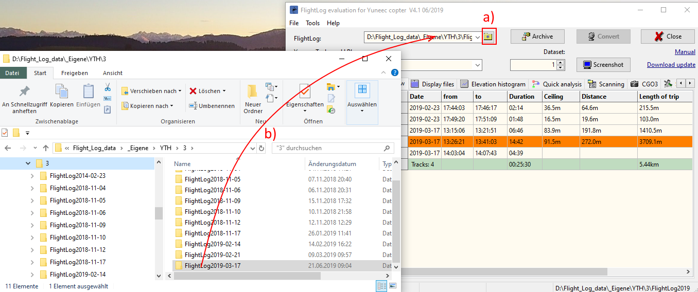
- Select the directory “FlightLog” or “Flight2Log” on your PC to open it with Q500log2kml [a)] or Drag and Drop the Flight Log directory to the program window [b)].
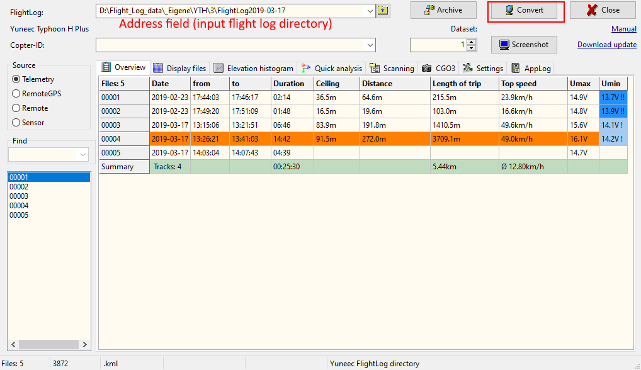
- Tab "Overview" shows the relationship between flight number (file numbering) and flight date/time.
- Click on button "Convert". All real flights will be converted to KML file.
- Double click on address field to open Flight Log directory with file manager. All created KML files listed here.
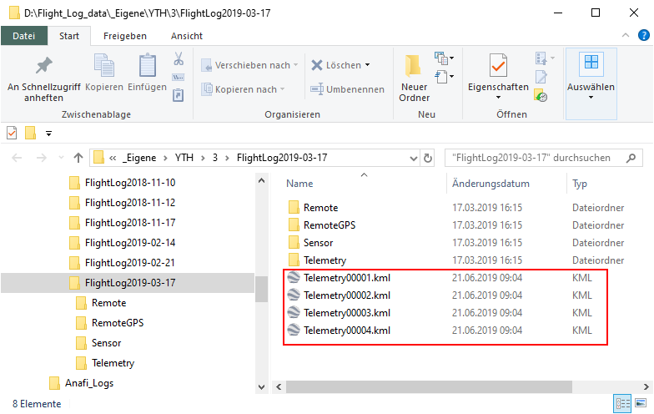
- Double click on the KML file you want see in GoogleEarth. GoogleEarth will be opened and the flight path will be shown. Zoom in or out to see it better.
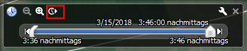
- Replay flight using the control bar.

