
Full functionality of CGO3+ or CGO-ET on Thunderbird

To get pan, tilt, pan mode, and tilt mode working, simply RC data messages from ST16 to camera over WiFi will be received, converted to gimbal control messages and sent to the gimbal via UART. To achieve this I use an ESP32 MCU board, the 5V from RealSense connector and the existing camera power supply from mainboard.

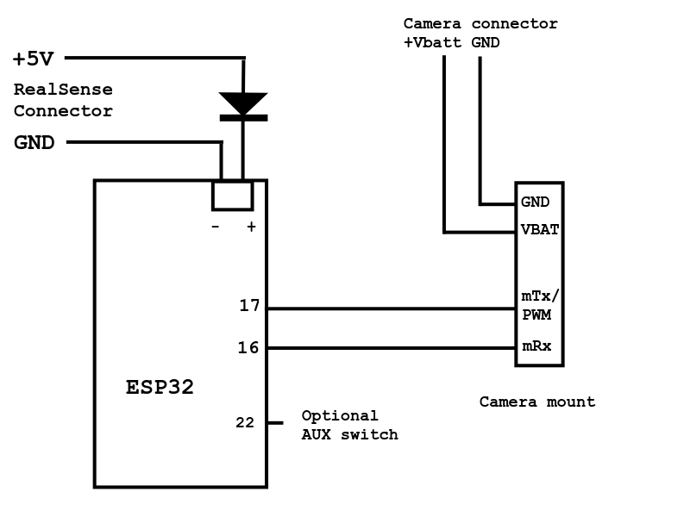
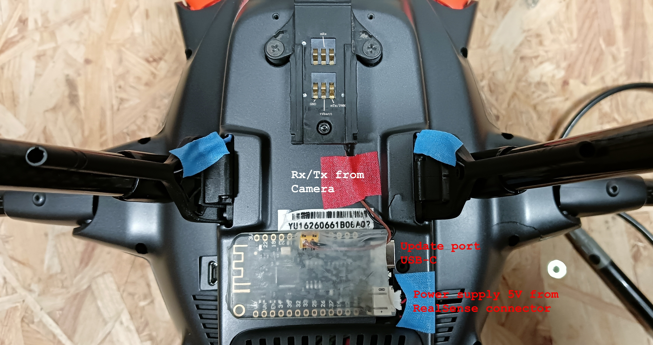
The ESP32 MCU module is outside to make it easy to update FW.

Note: The middle position of the pan mode switch is now an angle mode. It works like for the newer cameras C23 or E90. The camera points to the angle of the pan knob. If you don't want it, comment it out in the sketch.

Code:

/*
This device acts as controller for the CGO3+ on Thunderbird with ST16.
The processor reads the WiFi channel data from ST16 and send following
data via control message to CGO3+:
- pan
- tilt
- pan mode
- tilt mode.
Camera control, settings, and video stream all using WiFi connection.

You need a power source for the camera 12-16V (VBAT, GND) and a step-down
converter to 5V (or 3.3V depending on ESP32 module type) for the ESP32.
CGO3_TXD2 to cam mRx/PWM
CGO3_RXD2 to cam mTx
Wiring depends on HW port definition below.
*/

#define AUX_PIN 22 // Built-in LED
#define CGO3_RXD2 16 // mTx/PWM (black)
#define CGO3_TXD2 17 // mRx (brown)
#define sendbuffer_size 36
#define UART_speed 115200
#define panmode_F 683 // Pan mode Fixed, camera points forward
#define panmode_A 830 // Pan mode Angle - camera points to angle depending knob: 0x033E
#define panmode_P 1502 // Pan mode Position
const uint16_t X25_INIT_CRC = 0xFFFF;
const byte FEheader = 0xFE;

byte cgo3buffer[47];
byte cgo3sequno = 0;

// pan------ tilt----- pan mode- tilt mode CRC_l CRC_h
byte cgo3send_buffer[sendbuffer_size] = {0xFE,26,0,1,0,2,0,1,0,0,0,0,0,0,0,0,0,0,0x37,0,8,0, 0x00,0x08,0xAB,0x02, 0,8, 0xAB,0x02,0x88,0x08, 0xF4,1, 0x00, 0x00};

static inline void crc_accumulate(uint8_t data, uint16_t *crcAccum) {
// Accumulate one byte of data into the CRC
uint8_t tmp;
tmp = data ^ (uint8_t)(*crcAccum &0xFF);
tmp ^= (tmp<<4);
*crcAccum = (*crcAccum>>8) ^ (tmp<<8) ^ (tmp <<3) ^ (tmp>>4);
}

uint16_t UpscaleTo150 (int val, bool convert = true) { // Scale 683 to 3412 (100%)
if (convert) {
val -= panmode_F;
if (val < 0) {val = 0;}
float val_asfloat = val * 4095.0 / 2729.0; // Scale 0 to 4095 (150%)
val = round(val_asfloat);
}
return (val & 0x0FFF); // 12bit per channel
}

void setup() {
btStop();
// Serial.begin(UART_speed); // Debug
Serial2.begin(UART_speed, SERIAL_8N1, CGO3_RXD2, CGO3_TXD2); // Camera
pinMode(AUX_PIN, OUTPUT);
delay(100);
digitalWrite(AUX_PIN, LOW);
}

void loop() {
uint16_t crc16;
uint16_t aux;
byte cgo3len = 0;
byte incomingByte;
int numreadbytes;

uint16_t panmode = panmode_F;

if (Serial2.available() > 1) {
incomingByte = Serial2.read();
cgo3len = Serial2.peek();
if ((incomingByte == FEheader) && (cgo3len == 38)) { // Possible a message ChannelData 5GHz.
numreadbytes = Serial2.readBytes(cgo3buffer, cgo3len+9);
if ((cgo3len > 0) && (numreadbytes == cgo3len+9) && (cgo3buffer[2] == 4) && (cgo3buffer[6] == 8)) { // This SysID and Message ID contains channel data

// Read pan mode first, we need it later
panmode = ((cgo3buffer[39] & 0x0F) << 8) + cgo3buffer[40];
aux = ((cgo3buffer[36] & 0x0F) << 8) + cgo3buffer[37]; // 12 bytes per channel, camera pan

// Change panmode Position to panmode Angle (like E90)
if (panmode == panmode_P) { // Optional: Change pan mode to "Angle"
panmode = panmode_A;
aux = UpscaleTo150(aux);
}
cgo3send_buffer[22] = lowByte(aux); // Camera pan
cgo3send_buffer[23] = highByte(aux);
cgo3send_buffer[28] = lowByte(panmode);
cgo3send_buffer[29] = highByte(panmode);

// Read and write tilt and tilt mode
aux = (cgo3buffer[35] << 4) + (cgo3buffer[36] >> 4); // Camera tilt
cgo3send_buffer[24] = lowByte(aux);
cgo3send_buffer[25] = highByte(aux);
aux = (cgo3buffer[38] << 4) + (cgo3buffer[39] >> 4); // Camera tilt mode
cgo3send_buffer[30] = lowByte(aux);
cgo3send_buffer[31] = highByte(aux);

if ((cgo3buffer[42] & 0x0F) < 8) { // Optional: AUX button channel 11
digitalWrite(AUX_PIN, HIGH);
} else {
digitalWrite(AUX_PIN, LOW);
}

// Prepare CGO3+ control message, add CRC16, and send it to camera
cgo3send_buffer[2] = cgo3sequno;
crc16 = 0xFFFF;
for (uint8_t k=1; k<34; k++) {
crc_accumulate(cgo3send_buffer[k], &crc16);
}
crc_accumulate(0, &crc16);
cgo3send_buffer[34] = lowByte(crc16);
cgo3send_buffer[35] = highByte(crc16);
Serial2.write(cgo3send_buffer, sendbuffer_size);
cgo3sequno++;
}
}
}
}

